**Practical-15**

**Create Simple MVC web application Home Controller.cs:**

using System; using

System.Collections.Generic; using System.Linq; using System.Web; using System.Web.Mvc; namespace Practical_18.Controllers { public class HomeController :

Controller

{ public ActionResult Index() { return View();

} public ActionResult

About()

{

ViewBag.Message = "Your application description page."; return View();

} public ActionResult

Contact()

{

ViewBag.Message = "Your contact page."; return View();

}

}

}

**Layout.CsHtml:**

<!DOCTYPE html>

<html lang="en">

<head>

<meta charset="utf-8" />

<meta name="viewport" content="width=device-width, initial-scale=1.0" />

<title>@ViewData["Title"] - Movie App</title>

<link rel="stylesheet" href="~/lib/bootstrap/dist/css/bootstrap.css" />

<link rel="stylesheet" href="~/css/site.css" asp-append-version="true" />

</head>

<body>

<header>

<nav class="navbar navbar-expand-sm navbar-toggleable-sm navbar-light bgwhite border-bottom box-shadow mb-3">

<div class="container-fluid">

<a class="navbar-brand" asp-area="" asp-controller="Movies" aspaction="Index">Movie App</a>

<button class="navbar-toggler" type="button" databstoggle="collapse" data-bs-target=".navbar-collapse" ariacontrols="navbarSupportedContent" ariaexpanded="false" aria-label="Toggle navigation">

<span class="navbar-toggler-icon"></span>

</button>

<div class="navbar-collapse collapse d-sm-inline-flex justifycontent-between">

<ul class="navbar-nav flex-grow-1">

<li class="nav-item">

<a class="nav-link text-dark" asp-area="" aspcontroller="Home" asp-action="Index">Home</a>

</li>

<li class="nav-item">

<a class="nav-link text-dark" asp-area="" aspcontroller="Home" asp-action="Privacy">Privacy</a> </li>

</ul>

</div>

</div>

</nav>

</header>

<div class="container">

<main role="main" class="pb-3">

@RenderBody()

</main>

</div>

<footer class="border-top footer text-muted">

<div class="container">

&copy; 2022 - Movie App - <a asp-area="" asp-controller="Home" aspaction="Privacy">Privacy</a>

</div>

</footer>

<script src="~/lib/jquery/dist/jquery.js"></script>

<script src="~/lib/bootstrap/dist/js/bootstrap.js"></script>

<script src="~/js/site.js" asp-append-version="true"></script>

@await RenderSectionAsync("Scripts", required: false)

</body>

</html>

**Output:**

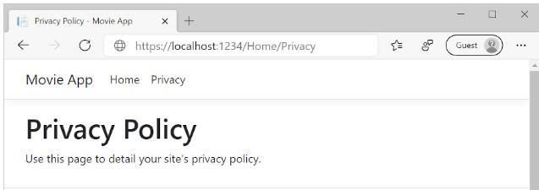

**About.CsHtml:**

@{

Layout = "_Layout";

}

@{ ViewData["Title"] = "Movie List";}

<h2>My Movie List</h2>

<p>Hello from our View Template!</p>

**Output:**

