**Practical-10**

**1. Student Information Page**

**Code:**

using System;

using System.Collections.Generic;

using System.ComponentModel;

using System.Data;

using System.Data.SqlClient;

using System.Drawing;

using System.Linq;

using System.Runtime.InteropServices.ComTypes;

using System.Text;

using System.Text.RegularExpressions;

using System.Threading.Tasks;

using System.Windows.Forms;

using static System.Windows.Forms.VisualStyles.VisualStyleElement.TreeView;

namespace Practical__10_

{

public partial class Form1 : Form

{

SqlConnection conn = new SqlConnection(@"Data Source=(LocalDB)\MSSQLLocalDB;AttachDbFilename=""C:\Users\AMIT GOSWAMI\source\repos\Practical_(10)\Database1.mdf"";Integrated Security=True");

public Form1()

{

InitializeComponent();

SqlConnection conn = new SqlConnection(@"Data Source=(LocalDB)\MSSQLLocalDB;AttachDbFilename=""C:\Users\AMIT GOSWAMI\source\repos\Practical_(10)\Database1.mdf"";Integrated Security=True");

}

private void Form1_Load(object sender, EventArgs e)

{

SqlConnection conn = new SqlConnection(@"Data Source=(LocalDB)\MSSQLLocalDB;AttachDbFilename=""C:\Users\AMIT GOSWAMI\source\repos\Practical_(10)\Database1.mdf"";Integrated Security=True");

}

private void button1_Click(object sender, EventArgs e)

{

conn.Open();

SqlCommand cmd = new SqlCommand("insert into STUDENT values('" +textBox1.Text + "','" + textBox2.Text + "','" + textBox3.Text + "','" + textBox4.Text + "')",conn);

cmd.ExecuteNonQuery();

MessageBox.Show("data inserted");

conn.Close();

}

private void button2_Click(object sender, EventArgs e)

{

conn.Open();

SqlCommand cmd = new SqlCommand("update STUDENT set Name='" +textBox2.Text + "', Branch='" + textBox3.Text + "',Semester='" + textBox4.Text + "' where Enroll_No. = '"+textBox1.Text+"'", conn);

cmd.ExecuteNonQuery();

MessageBox.Show("data updated");

conn.Close();

}

private void button3_Click(object sender, EventArgs e)

{

conn.Open();

SqlCommand cmd = new SqlCommand("delete from STUDENT where ROLL = '"+textBox1.Text+"'",conn);

cmd.ExecuteNonQuery();

MessageBox.Show("data deleted");

conn.Close();

}

private void button4_Click(object sender, EventArgs e)

{

conn.Open();

SqlCommand cmd = new SqlCommand("select * from STUDENT where ROLL = '"+textBox1.Text+"'",conn);

SqlDataReader dreader = cmd.ExecuteReader();

if (dreader.Read())

{

textBox2.Text = dreader[1].ToString();

textBox3.Text = dreader[2].ToString();

textBox4.Text = dreader[3].ToString();

}

else

{

MessageBox.Show(" No Record");

}

dreader.Close();

conn.Close();

}

}

}

**Output:**

**Data Inserting:**

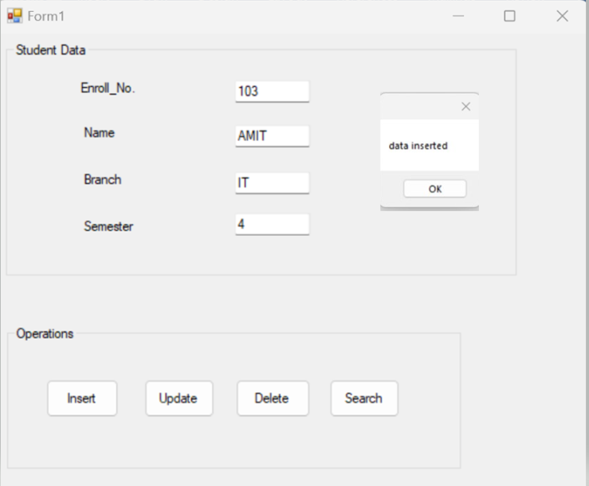

**Data Updation:**

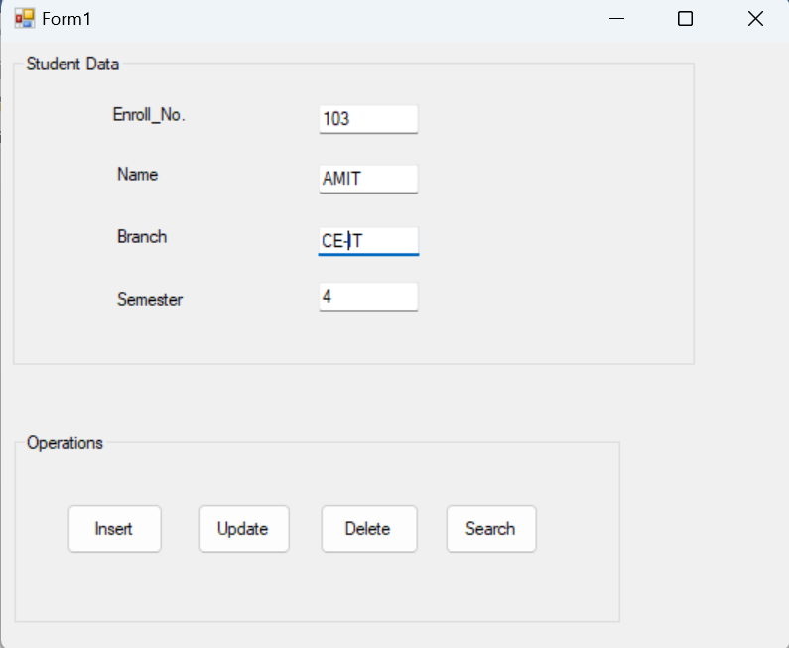

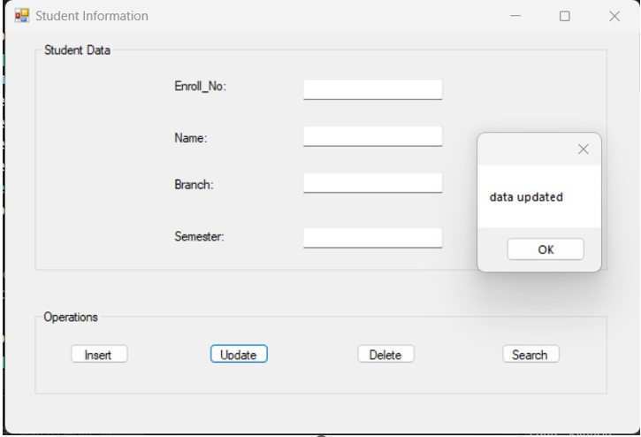

**Data Deletion:**

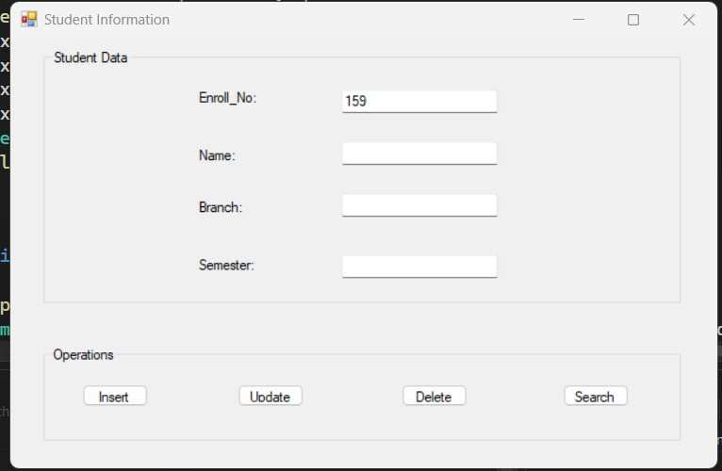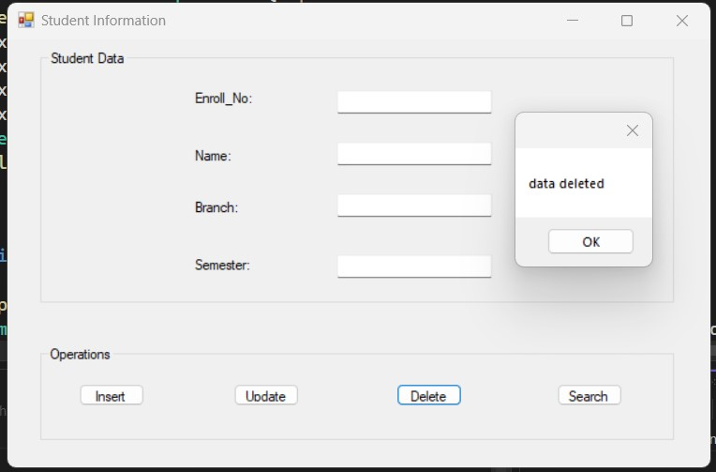

**Data Searching:**

