**Console applications: Object**

**Oriented Programming, StringBuilder**

**And CommandLine Argument**

**1. Write a program to create a Class named ATM having following methods**

**which performs ATM transaction:**

**Balance_check():- To Check the balance of Current Account**

**Debit() :- To Withdraw money into Current Account**

**Credit() :- To add money into Current Account**

**Get_info() :- To see information of Account Holder**

**INPUT :-**

using System;

using System.Collections.Generic;

using System.Linq;

using System.Text;

using System.Threading.Tasks;

namespace Practical_4

{

internal class Practical_4_1_

{

static void Main(string[] args)

{

Console.WriteLine("Name :AMIT GOSWAMI");

Console.WriteLine("Enrollment No. : 21012021003");

string name = "AMIT GOSWAMI ";

int ACC_NO = 12345;

int password = 123;

int Balance = 200000;

Console.WriteLine("Please Enter ACCOUNT information :");

Console.WriteLine("Please Enter Account Number :");

int acc_no = Convert.ToInt32(Console.ReadLine());

Console.WriteLine("Please Enter Password :");

int pass = Convert.ToInt32(Console.ReadLine());

if (ACC_NO != acc_no || password != pass)

{

Console.WriteLine("Please Enter Correct Information .");

}

else

{

Console.WriteLine("Welcome " + name);

label:

Console.WriteLine("Please Ener your choice : \n 1. Balance Check \n 2. Credit \n 3. Debit \n 4. Get Information ");

int a = Convert.ToInt32(Console.ReadLine());

switch (a)

{

case 1:

Balance_check(Balance);

break;

case 2:

Balance = Credit(Balance);

break;

case 3:

Balance = Debit(Balance);

break;

case 4:

Get_info(name, acc_no, Balance);

break;

default:

Console.WriteLine("Please Enter Correct Choice .");

break;

}

Console.WriteLine("Do You Want to Continue :\n 1. Yes \n 2. No");

int b = Convert.ToInt32(Console.ReadLine());

if (b == 1)

{

goto label;

}

else

{

Console.WriteLine("You Have completed your operations .");

}

}

}

public static void Balance_check(int Balance)

{

Console.WriteLine("Balance is :" + Balance);

}

public static int Credit(int Balance)

{

Console.WriteLine("Enter the Value to Credit :");

int n = Convert.ToInt32(Console.ReadLine());

Balance += n;

Console.WriteLine("Now Your Balance is : " + Balance);

return Balance;

}

public static int Debit(int Balance)

{

Console.WriteLine("Enter the Value to Debit :");

int n = Convert.ToInt32(Console.ReadLine());

Balance -= n;

Console.WriteLine("Now Your Balance is : " + Balance);

return Balance;

}

public static void Get_info(string name, int acc_no, int Balance)

{

Console.WriteLine("Your Account Information : \n Name : " + name + " \nAccount No. : " + acc_no + "\n Balance: " + Balance);

}

}

}

**OUTPUT :-**

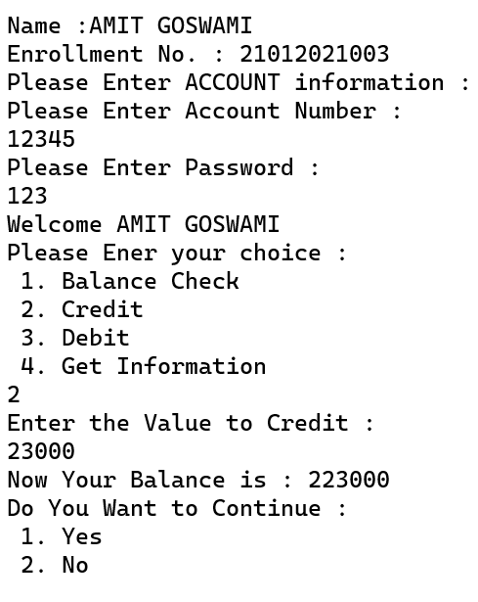

1. **Write a program to find frequency of each element in an array using command Line Arguments**

**INPUT :-**

using System;

using System.Collections.Generic;

using System.Linq;

using System.Text;

using System.Threading.Tasks;

using static System.Net.Mime.MediaTypeNames;

namespace Practical_4

{

internal class Practical_4_2_

{

static void Main(string[] args)

{

Console.WriteLine("21012021003_AMIT GOSWAMI");

int i, count, j;

int n = args.Length;

int[] a = new int[100];

int[] b = new int[100];

Console.WriteLine("Enter the value in the array");

for (i = 0; i < 10; i++)

{

a[i] = Convert.ToInt32(Console.ReadLine());

b[i] = -1;

}

for (i = 0; i < 10; i++)

{

count = 1;

for (j = i + 1; j < 10; j++)

{

if (a[i] == a[j])

{

count++;

b[j] = 0;

}

}

if (b[i] != 0)

{

b[i] = count;

}

}

Console.WriteLine("");

for (i = 0; i < 10; i++)

{

if (b[i] != 0)

{

Console.WriteLine(a[i] + " Occur " + b[i] + " Times ");

}

}

Console.ReadKey();

}

}

}

**OUTPUT :-**

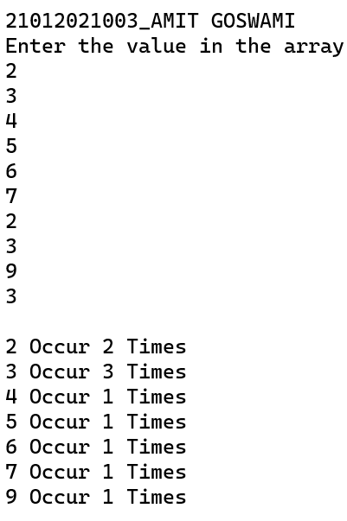

1. **Write a program to explain StringBuilder Class. [Note: Use Append(), AppendFormat(), Insert(), Remove(), Replace() Methods.]**

**INPUT :-**

using System;

using System.Collections.Generic;

using System.Text;

using System.Threading.Tasks;

namespace Practical_4

{

internal class Practical_4_3_

{

static void Main(string[] args)

{

Console.WriteLine("21012021003_AMIT GOSWAMI");

string a = "AMIT GOSWAMI";

string[] b = new string[3] { "GUNI", "UVPCE", "CE/IT" };

StringBuilder bs = new StringBuilder();

StringBuilder sb = new StringBuilder(a);

a = Convert.ToString(sb.Append("AMIT"));

Console.WriteLine(a);

int count = 0;

foreach (string v in b)

{

bs.AppendFormat("you have viisited {0} ({1}) \n", v, count);

count++;

}

Console.WriteLine(bs);

a = Convert.ToString(sb.Insert(4, "GOSWAMI"));

Console.WriteLine(a);

a = Convert.ToString(sb.Remove(3,1));

Console.WriteLine(a);

a = Convert.ToString(sb.Replace("AMIT GOSWAMI", "SUMIT GOSWAMI"));

Console.WriteLine(a);

Console.ReadLine();

}

}

}

**OUTPUT :-**

