**Demonstrate the use of textbox, label and button controls for given windows applications**

1. Create an application that allows the user to enter a number in the textbox named ‘getnum’. Check whether the number in the textbox ‘getnum’ is palindrome or not. Print the message accordingly in the label control named lbldisplay when the user clicks on the button ‘check’.

**INPUT :-**

using System;

using System.Collections.Generic;

using System.ComponentModel;

using System.Data;

using System.Drawing;

using System.Linq;

using System.Text;

using System.Threading.Tasks;

using System.Windows.Forms;

namespace pr6

{

public partial class Form1 : Form

{

public Form1()

{

InitializeComponent();

}

private void button1_Click(object sender, EventArgs e)

{

int a = Convert.ToInt32(getnum.Text), temp = a, rev, sum = 0;

while(a!=0)

{

rev = a % 10;

sum = (sum * 10) + rev;

a = a / 10;

}

if(temp==sum)

{

lbldisplay.Text = "the number is palindrome";

lbldisplay.Visible = true;

}

else

{

lbldisplay.Text = "the number is not palindrome";

lbldisplay.Visible = true;

}

}

}

}

**OUTPUT :-**

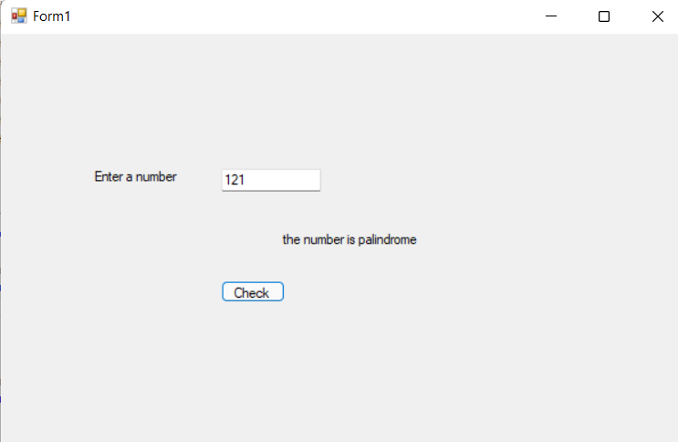

1. Develop windows form which has two textboxs to enter two numbers(range). Now find all the armstrong numbers between given range and dispaly all armstrong numbers in label.

**INPUT :-**

using System;

using System.Collections.Generic;

using System.ComponentModel;

using System.Data;

using System.Drawing;

using System.Linq;

using System.Reflection.Emit;

using System.Text;

using System.Threading.Tasks;

using System.Windows.Forms;

using static System.Windows.Forms.VisualStyles.VisualStyleElement;

namespace Practical_6

{

public partial class Form2 : Form

{

public Form2()

{

InitializeComponent();

}

private void button1_Click(object stextBox2er, EventArgs e)

{

StringBuilder sb = new StringBuilder("Number is : ");

for (int i = int.Parse(textBox1.Text); i <= int.Parse(textBox2.Text); i++)

{

int temp = i;

int temp1 = i;

int sum = 0;

int re, c, c1;

int count = 0;

while (temp1 > 0)

{

c1 = temp1 % 10;

count++;

temp1 = temp1 / 10;

}

while (temp > 0)

{

re = temp % 10;//153

c = (int)Math.Pow(re, count);

sum = sum + c;

temp = temp / 10;

}

if (i == sum)

{

sb.Append(Convert.ToString(i) + " , ");

}

label1.Text = sb.ToString();

}

}

}

}

**OUTPUT :-**

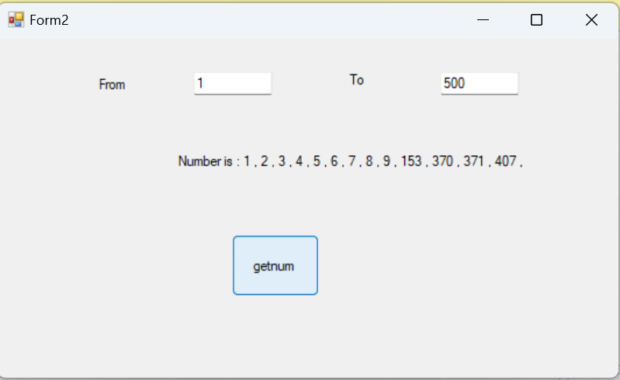

3. Create one form and three textboxs for mobile number, password and confirm password. Write a c#

code for following:

(i) To validate mobile number

(ii) To check weather password and confirm password are same or not

(iii) To check each and every textbox should not be empty

[Note: Use textbox as your input]

**INPUT :-**

using System;

using System.Collections.Generic;

using System.ComponentModel;

using System.Data;

using System.Drawing;

using System.Linq;

using System.Text;

using System.Text.RegularExpressions;

using System.Threading.Tasks;

using System.Windows.Forms;

namespace Practical_6

{

public partial class Form3 : Form

{

public Form3()

{

InitializeComponent();

}

private void button1_Click(object sender, EventArgs e)

{

string m = textBox1.Text;

string p = textBox2.Text;

string cp = textBox3.Text;

bool a, b, c;

Regex RM = new Regex("^[0-9]+$");

Regex RP = new Regex("(?=.*\\d)(?=.*[a-z])(?=.*[A-Z]).{8,}");

if (RM.IsMatch(m.Trim()) == false)

{

label4.Visible = true;

label4.Text = "*Please Enter Valid Mobile No. ";

a = false;

}

else if (m.Length > 10 || m.Length < 10)

{

label4.Visible = true;

label4.Text = "Please Enter Valid Mobile No. ";

a = false;

}

else

{

label4.Visible = false;

a = true;

}

if (RP.IsMatch(p.Trim()) == false || p == "")

{

label5.Visible = true;

label5.Text = "Must contain at least one number \n one uppercase and lowercase letter \n at least 8 or more characters";

b = false;

}

else

{

label5.Visible = false;

b = true;

}

if (cp.Equals(p) == false || cp == "")

{

label6.Visible = true;

label6.Text = "password doesn't match !";

c = false;

}

else

{

label6.Visible = false;

c = true;

}

if (a && b && c)

{

MessageBox.Show("form submitted successfully !!");

}

}

}

}

**OUTPUT :-**

