**Practical-13**

|  |
| --- |
| **Create Web Application having Registration Module of User** |

1. **Design ASP.net web forms to create User module for registration using various server controls, ajax and validation controls. Registration form accepts first name, last name, username, password, date of birth, contact no, email, country, state, city and address All the information entry is compulsory. Password should be reconfirmed. Email id should be valid. Username should have at least a capital letter and digit as well as length should be between 7 and 20 characters. Write ADO .Net code to insert record of user registration into user table.**

**@Registration.aspx**

<%@ Page Title="" Language="C#" MasterPageFile="~/Site1.Master" AutoEventWireup="true" CodeBehind="Registration.aspx.cs" Inherits="Practical_12.Registration" %>

<%--<%@ Register assembly="AjaxControlToolkit" namespace="AjaxControlToolkit" TagPrefix="ajaxToolkit" %>--%>

<asp:Content ID="Content1" ContentPlaceHolderID="head" runat="server">

</asp:Content>

<asp:Content ID="Content3" ContentPlaceHolderID="p12" runat="server">

<div style ="align-content :center; justify-content:left; margin-top:20px; float:left;" >

First Name:<asp:TextBox ID="TextBox1" runat="server" style="margin-left: 20px;

margin-top: 0px" Height="23px" Width="170px" placeholder ="Enter FirstName"></asp:TextBox>

<br /><br />

last Name:<asp:TextBox ID="TextBox2" runat="server" style="margin-left: 20px;

margin-top: 0px" Height="23px" Width="170px" placeholder ="Enter last Name"></asp:TextBox>

<br /><br />

Username:<asp:TextBox ID="TextBox3" runat="server" style="margin-left: 20px;

margin-top: 0px" Height="23px" Width="170px" placeholder ="Enter Username"></asp:TextBox>

<br /><br />

Password:<asp:TextBox ID="TextBox4" runat="server" style="margin-left: 20px;

margin-top: 0px" Height="23px" Width="170px" placeholder ="Enter Password"></asp:TextBox>

<br /><br />

DOB:<asp:TextBox ID="TextBox8" runat="server" style="margin-left: 20px;

margin-top: 0px" Height="23px" Width="170px" placeholder ="Enter date of birth"></asp:TextBox>

<br /><br />

ContactNo:<asp:TextBox ID="TextBox5" runat="server" style="margin-left: 20px;

margin-top: 0px" Height="23px" Width="170px" placeholder ="Enter ContactNo"></asp:TextBox>

<br /><br />

</div>

<div style =" justify-content:right; float:right;">

Email:<asp:TextBox ID="TextBox6" runat="server" style="margin-top: 40px;

margin-top: 0px" Height="23px" Width="170px" placeholder ="Enter email"></asp:TextBox>

<br /><br />

Address:<asp:TextBox ID="TextBox7" runat="server" style="margin-left: 20px;

margin-top: 0px" Height="23px" Width="170px" placeholder ="Enter Address"></asp:TextBox>

<br /><br />

City:

<asp:DropDownList ID="DropDownList1" runat="server" style="margin-left: 86px" Height="30px" Width="150px">

<asp:ListItem>Rajkot</asp:ListItem>

<asp:ListItem>Ahemdabad</asp:ListItem>

<asp:ListItem>Mahesana</asp:ListItem>

<asp:ListItem>Surat</asp:ListItem>

</asp:DropDownList>

<br /><br />

State:<asp:DropDownList ID="DropDownList2" runat="server" style="margin-left: 67px">

<asp:ListItem>Gujrat</asp:ListItem>

<asp:ListItem>Maharastra</asp:ListItem>

<asp:ListItem>Rajasthan</asp:ListItem>

</asp:DropDownList>

<br /><br />

Country:<asp:DropDownList ID="DropDownList3" runat="server" style="margin-left: 67px">

<asp:ListItem>India</asp:ListItem>

<asp:ListItem>USA</asp:ListItem>

<asp:ListItem>UK</asp:ListItem>

<asp:ListItem>Canada</asp:ListItem>

</asp:DropDownList>

<br /><br />

Role:&nbsp;&nbsp;&nbsp;

<asp:DropDownList ID="DropDownList4" runat="server">

<asp:ListItem>User</asp:ListItem>

<asp:ListItem>Admin</asp:ListItem>

</asp:DropDownList>

</div>

<center>

<asp:Button ID="Button1" runat="server" Text="Submit" Width="224px" style="margin-left: 270px" />

</center>

<br />

</asp:Content>

**@Registration.aspx.cs**

**@Login.aspx**

<%@ Page Title="" Language="C#" MasterPageFile="~/Site1.Master" AutoEventWireup="true" CodeBehind="login.aspx.cs" Inherits="Practical_12.Login" %>

<asp:Content ID="Content1" ContentPlaceHolderID="head" runat="server">

</asp:Content>

<asp:Content ID="Content2" ContentPlaceHolderID="p12" runat="server">

<p>

<center>

LOGIN MODULE

</center>

</p>

<p>

UserName:<asp:TextBox ID="TextBox1" runat="server"></asp:TextBox>

</p>

<p>

Password:<asp:TextBox ID="TextBox2" runat="server"></asp:TextBox>

</p>

<p>

<center>

<asp:Button ID="Button1" runat="server" Text="Login" />

</center>

</p>

</asp:Content>

**@Site Master Page**

<%@ Master Language="C#" AutoEventWireup="true" CodeBehind="Site1.master.cs" Inherits="Practical_12.Site1" %>

<!DOCTYPE html>

<html>

<head runat="server">

<title></title>

<asp:ContentPlaceHolder ID="head" runat="server">

</asp:ContentPlaceHolder>

<style>

#left {

background-color: aquamarine;

float:left;

width:20%;

height: 100%;

}

#right {

float:right;

padding-right : 300px;

}

</style>

</head>

<body>

<form id="form1" runat="server">

<div style="background-color:firebrick;width:100%;height:59px;font-size:xx-large;color:wheat" >

<center>Welcome to Website</center>

</div>

<div id="left" >

<ul list-style-type="none" >

<li style="padding-bottom:10px"><a href="Home.aspx" >HomePage</a></li>

<li style="width: 328px; height: 36px;"><a href="About.aspx">About</a></li>

<li style="height: 32px;padding-bottom:10px"><a href="ContactUs.aspx">Contact Us</a></li>

<li style="height: 32px;padding-bottom:10px"><a href="Registration.aspx">Registration</a></li>

<li style="height: 21px; padding-bottom:10px"><a href="login.aspx">Login</a></li>

</ul>

</div>

<div id="right" style="width:47%">

<asp:ContentPlaceHolder ID="p12" runat="server" >

</asp:ContentPlaceHolder>

</div>

</form>

</body>

</html>

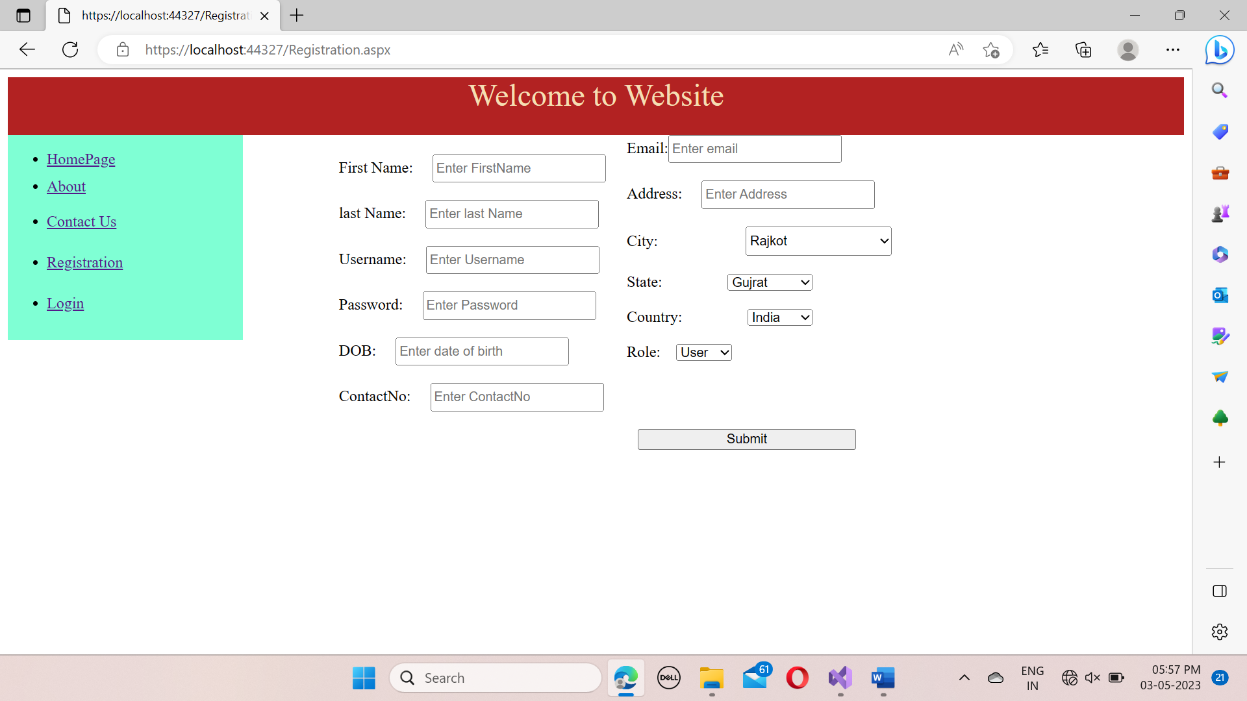****

1. **Develop Login Module of user by checking username and password using database. If user has entered correct login credentials then store the information into session and redirect user to welcome page and display welcome message**

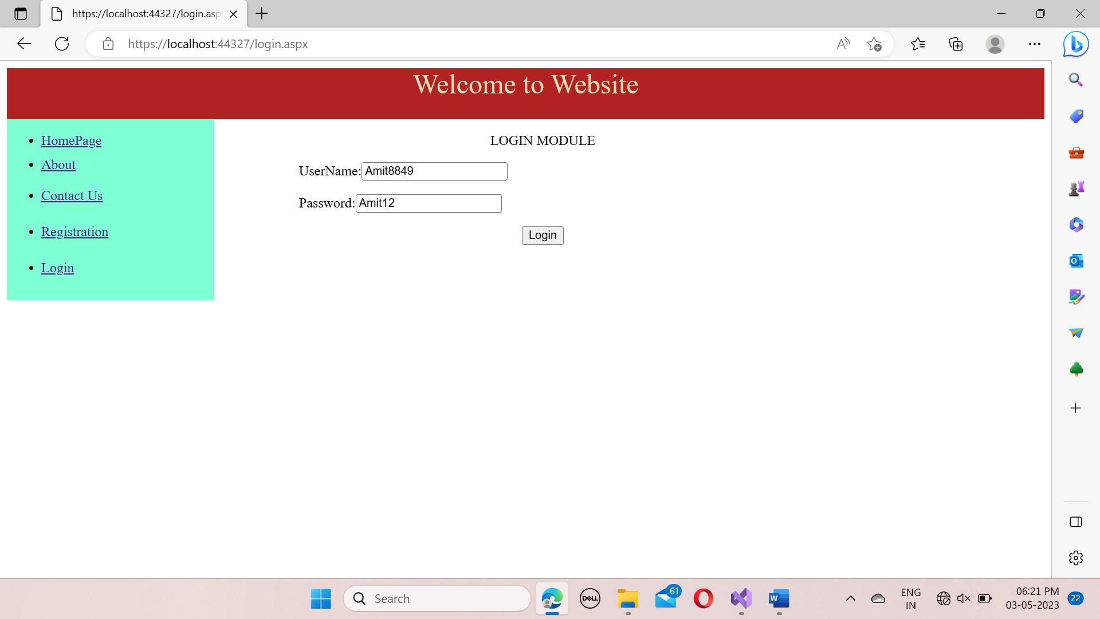

1. **Create a Admin Module to display list of user to admin using grid view and ajax controls using database.**
2. **Develop Login Module of admin by checking username and password using database. If admin has entered correct login credentials then store the information into session and redirect user to welcome page and display welcome message.**
3. **Write ADO .Net code in User Module to update and delete profile of user from database.**