|  |
| --- |
| **List box Control** |

Write a program to demonstrate use of ListBox control.

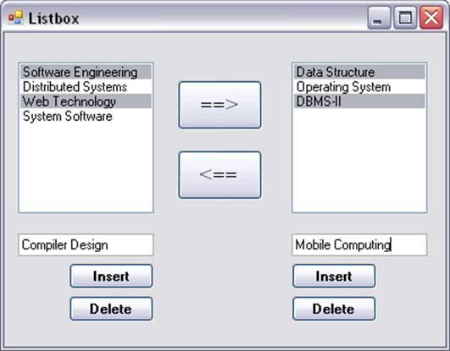

The form should contain List boxes, Text boxes, and buttons as displayed.

-  You should be able to select multiple values from list box. The multiple selected values can be shifted in another list box as displayed.