Practical - 5

**AIM :-** Implement program of Counting Sort.

***CODE :-***

#include <stdio.h>

void counting_sort(int size1,int arr1[],int arr2[],int size2)

{

int i,j; for(i=0;i<size2;i++)

{

arr2[i]=0;

}

for(i=0;i<=size1-1;i++)

{

arr2[arr1[i]]=arr2[arr1[i]]+1;

}

for(i=0;i<size2;i++)

{

if(arr2[i]!=0)

{

int temp=arr2[i]; for(j=1;j<=temp;j++)

{

printf("%d ",i);

}

}

}

}

int main(void) {

int arr1[]={3,7,5,8,3,5,8,9,5,4,3};

int size1=sizeof(arr1)/sizeof(arr1[0]);

int arr2[6];

int size2=sizeof(arr2)/sizeof(arr2[0]);

counting_sort(size1,arr1,arr2,size2);

return 0;

}

***OUTPUT :-***

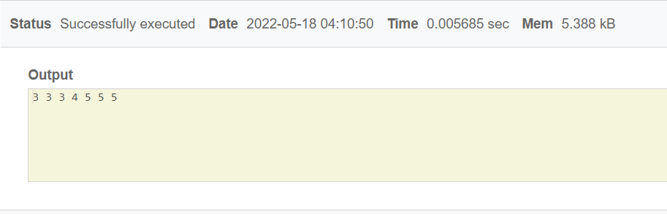

**Time Complexity:** O(n+k) where n is the number of elements in input array and k is the range of input.