# Assignment – 1

1. Create a data base named “hospital”.

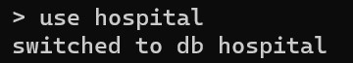

2.

Add the details of pati

ent

1.

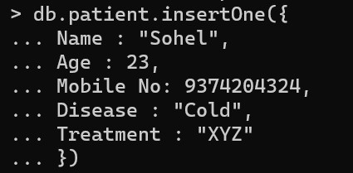

4.

Details of all

pati

ent.

he details

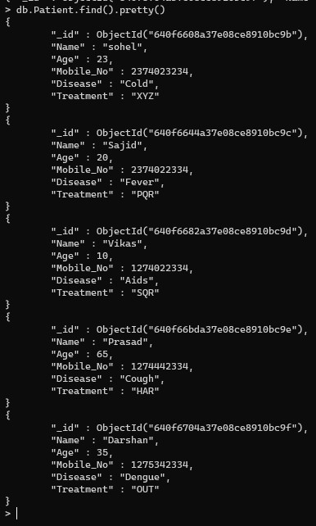

3.

Add the de

tails of other patient.

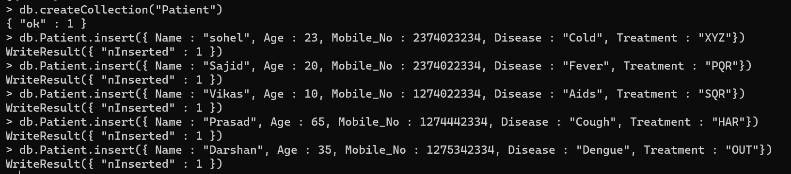

1. Update Name, Age, and Disease of patient.



1. After the update, all the details of the Patient.

