Practical-2 NoSQL

1. Installing Mongo shell.

Download MongoChef by using link: https://studio3t.com/download-thankyou/?OS=win64

After completion of installation of MongoChef, when you launch it, it’s first interfacelookslikeas below.

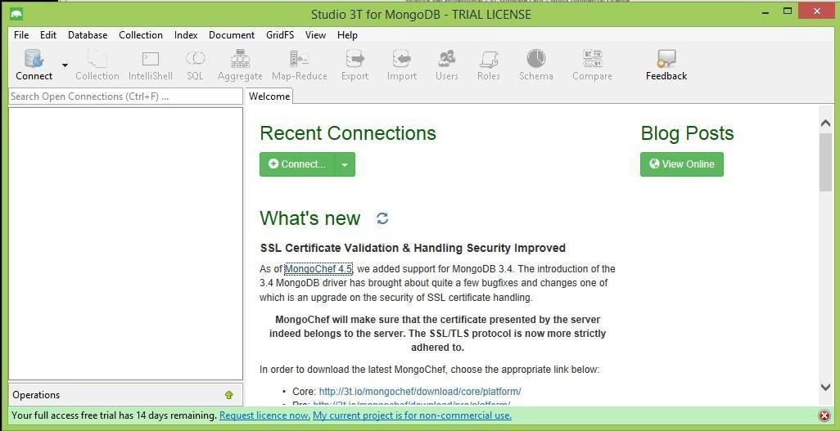

Open terminal and execute mongod.exe command, to make background daemon wait to establish connection.

Set path of MongoDB in environment variable as:

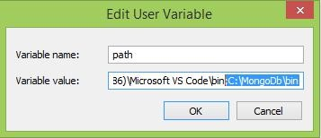

Practical-2 NoSQL

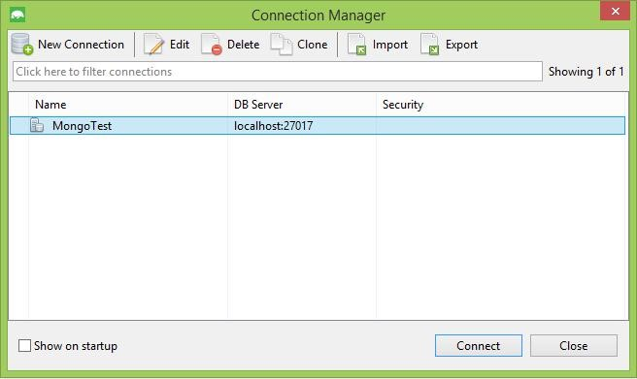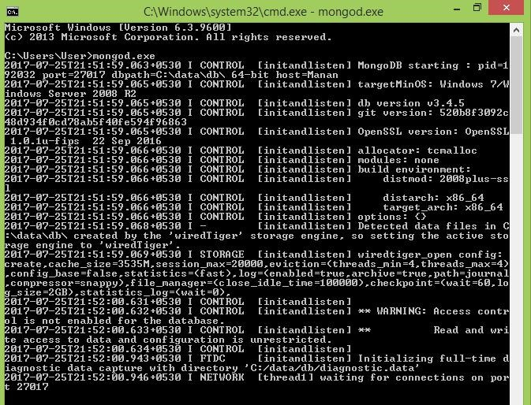

In MongoChef click on Connect, then click on New Connection. Give name of connection and click on save.

Select your connection and click on connect.

It will display all the collections under connection.

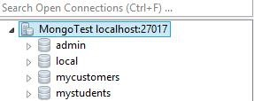

Click on IntelliShell. In that shell we can execute our executable statement or script.

# COMMANDS

1. CREATE USER db.createUser({ user: "prachi", pwd: "pds",

})

|  |
| --- |
| DESCRIPTION :- |

This is used to create user and put your username,pwd in

it.

1. CREATE DATABASE Use emp

## DESCRIPTION :-

This used to create database named ‘emp’.

3. CREATE COLLECTION

db.createCollection("emp")

## DESCRIPTION :-

In this we can create collection named ‘emp’.

1. INSERT DATA INTO DATABASE

o db.emp.insert( {"empid" : 1, "empname" : "martin"}) o db.emp.insert( {"empid" : 1, "empname" : "martin"}) o db.emp.insert( {"empid" : 2, "empname" : “neha", “age” : 23}) o var myemp=[ {"empid" : 3, "empname" : "smith"}, {"empid" :

4,"empname":"john"}]; db.emp.insert(myemp)

|  |
| --- |
| DESCRIPTION :- |

By this we can input command in it and by var variable

we can input using variable.

1. UPDATE AND DELETE DATA
   * db.emp.update({"empid" :1},{$set:{"empname" : "pds"}}) • db.emp.update({"empid" :1},{$set:{age:40}) • remove particular field: db.emp.update({"empid" :1},{$unset:{age:40})
   * update value of age by 5:

db.emp.update({"empid" :1},{$inc:{age:5})

* + removing whole document db.emp.remove({empid:3})
  + If no document matching with particular condition exists, then if we set upsert “true”, then initially it will also create it. db.emp.update({empid:3},{empid:5,empname:"heena"},{upsert:true

});

* + Renaming any particular field db.emp.update({empid:4},{$rename:{"empname":"nameemp"}});

|  |
| --- |
| DESCRIPTION :- |

by update command we can update anything in that data

and by remove command we can remove anything from that data.

1. RETRIVAL OF DATA
   * db.emp.find().forEach(printjson)
   * db.emp.find().pretty()
   * db.emp.find( { } )
   * db.emp.find({empname : "smith"} ).forEach(printjson)
   * db.emp.find({empid : {$gt:2}})
   * var myemp=db.emp.find( { empid : {$gt:2}}) while(myemp.hasNext()){ print(tojson(mye mp.next()));

}

DESCRIPTION:- By use of find command we can find anything from data.

1. DISPLAY DATABASE showdbs

|  |
| --- |
| DESCRIPTION :- |

We use this if we want to display all database which was

in our server

## EXTRA :-

create a user of your name with every database's admin.

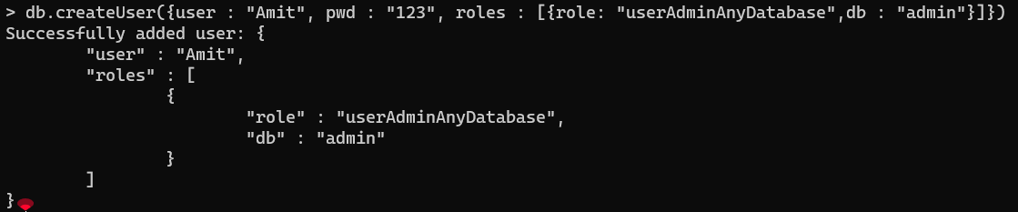

create a database named uvpce



create collection named "your name"



insert 7 records into that collection

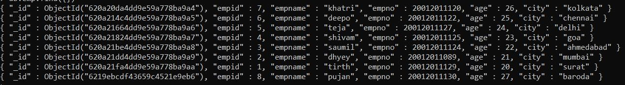

compulsory fields in every document: enno, age, city

1. display all the records having age 20.



1. display city and age of enno 4.



1. update the age to 25 whoes enno is greater than 3.

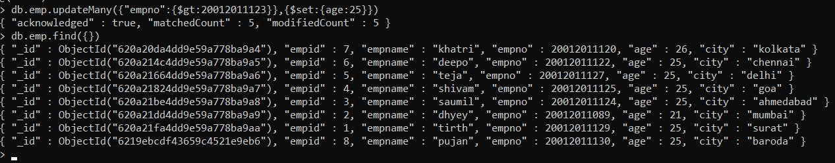

1. add a new field to enno 5.



1. delete the document for which city is baroda.

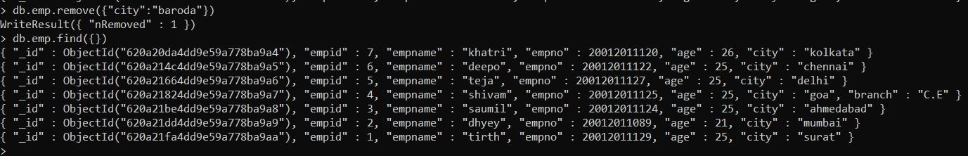

1. rename the field enno to rollno for every document.

