1. **Create three Config Server. Then Set one Config Server as Primary and remaining two as secondary.mongod --configsvr --dbpath "C:\config\c1" --port 27018 --replSet=c0**

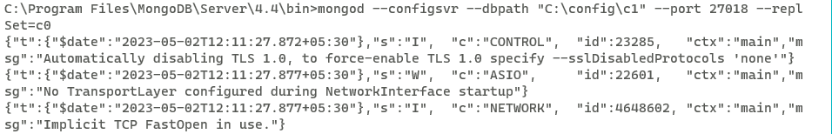

**mongod --configsvr --dbpath "C:\config\c2" --port 27019 --replSet=c0**

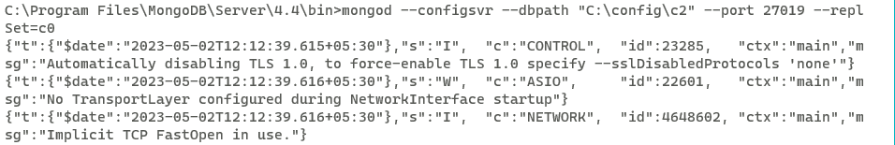

**mongod --configsvr --dbpath "C:\config\c3" --port 27020 --replSet=c0**

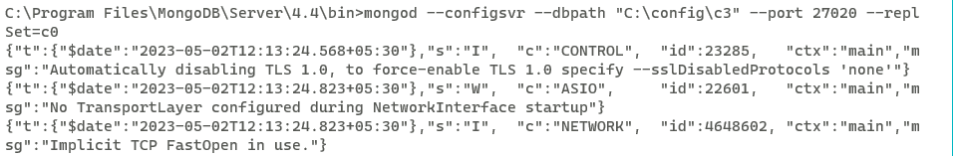

1. **Now open any mongo client among all and connect with server using below command.**

mongo --port 27019

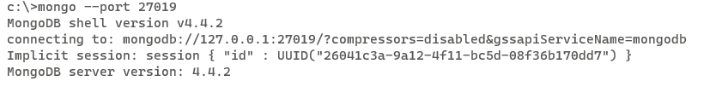

1. **Create a group ,assign ids and replica using below command.**

config = { _id: "c0", members:[

{ _id : 0, host : "localhost:27018" },

{ _id : 1, host : "localhost:27019" },

{ _id : 2, host : "localhost:27020" }]};

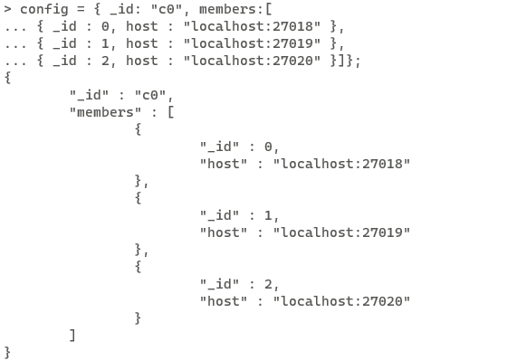

1. **Set any node as primary node using below given command.**

rs.initiate(config)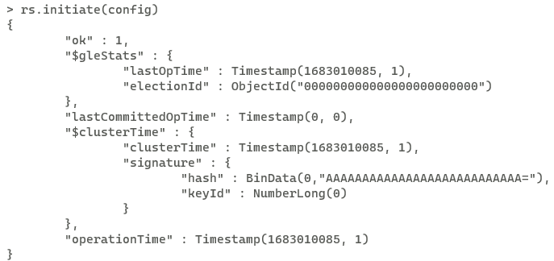

1. **(SHARD 1)**

**OPEN command Prompt.**

**Create three Shard Server. Then Set one shard Server as Primary and remaining two as secondary.**

mongod --replSet s1 --dbpath "C:\shard2\s1" --port 37019 –shardsvr

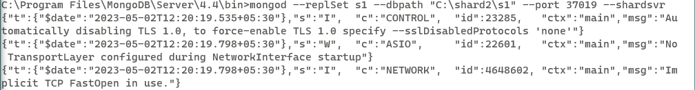

mongod --replSet s1 --dbpath "C:\shard2\s2" --port 37020 --shardsvr

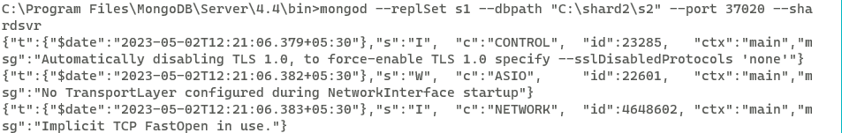

mongod --replSet s1 --dbpath "C:\shard2\s3" --port 37021 --shardsvr

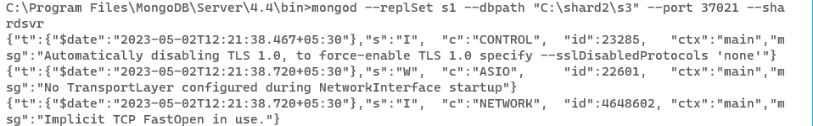

1. **Now open any mongo client among all and connect with server using below command.**

mongo --port 37019

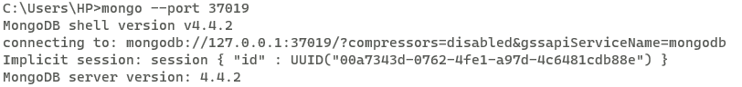

1. **Create a group ,assign ids and replica using below command.**

config = { _id: "s1", members:[

{ _id : 0, host : "localhost:37019" },

{ _id : 1, host : "localhost:37020" },

{ _id : 2, host : "localhost:37021" }]};

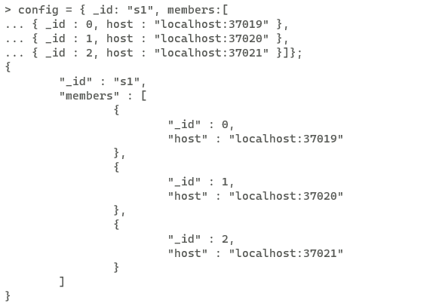

1. **Set any node as primary node using below given command.**

rs.initiate(config)

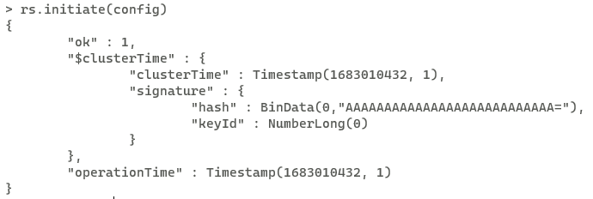

1. **(SHARD 2)**

**OPEN command Prompt.**

**Create three Shard Server. Then Set one shard Server as Primary and remaining two as secondary.**

mongod --replSet s0 --dbpath "C:\shard1\s1" --port 50001 –shardsvr

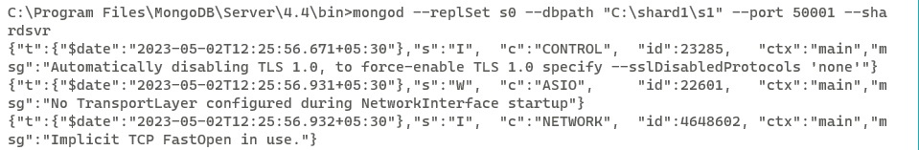

mongod --replSet s0 --dbpath "C:\shard1\s2" --port 50002 --shardsvr

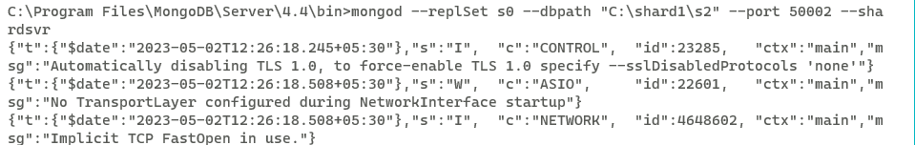

mongod --replSet s0 --dbpath "C:\shard1\s3" --port 50003 --shardsvr

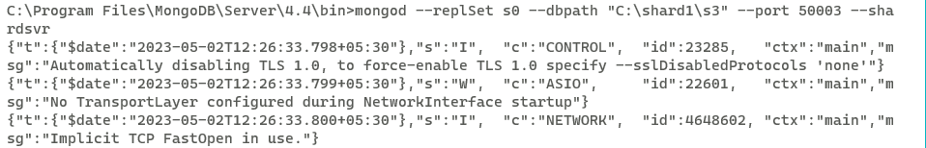

1. **Now open any mongo client among all and connect with server using below command.**

mongo --port 50001

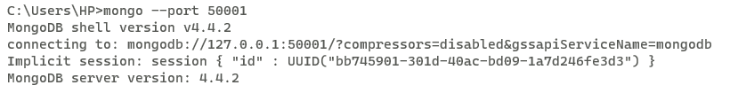

1. **Create a group ,assign ids and replica using below command**

config = { _id: "s0", members:[

{ _id : 0, host : "localhost:50001" },

{ _id : 1, host : "localhost:50002" },

{ _id : 2, host : "localhost:50003" }]};

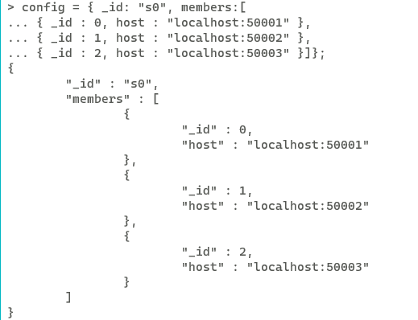

1. **Set any node as primary node using below given command.**

rs.initiate(config)

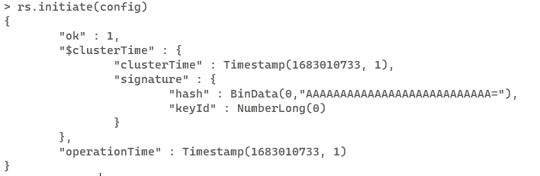

1. **Communication with both shards is possible using config servers.**

**So open cmd and write command.This creates mongos config server.**

mongos.exe --configdb c0/localhost:27018,localhost:27019,localhost:27020 --port 1000

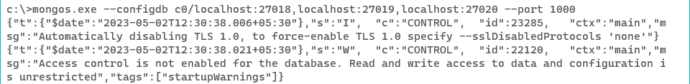

1. **Open a client mongos command window to communicate with server.**

mongo.exe --host localhost --port 1000

1. **And then both the shards which we are created add that shards into shard cluster using given below commands.**

sh.addShard("s0/localhost:50001");

sh.addShard("s1/localhost:37019");

1. **To see the shards which are in shard cluster run the command in the same**

command prompt(1000)

db.runCommand({listShards:1});

1. **Now create database.**

mongos> use projectionDB

1. **Move to admin mode.**

mongos> use admin

1. **Enable Database Sharding property.So that table data can be distributed on multiple shards using given command.**

mongos> db.runCommand({enableSharding:"projectionDB"});

1. **Create collection and set hash key.**

mongos> sh.shardCollection("projectionDB.bios", {"name":"hashed"})

1. **Now insert data into bios table.**

mongos> db.bios.insert({

name:"Prachi",

lname:"Shah",

city:"Mehsana",

state:"Gujarat"

});

mongos> db.bios.insert({

name:"sunita",

lname:"chauhan",

city:"Ahmedabad",

state:"Gujarat" })

mongos> db.bios.insert({

... name:"agam",

... lname:"shah",

... city:"Mehsana",

... state:"Gujarat"

... })

mongos> db.bios.insert({

... name:"Shraddha",

... lname:"Mehta",

... city:"Baroda",

... state:"Gujarat"

... })

mongos> db.bios.insert({

... name:"Shurya",

... lname:"Pandya",

... city:"Mehsana",

... state:"Gujarat"

... })

mongos> db.bios.insert({

... name:"Khushi",

... lname:"Patel",

... city:"Mehsana",

... state:"Gujarat"

... })

mongos> db.bios.insert({

... name:"Pooja",

... lname:"Mevada",

... city:"Ahmedabad",

... state:"Gujarat"

... })

mongos> db.bios.insert({

... name:"Meeta",

... lname:"Shah",

... city:"Ahmedabad",

... state:"Gujarat"

... })

mongos> db.bios.insert({

... name:"Avinash",

... lname:"Mehta",

... city:"Ahmedabad",

... state:"Gujarat"

... })

mongos> db.bios.insert({

... name:"Vency",

... lname:"Parekh",

... city:"Ahmedabad",

... state:"Gujarat"

... })

mongos> db.bios.insert({

... name:"Dhruv",

... lname:"Shah",

... city:"Ahmedabad",

... state:"Gujarat"

... })

1. **Run the command to see the total number of documents in bios table.**

db.gnu.count();

1. **To see how data is distributed on shard 1.**

**Open the mongo client of shard 1 which is on port 50001.**

**Run the commands like.**

Show dbs

Show collection

use projectionDB;

db.bios.count();

1. **To see how data is distributed on shard 2.**

**Open the mongo client of shard 2 which is on port 37019.**

**Run the commands like.**

Show dbs

Show collection

use projectionDB;

db.bios.count();