**PRACTICAL-1**

1. **TOUCH** :- The touch command is a standard command used in UNIX/Linux operating system which is used to create, change and modify timestamps of a file.

**Syntax: touch<filename> | e.g., touch abc1.txt**

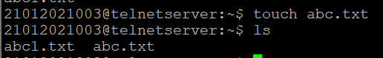

1. **CAT** :- Cat command is very frequently used in Linux. It reads data from the file and gives their content as output. It helps us to create, view, concatenate files.

**Syntax: cat<filename> | e.g. cat abc.txt**



1. **LS** :- LS is a Linux shell command that lists directory contents of files and directories.

**Syntax: we have to go in particular directory and have to print ls.**

1. **LS** :- LS is a Linux shell command that lists directory contents of files and directories.

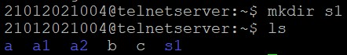

1. ls –a :

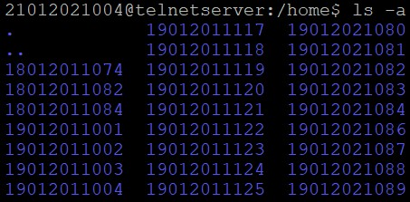

1. ls -A :

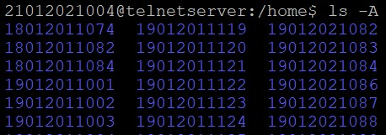

1. ls –c:

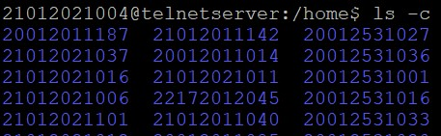

1. ls -C:

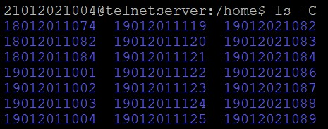

1. Ls –f:

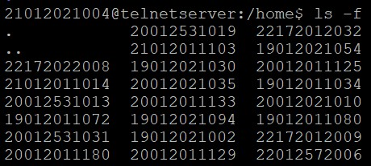

1. Ls –F:

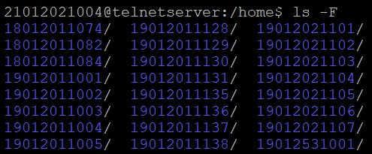

1. Ls –g:

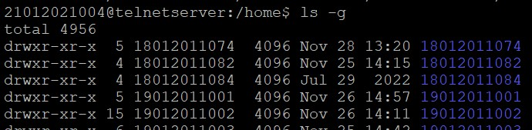

1. Ls -i:

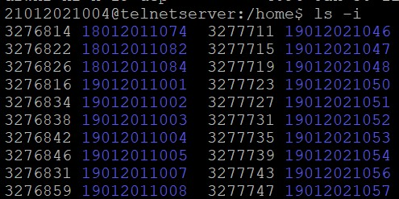

1. Ls -l:-

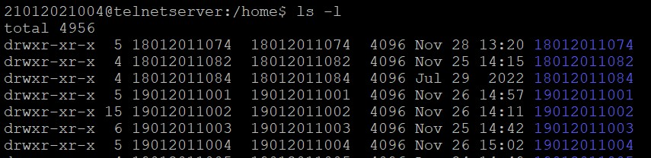

1. Ls -L:-

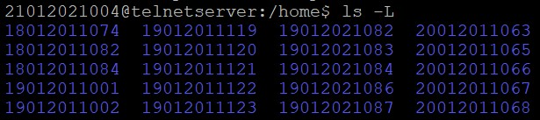

1. Ls -m:-

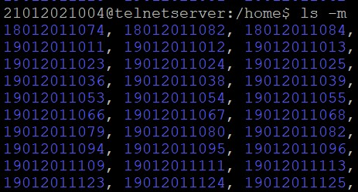

1. Ls -n:-

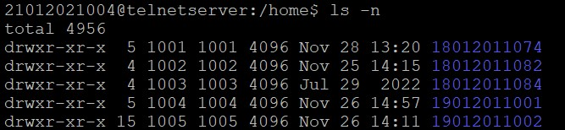

1. Ls -o:-

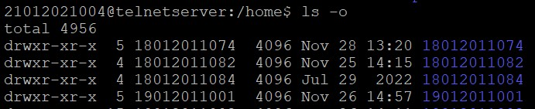

1. Ls -p:-

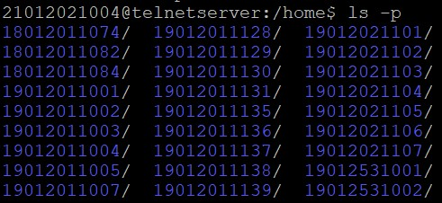

1. Ls -r:-

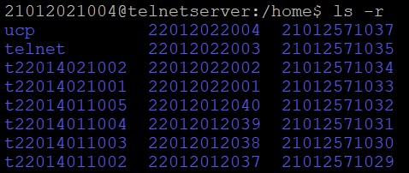

1. Ls -R:-

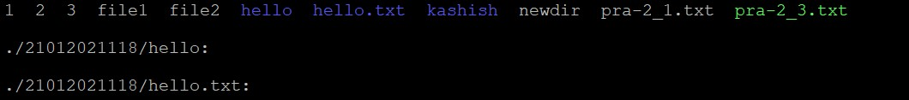

1. Ls -s:-

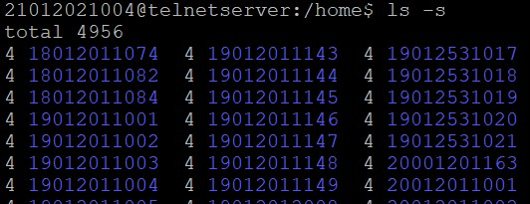

1. Ls -t:-

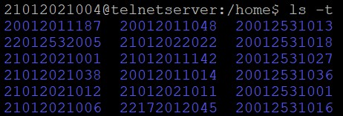

1. Ls -u:-

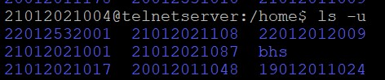

1. Ls -x:-

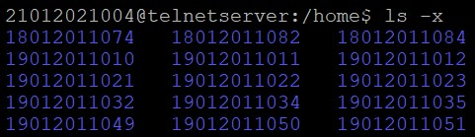

1. **MKDIR** :- MKDIR command in Linux allows the user to create directories.

**Syntax: mkdir<dirname>|e.g. mkdir f1**

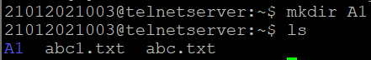

1. **RMDIR** :- RMDIR command is used remove empty directories from the file system in Linux.

**Syntax: rmdir<dirname>|e.g. rmdir f1**

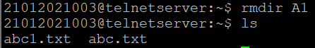

1. **CD** :- CD command in linux known as change directory command. It is used to change current working directory.

**Syntax: cd<dirname> | e.g. cd f2 // cd path**



1. **CLEAR** :- clearis a standard Unix computer operating system command that is used to clear the terminal screen.i

**Syntax: clear**

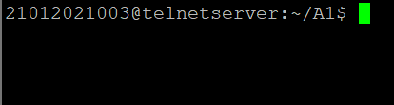

1. **CP** :- cp stands for copy. This command is used to copy files or group of files or directory. It creates an exact image of a file on a disk with different file name. cp command require at least two filenames in its arguments.

**Syntax: cp <existing file name> <new file name>**  **|e.g. cp f1.txt f2.txt**

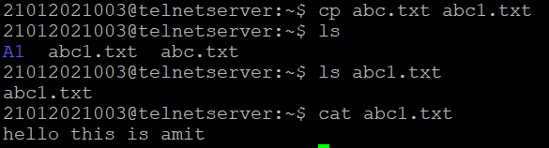

1. **CAL** :- cal command is a calendar command in Linux which is used to see the calendar of a specific month or a whole year.

**Syntax: cal [[month]year] | e.g. cal [[January]2020]**

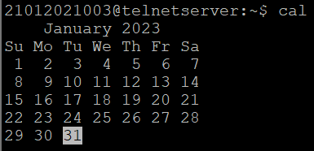

1. **HISTORY** :- history command is used to view the previously executed command.

**Syntax: history**

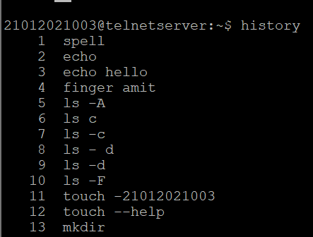

1. **CHMOD** :- In Unix-like operating systems, the chmod command is used to change the access mode of a file.

**Syntax: chmod [reference][operator][mode] file**

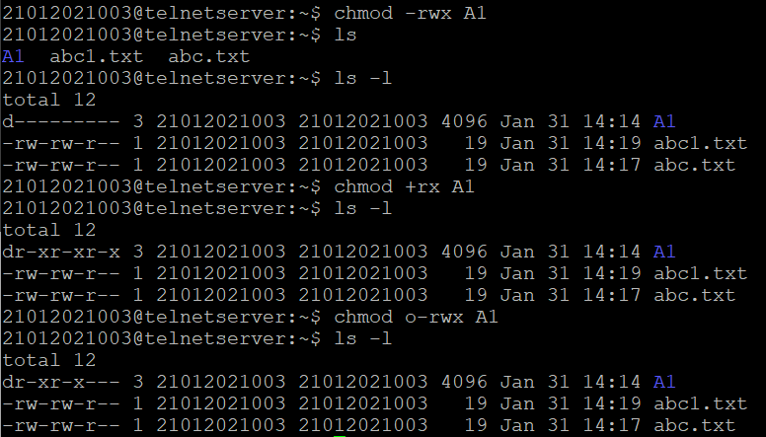

1. **HEAD** :- The head command, as the name implies, print the top N number of data of the given input. By default, it prints the first 10 lines of the specified files. If more than one file name is provided then data from each file is preceded by its file name.

**Syntax: head [command] <filename>**



1. **TAIL** :- The tail command, as the name implies, print the last N number of data of the given input. By default it prints the last 10 lines of the specified files. If more than one file name is provided then data from each file is precedes by its file name.

**Syntax: tail [option] <filename> | e.g. tail abc.txt**



1. **DATE** :- datecommand is used to display the system date and time. date command is also used to set date and time of the system.

**Syntax: date [option] [format] | e.g. date “10 days ago”**



1. **EXPR** :- The **expr** command in Unix evaluates a given expression and displays its corresponding output. Basic operations like addition, subtraction, multiplication, division, and modulus on integers.

**Syntax: expr expression | e.g. expr --version**

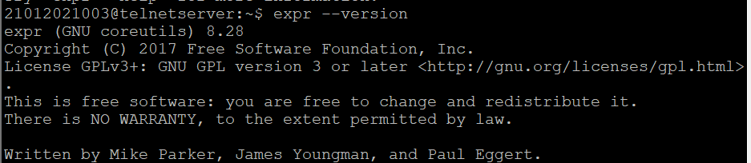

1. **WHO** :- The who command is used to get information about currently logged in user on to system.

**Syntax: who [option] <filename>**

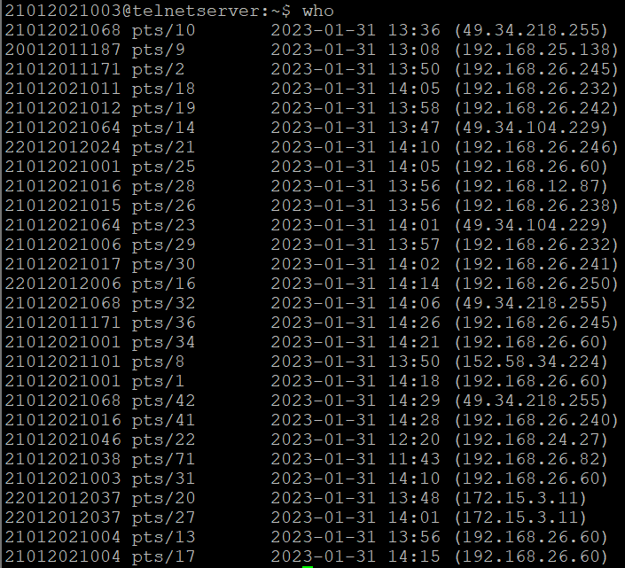

1. **UNAME** :- The command uname displays the information about the system.

**Syntax: uname [option]**



1. **FINGER** :- Finger command is a user information lookup command which gives details of all the users logged in. This tool is generally used by system administrators. It provides details like login name, user name, idle time, login time, and in some cases their email address even.

**Syntax: finger [option] username**

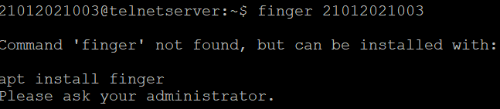

1. **CMP** :- cmp command in Linux/UNIX is used to compare the two files byte by byte and helps you to find out whether the two files are identical or not.

**Syntax: cmp <filename1> <filename2>**

1. **COMM** :- comm compare two sorted files line by line and write to standard output; the lines that are common and the lines that are unique.

**Syntax: comm <filename1> <filename2>**



1. **SORT** :- SORT command is used to sort a file, arranging the records in a particular order. By default, the sort command sorts file assuming the contents are ASCII. Using options in the sort command can also be used to sort numerically.

**Syntax: sort <filename>**



1. **SPELL** :- Spellcommand is used as a spell checker in Linux. Generally, it will scan the given files or anything from standard input then it check for misspellings. Finally it allows the user to correct the words interactively.

**Syntax: spell [option] <filename>**

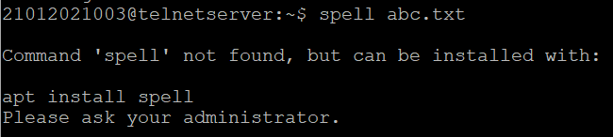

1. **WC** :- wc stands for word count. As the name implies, it is mainly used for counting purpose.

**Syntax: wc <filename>**



1. **TYPE** :- The type command is used to describe how its argument would be translated if used as commands. It is also used to find out whether it is built-in or external binary file.

**Syntax: type [command name]**

1. **ECHO** :- Echo command in linux is used to display line of text/string that are passed as an argument . This is a built in command that is mostly used in shell scripts and batch files to output status text to the screen or a file.

**Syntax: echo [string] | e.g. echo “hello world”**



1. **MAN** :- Man command in Linux is used to display the user manual of any command that we can run on the terminal. It provides a detailed view of the command which includes NAME, SYNOPSIS, DESCRIPTION, OPTIONS, EXIT STATUS, RETURN VALUES, ERRORS, FILES, VERSIONS.

**Syntax: man [command name] | e.g. man printf**

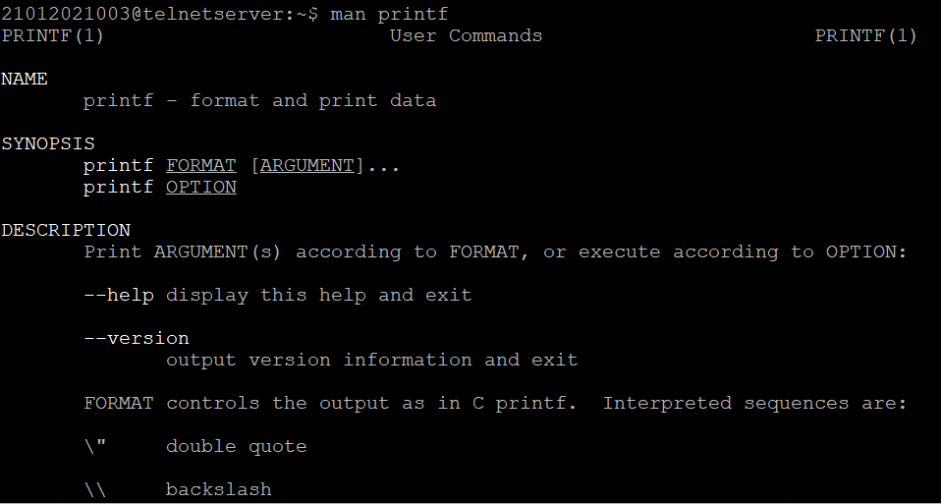

1. **MORE** :- More command is used to view the text files in the command prompt, displaying one screen at a time in case the file is large (For example log files). The more command also allows the user do scroll up and down through the page.

**Syntax: more[option] filename | e.g. more -d ab.txt**



1. **PASSWD** :- passwd command in Linux is used to change the user account passwords.

**Syntax: passwd [option] [username]**



1. **PWD** :- pwd stands for **P**rint **W**orking **D**irectory. It prints the path of the working directory, starting from the root.

**Syntax: pwd**



1. **GREP** :- The grep filter searches a file for a particular pattern of characters, and displays all lines that contain that pattern.

**Syntax: grep [option] pattern filename | e.g. gerp -l “unix” f1.txt f2.txt**

1. **PS** :- Linux provides us a utility called ps for viewing information related with the processes on a system which stands as abbreviation for **“Process Status”.** ps command is used to list the currently running processes and their PIDs along with some other information depends on different options.

**Syntax: pwd -p/-l**

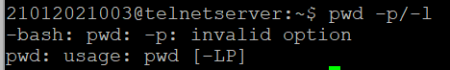

1. **RM** :- rm stands for remove here. rm command is used to remove objects such as files, directories, symbolic links and so on from the file system like UNIX.

**Syntax: rm <filename> | e.g. rm b.txt**

1. **SET** :- Linux set command is used to set and unset certain flags or settings within the shell environment.

**Syntax: set[options]**

1. **CUT** :- The cut command in UNIX is a command for cutting out the sections from each line of files and writing the result to standard output.

**Syntax: cut[option] filename |e.g. cut abc.txt**

1. **READ** :- read command in Linux system is used to read from a file descriptor. Basically, this command read up the total number of bytes from the specified file descriptor into the buffer. If the number or count is zero then this command may detect the errors. But on success, it returns the number of bytes read.

**Syntax: read text | e.g. read Hello World**



1. **AWK** :- Awk is a scripting language used for manipulating data and generating reports. The awk command programming language requires no compiling and allows the user to use variables, numeric functions, string functions, and logical operators.

**Syntax: awk option inputfilename>outputfilename |e.g. awk -f ab1.txt ab2.txt**

1. **LN** :- The ln command is used to create links between files.

**Syntax: ln [option]... target... directory**

1. **KILL** :- kill command in Linux (located in /bin/kill), is a built-in command which is used to terminate processes manually. kill command sends a signal to a process which terminates the process.

**Syntax: kill -l**

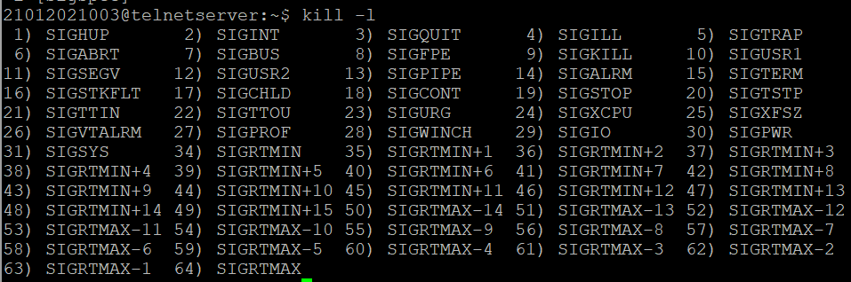

1. **FIND** :- The find command in UNIX is a command line utility for walking a file hierarchy. It can be used to find files and directories and perform subsequent operations on them.

**Syntax: find [where to start searching from] [expression determines what to find] [-options] [what to find]**

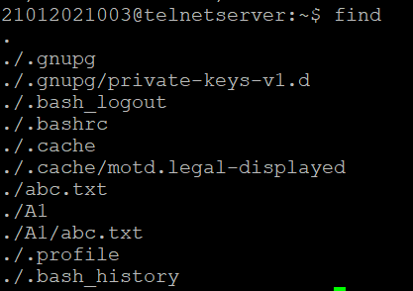

1. **INFO** :- infocommand reads documentation in the info format. It will give detailed information for a command when compared with the man page.

**Syntax:** **info [OPTION]... [MENU-ITEM...] | e.g. info -a cvs**