* 1. **Write a shell script to scan your name and display it like My college Name is :UVPCE**

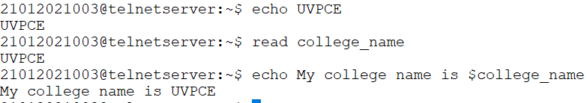

* 1. **Write a shell script to scan two variables and to display their sum, mul, div, sub and modulo division.**

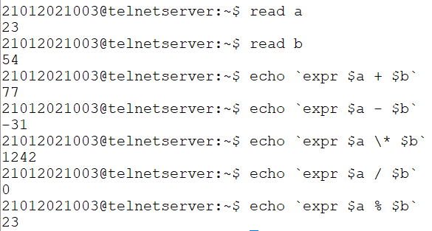

* 1. **Write a shell script to scan two variables and to display their sum, mul, div, sub and modulo division as per the user choice. (no need to continue, only once is OK)**

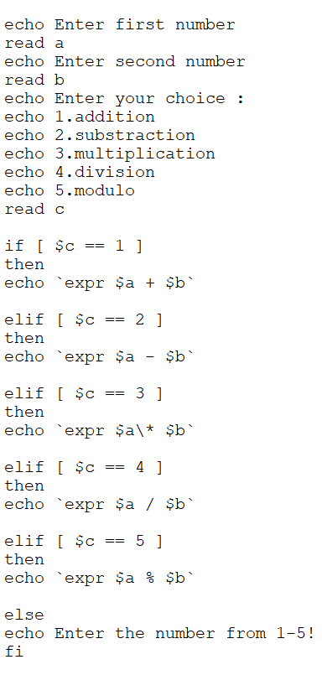

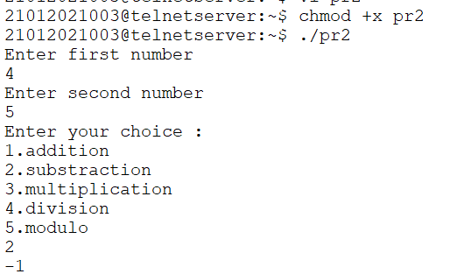

* 1. **Write a shell script to find greatest of two. Script must consider the case where two numbers are equal.**

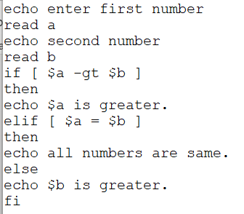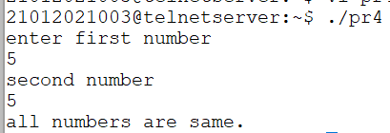

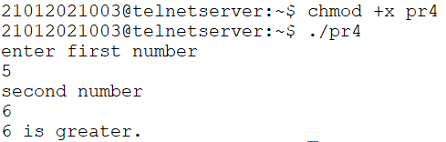

* 1. **Write a shell script to find greatest of three. Script must consider the case where two numbers are equal.**

