1. **To create new database and collection**

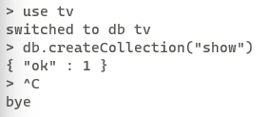

1. **To import the json file**



1. **To find the count**

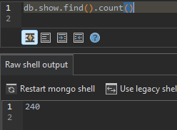

1. **To skip an item**

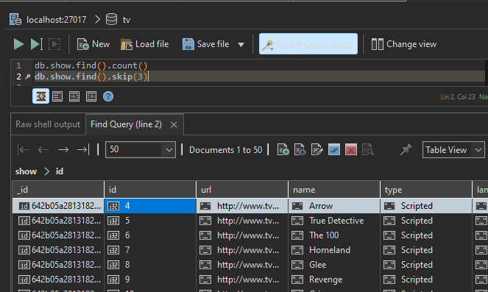

1. **To print data using pretty()**

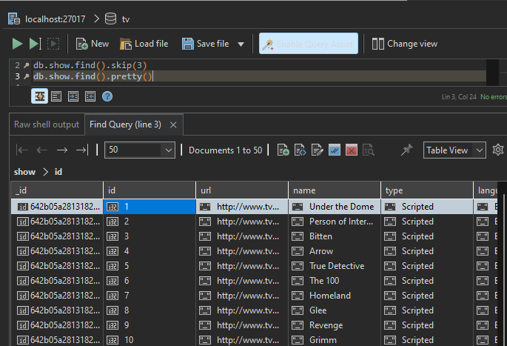

1. **To print data using limit()**

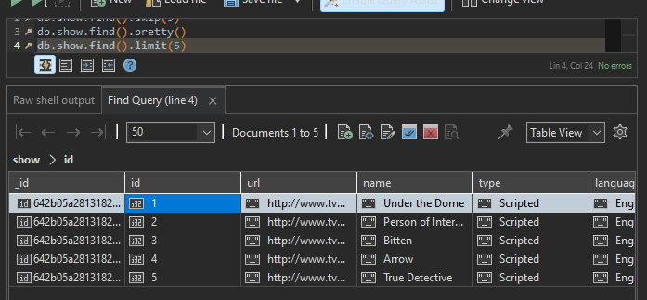

1. **To print the data by using a condition**
   1. **Condition-Generes**

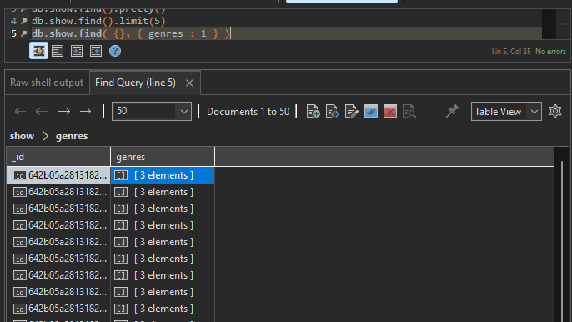

* 1. **Condition-Name**

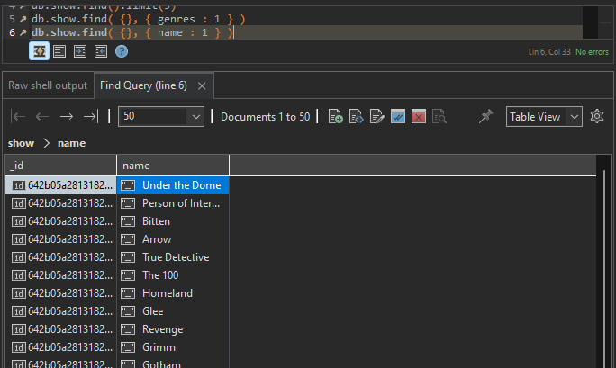

1. **To print data using find().limit().skip()**

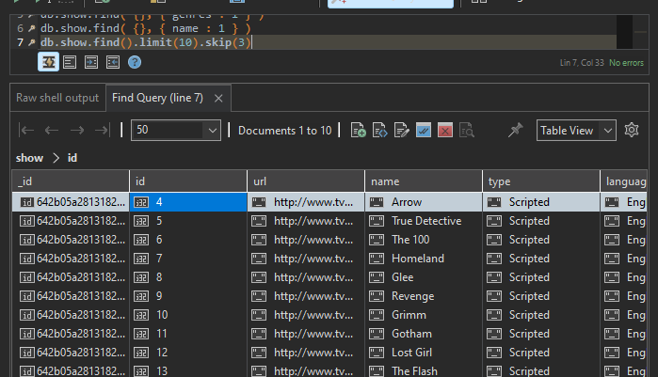

1. **To sort the data**

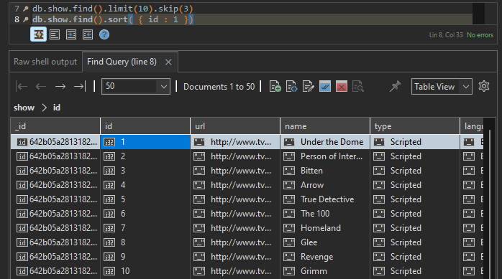

1. **To print the data using find().limit().skip().sort()**

