## PRACTICAL – 3

1. Write a shell script to calculate the loss percentage of an article. Scan the cost price and selling price

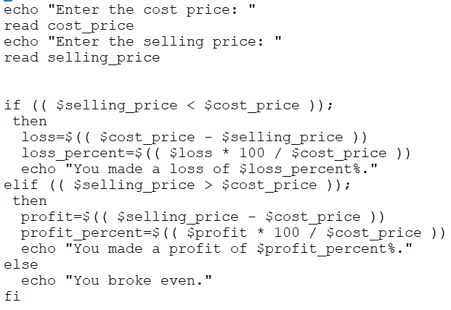

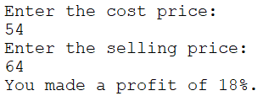

1. Write a shell script to accept numbers below 50 and to display the square of each. This should continue as long as the user wishes.

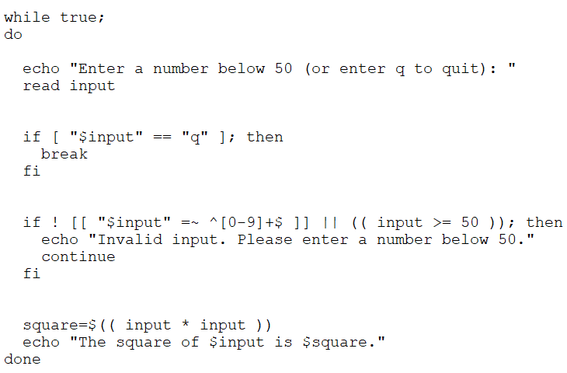

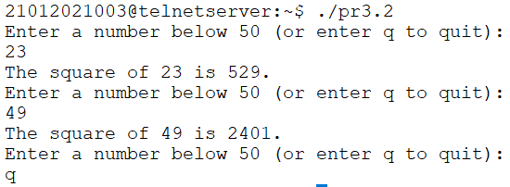

1. Write a shell script to display $50



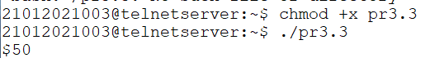

1. Write a shell script to check whether the scanned string is found in a file or not. Display appropriate message.

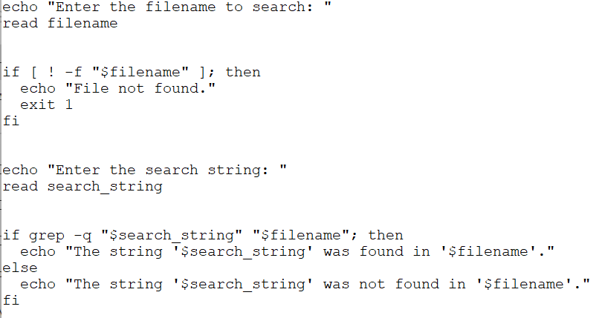

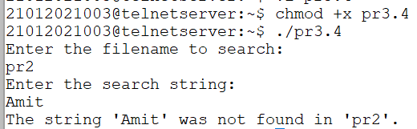

1. Write a shell script, which scans the name of the command and executes it.

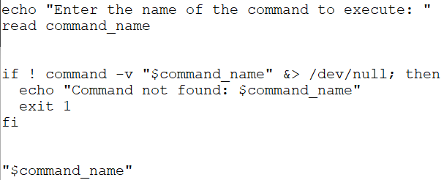

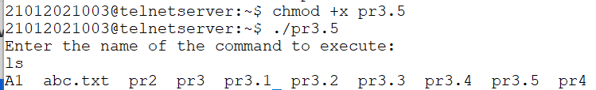

1. Write a shell script which displays January if we enter Jan, Janu, Janua or January.

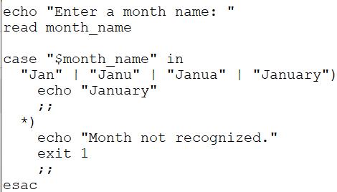  
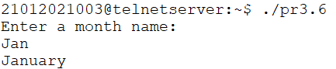

1. Write a shell script to generate Fibonacci series.

