1. Write a shell script to check whether the entered number is prime or not.

**echo -n "Enter number for checking: " read n**

**isPrime=true**

**for (( i=2; i<$n; i++)); do if [ `expr $n % $i` -eq 0 ]; then**

**isPrime=false**

**break**

**fi**

**Done**

**if $isPrime; then**

**echo "Entered number is a Prime number"**

**else**

**echo "Entered number is not a Prime number"**

**fi**

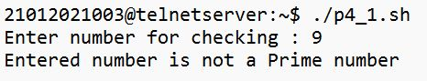

1. Write a shell script to calculate HRA of employees depending upon their basic.

**echo -n "Enter your salary :" read salary**

**echo -n "Do you live in city(Y/N) :" read city**

**city=${city:-"N"}**

**if [ $city == 'y' ] || [ $city == 'Y' ]; then**

**hra=$(bc <<< "scale=2; $salary * 0.5")**

**elif [ $city == 'n' ] || [ $city == 'N' ]; then hra=$(bc<<< "scale=2; salary * 0.4")**

**fi**

**echo "HRA: $hra/- Rs"**

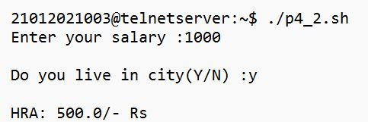

1. Write a shell script that greets the user by saying Good Morning, Good Afternoon, and Good Evening according to the system time.

**>>>> time=`date +%H`**

**if [ $time -ge 6 ] && [ $time -lt 12 ]; then**

**echo "Good Morning"**

**elif [ $time -ge 12 ] && [ $time -lt 17 ]; then**

**echo "Good Afternoon" else**

**echo "Good Evening" fi**

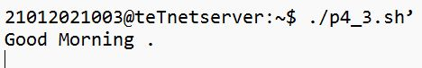

1. Write a shell script, which takes a filename as command line argument, asks the user if he wants to revoke the read, write permissions for the group and others for that particular file. If the answer is “y” then it should do so or else it should abort the operation.

**echo -n "Do you want to revoke read/write permission for group(y/n): " read ch**

**if [ $ch == "y" ] || [ $ch == "Y" ]; then chmod g-rw $1 echo "operation Successful"**

**ls -l else**

**echo "operation Aborted"**

**fi**

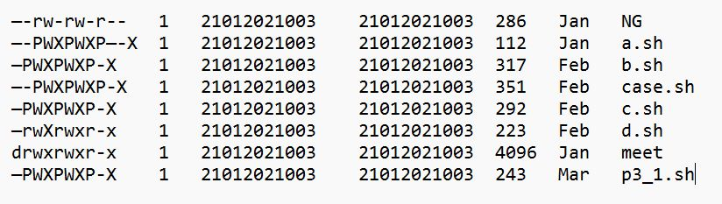

1. Write a shell script that asks the capital of Gujarat and repeats the question until the user gives correct answer.

**>>>> state="Gujrat" capital="gandhinagar" while(true); do**

**echo -n "Capital of $state: " read ans**

**if [ $ans == $capital ]; then**

**echo "Congratulation, Correct Answer..." break**

**fi**

**echo "Wrong Answer"**

**done**

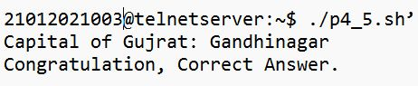

1. Write a shell script to display desired line from a file.

**echo -n "Enter file name: " read file**

**echo -n "Enter line num: "**

**read n head -$n $file | tail -1**

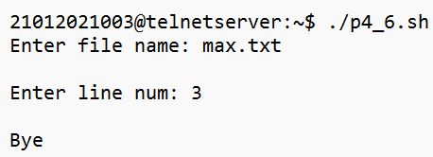

1. Write a shell script to count number of newline characters in a file.

**echo -n "Enter file name: " read file**

**lineCount=$(wc -l $file | cut -d " " -f1) lineCount=`expr $lineCount + 1`**

**echo "$file contains $lineCount lines"**

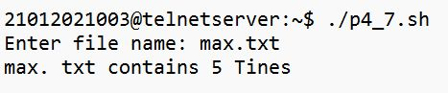

1. Write a shell script to count number of spaces in a file.

**echo -n "Enter file name: " read file**

**spaceCount=$(grep -o " " $file | wc -l)**

**echo "$file contains $spaceCount spaces"**

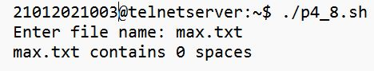

1. Write a Shell script, which counts the number of words in a file, without taking into consideration the blank space, tab spaces and the newline characters using WC.

**echo -n "Enter file name: " read file**

**wordCount=$(wc -w $file | cut -d " " -f1)**

**echo "$file contains $wordCount words"**

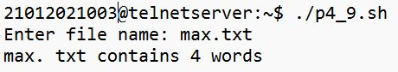

1. Write a Shell script, which counts the number of words in a file, without taking into consideration the blank space, tab spaces and the newline characters without using WC.

**echo -n "Enter file name: "**

**read file**

**words=($(grep -E '\w+' $file)) wordCount=${#words[@]}**

**echo "$file contains $wordCount words"**

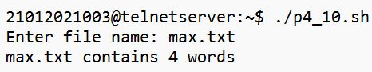

1. Write a Shell script, which counts the number of characters in a file, without taking into consideration the blank space, tab spaces and the newline characters using WC.

**echo -n "Enter file name: " read file**

**charCount=$(wc -c $file | cut -d " " -f1)**

**echo "file $file contains $charCount characters"**

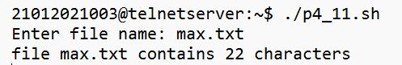

1. Write a Shell script, which counts the number of characters in a file, without taking into consideration the blank space, tab spaces and the newline characters without using WC.

**echo -n "Enter file name: " read file**

**charCount=$(cat $file | tr -c '\n' '[\n*]' | grep -c '^')**

**echo "file $file contains $charCount characters"**

