**Practical-2: Basic Python Programming**

**1) Write a python program to print “Welcome to UVPCE”.**

**Code:**

print("21012021003_AMIT GOSWAMI")

print("WELCOME UVPCE")

**Output:**

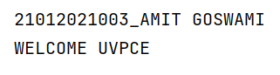

**2) Write a python program which takes student information such as Name, Enrollment Number, Branch, Age, Email and Mobile number from user and print as following:**

|  |
| --- |
| “===========================”  Your Name  Your Enrollment No.  Branch: CE/IT  Age:XX years  Email:your mail ID  Mobile No: your No.  “===========================” |

**Code:**

print("21012021003_AMIT GOSWAMI")

Name = input("Enter your name : ")  
Num = input("Enter your enrollment no : ")  
Branch = input("Enter your branch : ")  
Age = input("Enter your age : ")  
Email = input("Enter your email : ")  
Mob = input("Enter your mobile number : ")  
print("============================")  
print("your name : {} \n enrollment no : {} \n branch : {} \n age : {} \n email : {} \n mobile number : {}".format(Name,Num,Branch,Age,Email,Mob))  
print("============================")

**Output:**

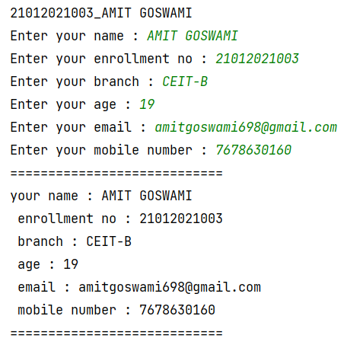

**3) Write python programs to evaluate the following expressions to demonstrate the use of operator precedence and associativity.**

**12 + 3 - 4 / 2 < 3 + 1**

**X = (10 * 2) % 2 << 4++**

**Code:**

print("21012021003_AMIT GOSWAMI")  
x=12 + 3 - 4 / 2 < 3 + 1  
print(x)  
y=(10 * 2) % 2 << 4  
print(y)

**Output:**

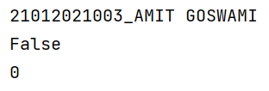

**4) Write a python program to display data types of different variables.**

**Code:**

print("21012021003_AMIT GOSWAMI")  
x,y,z,a,b,c=3,6.34,'hello',[2,4,8,'patel'],(1,2,3,'uvpce'),True

print("type of x = {} \n type of y = {} \n type of z = {} \n type of a = {} \n type of b = {}\n type of c = {} \n".format(type(x),type(y),type(z),type(a),type(b),type(c)))

**Output:**

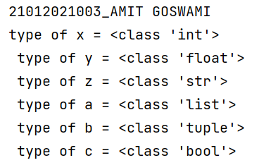

**5) Write a python program to check given character is a vowel or not.**

**Code:**

print("21012021003_AMIT GOSWAMI")  
print('Enter the character')  
inp = input()  
  
if 'a'==inp or 'e'==inp or 'i'==inp or 'o'==inp or 'u'==inp or 'A'==inp or 'E'==inp or 'I'==inp or 'O'==inp or 'U'==inp:  
 print('Entered character is vowel')  
  
else:  
  
 print('character is not vowel')

**Output:**

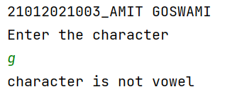

**6) Write a python program to for library charges a fine for books returned late. Following are the fines:**

First five days: 40 paisa per day.

Six to ten day: 65 paisa per day.

Above ten days: 80 paisa per day

**Code:**

print("21012021003_AMIT GOSWAMI")  
day = int(input("Enter the number of days you are late to submit Books : "))  
if(day<=5):  
 amount=day*0.4  
elif(day>=6 and day<=10):  
 amount =(5 *0.4)+(day-5)*0.65  
else:  
 amount=(5 *0.4)+(5 *0.65)+(day - 10)*0.80  
  
print("Your fine for {} days is {}.".format(day,amount))

**Output:**

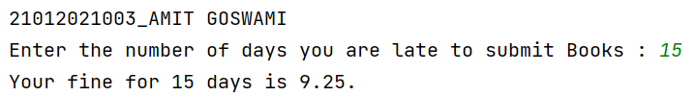

**7) Write a python program to count odd numbers from given three numbers and display maximum odd number.**

**Code:**

print("21012021003_AMIT GOSWAMI")  
x=int(input("enter value of x : "))  
y=int(input("enter value of y : "))  
z=int(input("enter value of z : "))  
c=0  
m=0  
if(x%2==1):  
 c+=1  
 if(x>y and x>z):  
 m=x  
if(y%2==1):  
 c+=1  
 if(y>x and y>z):  
 m=y  
if(z%2==1):  
 c+=1  
 if(z>x and z>y):  
 m=z  
if(c==0):  
 print("even number is there")  
  
else:  
 print("no of odd number is",c)  
 print("greatest odd number is :",m)

**Output:**

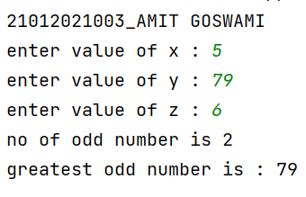

8) Enter the following statements into the interpreter and note which ones produce an error, give reason for error:

str1 = “welcome”

print str1*2

2) 15 % 12

3) print (18.0 // 4)

4) 7<=7

5) -1<>-1.0

6) print( ‘Steve's “ Laptop”’)

**Code:**

Paste your own code here

**Output:**

