**Practical-4: Lists and Tuples**

1) Explain difference between insert, append and extend operations on list. Write a program to create and initialize list with your name, enrollment number, age, branch and result. Perform insert, remove, update, append and extend operation on list.

**Answer & Code:**

intro=["AMIT GOSWAMI",21012021003,20,"CEIT-B",9.25]  
intro.insert(2,'U.V.P.C.E')  
print("After using insert : ",intro)  
intro.remove('CEIT-B')  
print("After using remove : ",intro)  
intro.append('GUNI')  
print("After using append : ",intro)  
intro.extend("P-PY")  
print("After using expend : ",intro)  
intro[2]='NILESH SIR'  
print("After using update :",intro)

**Output:**

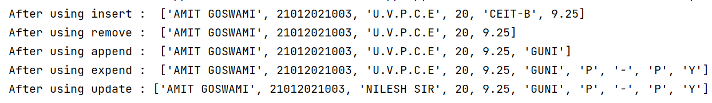

2) Write a program to search an element, find maximum & minimum value from the list.

Using inbuilt function 2) Using for loop.

**Code:**

print("21012021003_AMIT GOSWAMI")  
li=[4,4,6,7,4,9,2,3,6,9,10,11,16]  
print(li)  
i=int(input("Enter the number to search : "))  
j=li.index(i)  
print("the element you want to find is at index : ",j)  
n=max(li)  
print("Maximun value is : ",n)  
m=min(li)  
print("Mininum value is : ",m)

**Output:**

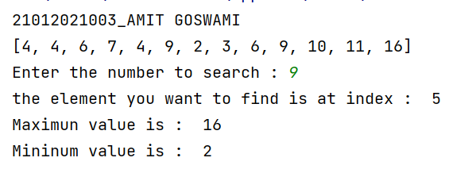

**2. Code:**

print("21012121003_AMIT GOSWAMI")  
li=[4,4,6,7,4,9,2,3,6,9,10,11,16]

print(li)  
n=int(input("Enter the number to search : "))  
max=min=li[0]  
temp=0  
for i in li:  
 if(n==i):  
 temp=0  
  
if(i>max):  
 max=i  
elif(i<min):  
 min=i  
if(temp==0):  
 print("element is present in list.")  
else:  
 print("element is not present in list.")  
print("The max element is : ",max)  
print("The min element is : ",min)

**Output:**

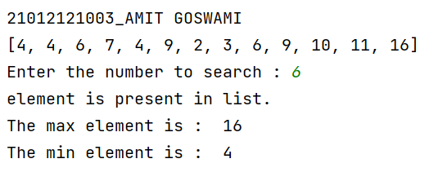

3) Create a program that asks the user for a number and then prints out a list of all the divisors of that number.

**Code:**

print("21012121003_AMIT GOSWAMI")  
n=int(input("Enter a number : "))  
li=[]  
for i in range(1,(n+1)):  
 if(n%i==0):  
 li.append(i)  
print(li)

**Output:**

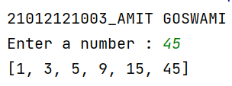

4) WAP to sort element in list

1. In same list

**Code:**

print("21012121003_AMIT GOSWAMI")  
li=[1,2,4,6,7,5,7,4]  
li.sort()  
print(f"After sorting list is : {li}")

**Output:**

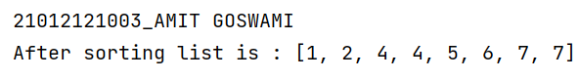

2. Create sorted copy of original list & print both.

**Code:**

print("21012121003_AMIT GOSWAMI")  
li=[2,4,6,9,5,4,7,8,5,5]  
print("List before sorting : {}".format(li))  
l2=sorted(li)  
print("List after sorting:{}".format(l2))

**Output:**

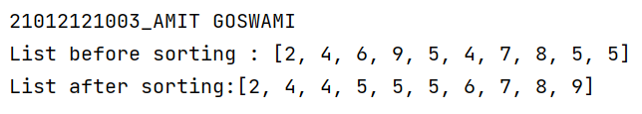

3. Sort without any built-in function

**Code:**

print("21012121003_AMIT GOSWAMI")  
li=[2,5,6,7,8,9,4,3,2,1]  
for i in range(0,len(li)):  
 for j in range(i+1,len(li)):  
 if(li[i]>li[j]):  
 temp=li[i]  
li[i]=li[j]  
li[j]=temp  
print("list after sorting :{}".format(li))

**Output:**

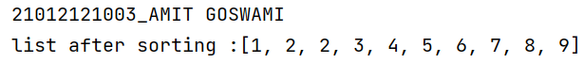

5) Take two lists, say for example these two:

a = [1, 1, 2, 3, 5, 8, 13, 21, 34, 55, 89]

b = [1, 2, 3, 4, 5, 6, 7, 8, 9, 10, 11, 12, 13]

and write a program that returns a list that contains only the elements that are common between the lists (without duplicates). Make sure your program works on two lists of different sizes.

**Code:**

print("21012121003_AMIT GOSWAMI")  
a=[1,1,2,3,5,8,13,21,34,55,89]  
b=[1,2,3,4,5,6,7,8,9,10,11,12,13]  
print(a)  
print(b)

c=[]  
for i in a:  
 if i in b and i not in c :  
 c.append(i)  
print("common in both is: {}".format(c))

**Output:**

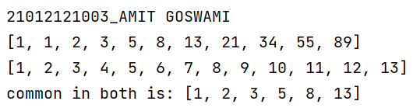

6) Write a Python program which takes a list and returns a list with the elements "Shifted left by one position" so [1, 2, 3] yields [2, 3, 1]. Example: [11, 12, 13] → [12, 13, 11].

**Code:**

l1 = [1,2,3]  
l2=[]  
for i,j in enumerate(l1) :  
 l2.insert(i-j,j)  
print("original list {}".format(l1))  
print("after shifting element list : {}".format(l2))

**Output:**

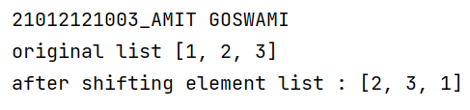

7) Write a program which takes a comma separated string from user & store each string which separated by comma in list & display list.

**Code:**

print("21012121003_AMIT GOSWAMI")  
str=input("enter a string : ")  
print(str.split(sep=","))

**Output:**

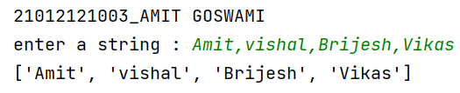

8) Write a program to create and initialize the tuple. Also remove 3rd element from tuple.

**Code:**

print("21012121003_AMIT GOSWAMI")  
l1=("AMIT","GOSWAMI","UVPCE","IT","4th sem")  
print(f"original tuple is : {l1}")  
l1=l1[:2]+l1[3:]  
print(f"after removing 3rd element from tuple : {l1}")

**Output:**

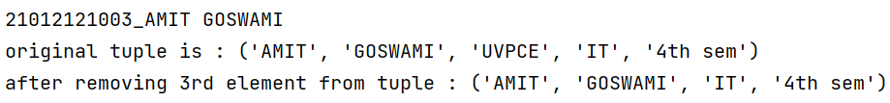

9) Create a tuple with name courses and initialize it with JAVA, PHP, C#, Android. Insert two items HTML and Python at the 3rd position in tuple.

**Code:**

print("21012121003_AMIT GOSWAMI")  
l1=["JAVA","PHP","C#","ANDROID"]  
l2=["HTML","PYTHON"]  
a=list(l1)  
a.insert(2,l2)  
l3=tuple(a)  
print(f"original tuple : {l1}")  
print(f"after inserting tuple at 3rd position is : {l3}")

**Output:**

