**Practical-7: File Operations**

1. **Write a Python program to read content from a file and display the word with maximum length.**

**Code:**

with open("Amit.txt","r") as f:  
 x=f.read()  
 l1=x.split()

l=len(max(l1,key=len))  
for i in l1:  
 if(len(i)==l):  
 print(i)

**Ouput:**

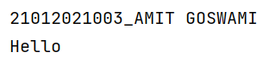

1. Write a Python program to combine each line from first file with the corresponding line in second file.

**Code:**

print("21012021003_AMIT GOSWAMI \n")  
with open("f1.txt","r") as f1:  
 with open("f2.txt","r") as f2:  
 x=f1.readlines()  
 y=f2.readlines()  
 m=min(len(x),len(y))  
 for i in range(m):  
 z=x[i].strip() + " "+y[i].strip()  
 print(z)

**Output:**

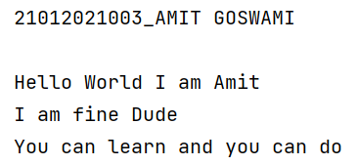

1. Write a Python program to read first n lines of a file.

**Code:**

print("Enter the number of line you want to read:")  
n = int(input())  
with open("f1.txt","r") as f1:  
  
 for i in range(n):  
 x = f1.readline()  
 print(x)  
f1.close()

**Output:**

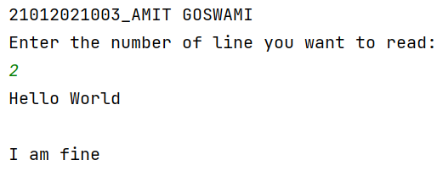

1. Write a Python program to write students information into csv file and read that details.

**Code:**

**Output:**