**PRACTICAL-1**

**AIM :-Ripple Carry Adders.**

**Theory :-**

**Design of Ripple Carry Adders :**

Arithmetic operations like addition, subtraction, multiplication, division are basic operations to be implemented in digital computers using basic gates likr AND, OR, NOR, NAND etc. Among all the arithmetic operations if we can implement addition then it is easy to perform multiplication (by repeated addition), subtraction (by negatingone operand) or division (repeated subtraction).

Half Adders can be used to add two one bit binary numbers. It is also possible to create a logical circuit using multiple full adders to add N-bit binary numbers.Each full adder inputs a **Cin**, which is the **Cout** of the previous adder. This kind of adder is a **Ripple Carry Adder**, since each carry bit "ripples" to the next full adder. The first (and only the first) full adder may be replaced by a half adder.The block diagram of 4-bit Ripple Carry Adder is shown here below -

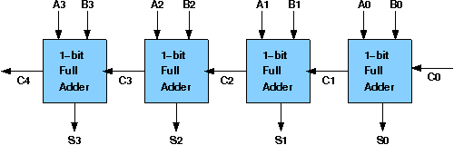

The layout of ripple carry adder is simple, which allows for fast design time; however, the ripple carry adder is relatively slow, since each full adder must wait for the carry bit to be calculated from the previous full adder. The gate delay can easily be calculated by inspection of the full adder circuit. Each full adder requires three levels of logic.In a 32-bit [ripple carry] adder, there are 32 full adders, so the critical path (worst case) delay is 31 * 2(for carry propagation) + 3(for sum) = 65 gate delays.

**Design Issues :**

The corresponding boolean expressions are given here to construct a ripple carry adder. In the half adder circuit the sum and carry bits are defined as

**sum = A ⊕ B**

**carry = AB**

In the full adder circuit the the Sum and Carry outpur is defined by inputs A, B and Carryin as

**Sum=ABC + ABC + ABC + ABC**

**Carry=ABC + ABC + ABC + ABC**

Having these we could design the circuit.But,we first check to see if there are any logically equivalent statements that would lead to a more structured equivalent circuit.

With a little algebraic manipulation,one can see that

**Sum= ABC + ABC + ABC + ABC**

**= (AB + AB) C + (AB + AB) C**

**= (A ⊕ B) C + (A ⊕ B) C**

**=A ⊕ B ⊕ C**

**Carry= ABC + ABC + ABC + ABC**

**= AB + (AB + AB) C**

**= AB + (A ⊕ B) C**

**Objective**

**Objective of 4 bit ripple carry adder:**

To understand the operation of a ripple carry adder, specifically how the carry ripples through the adder.

1. examining the behavior of the working module to understand how the carry ripples through the adder stages
2. to design a ripple carry adder using full adders to mimic the behavior of the working module
3. the adder will add two 4 bit numbers

**Examining behaviour of ripple carry adder for the workng module and the module designed by the student as part of the experiment (refer to the circuit diagram)**

**Loading data in the ripple carry adder (refer to procedure tab for pin numbers)**

* each unit of adder will add single bits of the two numbers along with the carry from the previous adder
* load the two input numbers in the adder units as:
  + A(A3 A2 A1 A0): A3=1, A2=1, A1=1, A0=1
  + B(B3 B2 B1 B0): B3=0, B2=0, B1=0, B0=1

**Examining the rippling of carry behaviour:**

* check output sum:
  + sum(S3 S2 S1 S0): S3=0, S2=0, S1=0, S0=0
* check output carry:
  + cout=1
* check intermediate carry bit of all the unit adders which will be 1
* probing the carry port can be done by verifying the color of the wire coming out of the port

**Recommended learning activities for the experiment:**

Leaning activities are designed in two stages, a basic stage and an advanced stage. Accomplishment of each stage can be self-evaluated through the given set of quiz questions consisting of multiple type and subjective type questions. In the basic stage, it is recommended to perform the experiment firstly, on the given encapsulated working module, secondly, on the module designed by the student, having gone through the theory, objective and procuder. By performing the experiment on the working module, students can only observe the input-output behavior. Where as, performing experiments on the designed module, students can do circuit analysis, error analysis in addition with the input-output behavior. It is recommended to perform the experiments following the given guideline to check behavior and test plans along with their own circuit analysis. Then students are recommended to move on to the advanced stage. The advanced stage includes the accomplishment of the given assignments which will provide deeper understanding of the topic with innovative circuit design experience. At any time, students can mature their knowledge base by further reading the references provided for the experiment.

• color configuration of wire for 5 valued logic supported by the simulator:

* if value is UNKNOWN, wire color= maroon
* if value is TRUE, wire color= blue
* if value is FALSE, wire color= black
* if value is HI IMPEDENCE, wire color= green
* if value is INVALID, wire color= orange

**Test plan:**

1. Set one input to zero(0) and check the output.
2. Set one input to all one and another as 0001 in ripple carry adder. Check the output and how the carry ripples.
3. Check the ripple carry adder with input carry with two arbritrary input.

Use Display units for checking output. Try to use minimum number of components to build. The pin configuration of the canned components are shown when mouse hovered over a component.

**Assignment Statements :**

1. Create a half adder circuit using only logic gates and test it by giving proper input.

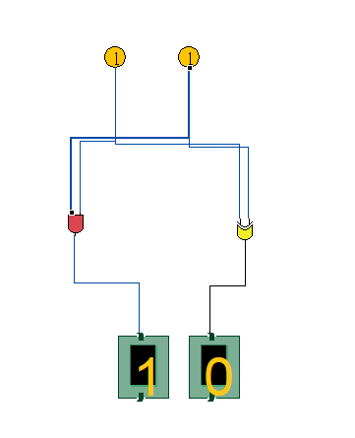

1. Create a full adder circuit using only logic gates and test it by giving proper input.

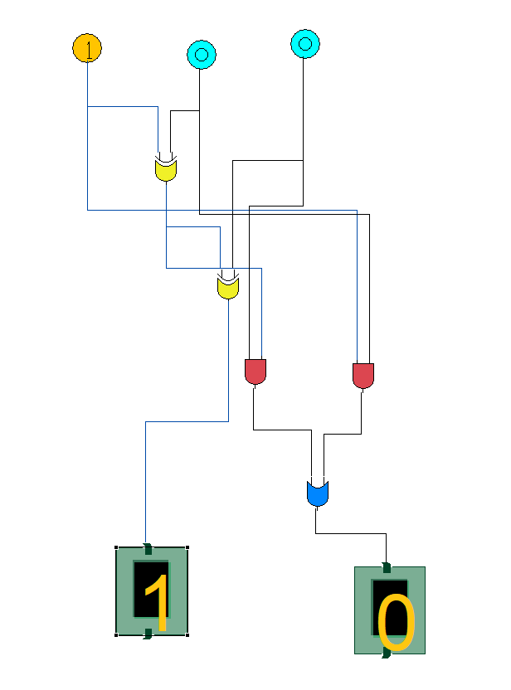

1. Create a full adder circuit using half adder and test it by giving proper input.

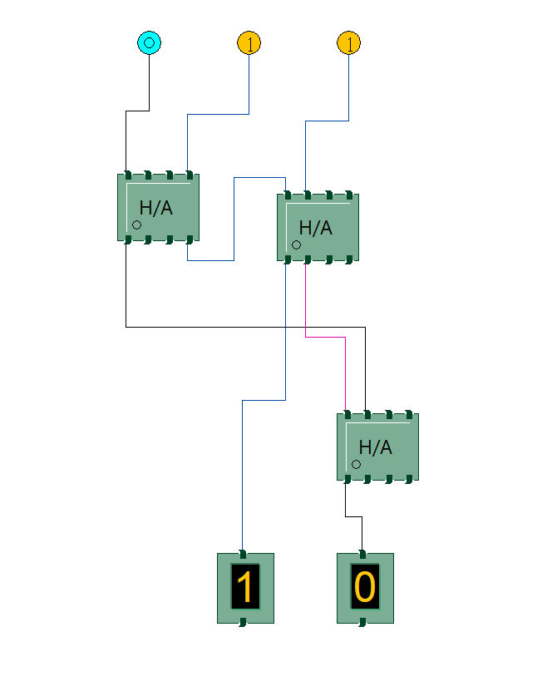

1. Create a 4-bit ripple carry adder circuit using half adders and full adders and test it by giving proper input.

Procedure

**Design of Ripple Carry Adders:**

**Procedure to perform the experiment:Design of Ripple Carry Adders**

1. Start the simulator as directed.This simulator supports 5-valued logic.
2. To design the circuit we need 3 full adder, 1 half adder, 8 Bit switch(to give input), 3 Digital display(2 for seeing input and 1 for seeing output sum), 1 Bit display(to see the carry output), wires.
3. The pin configuration of a component is shown whenever the mouse is hovered on any canned component of the palette or press the 'show pinconfig' button. Pin numbering starts from 1 and from the bottom left corner(indicating with the circle) and increases anticlockwise.
4. For half adder input is in pin-5,8 output sum is in pin-4 and carry is pin-1, For full adder input is in pin-5,6,8 output sum is in pin-4 and carry is pin-1
5. Click on the half adder component(in the Adder drawer in the pallet) and then click on the position of the editor window where you want to add the component(no drag and drop, simple click will serve the purpose), likewise add 3 full adders(from the Adder drawer in the pallet), 8 Bit switches, 3 digital display and 1 bit Displays(from Display and Input drawer of the pallet,if it is not seen scroll down in the drawer)
6. To connect any two components select the Connection menu of Palette, and then click on the Source terminal and click on the target terminal. According to the circuit diagram connect all the components, connect 4 bit switches to the 4 terminals of a digital display and another set of 4 bit switches to the 4 terminals of another digital display. connect the pin-1 of the full adder which will give the final carry output. connet the sum(pin-4) of all the adders to the terminals of the third digital display(according to the circuit diagram shown in screenshot). After the connection is over click the selection tool in the pallete.
7. To see the circuit working, click on the Selection tool in the pallet then give input by double clicking on the bit switch, (let it be 0011(3) and 0111(7)) you will see the output on the output(10) digital display as sum and 0 as carry in bit display.

**Circuit diagram of Ripple Carry Adder:**

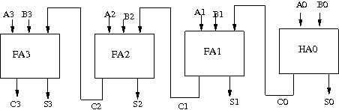

**Screenshot of Ripple Carry Adder:**

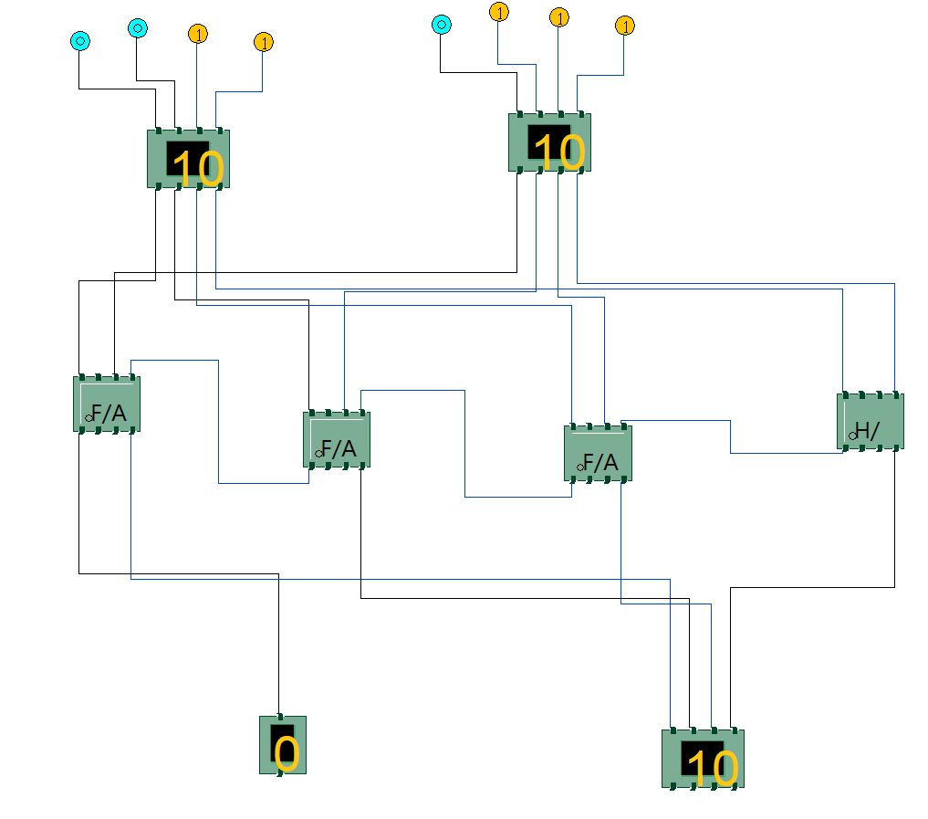

Components :

The components needed to create 4 bit ripple carry adder is listed here -

* 4 full-adders
* wires to connect
* LED display to obtain the output

or we can use

* 3 full-adders
* 1 half adder
* wires to connect
* LED display to obtain the output

**General guideline to use the simulator for performing the experiment:**

* Start the simulator as directed. For more detail please refer to the manual for using the simulator
* The simulator supports 5-valued logic
* To add the logic components to the editor or canvas (where you build the circuit) select any component and click on the position of the canvas where you want to add the component
* The pin configuration is shown when you select the component and press the 'show pinconfig' button in the left toolbar or whenever the mouse is hovered on any canned component of palette
* To connect any two components select the connection tool of palette, and then click on the source terminal and then click on the the target terminal
* To move any component select the component using the selection tool and drag the component to the desired position
* To give a toggle input to the circuit, use 'Bit Switch' which will toggle its value with a double click
* Use 'Bit Display' component to see any single bit value. 'Digital Display' will show the output in digital format
* undo/redo, delete, zoom in/zoom out, and other functionalities have been given in the top toolbar for ease of circuit building
* Use start/stop clock pulse to start or stop the clock input of the circuit. Clock period can be set from the given 'set clock' button in the left toolbar
* Use 'plot graph' button to see input-output wave forms
* Users can save their circuits with .logic extension and reuse them
* After building the circuit press the simulate button in the top toolbar to get the output
* If the circuit contains a clock pulse input, then the 'start clock' button will start the simulation of the whole circuit. Then there is no need to again press the 'simulate' button.