**[ 2CEIT503 COMPUTER NETWORKS]**

Practical: 3



**AIM- Studying Windows network commands.**

**ping, pathping, ipconfig/ifconfig, arp, netstat, nbtstat,**

**nslookup, route, traceroute/tracert, nmap.**

**.**

Submitted By:

21012021003



**Department of Computer Engineering/Information Technology**

* **Hostname :**

Useful to know machine name.

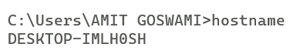

* **Ipconfig :**

The ipconfig command is a fast way of determining your computer’s IP address and other information, such as the address of its default gateway useful if you want to know the IP address of your router’s web interface.

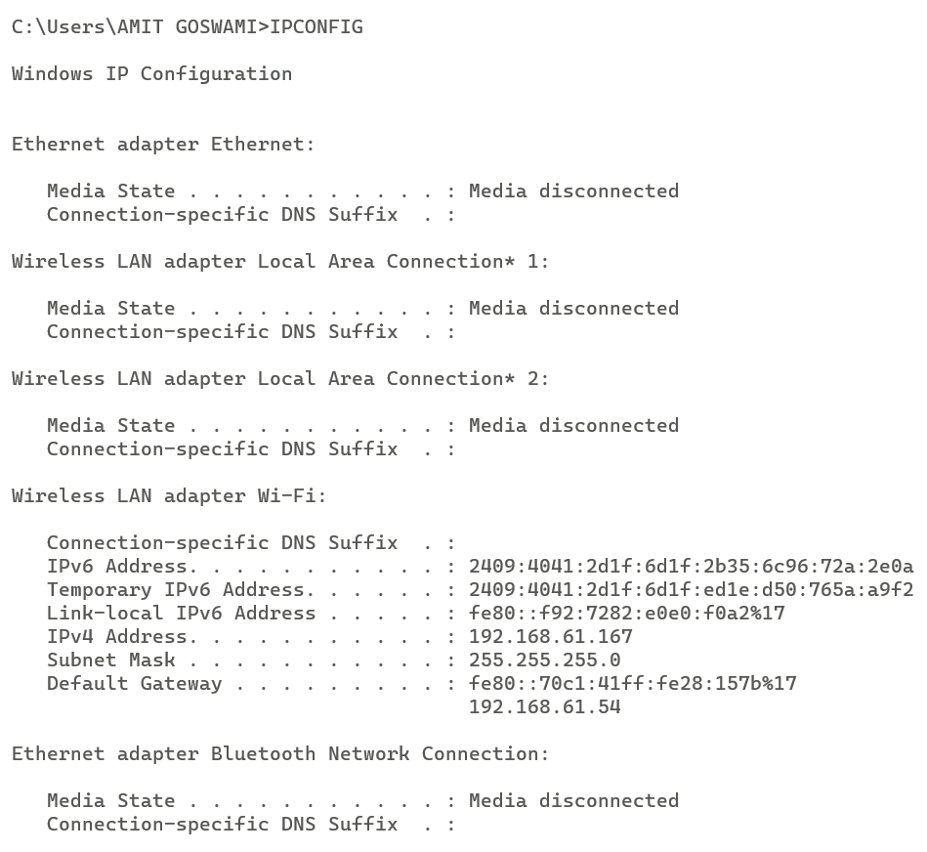

* **Ipconfig/all :**

Displays all current TCP/IP network configuration values and refreshes Dynamic Host Configuration Protocol (DHCP) and Domain Name System (DNS) settings. Used without parameters, ipconfig displays Internet Protocol version 4 (IPv4) and IPv6 addresses, subnet mask, and default gateway for all adapters. 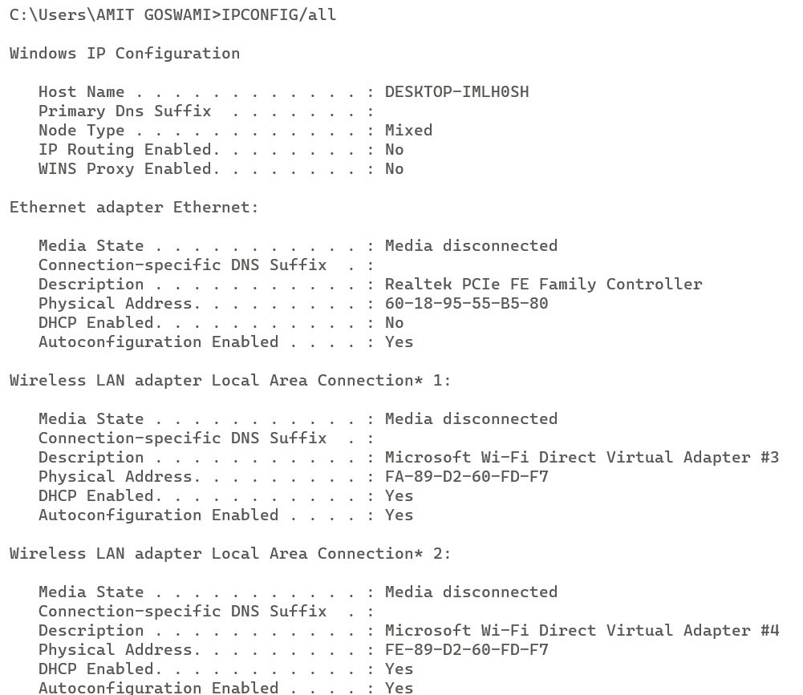

* **Ping :**

Ping sends out a packet to a designated internet host or network computer and measures its response time. Use ping whenever you need to verify that a host computer can connect to the TCP/IP network and network resources.

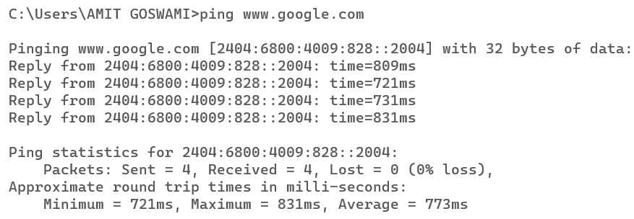

* **Arp -a :**

A device that wants to communicate with others over the internet then ARP will broadcast a packet to all the devices of the source network. There the network ID of the packet is validated with the destination IP’s network ID of the packet and if it’s equal then it responds to the source with the MAC address(Physical Address) of the destination, else the packet reaches the gateway of the network and broadcasts packet to the devices it is connected with and validates their network ID. The above process continues till the second last network device in the path reaches the destination where it gets validated and ARP, in turn, responds with the destination MAC address.

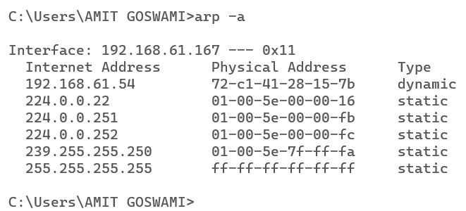

* **Netstat :**

netstat stands for network statistics. This command displays incoming and outgoing network connections as well as other network information. The netstat utility can show you the open connections on your computer, which programs are making which connections, how much data is being transmitted, and other information.The netstatcommand is a used to display very detailed information about how your computer is communicating with other computers or network devices.

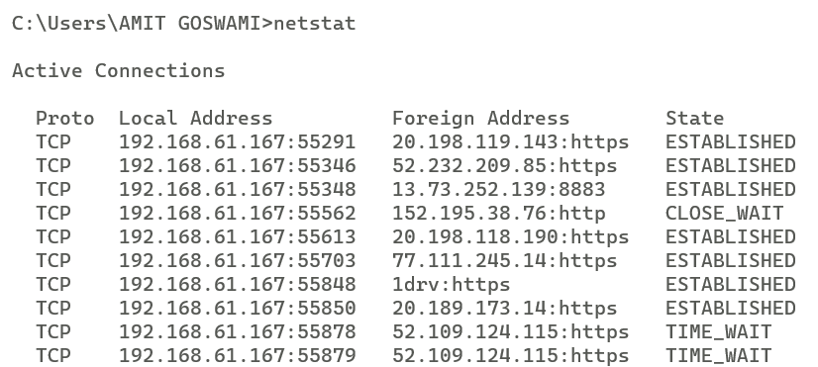

* **Nslookup :**

nslookup, which stands for "name server lookup", is a useful tool for finding out information about a domain named . This command helps diagnose the Domain Name System (DNS) infrastructure and comes with a number of sub-commands. These are mainly for systems administrators. The primary interest for average PC users is its use to find the computer name corresponding to a numeric IP.

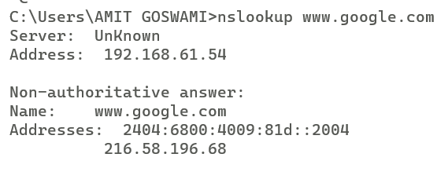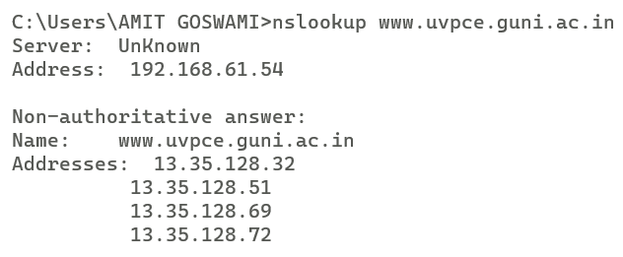

* **Nbtstat :**

Displays NetBIOS over TCP/IP (NetBT) protocol statistics, NetBIOS name tables for both the local computer and remote computers, and the NetBIOS name cache. This command also allows a refresh of the NetBIOS name cache and the names registered with Windows Internet Name Service (WINS). Used without parameters, this command displays Help information.

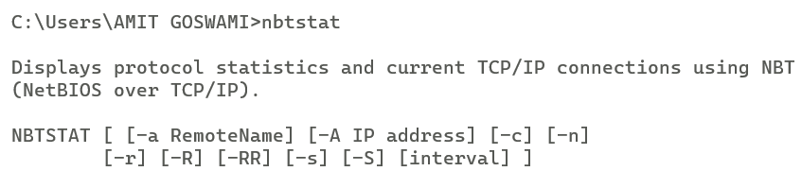

* **Tracert :**

A tracert is a tracking of a packet sent to a server. During its route this packet goes through several network devices (routers, firewall, etc.) and then goes finally at the server. With the tracert you can see the IP as well as the response time between each barrier.

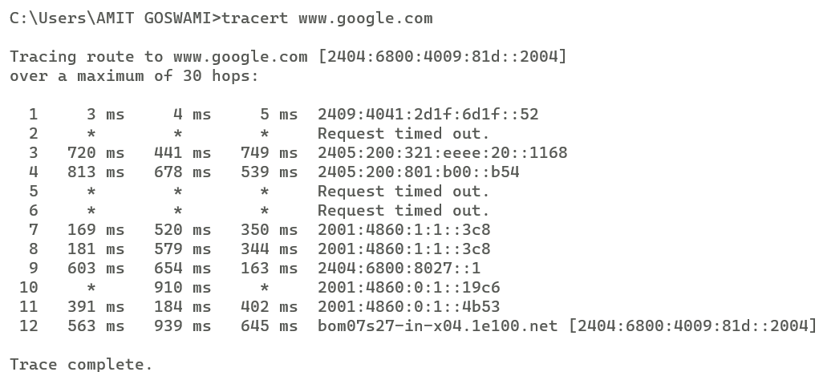

* **Route :**

If this is used in conjunction with one of the commands (such as add, change, or delete), the table is cleared prior to running the command. -p : When used with the add command, the specified route is added to the registry and is used to initialize the IP routing table whenever the TCP/IP protocol is started.

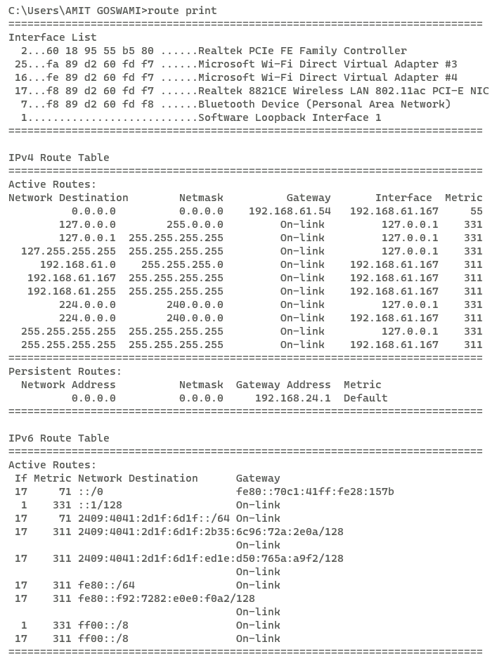

* **Ipconfig -flusdns :**

To ensure Windows is getting addresses from the new DNS servers instead of using old, cached entries, run the ipconfig /flushdns command after changing your DNS server.

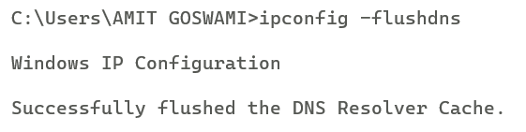

* **Pathping :**

The pathping command is a route tracing tool that combines features of the ping and tracert commands with additional information that neither of those tools provides. The pathping command sends packets to each router on the way to a final destination over a period of time, and then computes results based on the packets returned from each hop. Since the command shows the degree of packet loss at any given router or link, it is easy to determine which routers or links might be causing network problems.

The main difference between tracert and pathping is that tracert helps to find the actual path from the source to the destination device while pathping is a command that provides information about network latency and network loss at intermediate hops between the source and the destination devices.

