**[ 2CEIT503 COMPUTER NETWORKS]**

**Practical: 4**



**AIM- Write a program to implement various framing techniques.**

**a. Bit Stuffing**

**b. Byte Stuffing**

**.**

Submitted By:

21012021003_AMIT GOSWAMI



Department of Computer Engineering/Information Technology

**BIT STUFFING:**

* Allows frame to contain arbitrary number of bits and arbitrary character size. The frames are separated by separating flag.
* Each frame begins and ends with a special bit pattern, 01111110 called a flag byte. When five consecutive l's are encountered in the data, it automatically stuffs a '0' bit into outgoing bit stream.
* In this method, frames contain an arbitrary number of bits and allow character codes with an arbitrary number of bits per character. In his case, each frame starts and ends with a special bit pattern, 01111110.
* In the data a 0 bit is automatically stuffed into the outgoing bit stream whenever the sender's data link layer finds five consecutive 1s.
* This bit stuffing is similar to byte stuffing, in which an escape byte is stuffed into the outgoing character stream before a flag byte in the data.
* When the receiver sees five consecutive incoming i bits, followed by a o bit, it automatically destuffs (i.e., deletes) the 0 bit. Bit Stuffing is completely transparent to network layer as byte stuffing. The figure1 below gives an example of bit stuffing.
* This method of framing finds its application in networks in which the change of data into code on the physical medium contains some repeated or duplicate data. For example, some LANs encodes bit of data by using 2 physical bits.

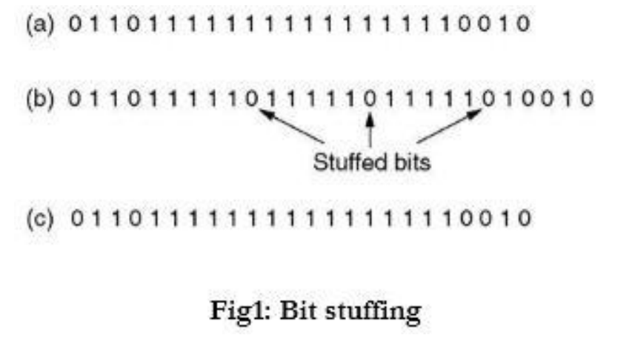

**Code :**

def bit_stuffing(data, flag, stuffed_bit='0'):

stuffed_data = flag

count = 0

for bit in data:

if bit == '1':

count += 1

if count == len(flag)-2:

stuffed_data += stuffed_bit + bit

count = 0

else:

stuffed_data += bit

else:

count = 0

stuffed_data += bit

stuffed_data += flag

return stuffed_data

flag = input("Enter the flag : ")

data_to_send = input("Enter the data : ")

stuffed_data = bit_stuffing(data_to_send, flag)

print("Original data:", data_to_send)

print("Stuffed data:", stuffed_data)

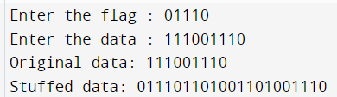

**BYTE STUFFING:**

* n this method, start and end of frame are recognized with the help of flag bytes. Each frames starts with and ends with a flag byte. Two consecutive flag bytes indicate the end of one frame and start of the next one. The flag bytes used in the figure 2 used is named as “ESC” flag byte.
* A frame delimited by flag bytes. This framing method is only applicable in 8-bit

character codes which are a major disadvantage of this method as not all

character codes use 8-bit characters e.g. Unicode.

* Four example of byte sequences before and after stuffing:

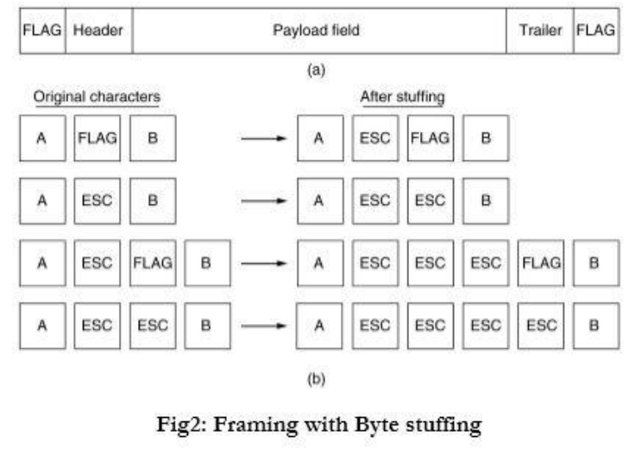

**Code :**

flag = input("Enter the flag character : ")

esc = input("Enter the esc character : ")

data = list(input("Enter the data : "))

def stuffed_data():

str = ''

for i in range(0, len(data)):

if (data[i] == flag):

data.insert(i, esc)

if (data[i] == esc):

data.insert(i, esc)

pass

data.insert(0, flag)

data.extend(flag)

print("stuffed data is : ", str.join(data))

stuffed_data()

