**`[ 2CEIT503 COMPUTER NETWORKS]**

Practical: 7



**AIM- Implementation of .tcl script in Ns2 .**

**a) Write a tcl script to add two nodes and one link (example.tcl).**

**b) Modify example.tcl such that node n0 sends data to node n1.**

Submitted By: 21012021003_AMIT GOSWAMI



Department of Computer

Engineering/Information Technology

1. **Write a tcl script to add two nodes and one link.**

**Example1a.tcl**

set ns [ new Simulator ]

set nf [ open out.nam w ]

$ns namtrace-all $nf

proc finish {} {

global ns nf

$ns flush-trace

close $nf

exec nam out.nam &

exit 0

}

set n0 [$ns node]

set n1 [$ns node]

$ns duplex-link $n0 $n1 1Mb 10ms DropTail

$ns at 5.0 "finish"

$ns run

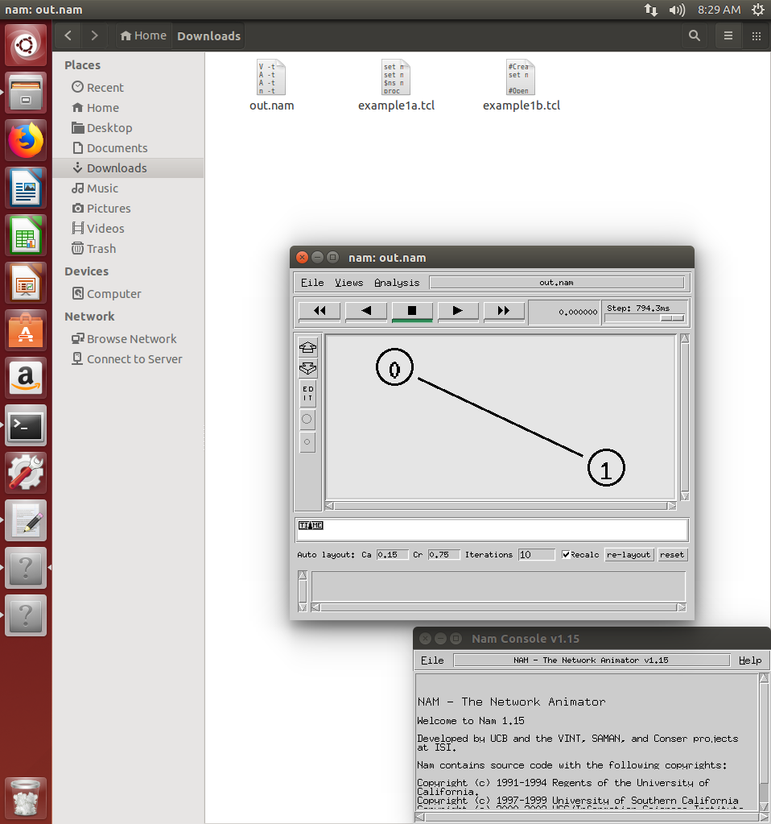

1. **Example1b.tcl**

#Create a simulator object

set ns [new Simulator]

#Open the nam trace file

set nf [open out.nam w]

$ns namtrace-all $nf

#Define a 'finish' procedure

proc finish {} {

global ns nf

$ns flush-trace

#Close the trace file

close $nf

#Execute nam on the trace file

exec nam out.nam &

exit 0

}

#Create two nodes

set n0 [$ns node]

set n1 [$ns node]

#Create a duplex link between the nodes

$ns duplex-link $n0 $n1 1Mb 10ms DropTail

#Create a UDP agent and attach it to node n0

set udp0 [new Agent/UDP]

$ns attach-agent $n0 $udp0

# Create a CBR traffic source and attach it to udp0

set cbr0 [new Application/Traffic/CBR]

$cbr0 set packetSize_ 500

$cbr0 set interval_ 0.005

$cbr0 attach-agent $udp0

#Create a Null agent (a traffic sink) and attach it to node n1

set null0 [new Agent/Null]

$ns attach-agent $n1 $null0

#Connect the traffic source with the traffic sink

$ns connect $udp0 $null0

#Schedule events for the CBR agent

$ns at 0.5 "$cbr0 start"

$ns at 4.5 "$cbr0 stop"

#Call the finish procedure after 5 seconds of simulation time

$ns at 5.0 "finish"

#Run the simulation

$ns run

