**Practical 1**

Aim: Introduction and Installation of Node.js

1. **Differentiate JavaScript and Node.js**

|  |  |  |
| --- | --- | --- |
| **Features** | **JavaScript** | **Node JS** |
| **Definition** | It is an open-source, cross-platform, interpreted, lightweight scripting programming language that is used to develop dynamic and web  applications. | It is a cross-platform, open-source JavaScript runtime environment that allows JavaScript to be run on the server. |
| **Type** | It is a programming language. It works in any browser that has a proper browser engine. | It's a JavaScript interpreter and environment with some valuable libraries  that JavaScript programming can use separately. |
| **Dedicated Server** | It is generally used on the client-side server. | It is generally used on the server-side. |
| **Community** | All the JavaScript is not important to the node community. | All node projects represent the JavaScript community. |
| **Running Engines** | JavaScript can be run on any engine, including Spider Monkey, V8, and JavaScript Core. | Node JS is only supported by the V8 engine, which Google Chrome mostly uses. Any JavaScript program written with Node JS will always be run in the  V8 engine. |
| **Used for** | It is designed to build network-centric applications. | It's designed for data-intensive real-time applications that run on several platforms. |
| **Languages** | It's a newer version of the ECMA script that runs on Chrome's V8  engine, which is written in C++. | It uses C, C++, and JavaScript. |
| **Modules** | Few JavaScript frameworks are  **TypedJS, RamdaJS**, etc. | Lodash, express are examples of Nodejs  modules. These all modules are to be imported from **npm**. |
| **Companies Uses** | Various companies use JavaScript like  **Google, Shopify, Udacity, Sendgrid, Groupon, Okta, Instacart**, etc. | Various companies use Node Js like  **Netflix, Hapi, Walmart, Paypal, Linkedin, Trello, Medium, eBay**, etc. |

1. **What is the difference between ‘front-end’ and ‘back-end’ development?**

|  |  |  |
| --- | --- | --- |
| **Basis** | **Front End** | **Back End** |
| **Definition** | Front end development involves the effective implementation of visual components of a web application | Back end development involves the effective implementation of functions of a web application that includes  databases, server management, etc. |
| **Skills Required** | The skill set required for the front end  includes HTML, CSS, SASS, JavaScript, etc. | The skill set required for the back end  development includes Python, Ruby, Java, PHP, etc. |
| **Independence** | Front end development cannot work  independently except in the case of static sites. | Back end development works  independently of the front end as Back end |
| **Goal** | The goal of the front end development is to ensure that the application is accessible by everyone and it remains responsive on all the platforms such as desktop, talbot, and phone. | The goal of the back end development is to ensure that the application runs under all the provided cases, be scalable, and work efficiently with low latency without  fail. |
| **Development Team** | The work of the front end development team is to design and develop the  appearance of the application based on the user’s input and test it. | The work of the back end development team is to assist the  front end in linking pages up, provide security and support to the users. |
| **Frameworks Used** | AngularJS, React, vue.js, etc. | Django, Flask, CakePHP, Laravel, Ruby on Rails, etc. |
| **Additional skills** | A good understanding of UI and UX designing. | Logical reasoning and problem- solving. |

1. **What is Node.js?**

Node.js is an open source, cross-platform runtime environment for developing server-side and networking applications. Node.js applications are written in JavaScript, and can be run within the Node.js runtime on OS X, Microsoft Windows, and Linux. It is a server-side platform built on Google Chrome's JavaScript Engine (V8 Engine) and was developed by Ryan Dahl in 2009 and its latest version is v0.10.36.

It also provides a rich library of various JavaScript modules which simplifies the development of web applications using Node.js to a great extent.

1. **Write down advantages of Node.js**

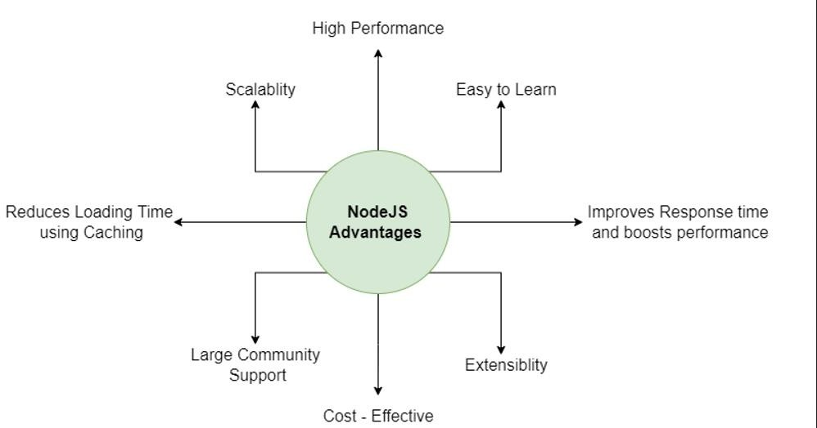**High Performance**

Its event-driven, single-threaded design rapidly processes several simultaneous requests without clogging the RAM.

# Scalability

developers can easily grow applications in both horizontal and vertical orientations.

# Easy to Learn

Most frontend developers are familiar with JavaScript because it is one of the most extensively used programming languages. It will be lot easier for them to get started using Node.js on the backend.

**Cost Effective**

One of the major node.js advantages is that it eliminates the need for two resource teams, saving time, money, and energy for overall project development.

**Extensibility**

It offers a lot of extensibility, which means it can be changed and improved to fit unique requirements.

# Large Community Support

Millions of developers actively contribute to the Node.js community.

**Improve Response Time And Boost Performance**

When Netflix used Java and JavaScript, the startup time was 40 minutes. They then moved to node.js and succeeded in cutting the startup time to under 40 seconds

# Reduce Loading Time Using Caching

The Node.js Caching module makes it simple for developers to decrease task workload and code re- execution. It is one of the major node.js advantages.

1. **How does Node.js differ with other languages?**

Node.js sits in a category of its own in the development niche. It is neither a programming language nor an individual framework. It can best be defined as a mixture of both. In the eyes of some developers, Node.js may be a jack of all trades and a master of none, but there is more to this environment than is perceived.

Node.js is definitely among the best when it comes to programming languages as well as frameworks. Node.js is best defined as a JavaScript runtime that works on the famous and ultra-powerful V8 engine by JavaScript.

In simpler terms, Node.js can be defined as a programming language that works well as a development runtime. Node.js is recognized for its ability to work both as a frontend and backend development environment. The runtime can be amalgamed with React and Angular to work as a JavaScript frontend framework. The design for Node.js development is similar to Event Machine by Ruby and Twisted by Python.

Who uses Node.js?

Here are some of the most popular applications and websites that use Node.js in the digital sphere, ones you’ve certainly interacted with. Top 10 companies using Node.js for backend are as follows:

PayPal, Uber, LinkedIn, eBay, Netflix, Trello, NASA, Twitter, Walmart, Groupon.

1. **Which are the applications of Node.js?**

Real-Time Chat Application

Social Media Platform

Internet Of Things (IOT)

Streaming App

Online Payment Processor

Remote Collaboration Tool

1. **How to download & install Node.js?**

Download the **Windows Installer** from [NodeJs official website.](https://nodejs.org/en/download/)

1. **How to check installed version of node.js?**

If you have a doubt whether you have installed everything correctly or not, let’s verify it with “Command Prompt”

Command Prompt window will appear on the screen. To confirm Node installation, type node -v command. To confirm NPM installation, type npm -v command.

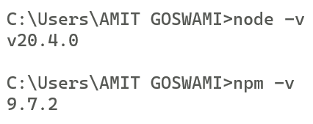

1. **How to write and execute Node.js program to print “Hello World” in console?**

To write and execute a Node.js program that prints "Hello World" in the console, follow these steps:

1. Open a text editor and create a new file with a .js extension (e.g., helloworld.js).
2. Inside the file, add the following line of code:

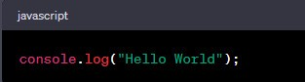

1. Save the file.
2. Open a terminal or command prompt and navigate to the directory where you saved the file.
3. To execute the Node.js program, type the following command in the terminal:

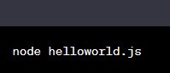

1. Press Enter, and you should see "Hello World" printed in the console.

C:\Users\Admin\AppData\Local\Packages\5319275A.WhatsAppDesktop_cv1g1gvanyjgm\TempState\8832AE39136FB470B3FBBF9F47B4570D\WhatsApp Image 2023-07-15 at 17.59.16.jpg