**PRACTICAL-2**

**Console based node.js applications**

1. **Create Node.js application which allow users to perform basic mathematical operations such as addition, subtraction, multiplication, and division. Description:**
   * **Create a Node.js script that takes command-line arguments to perform the desired mathematical operation.**
   * **Implement a logic for each mathematical operation (addition, subtraction, multiplication and division).**
   * **Handle invalid inputs and display appropriate error messages.**
   * **Ensure that the application can handle both integer and floating-point numbers.**

const args=process.argv;

var a = parseInt(args[2]);

var b = parseInt(args[4]);

console.log("21012021003_AMIT GOSWAMI")

switch(args[3]){

case '+' :

console.log("Result: " + (a+b));

break;

case '-' :

console.log("Result: " + (a-b));

break;

case '*' :

console.log("Result: " + (a*b));

break;

case '/' :

console.log("Result: " + (a/b));

break;

case '%' :

console.log("Result: " + (a%b));

break;

default :

console.log("you enter wrong arithmetic operator");

break;

}

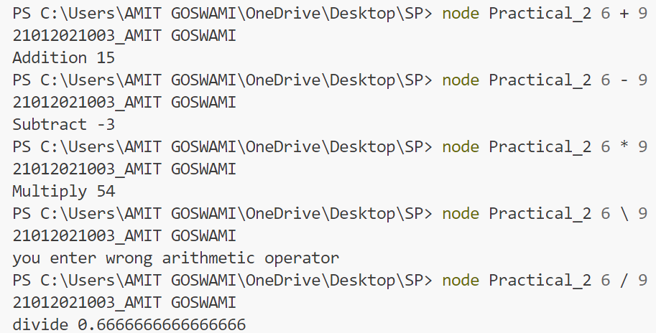

1. **Write a node.js program to build a console application which allow users to perform the following operations:**
   * **Take contact details from user using ReadLine package.**
   * **Add a new contact details like name & phone number (Length should be 10) and store details in an array.**
   * **Display value of an array.**

console.log('21012021003_AMIT GOSWAMI');

const readline = require('readline');

let r1 = readline.createInterface(process.stdin,process.stdout);

r1.question('Enter your name: ', (Name) =>{

    r1.question('Enter your phone number: ', (Contact) => {

        if(Contact.length ==10){

            const array = [Name,Contact]

            console.log('Name ' + array[0]);

            console.log('Phone number ' + array[1]);

        }else{

            console.log('Invalid Contact Number');

        }

        r1.close();

    });

});

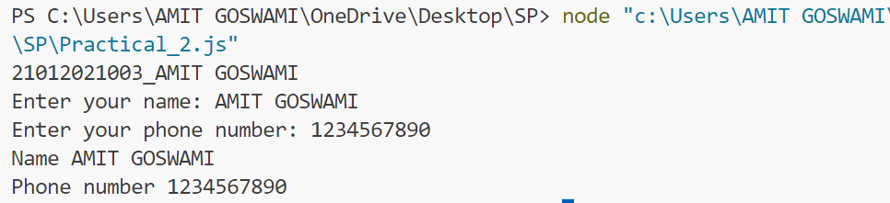

1. **Write a Node.js program to create an object named book using object literal syntax. Add book_title, author and publish_year as properties to the book object and assign it’s appropriate values. Now create function print_info() to print the book object to the console so the final output looks as below:**

**title: Harry Potter and the Sorcerer's Stone**

**author: J.K. Rowling**

**publish_year: 1997**

var book = {

book_title:'Harry Potter and the Sorcerers Stone',

author:'J.K. Rowling',

Publish_year:1997

}

console.log("21012021003_AMIT GOSWAMI");

function print_info(){

for(i in book){

console.log(i,":", book[i]);

}

};

print_info();

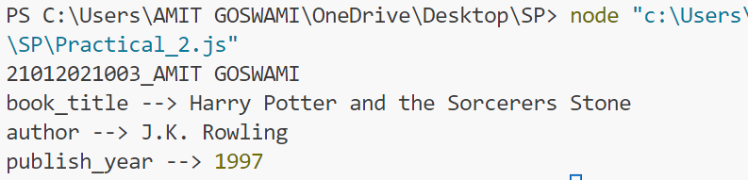

1. **Create an array named products. Add objects to the array. Each object should be a single product, with 3 properties: name, inventory and unit_price. Create two functions named listProducts() and totalValue(). A listProducts() function accepts a parameter -- the array of products and it should return an array of the names of the products. A function named totalValue() should accept a parameter -- the array of products and it should return the total value of all of the products in the array. To calculate the total value of one product multiply the inventory value with the unit_price.**

var Brands =[

{Name:'soap',Quantity:2,Per_Qn_Price:50},

{Name:'Facewash',Quantity:2,Per_Qn_Price:200},

{Name:'Sampoo',Quantity:2,Per_Qn_Price:380},

{Name:'tooth-paste',Quantity:1,Per_Qn_Price:120},

{Name:'Handwash',Quantity:3,Per_Qn_Price:100}

];

var Stock_List =function(n){

console.log("List of the products")

for(var temp in Brands){

console.log(n[temp].Name)

}

}

Stock_List(Brands);

var Total_Cost = function(m){

var sum=0;

for(var temp in Brands){

var ans = (m[temp].Quantity*m[temp].Per_Qn_Price)

sum = sum + parseInt(ans);

}

console.log("Total Cost: ",sum);

}

Total_Cost(Brands);

