**PRACTICAL-3**

**Core, user defined and third party module**

1. **Using HTTP and other required core modules, create HTTP server and display the following message to console and on the webpage for different URL entered by the user.**
   1. **If user enter “/ ” then display “Home Page”**
   2. **If the user enters ”/exam” then display the following table.**
   3. **If user enter “/exam/semester_end” then redirect user to timetable of “Regular exam”**

**Note: You can use either switch case or else if statement.**

var http = require("http");

var url = require("url");

http.createServer(function(req, res){

if (req.url=='/'){

res.write("This is test");

}

else if (req.url=='/exam'){

res.writeHead(200,{"Content-Type": "text/html"});

res.write('<table border="1">')

res.write('<tr><th><b>Date</b></th><th><b>Code</b></th><th><b>Subject</b></th></tr>');

res.write('<tr><td>28/08/2023</td><td>2CEIT501</td><td>Computer Architecture and Organisation</td></tr>');

res.write('<tr><td>30/08/2023</td><td>2CEIT503</td><td>Computer Network</td></tr>');

res.write('<tr><td>01/09/2023</td><td>2CEIT5PE4</td><td>Software Packages</td></tr>');

res.write('</table>')

}

else if(req.url=='/exam/semester_end') {

res.write('Regular Exam');

}

res.end();

}).listen(5001);

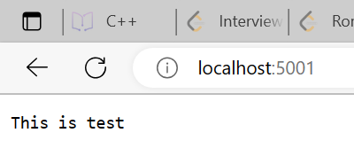 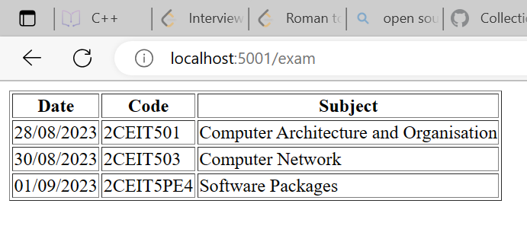 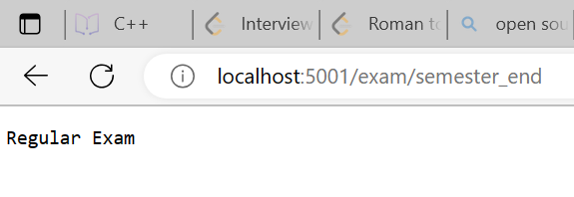

1. **In a given query string of URL, give two parameters num1 and num2 and assign integers values to them and then find the smallest number among those two numbers.[URL: localhost:8080/?num1=14&num2=40].**

let http = require('http');

let url = require('url');

http.createServer((req, res) => {

let q = url.parse(req.url , true).query;

if(q.num1 < q.num2){

res.end("Number-1 is Small.");

}

else if(q.num2 < q.num1){

res.end("Number-2 is Small.");

}

else{

res.end("Invalid Query!");

}

}).listen(8080);

console.log("Program is Executed on Port : 8080");

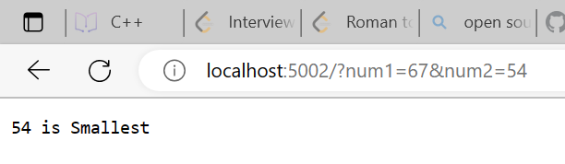

1. **Create a local module named as ‘todoList’ which contains 3 functions for adding, removing and listing tasks. Export it in another file main.js and display their result.**

**Practical_3_1.js :**

let list = [];

function add_todo(task){

list.push(String(task));

console.log("Task Added.");

}

function remove_todo(task){

const index = list.indexOf(String(task));

if(index != -1){

list.slice(index,1);

console.log("Task Removed.");

}

else{

console.log("Task Not Found.");

}

}

function list_todo(){

console.log("\n")

for(let i in list){

console.log(list[i]);

}

console.log("\n")

};

module.exports={

add_todo,

remove_todo,

list_todo

}

**Practical_3.js :**

let todo = require("./tl.js")

console.log("21012021003_AMIT GOSWAMI")

todo.add_todo("Complete CAO Practical 1,2,3,4")

todo.add_todo("Complete CAO Assignment")

todo.add_todo("Study CAO For Exam")

todo.list_todo()

todo.remove_todo("Complete CAO Notes")

todo.remove_todo("Complete CAO Practical 1,2,3,4")

todo.list_todo()

