Week 4 Internship Report
Statistical Analysis and Predictive Modeling

Junior Data Analyst – Business Analytics with Python Internship
Week 4 Task Report
Dataset: Online Retail Sales Dataset

1. Introduction and Business Problem

The objective of this analysis was to apply statistical techniques and predictive modeling to understand patterns in an online retail sales dataset and investigate the feasibility of forecasting future daily sales. Retail businesses require reliable insights into customer purchasing behavior, sales variation, and revenue trends to support inventory planning, staffing, and strategic decision-making. The business problem considered in this project was therefore to identify meaningful statistical relationships within transaction data and develop a baseline model for predicting daily sales revenue.

The analysis followed a structured workflow consisting of exploratory data analysis, correlation analysis, hypothesis testing, preparation of a daily sales forecasting dataset, development of a Linear Regression model, and evaluation of its predictive performance. Rather than assuming that a predictive model would necessarily produce high accuracy, the model was critically evaluated using appropriate performance metrics and visual diagnostics. This approach provides both technical findings and practical business insights.

2. Dataset and Exploratory Analysis

The analysis used the cleaned and transformed Online Retail dataset developed during the earlier data preparation stage. The dataset contains transaction-level information including invoice details, products, quantities, unit prices, customer information, countries, and derived sales and calendar variables. TotalSales was used as the principal revenue variable for statistical exploration.

Sales Metric | Result
Total Revenue | £10,642,110.80
Average Transaction Value | £20.28
Median Transaction Value | £9.92

The difference between the average and median transaction values indicates that transaction values are not evenly distributed and that higher-value transactions influence the overall average. This observation is consistent with the need to examine the distribution of sales carefully when developing and interpreting a predictive model.

3. Correlation Analysis

A correlation analysis was performed to examine the linear relationships between Quantity, UnitPrice, and TotalSales. Quantity showed a strong positive relationship with TotalSales (approximately 0.907), while UnitPrice showed a comparatively weak positive relationship with TotalSales (approximately 0.137). The relationship between Quantity and UnitPrice was close to zero (approximately -0.004).

These findings suggest that the number of items purchased was strongly associated with transaction revenue in this dataset, whereas unit price alone was less strongly associated with total transaction sales. Correlation does not establish causation, but it provides useful evidence about which variables may be informative during business analysis and model development.

4. Statistical Hypothesis Testing

4.1. Weekday versus Weekend Sales: Independent T-Test

An independent t-test was used to examine whether sales behavior differed between weekday and weekend transactions. The null hypothesis stated that there was no statistically significant difference in the mean transaction values of the two groups. The alternative hypothesis stated that a significant difference existed.

Statistic | Result
T-statistic | 18.8241
P-value | Reported as 0.000000
Average weekday sales | £21.26
Average weekend sales | £12.94

Because the reported p-value was effectively zero at the displayed precision, the null hypothesis was rejected. The analysis therefore provided statistical evidence of a significant difference between weekday and weekend transaction sales. This finding can support business decisions related to staffing, promotions, and operational planning across different days of the week.

4.2. Transaction Category Association: Chi-Square Test

A chi-square test was also conducted to examine whether transaction value categories were associated with the categorical groups used in the analysis. The null hypothesis assumed independence between the variables, while the alternative hypothesis assumed a statistically significant association.

Statistic | Result
Chi-square statistic | 3712.2144
Degrees of freedom | 2
P-value | Reported as 0.000000

The reported result led to rejection of the null hypothesis, indicating a statistically significant association between the transaction value categories and the categorical grouping tested. This supports the conclusion that sales patterns are not completely uniform across the relevant business groups.

5. Predictive Modeling Methodology

To transform the transaction-level data into a forecasting problem, sales were aggregated into a daily sales dataset containing 305 daily observations. Calendar and time-related variables were used as predictors, including TimeIndex, Month, Day, and DayOfWeek. A Linear Regression model was selected as a simple and interpretable baseline model.

A chronological train-test split was used instead of a random split because forecasting should evaluate the model on observations occurring after the training period. The first portion of the time series was used for training and the later observations were reserved for testing.

Dataset Split | Observations
Training set | 244
Testing set | 61

The fitted model produced coefficients for the selected features, including TimeIndex (-11.14), Month (1535.78), Day (2.97), and DayOfWeek (-2976.40), with an intercept of approximately £30,570.37. These coefficients describe the relationships learned by the baseline linear model and should be interpreted together with the model validation results.

6. Model Validation and Evaluation

The model was evaluated on the unseen test set using Mean Absolute Error (MAE), Root Mean Squared Error (RMSE), and the coefficient of determination (R²). These measures provide complementary information about the magnitude of prediction errors and the model's ability to explain variation in daily sales.

Metric | Result | Interpretation
MAE | £21,067.19 | Average magnitude of prediction error.
RMSE | £31,243.56 | Penalizes larger prediction errors more heavily.
R² | -0.3547 | The model performed worse than a simple mean baseline on the test period.

The negative R² score is an important result. It indicates that the simple Linear Regression model did not explain the variation in the test-period daily sales effectively. The relatively large MAE and RMSE also show that prediction errors were substantial. These findings demonstrate why model validation is essential: building a model alone is insufficient without evaluating how well it performs on unseen data.

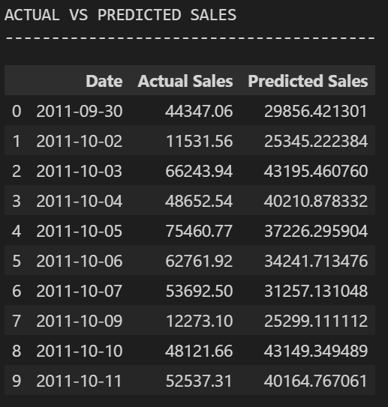
Figure 1. Actual versus predicted daily sales during the test period.

The Actual versus Predicted Sales visualization shows that the predicted series was considerably smoother than the observed sales series. Although the model estimated a general sales level, it did not capture several sharp fluctuations and high sales peaks. In particular, unusually large increases in daily sales were substantially underestimated, which is consistent with the negative R² score.
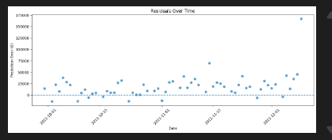
Figure 2. Residuals over time for the Linear Regression model.

The residual plot provides additional evidence of model limitations. Several large positive residuals are visible, meaning that actual sales exceeded predicted sales by a substantial amount on those days. The residuals therefore suggest that important patterns and sudden changes in sales were not captured by the selected calendar-based predictors.

7. Business Insights and Recommendations

- Sales behavior differs significantly between weekdays and weekends, suggesting that operational resources and promotional strategies can be adjusted according to day-based demand patterns.
- Quantity has a strong relationship with TotalSales, highlighting the importance of monitoring purchasing volume and product demand when analyzing revenue performance.
- The baseline Linear Regression model should not be used as a standalone high-accuracy forecasting system because its test performance was limited.
- Future forecasting models could include additional explanatory variables, such as product categories, customer behavior, promotions, holidays, seasonal effects, and lagged sales values.
- More advanced forecasting approaches can be compared with the Linear Regression baseline to determine whether they better capture irregular sales patterns and extreme peaks.

8. Conclusion

This project demonstrated a complete analytical workflow from exploratory analysis and hypothesis testing to predictive modeling and model validation. The statistical tests identified meaningful differences and associations within the online retail data, while the correlation analysis highlighted a strong relationship between quantity and transaction revenue. A Linear Regression model was then developed to forecast daily sales using time and calendar features.

The final evaluation produced an MAE of £21,067.19, an RMSE of £31,243.56, and an R² score of -0.3547. These results indicate limited predictive performance and show that the baseline model was unable to capture the full complexity of daily retail sales fluctuations. The Actual versus Predicted and residual analyses reinforced this conclusion by revealing substantial errors during periods of unusually high sales. Overall, the analysis provides a useful baseline and demonstrates the importance of combining statistical evidence, predictive modeling, and critical model validation when making data-driven business decisions.

