WEEK 5 REPORT
DASHBOARD DEVELOPMENT AND REPORTING
Junior Data Analyst – Business Analytics with Python Internship
Project: Retail Sales & Customer Analytics Using Python

1. Introduction
Week 5 focused on designing and implementing an interactive business analytics dashboard using Python and Streamlit. The purpose of the dashboard is to transform the cleaned Online Retail dataset into a practical decision-support interface where users can quickly monitor sales performance, product contribution, geographic markets, and transaction behaviour. The dashboard extends the analytical work completed in Weeks 2–4 by integrating previously prepared metrics and visualizations into a single interactive application.
The implementation uses Pandas for data processing, Matplotlib for analytical charts, and Streamlit for the interactive web-based interface. Users can filter the dashboard by country and year, while KPI cards and visualizations update according to the selected filters.

2. Dashboard Objectives
- Provide a centralized view of key retail performance indicators.
- Allow users to filter results by country and year.
- Show revenue trends over time.
- Identify the highest-revenue products and countries.
- Highlight day-of-week purchasing patterns.
- Provide a distribution view of transaction sales values.
- Convert analytical results into accessible business information.

3. Key Performance Indicators
Six KPI cards provide an immediate overview. In the full-data view, the dashboard shows 524,878 transactions and £10,642,110.80 total revenue. KPI values dynamically change when filters are applied.
KPI | Purpose | Full-Dataset Result
Total Revenue | Overall sales value | £10,642,110.80
Total Transactions | Transaction volume | 524,878
Average Transaction | Average revenue per transaction | £20.28
Total Quantity | Items sold | 5,572,420
Unique Products | Product variety | 3,922
Countries | Geographic coverage | 38

4. Dashboard Components

4.1 Interactive Filters
The sidebar contains Country and Year controls. Selecting a country or year filters the DataFrame and causes the KPIs and analytical views to recalculate.

4.2 Monthly Sales Revenue Trend
A line chart displays monthly revenue. The chronological view helps users identify changes in performance and potential seasonal patterns.

4.3 Top 10 Products by Revenue
A horizontal bar chart ranks the ten products with the highest total revenue, supporting inventory and promotional decisions.

4.4 Top 10 Countries by Revenue
A horizontal bar chart compares the leading markets and supports geographic performance monitoring.

4.5 Revenue by Day of Week
A day-of-week chart helps identify differences in weekly purchasing activity and can support staffing and promotional planning.

4.6 Transaction Sales Distribution
A histogram focuses on the typical 99% of transactions so that extreme values do not obscure the main purchasing pattern.

5. Data Flow and Technical Workflow
- Start the Streamlit application.
- Load the cleaned CSV dataset with Pandas.
- Convert InvoiceDate to datetime format.
- Read Country and Year selections from the sidebar.
- Filter the DataFrame according to user selections.
- Calculate KPI values from the filtered data.
- Group data for monthly, product, country, and day-of-week analysis.
- Generate charts with Matplotlib.
- Render KPIs, charts, tables, and text through Streamlit.
- Refresh the displayed results when filters change.

6. Technical Rationale
Streamlit was selected because it allows Python analytical logic to be converted into an interactive web application without requiring a separate front-end framework. Pandas provides efficient data manipulation and aggregation, while Matplotlib provides flexible chart generation. Together, these tools create a lightweight, reproducible dashboard suitable for business analytics.
The dashboard uses cached data loading to reduce unnecessary repeated file processing. The layout uses columns for KPI presentation and a sidebar for filters, creating a clear separation between controls and analytical outputs.

7. Dashboard Implementation Evidence
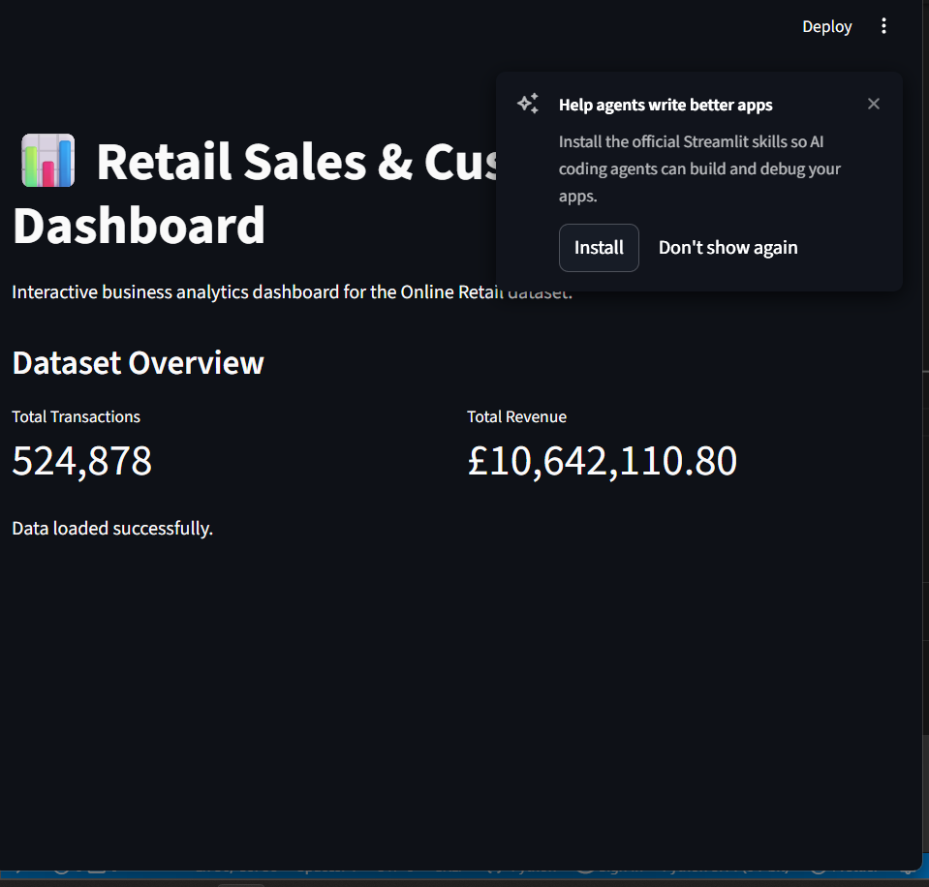
Figure 1. Initial Streamlit dashboard and KPI interface.
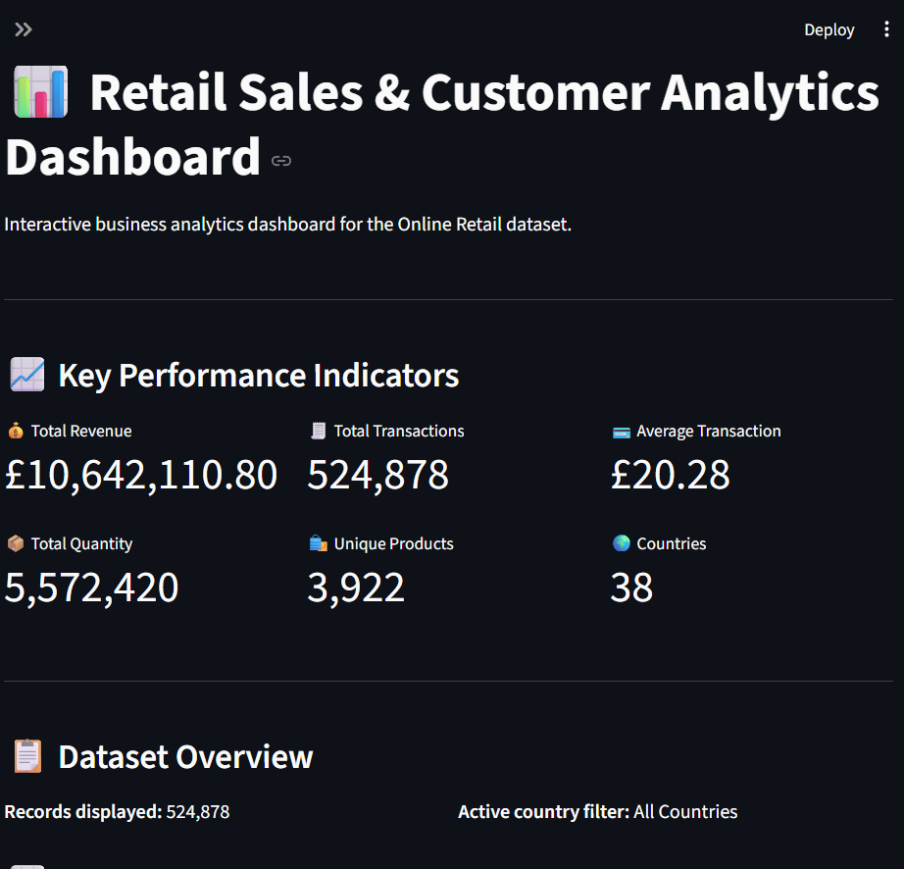
Figure 2. Dashboard showing KPIs, filters, revenue trend, and product analysis.
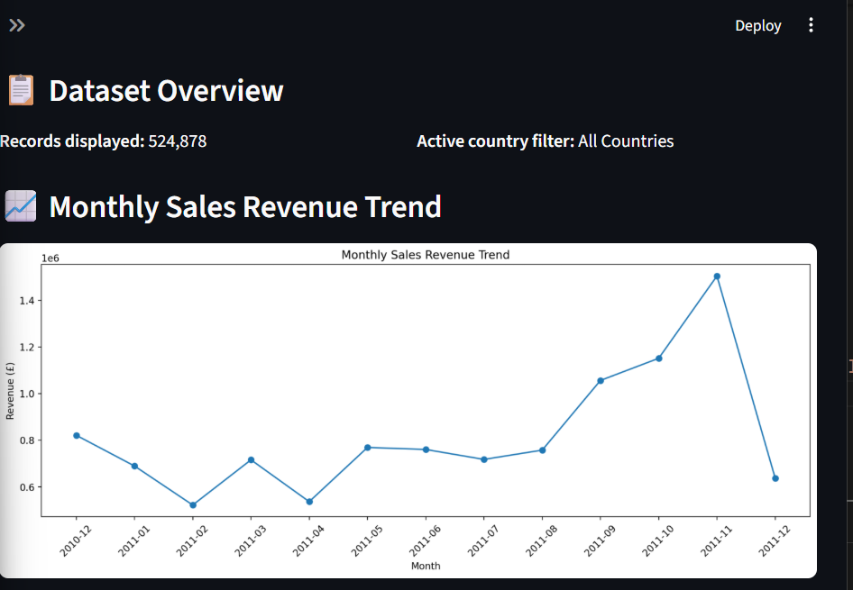
Figure 3. Dashboard product and country performance views.
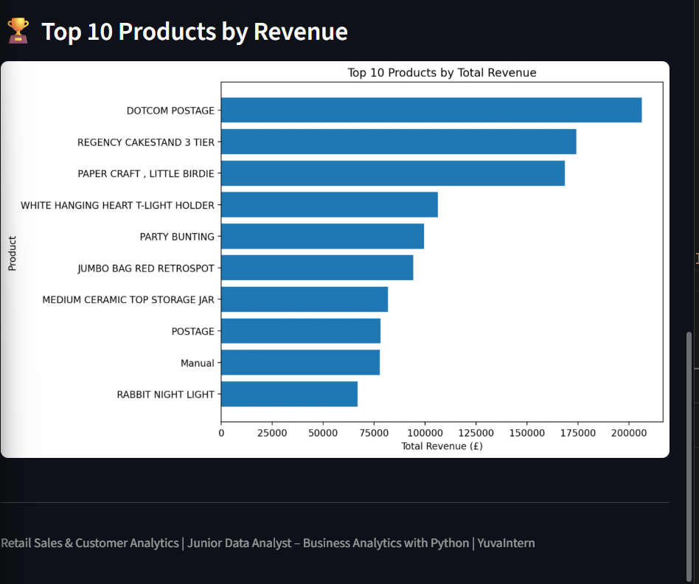
Figure 4. Additional dashboard analytical sections.
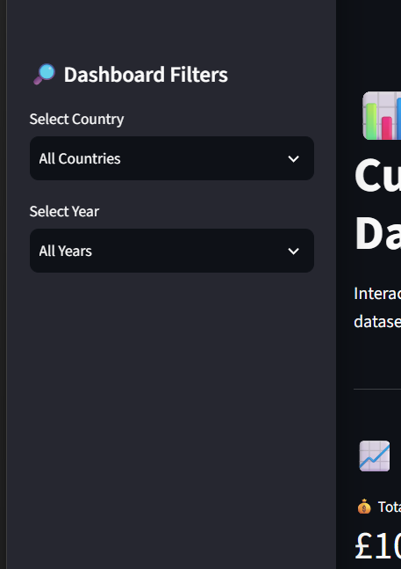
Figure 5. Interactive dashboard filtering demonstration.
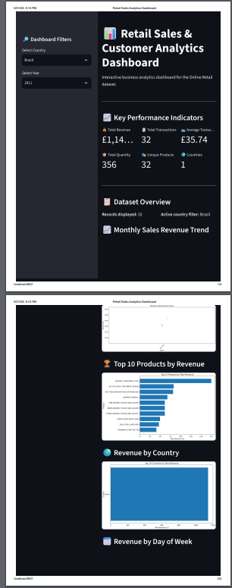
Figure 6. Country-filtered dashboard view showing dynamic results.

8. Business Insights and Recommendations
- KPI cards provide a rapid summary of overall business performance.
- Country and year filters allow focused investigation of individual markets and periods.
- Product ranking can guide inventory and promotional prioritization.
- Country ranking can support geographic expansion decisions.
- Day-of-week analysis can inform staffing and promotional scheduling.
- Transaction distribution helps distinguish typical purchasing behaviour from extreme transactions.

9. Testing and Validation
The dashboard was run locally using Streamlit and successfully loaded the cleaned dataset. The full-data view displayed 524,878 transactions and £10,642,110.80 total revenue. Country and year filters were tested, and the screenshots demonstrate that KPI values and analytical views respond to selected filters. This confirms the main interactive workflow is functioning as intended.

10. Future Improvements
Future versions could include downloadable filtered data, additional customer-level KPIs, profit or margin measures where cost information is available, richer interactive charts, forecasting outputs from the Week 4 model, period comparisons, and deployment to a hosted environment.

11. Conclusion
The Week 5 project successfully demonstrates the development of an interactive retail business analytics dashboard using Python and Streamlit. The dashboard consolidates KPIs, filters, revenue trends, product rankings, geographic analysis, day-of-week analysis, and transaction distributions into a single interface. It builds directly on the analytical work completed in earlier weeks and demonstrates how cleaned transactional data can be transformed into accessible, decision-support information.
The combination of automated calculations and interactive filtering allows users to move from a high-level business overview to focused analysis. The dashboard therefore provides a practical foundation for monitoring retail performance and supporting data-driven decisions.

