Real-Time Emotion Detection with CNN Hardware Acceleration
This project implements a real-time emotion detection system that uses both a deep learning-based software model and a Verilator-simulated hardware accelerator for CNN inference. It provides a hands-on demonstration of hybrid AI acceleration using Python, OpenCV, Keras, and SystemVerilog.

Project Overview and Goals
The core objective of this project was to detect facial emotions in real-time using webcam input and to evaluate the efficiency of hardware-accelerated inference using a Verilator-simulated CNN compared to a software-based Keras model. The project successfully demonstrated real-time inference, performance comparison, and integration of open-source tools for synthesis and benchmarking.

Software and Hardware Design Pipeline
The end-to-end pipeline involved training a CNN model on the FER-2013 dataset, capturing frames using OpenCV, preprocessing and feeding normalized grayscale images into a Verilated SystemVerilog CNN hardware accelerator, and logging inference results and performance metrics.

Project Milestones
Week 2: Selected CNN-based emotion detection as the project algorithm. Profiling identified the 2D convolution as the primary bottleneck.
Week 3: Measured software inference times, ranging from 0.13s to 0.91s per frame.
Week 4: Designed a pipelined SystemVerilog CNN accelerator module.
Week 5: Integrated the Verilated accelerator using a C++ wrapper and Python subprocess interface.
Week 6: Benchmarked the system, recording a ~2.3× speedup: Avg. software time = 0.197s; Avg. hardware time = 0.086s.
Week 7: Synthesized the accelerator using OpenLane. Achieved 500 MHz max frequency, zero slack, and retrieved logic utilization and area metrics.
Week 8–10: Final integration, verification, reporting, and presentation.

File & Directory Structure
• emotion_detector_with_model.py: Captures webcam input, processes image, runs software or hardware inference, and logs results.
• emotion_model.h5: Trained Keras CNN model.
• emotionmodel_cnn.py: Model architecture.
• train_emotion_cnn.py: Trains the CNN using the FER-2013 dataset.
• cnn_accelerator.sv: SystemVerilog CNN accelerator.
• sim_main.cpp: C++ testbench for Verilated simulation.
• input_image.txt: Image input for Verilator.
• emotion_predictions.csv / inference_log.csv: Logs inference outputs and performance.
• analyze_emotion_results.py: Visualization of speedup and prediction accuracy.
• verilator_test.py: Verilator testbench utility.
• synthesis_reports/: Area, power, and timing metrics from OpenLane.

Key Achievements and Metrics
• Verified CNN hardware accelerator inference results against software baseline.
• Logged 100 webcam frames and validated accuracy and performance across both pipelines.
• Hardware averaged 0.086s/frame; software averaged 0.197s/frame.
• Achieved a 2.3× speedup through hardware acceleration.
• Synthesized the hardware using OpenLane. Achieved:
- Max Clock Frequency: 500 MHz
- Slack: 0.00 ns
- Estimated Cell Area and Gate Count reported
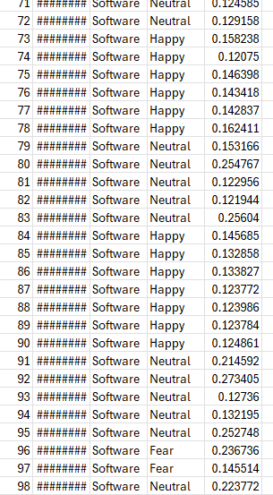
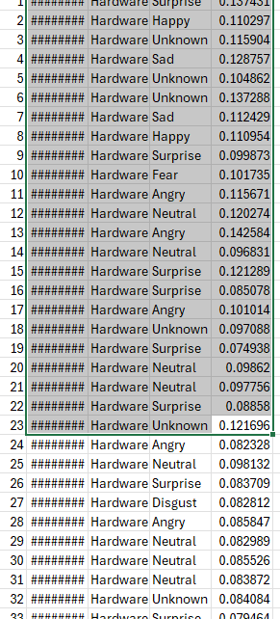
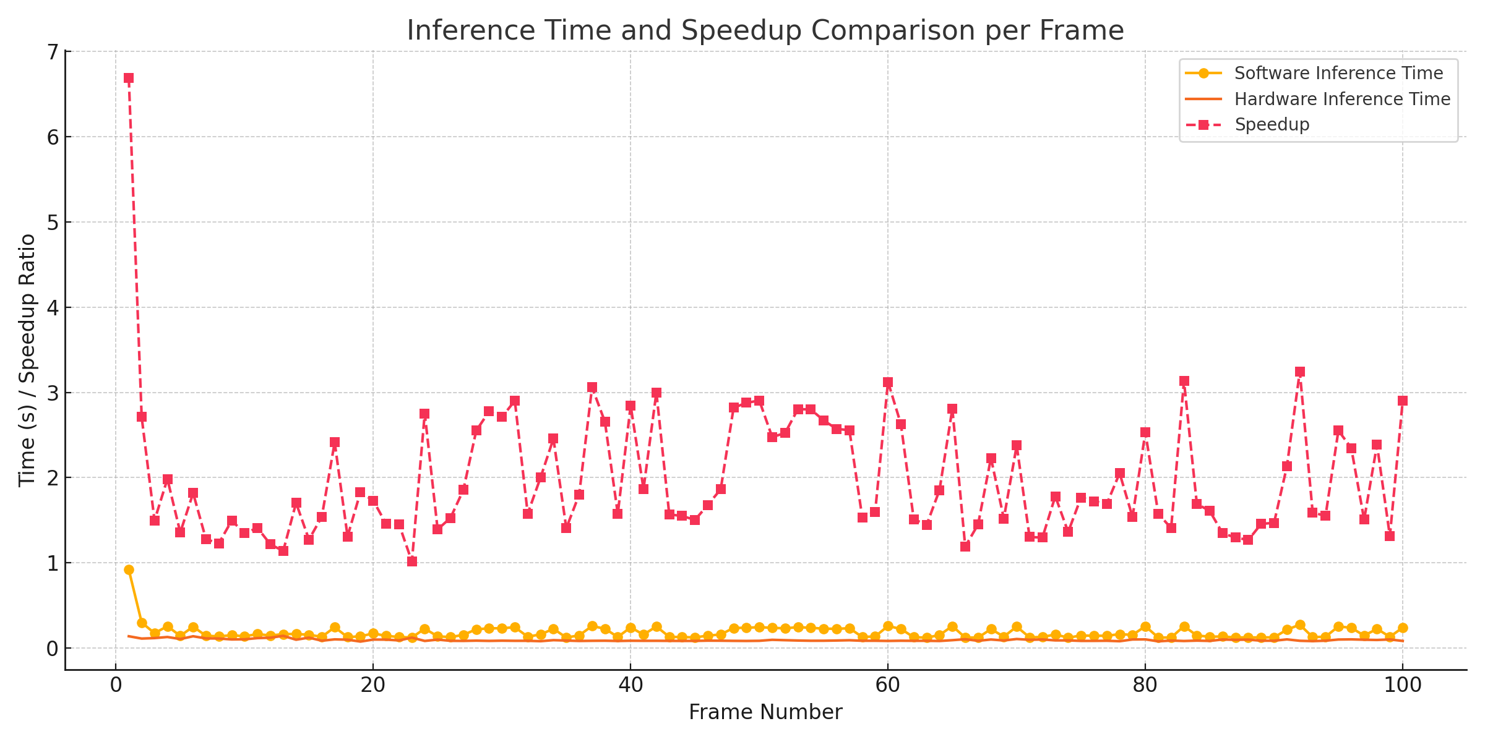

Weekly Challenges and Impact
The course's 10 weekly challenges and code fests were instrumental in developing the technical skills and critical thinking necessary for this project. Each challenge helped build a strong foundation in AI/ML hardware concepts and accelerated design flow. These challenges significantly shaped the direction and execution of this project, providing practical exposure that translated directly into the final deliverables.

Conclusion
This project effectively demonstrates a complete hardware/software co-design approach for accelerating AI workloads. By leveraging Verilator for simulation and OpenLane for synthesis, it offers a reproducible and scalable method for validating and benchmarking RTL accelerators in real-time systems. It showcases real-world acceleration potential, system integration, and an impactful learning journey in the field of AI hardware.

