**AMITHA S L**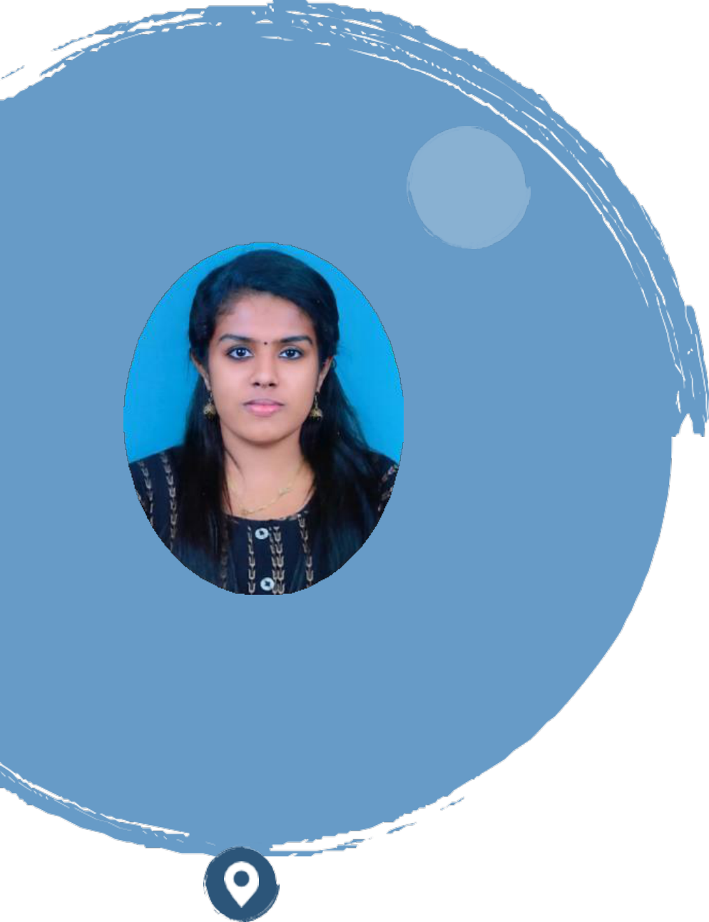

|  |  |  |  |
| --- | --- | --- | --- |
|  | ABHILASH BHAVAN IQBAL NAGAR 81,  VADAKKEVILA. P. O KOLLAM,691010 | Web developer with experience who is skilled in all phases of | |
| sophisticated web development. knowledgeable | about |
| testing, debugging, and user interfaces. bringing knowledge | |
| in testing, design, installation, and maintenance of web | |
| systems. Equipped with a diverse and promising skill-set. | |
| Proficient in an assortment of technologies, including Python, | |
| Django, HTML, CSS, JS, and Microsoft SQL Server. Able to | |
| work successfully in a team environment as well as manage | |
| oneself during independent initiatives. | |
| **Experience** | |
| **January 2021–Present**  Web Developer **•** Cyberia Softwares Pvt. Ltd | |
| ➢ Managed front-end and back-end development in the | |
| 9633887209 |
| company's Account Management, Portfolio Analysis, and | |
|  | amithasuresh.e@gmai l.com | Employee Tracking. | |
| ➢ Provided effective troubleshooting and remediation for | |
| web applications. | |
| **Software Skills** | ➢ Interfaced with clients to identify business requirements. | |
| ➢ Under the supervision, implemented and upgraded | |
| application modules | |

➢ Programming Languages: Python, C, C++   
➢ Framework: Django   
➢ Web Technologies: HTML, CSS, JS, JQuery, Ajax   
➢ Database: SQL   
➢ Computer Skill: MS Office

**Skills**

➢ Adaptability   
➢ Analytical Thinking Skills ➢ Communication Skills   
➢ Computer Skills   
➢ Decision Making   
➢ Microsoft Office

**Education**

**Graduation (2014-2018)**

TKM Institute Of Technology, KOLLAM, KERALA

B.Tech in Electronics And Communication

**Higher Secondary (2014)**

Navdeep Public School Kollam

**Project**

➢ Developed a diverse range of web applications and utilized

machine learning techniques to deliver innovative solutions,

leveraging Django, Flask, and other cutting-edge

technologies.

➢ Main Projects on Django: Hospital Management

|  |  |
| --- | --- |
| Languages Known➢ English  ➢ Malayalam  Certifications | ➢ Projects on Machine Learning: Credit Card Fraud Detection with Autoencoder, Web service composition using PSO-ACO  ➢ Mini projects: wholesale marketing, Hospital Management Sytems |

Successfully completed   
Internship on Python-   
Django   
(2020-2021) 

