**AMITHA S L**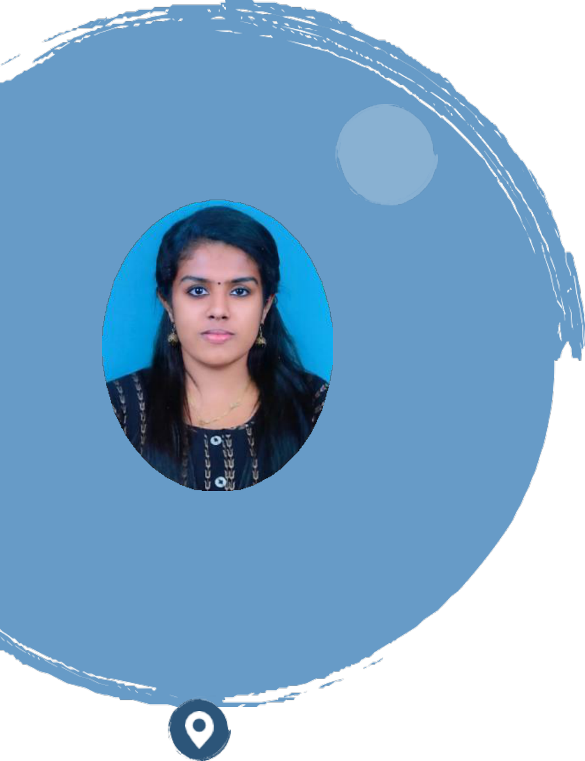

|  |  |
| --- | --- |
| Web developer with experience who is skilled in all phases of | |
| sophisticated web development. knowledgeable | about |
| testing, debugging, and user interfaces. bringing knowledge in testing, design, installation, and maintenance of web systems. Equipped with a diverse and promising skill-set. Proficient in an assortment of technologies, including Python, Django, HTML, CSS, JS, and Microsoft SQL Server. Able to work successfully in a team environment as well as manage oneself during independent initiatives. | |

|  |  |
| --- | --- |
|  | ABHILASH BHAVAN IQBAL NAGAR 81,  VADAKKEVILA. P. O KOLLAM,691010  9633887209  amithasuresh.e@gmai l.com |

**Software**   
**Skills**

➢ Programming Languages: Python, C, C++   
➢ Framework: Django   
➢ Web Technologies: HTML, CSS, JS, JQuery, Ajax   
➢ Database: SQL   
➢ Computer Skill: MS Office

**Skills**

➢ Adaptability   
➢ Analytical Thinking Skills ➢ Communication Skills   
➢ Computer Skills   
➢ Decision Making   
➢ Microsoft Office

**Experience**

**January 2021–Present**   
Web Developer **•** Cyberia Softwares Pvt. Ltd

➢ Developed and maintained web applications using Django framework, ensuring high-performance and scalability.

➢ Collaborated with cross-functional teams to gather project requirements and translate them into technical specifications.

➢ Implemented responsive web designs using HTML, CSS, and JavaScript, ensuring optimal user experience across multiple devices.

➢ Integrated various APIs and third-party services to enhance functionality and improve data retrieval.

➢ Implemented data models, database queries, and complex SQL operations to efficiently manage large datasets.

➢ Conducted code reviews and performed thorough testing to ensure code quality, usability, and security. ➢ Implemented machine learning models using Python libraries such as Scikit-learn and TensorFlow to solve complex problems.

➢ Deployed web applications to cloud platforms such as Heroku and AWS, ensuring seamless deployment and monitoring.

➢ Actively participated in Agile development methodologies, including daily stand-ups, sprint planning, and retrospectives.

|  |  |
| --- | --- |
| Languages Known  ➢ English  ➢ Malayalam  Certifications  Successfully completed Internship on Python- Django  (2020-2021) | **Education** ➢**Graduation (2014-2018)**  TKM Institute Of Technology, KOLLAM, KERALA B.Tech in Electronics And Communication  ➢**Higher Secondary (2014)**  Navdeep Public School Kollam  **Project** ➢ Developed a diverse range of web applications and utilized machine learning techniques to deliver innovative solutions, leveraging Django, Flask, and other cutting- edge technologies. |

➢ Main Projects on Django: Hospital Management

➢ Projects on Machine Learning: Credit Card Fraud   
Detection with Autoencoder, Web service composition   
using PSO-ACO

➢ Mini projects: wholesale marketing, Hospital   
 Management Sytems

**Declaration**

I hereby declare that all the information provided above is true to the best of my knowledge and belief. I understand that any misrepresentation or falsification of information may result in disqualification from opportunities or employment.

