# 

# **3- NOISE MODELS AND DENOISING FILTERS**

## **3.1 Noise Models**

Mammography is a technology that used to aid in the diagnosis of breast diseases in women at early stages. Noise is an inevitable parameter that must be considered while analysing the medical images. Like any other image acquisition model mammogram also affected with noise. It is a challengeable task for researchers to identify the noise and remove those noise without losing fine details in the mammogram. The main noises that affect the mammogram images are salt and pepper, gaussian, speckle and poisson noise. In early days, noises in the mammogram images are denoised using linear filters. The main problem of linear filtering is that it produces blurring effect and incomplete noise filtration while denoising[52]. Noise may be classified as substitutive noise (impulsive noise:salt and pepper noise,random valued impulse noise,etc.) and additive noise (e.g.additive white Gaussian noise).[53][54]

### **3.1.1 Salt And Pepper Noise**

Salt and pepper noise can corrupt images where the corrupted pixel takes either maximum or minimum gray level value; leading to severe degradation of image quality and loss of fine details. The objective of noise suppression in such corrupted images is to filter the impulses (specks of salt and pepper) so that the noise free image is fully restored with minimum signal distortion. The main reason behind the appearance of salt and pepper noise are sharp and sudden changes of image signal and dust particles in the image acquisition source[55]. Mammogram images affected by salt and pepper noise on various densities shown in figure

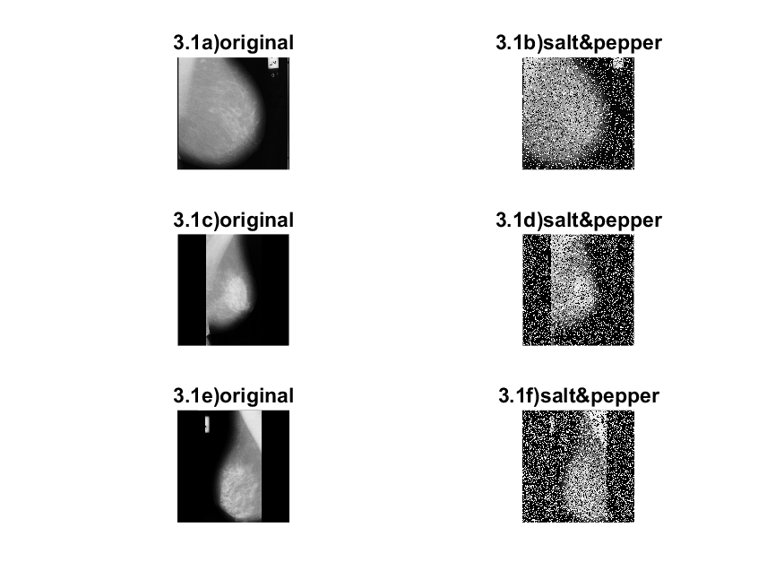

Fig.3.1. Original mammogram image and its Salt and pepper noise affected image

### **3.1.2 Gaussian Noise**

Gaussian noise model follow Gaussian distribution in which each pixel in the noisy image is the sum of the random Gaussian distributed noise value and the true pixel value. The noise is mainly due to electronic circuit noise and sensor noise [53][55]. This type of noise has a Gaussian distribution, which has a bell shaped probability distribution function given by 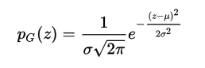

Where, $z$ represents the Gaussian random variable, *μ* is the mean of $z$ and *σ* is the standard deviation of $z$.

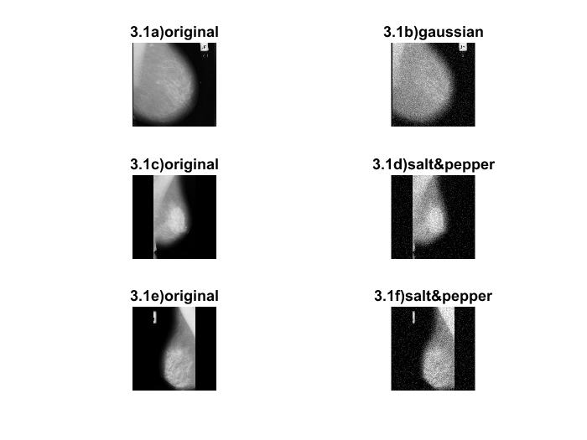

Fig.3.2. Original mammogram image and its Gaussian noise affected image

**3.2 Denoising Filters**

Image denoising is the manipulation of the image data to produce a visually high quality image. It is essential where degradation of image quality affects further analysis of images. Also there is a chance for loss or damage of information related to image data. Images are often corrupted by noise due to errors generated in noisy sensors or communication channels. So it is important to eliminate noise in the images before some subsequent processing, such as edge detection, image segmentation and object recognition. It is important to restore the image from noises for acquiring maximum information from images. For this purpose, several denoising filters are available. Among them median-based filters have attracted much attention because of their simplicity and capability of preserving image edges[56].

**3.2.1. Median filter**

Median filter is a nonlinear method in which each pixel replaced by median value of its nearby neighbors. Median filter uses a sampling window of size 3X3,5X5 or 7X7 to perform filtering. The pattern of neighbors is called the "window", which slides, pixel by pixel over the entire image. The median is calculated by first sorting all the pixel values from the window into numerical order, and then replacing the pixel being considered with the middle (median) pixel value[57]. A median filter is a nonlinear filter which is efficient in removing salt and pepper noise. Median filter tends to keep the sharpness of image edges while removing noise. The different types of median filters are, Centre-weighted median filter, Weighted median filter, Max median filter. Median is widely used as very effective method for removing noise while preserving edges. It is particularly effective in removing ‘salt and pepper’ type noise[57]. The median value of sampling window used to replace the pixel studied. This filter is given by,

$y[m,n]=median\{x[i,i],(i,j)∈w$**------(3.2)**

Where w represent neighbourhood defined by user centered around location [m,n] in the image. The working of median filter using sampling window of size 3x3 is shown in figure 3.3.

|  |  |  |  |  |
| --- | --- | --- | --- | --- |
| 123 | 125 | 126 | 130 | 140 |
| 122 | 124 | 126 | 127 | 135 |
| 118 | 120 | 150 | 125 | 134 |
| 119 | 115 | 119 | 123 | 133 |
| 111 | 116 | 110 | 120 | 13O |

**Figure 3.3 : Working of Median Filter**

|  |  |  |  |  |  |  |  |  |
| --- | --- | --- | --- | --- | --- | --- | --- | --- |
| **115** | **119** | **120** | **123** | **124** | **125** | **126** | **127** | **150** |

**Median value is 124**

Median filter is a useful nonlinear image smoothing and enhancement technique. It possess some disadvantages. Standard median filters tend to modify both noisy and noise-free pixels during filtering. Consequently, effective removal of salt and pepper noise causes blurring and distorted features in the restored image. The median filter can't distinguish fine detail from noise.

**3.2.2 Progressive Switching Median Filter**

Median filters are implemented uniformly across the image, they tend to modify both noise pixels and unaffected pixels. To avoid the damage of good pixels, the switching scheme is introduced by some recently published works[58], in which impulse detection algorithms are employed before filtering. The detection results are used to control whether a pixel should be modified.

A new median-based filter, Progressive Switching Median (PSM) filter, is proposed to restore images corrupted by salt–pepper impulse noise. The algorithm is developed by the following two main points: 1) switching scheme—an impulse detection algorithm is used before filtering, thus only a proportion of all the pixels will be filtered and 2) progressive methods—both the impulse detection and the noise filtering procedures are progressively applied through several iterations. The impulse detector and the noise filter are applied progressively in iterative manners. The noise pixels processed in the current iteration are used to help the process of the other pixels in the subsequent iterations.

A main advantage of such a method is that some impulse pixels located in the middle of large noise blotches can also be properly detected and filtered. Therefore, better restoration results are expected, especially for the cases where the images are highly corrupted. 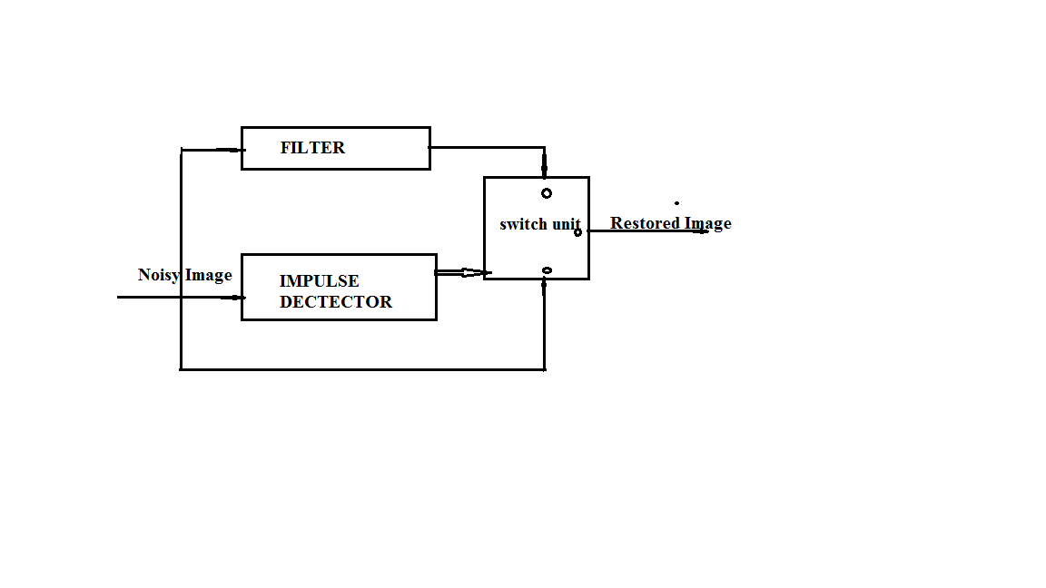 **Figure 3.4 working of progressive switched median filter(psmf)**

#### **3.2.2.1 Impulse detection**

Two image sequences are generated during the impulse detection procedure. The first is a sequence of grayscale images,

**{{** X**i (0) },{** X**i (1) },......{** X**i (n) },............},**

wherethe initial image **{** X**i (0) }** is the noisy image to be detected, x i(0) denotes the pixel value at position i = (i1; i2) in the initial noisy image and **{** X**i (n) }** represents the pixel value at position i in the image after the nth iteration.

The second is a binary flag image sequence, **{{fi(0) }, {fi(1)} , _ _ _ ,{fi(n)},…}**, where the binary value **fi(n)** is used to indicate whether the pixel *i* has been detected as an impulse, i.e. **fi(n)** =0 means the pixel i is good and **fi(n)**= 1 means it has been found to be an impulse. Before the first iteration, all the image pixels are considered as good, i.e. fi(0) =0[58]. In the nth iteration the median value of the sample window W for each pixel X**i (n-1)** calculated. The term **Ωiw** to represent the set of the pixels within a window centered about i.

Ωiw= {j=(j1,j2)|i1 - (w-1)/2≤ j1 ≤ i1 +(w-1)/2, i2 -(W-1)/2 ≤ j2 ≤ i2+(W-1)/2}.......(3.3)

Then ***mi(n-1)= Med*{*xj(n-1)*| j $ϵ$*Ωi* WD} ………………**.(3.4)

The difference between mi(n-1) and xi(n-1) provides measurement to detect impulses.

*Fi(n)*={

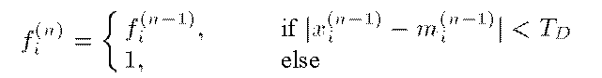

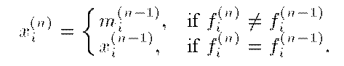

#### **3.2.2.2 Noise Filtering**

Like the impulse detection procedure, the noise filtering procedure also generates a grey scale image sequence,{{yi(0) },{ yi(1)}, …{yi(n) }….}, and a binary flag image sequence {{gi(0) }, {gi(1) }…, {gi(n) }….}. In the gray scale image sequence, we still use yi(0) to denote the pixel value at position ii in the noisy image to be filtered and use yi(n) to represent the pixel value at position i in the image after the nth iteration. Ina binary flag image { gi(n) } , the value gi(n)= 0 means the pixel i is good and g(n) i = 1 means it is an impulse that should be filtered. A difference between the impulse detection and noise-filtering procedures is that the initial flag image {gi(0)} of the noise-filtering procedure is not a blank image, but the impulse detection result {fi(N D) }, i.e gi(0)= fi(ND)  [58].

In the nth iteration for each pixel yi(n-1) , median value mi(n-1) is calculated window centered about it. However,unlike that in the impulse detection procedure, the median value here is selected from only good pixels with gj(n-1)=0 in the window.Let M denote the number of all the pixels with gj(n-1)=0 in the window. If M is odd, then



If M is even but not 0, then

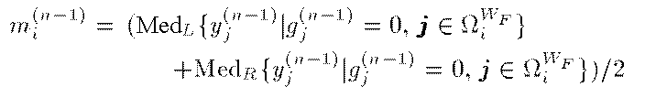

where MedL and MedR denote the left and the right median values,respectively. That is, MedL is the (M/2)th largest value and MedR is the (M/2+1)th largest value of the sorted data. The value of yi(n) is modified only when the pixel i is an impulse and M is greater than 0:

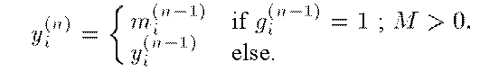

Once an impulse pixel is modified, it is considered as a good pixel in the subsequent iterations,

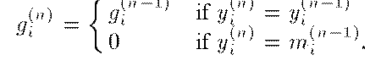

The procedure stops after the NF th iteration when all of the impulse pixels have been modified, i.e.,

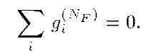

The output image obtained is{*Yi(NF)*}

### **3.2.3 Noise Adaptive Fuzzy Switching Median Filter Reduction (NAFSM)**

The NAFSM filter is a recursive double-stage filter, where initially it will perform the salt-and-pepper noise intensities detection before identifying the locations of possible noise pixels. When a “noise pixel” is detected, it is subjected to the next filtering stage. Otherwise, when a pixel is classified as “noise-free,” it will be retained and the filtering action is spared to avoid altering any fine details and textures that are contained in the original image.

#### **3.2.3.1 Detection Stage**

The NAFSM filter will utilize the noisy image histogram to estimate the two salt-and-pepper noise intensities. Based on the assumption that an image corrupted with salt-and-pepper noise will produce two peaks at the noisy image histogram [59], the detection stage begins by searching for these two peak intensities. However, this assumption does not always hold true, especially when an image is corrupted with extremely low-density of salt-and-pepper noise. In this case, other noise free intensities will peak in the noisy image histogram instead of the salt-and-pepper noise intensities. As a result, when the noise intensities are wrongly detected, the salt-and-pepper noise will be left unfiltered in the noisy image.

As to overcome this problem, the local maximum, which is the first peak encountered when traversing the image histogram in a particular direction, is used . Therefore, the detection algorithm of the NAFSM filter will search for the two local maximums, and , representing the two salt and-pepper noise intensities starting from both ends of the noisy image histogram. The search is directional sensitive and will be directed towards the center of the histogram. When both local maximums are found, the search will be halted immediately [59].

These two salt-and-pepper noise intensities will be used to identify possible “noise pixels” in the image. A binary noise mask N (i, j) will be created to mark the location of “noise pixels” by using

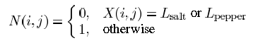

Where X(i, j) is the pixel at location (i, j)with intensity X, N(i, j)=1,represents “noise-free pixels” to be retained from the noisy image while N(i, j)=0 represents “noise pixels” subjected to the next filtering stage.

#### **3.2.3.2 Filtering Stage**

After the binary noise mask N(i, j) is created, “noise pixels” marked with N(i, j)=0 will be replaced by an estimated correction term. The proposed NAFSM filter uses a square filtering window W2s+1(i,j) with odd dimensions, (2s+1)x(2s+1) given as

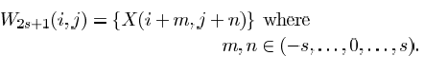

Then the number of noisy pixel is counted using,

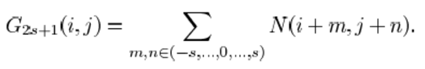

If the current filtering window does not have minimum one noise free pixel, then filtering window get expanded. This procedure repeated until count of noise free pixel is greater than one.

For each detected noise pixels window size set as 3. THen median is calculated using,



Detection of “noise pixels” is based on the detected salt-and-pepper noise intensities L salt and L pepper  , noise-free pixels may be falsely identified as “noise pixels” at image uniform regions having same intensities as or . Consequently, the filtering window will be expanded continuously and the selected median pixel may be inappropriate to be used as a correction term. So the first four pixels in the 3X 3 filtering window defined by



It is used to compute the median pixel,

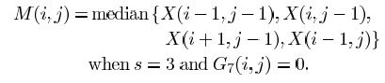

After the median pixel is found, the local information in window is extracted by first computing the absolute luminance difference as given by

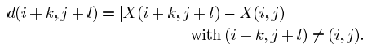

Then, the local information is defined as the maximum absolute luminance difference in the 3X 3 filtering window



As part of the filtering mechanism in the NAFSM filter, fuzzy reasoning is applied to the extracted local information D(i,j). The fuzzy by the fuzzy membership function F(i,j) is defined as,

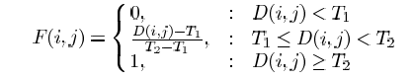

Finally, the correction term to restore a detected “noise pixel” is a linear combination between the processing pixel and median pixel. The restoration term Y(i, j)is given here as,



## **3.3 Performance metrics**

## To evaluate the performance of the proposed algorithm we have used the Peak Signal to Noise Ratio (PSNR) , Feature Similarity(FSIM), the Structural Similarity (SSIM) measure and image quality index(IQI)[60][61. These are widely used objective measures for evaluating the performance of image denoising algorithms.

### **3.3.1 Peak Signal to Noise Ratio**

The peak signal to noise ratio (PSNR) represents the ratio between the maximum powers of a signal to the noise which degrades the original image. This measure is based on the Mean Squared Error (MSE) which assesses the difference between the original image data and the degraded image data[60]. Given the original image data $u_{ij}$ and the degraded image data $v_{ij}$ of size *M×N*, MSE is defined as,

$MSE= \frac{1}{MXN}\sum_{i=0}^{M}{}\sum_{j=0}^{N}{}{(u_{ij}-v_{ij})}^{2}$ (1)

$PSNR=10\log_{10 }\{\frac{{MAX}^{2}}{MSE}\}$ (2)

Where *MAX* is the maximum possible pixel intensity value. High PSNR value indicates a better reconstruction or de-noising.

### **3.3.2 Feature Similarity Index Meassurement**

Human visual system (HVS) understands an image mainly according to its low-level features. Specifically, the phase congruency (PC), which is a dimensionless measure of the significance of a local structure, is used as the primary feature in FSIM. Considering that PC is contrast invariant while the contrast information does affect HVS’ perception of image quality, the image gradient magnitude (GM) is employed as the secondary feature in FSIM. PC and GM play complementary roles in characterizing the image local quality. After obtaining the local quality map, PC again as a weighting function to derive a single quality score.

The computation of FSIM index consists of two stages. In the first stage, the local similarity map is computed, and then in the second stage, we pool the similarity map into a single similarity score. We separate the feature similarity measurement between *f*1(**x**) and *f*2(**x**) into two components, each for PC or GM. First, the similarity measure for *PC*1(**x**) and *PC*2(**x**) is defined as,

http://sse.tongji.edu.cn/linzhang/IQA/FSIM/FSIM.files/image002.gif

where T1 is a positive constant to increase the stability of *SPC*. Similarly, the GM values *G*1(**x**) and *G*2(**x**) are compared and the similarity measure is defined as

http://sse.tongji.edu.cn/linzhang/IQA/FSIM/FSIM.files/image004.gif

where *T*2 is a positive constant depending on the dynamic range of GM values. In our experiments, both *T*1and *T*2 will be fixed to all databases so that the proposed FSIM can be conveniently used[60][61]. Then, *SPC*(**x**) and *SG*(**x**) are combined to get the similarity *SL*(**x**) of *f*1(**x**) and *f*2(**x**). We define *SL*(**x**) as *SL*(**x**) = S*PC*(**x**)·S*G*(**x**).

### **3.3.3 Structural Similarity Index**

The structural similarity index is used to find similarity between two images. Similar pixels have strong inter-dependencies when they are closer. The following equation measures SSIM

$SSIM= \frac{(2μ_{x}μ_{y}+c_{1})(2σ_{xy}+c_{2})}{(μ_{x}^{2}μ_{y}^{2}+c_{1})(σ_{x}^{2}σ_{y}^{2}+c_{2})}$

Where, *x* and *y* are two windows of identical size. In this equation *μ*𝑥 and *μ*𝑦 are the average of *x* and *y*, 𝜎𝑥2 and 𝜎𝑦2 are the variance of *x* and *y* and 𝜎𝑥𝑦 is the co-variance. 𝑐1 = (𝑘1𝐿)2 and 𝑐2 = (𝑘2𝐿)2, 𝑘1 ≪ 1 , 𝑘2 ≪ 1 and *L* is the dynamic range of pixel values[60][61].

### **3.3.4 Image Quality Index**

IQI breaks the comparison between original and distorted image into three omparisons: luminance, contrast, and structural comparisons. x = { xi, i= 1, 2, …….., N} original image , y = {yi, i= 1,2,………..,N} Reconstructed or corrupted image [60][61]. The proposed quality index is defined as:

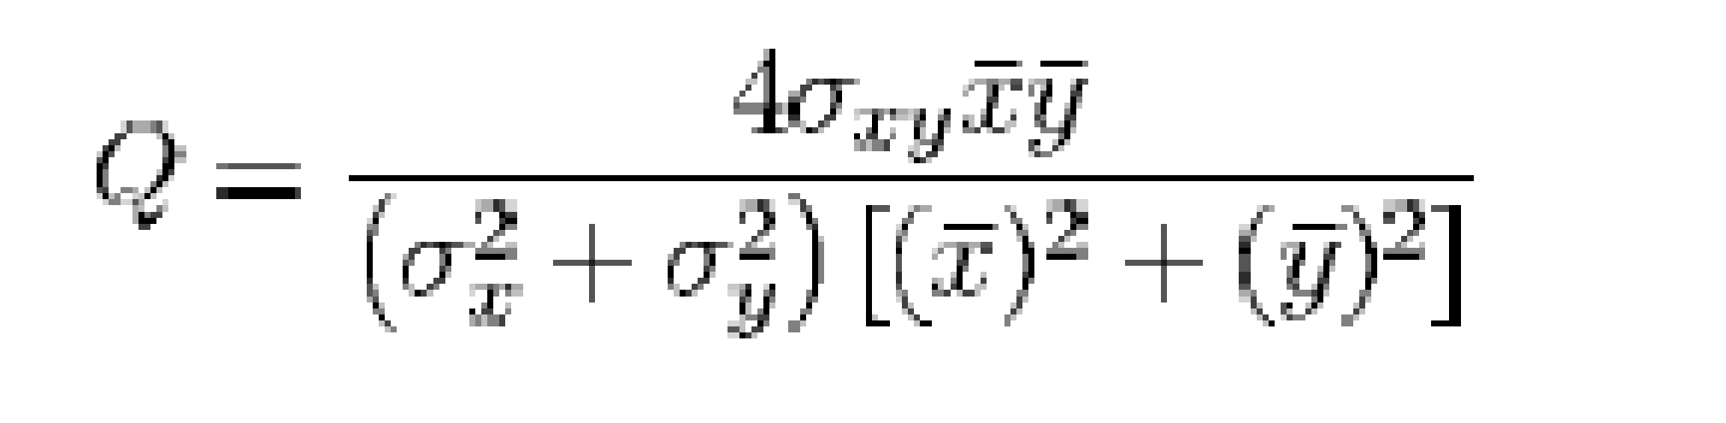

Where

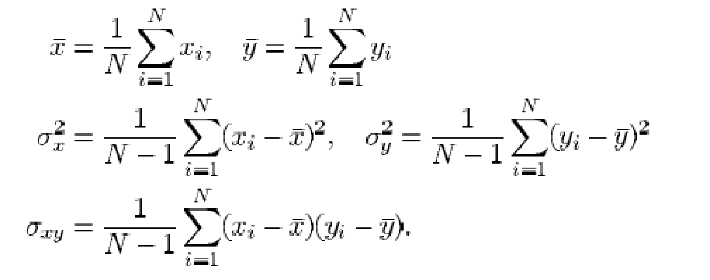

## **3.4 Result and discussion**

We have used mammogram images for our test purpose. The original MIAS Database (digitised at 50 micron pixel edge) has been reduced to 200 micron pixel edge and clipped/padded so that every image is 1024 × 1024 pixels.Figure 3.5 shows the test images. These standard images are initially noise free. They are applied with salt and pepper noise for testing purpose.

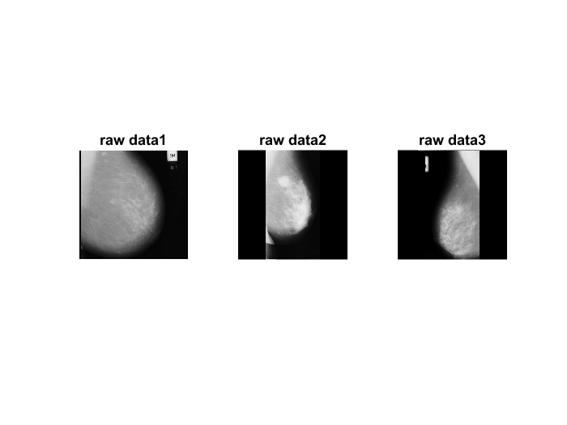

Fig 3.5 Mammogram images from MIAS database.

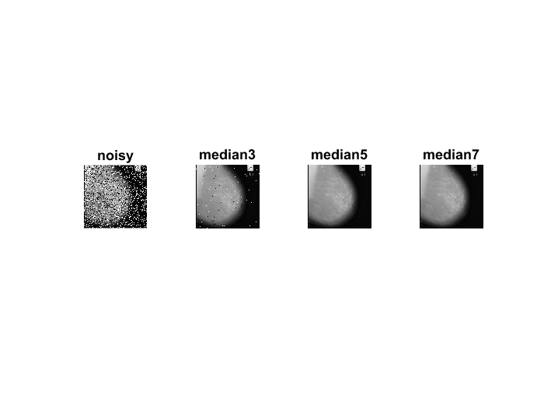

**Figure 3.6;median filters on salt and pepper noise density 30%**

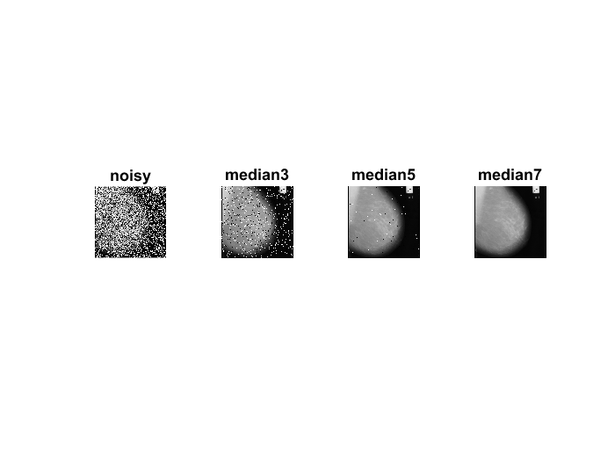

**Figure 3.7:median filters on salt and pepper noise density 50%**

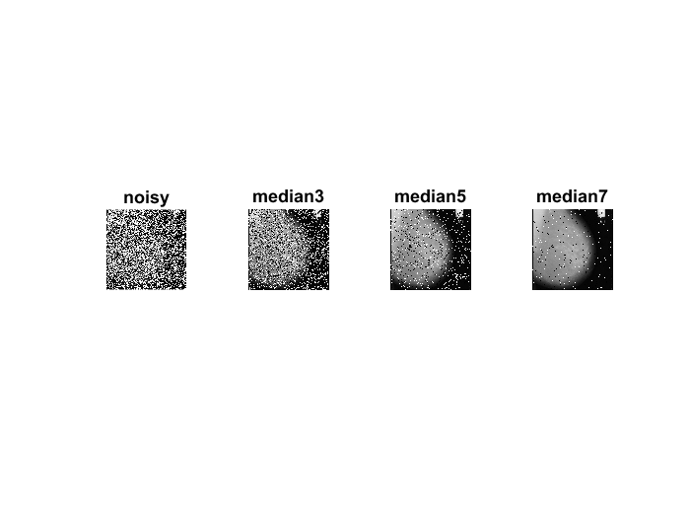

**Figure 3.8:median filters on salt and pepper 70%**

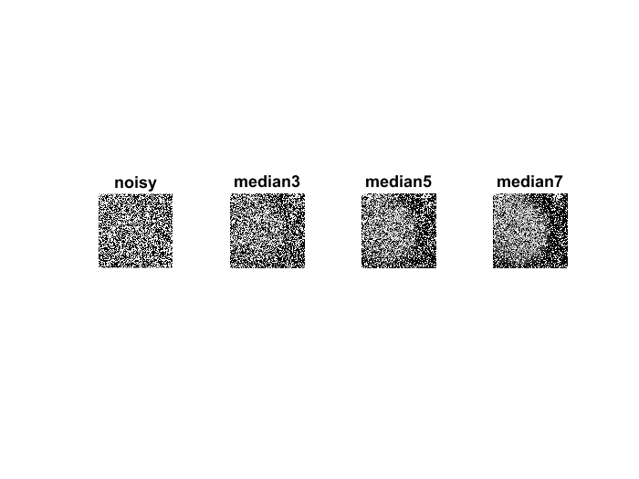

**Figure 3.9:median filters on salt and pepper noise density 90%.** 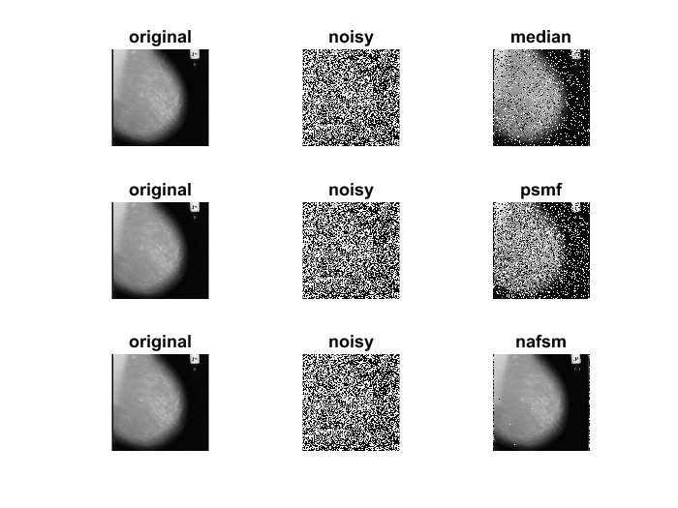

**Figure 3.10: median ,psmf and nafsm at noise density 70%**

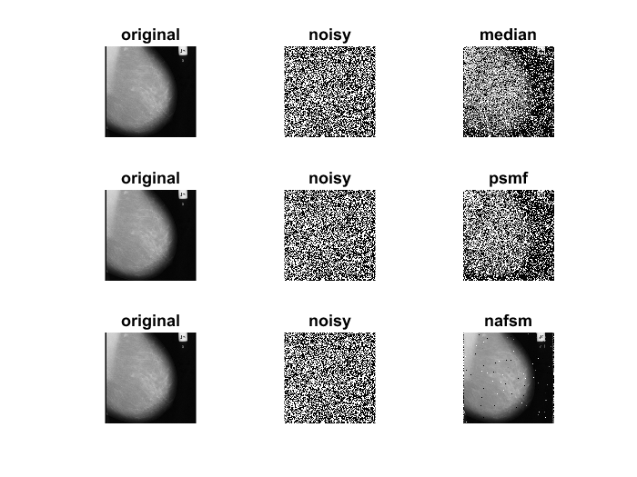

**Figure 3.11: median ,psmf and nafsm at noise density 90%**

### 

### 

### 

### 

### 

### 

### **3.4.1 Tables**

|  |  |  |  |  |  |  |
| --- | --- | --- | --- | --- | --- | --- |
| Noise Density | Filters | Meassures | | | | |
|
| 30% | MEDIAN |  | PSNR | SSIM | IQI | FSIM |
| median3 | 43.8609 | 0.7489 | 0.8196 | 0.907 |
| median 5 | 44.85 | 0.9591 | 0.778 | 0.9964 |
| median 7 | 43.801 | 0.9524 | 0.7677 | 0.9934 |
| PSMF | |  |  |  |  |
| NAFSM | |  |  |  |  |
| 50% | MEDIAN |  | PSNR | SSIM | IQI | FSIM |
| median3 | 43.7883 | 0.7506 | 0.8191 | 0.9069 |
| median 5 | 44.8208 | 0.9588 | 0.7753 | 0.9963 |
| median 7 | 43.8024 | 0.9524 | 0.7577 | 0.9934 |
| PSMF | |  |  |  |  |
| NAFSM | |  |  |  |  |
| 70% | MEDIAN |  | PSNR | SSIM | IQI | FSIM |
| median3 | 32.6716 | 0.0245 | 0.6969 | 0.3005 |
| median 5 | 36.3123 | 0.2429 | 0.7595 | 0.46 |
| median 7 | 39.4951 | 0.6662 | 0.7424 | 0.751 |
| PSMF | | 33.9245 | 0.2681 | 0.7372 | 0.6099 |
| NAFSM | |  |  |  |  |
| 90% | MEDIAN |  | PSNR | SSIM | IQI | FSIM |
| median3 |  |  |  |  |
| median 5 |  |  |  |  |
| median 7 | 31.1303 | 0.0401 | 0.6369 | 0.1843 |
| PSMF | | 29.4212 | 0.015 | 0.635 | 0.171 |
| NAFSM | | 42.3497 | 0.8158 | 0.7761 | 0.9113 |

By analyzing the table above it can see that median 7X7 filter perform better than progressive switched median filter (psmf).So a noise density of upto 50% median 7X7 filter gives better restored image .The comparison measures of median are psnr= 43.0478 ,ssim= 0.9413 , iqi=0.7571 fsim=0.9882 where as that of psmf is psnr= 37.5786 , ssim= 0.6498, iqi=0.7290 and fsim=0.9394 which shows that psmf is not suitable for high noise density.