CAP 4601 Project 2: Wumpus World
Alexander Bachmann and Joshua LaRocca

Background:

Wumpus World is the representation of a simple world where an explorer searches a dark, dangerous cave in search for a bounty of gold. In this cave, there are two threats to the explorer’s life: falling in bottomless pits and being slain by the Wumpus. The explorer’s goal is to find the gold then exit safely by backtracking through the cave. Typically, the cave is represented by a 4×4 grid or 16 rooms. Each room will have indicators that can be detected by the explorer. If the explorer smells a stench that means that Wumpus may be in an adjacent tile. If the explorer feels a breeze that means that a bottomless pit may be in an adjacent tile. If the agent sees glitter that means that there is gold in the current room and upon retrieval of the gold, the explorer is allowed to leave the cave. While exploring the cave, the explorer gathers knowledge and acts according to the gathered knowledge; this type of behavior makes the explorer a knowledge-based agent.

The following frames will be used to explain the agent’s ability to gather knowledge from its sensors, store that knowledge, then make predictions about the locations of threats throughout the cave.

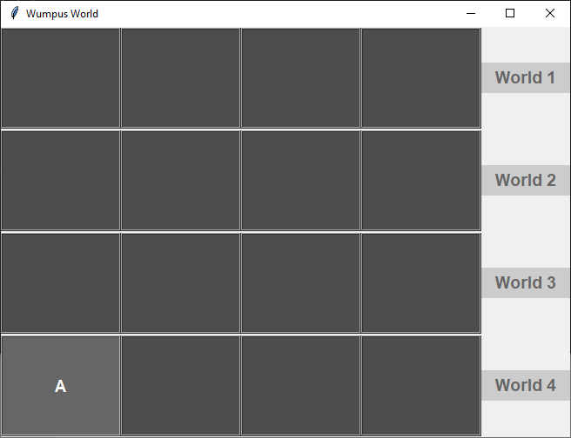
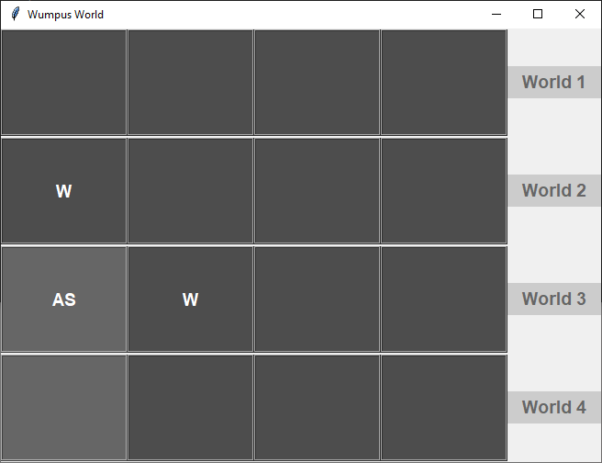

In the first frame, we see that the agent, represented by ‘A’, enters the cave from the bottom left [3, 0]. Upon entering the cave, the agent does not perceive any threat indicators. In the second frame, we see that the agent smelled a stench [2, 0], represented by ‘S’, indicating that the Wumpus is in an adjacent tile [1, 0] & [2, 1]. From this indicator, the agent predicts all potential locations of the Wumpus and stores that information in its knowledge base.

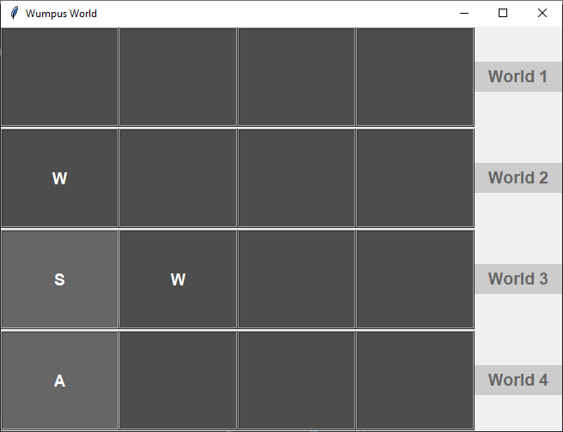
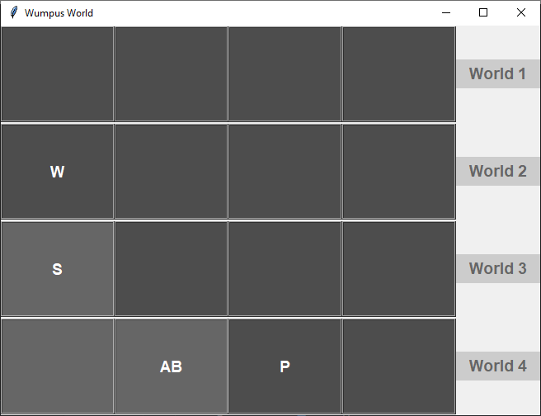

In the third frame, we see that the agent was forced to backtrack [3, 0] because there was no perceptibly safe move given its current knowledge base. In the fourth frame, we see that the agent traveled one tile to the right [3, 1]. In this tile, the agent sensed a breeze indicating that a pit could only be in [3, 2] because a breeze was not sensed when the agent visited [2, 0] in frame 2. In frame 4, we also see that the agent further updated its knowledge of the cave by removing its prediction of there being a Wumpus in [2, 1]; the agent was able to remove this prediction because it did not smell a stench in its newly visited tile (all indicators must be adjacent to the possible threat).

Methods and Algorithms:

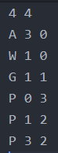
Our program begins by reading and parsing a text file. The text file is a representation of the world for the agent to solve. The file begins by specifying the dimensions of the cave followed by the starting coordinates of the agent which must be followed by the location of the Wumpus, gold, and all of the pits. To the side of this paragraph is the text file for populating ‘World 1’.
Upon initialization of a world, a three-dimensional Python list is populated using the coordinates provided from the world generation text file. After the agent, gold, Wumpus, and pits are populated, their respective indicators are generated. We chose to generate breezes and stenches for our users because otherwise creating new world text files would feel very cumbersome.

Below: before and after indicators are generated (breezes and stenches)
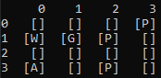
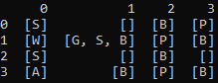

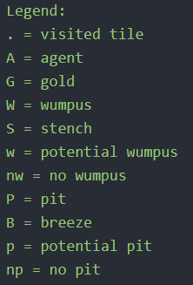
At the beginning of the agent’s exploration, it knows nothing of the cave other than the dimensions of the cave. As the agent explores the cave, it senses and updates its knowledge and threat predictions based on that knowledge. Wumpus must have a stench in all adjacent rooms and a pit must have a breeze in all adjacent rooms. If either of these requirements are broken, then the agent can confirm its prediction was mistaken and update its knowledge accordingly. Below are screenshots representing how the agent stores its understanding of the world in its knowledge base
(3D Python list) and the legend that the agent uses to update its knowledge base
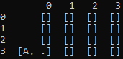
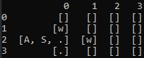

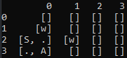
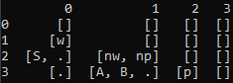

(These 4 screenshots are exact representations of the first 4 frames at the beginning of the report.)

**waiting 1.5 seconds**

Agent Behavior:

Bread crumb exiting:
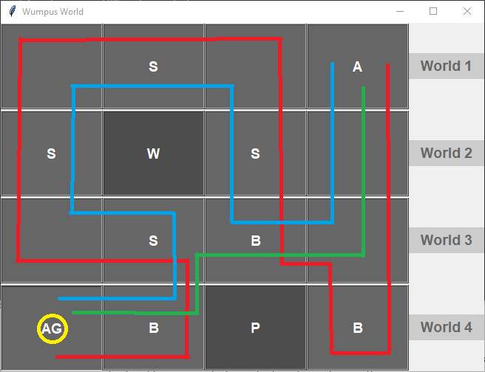

Above is a screenshot detailing the agents movement through World 4. The agent enters the cave from the top right of the matrix and explores the cave down to the bottom left of the matrix. The agents exploration for the gold is indicated by the red line. Upon retrieval of the gold, the agent backtracks through the cave, indicated by the blue line.
This backtracking is inefficient in terms of number of steps taken. We are aware of this and still decided to go with a breadcrumb approach for the agent to return safely to the exit. This decision is predicated on the reasoning that a real human would much more likely return out of a dark cave by using a breadcrumb approach. Even if a new path has been revealed as being safe, indicated by the green line, a human is far more likely to take a slightly inefficient route because the most recent route is more solidified in our memory.

Free Exploration:
the agent is not governed by the standard point system. did not integrate the standard performance measures because our agent always solves the world given that a world is solvable.

Pacifistic:
no arrow shooting

We wanted our agent to be more representative of a free, pacifistic human explorer – like a Buddhist Indiana Jones.

We created four different world generation text files. Each text file is unique and will be simulated by clicking on the appropriate button on the right side of the interface.

report provides detailed background, discussion of methods, results, and conclusions

- methods and algorithms used to solve the problem
approach:

- results (in your case that could be a discussion of different worlds given and the outcome)

- conclusions

report provides detailed background, discussion of methods, results, and conclusions

