

# ABSTRACT

The main aim of the project is to design and development of a Smart shopping trolly using Arduino. A line follower robot is an autonomous vehicle capable of detecting and following a predefined path, usually marked as a black or white line on a contrasting surface.

The system integrates sensors, an Arduino microcontroller, and motor control modules to achieve precise navigation. Infrared (IR) sensors are employed to detect the path by identifying the contrast between the line and the background. The Arduino processes sensor inputs and adjusts the robot's movements by controlling the motors through a motor driver module.

The robot is programmed to respond dynamically to curves, intersections, and varying speeds along the path. This project demonstrates the integration of hardware and software to develop a low cost, efficient, and scalable solution for automation applications, including warehouse logistics, industrial transportation, and educational robotics. The modular design also allows for future enhancements such as obstacle avoidance, wireless control, and adaptive navigation.



# CONTENTS

## CHAPTER 1: INTRODUCTION Page No

* 1. Introduction 1
  2. Objectives 1
  3. Literature survey 2
  4. Problem statement 3
  5. Proposed system 3

CHAPTER 2: SYSTEM DESIGN

* 1. Block diagram 4
  2. Components 5-10
  3. Circuit diagram 11
  4. Flowchart 12-13

CHAPTER 3: RESULT

Snapshots 14

Conclusion 15

Advantages 16

Applications 17

Disadvantages 18

Future Scope 19

Reference 20



**CHAPTER 1: INTRODUCTION**

### INTRODUCTION:

In recent years, automation and robotics have played a significant role in enhancing human convenience and productivity. The concept of a human-following robot for a smart shopping trolley integrates robotics with consumer needs to create a seamless shopping experience. This system aims to reduce the burden of carrying shopping items and provides an efficient, hands-free experience for users in supermarkets and retail environments. Shopping malls are one of the most popular places for leisure activities, shopping, and entertainment, which attract a large number of people every day. With the increasing popularity of online shopping, brick-and-mortar stores have faced challenges to retain customers. As a result, shopping malls have been looking for innovative ways to provide a more personalized shopping experience to attract and retain customers. One such solution is smart human following shopping trolleys.

Smart human following shopping trolleys are designed to follow customers automatically, eliminating the need for them to push the cart manually. This technology offers convenience and ease for shoppers, allowing them to focus on shopping and enjoying their experience. The smart trolley is equipped with various sensors and cameras that can detect the customer's location and follow them while they shop**.**

Furthermore, smart human following shopping trolleys offer a more efficient shopping experience. Customers can quickly find the products they want, place them in their trolley, and move on to the next item without the need to keep track of their trolley. This means that customers can shop more efficiently, saving time and reducing the stress associated with shopping.

### OBJECTIVES:

To design and implement a human-following robot for smart shopping. To enhance the shopping experience by minimizing manual effort.

To ensure safety and reliability through obstacle detection and avoidance mechanisms.

* + 1. Improve Shopping Experience: Enhance customer satisfaction by providing a seamless and efficient shopping experience.
    2. Increase Operational Efficiency: Automate tasks, reduce labor costs, and optimize store operations.
    3. Enhance Inventory Management: Accurately track inventory levels, detect stockouts, and automate reordering.
    4. Convenience: The robot should effortlessly follow the shopper, eliminating the need to manually push the trolley.



* + 1. Reduced Physical Effort: This is especially beneficial for elderly shoppers or those with physical limitations.
    2. Integration with Existing Systems: Seamlessly integrate with existing store systems, such as POS, inventory management, and loyalty programs.
    3. Scalability and Flexibility: Design the system to accommodate varying store sizes, layouts, and product offerings.
    4. User-Friendly Interface: Develop an intuitive and user-friendly interface for customers, store staff, and administrators.
    5. Reliability and Uptime: Ensure the system is reliable, stable, and available 24/7, with minimal downtime.
    6. Real-time Analytics: Provide insights into customer behavior, shopping patterns, and sales trends to inform business decisions.

### LITERATURE SURVEY:

Several studies and systems have been developed in the field of autonomous and human-following robots. Key contributions include:

Human-Following Robots: Research has demonstrated the ability of robots to follow humans using sensors like ultrasonic, infrared, and camera-based vision systems.

Smart Trolleys: Human follower for the smart work.

Challenges Identified: Limited adaptability to dynamic environments and real-time human detection are persistent challenges.

Udayagiri R Pranava et al. [1]. authors have explored an automatic identification by using RFID that helps to benefit the quality of service provided by the retailers. Besides, ZigBee, IR sensor module will be used to transfer the billing data to the counter computer to detect a selected light wavelength in the infrared spectrum

Abhinav Gupta et al. [2]. This paper is targeted to reduce the Queue at a billing counter and uses Arduino module and Xbee modules for testing of the hardware.

Harpreet Singh Bedi et al. [3]. This paper provided us with future endeavours of the product and motivation for the same by using RFID membership cards of the customers, there by a good security module for the trolley.

Rejini Jose et al. [4] This paper carried out a survey regarding the difficulties in traditional shopping system and concluded that if this smart system is implemented in hypermarkets, it will reduce the long waiting queue in front of the counter, thus saving the time of customers for a very enjoyable shopping experience.



### PROBLEM STATEMENT:

Traditional shopping trolleys require manual operation, which can be inconvenient and physically demanding for users. This project addresses the need for a smart, human-following trolley that simplifies the shopping process by reducing the physical effort required. There is a ton of manual activity engaged with the ordinary shopping framework. The current framework practices more in following and recognizing the shopping basket as they move, which may be valuable for the shop’s administration however not for the client.

It additionally does nothing to decrease the normal time the client spends in the market and does not lessen the charging time in any case. It consumes so much of time in long queues while manual stocking and inventory updates it also led to human error leading to inaccurate stock levels These challenges negatively impact both retailers and customers.

### PROPOSED SYSTEM:

The proposed system is a robotic trolley equipped with sensors and Arduino UNO to follow the user autonomously. It incorporates:

Obstacle detection and avoidance capabilities. Real-time human detection using sensors.

Used for human detection, tracking, and obstacle avoidance. Used to improve human detection and tracking accuracy

Sensors to detect potential collisions and adjust the robot's path accordingly. Compact design for easy maneuverability in crowded spaces.

A computer that processes sensor data and controls the robot's movements.

This proposed system provides a foundation for developing a human-following robot. However, further development and testing are necessary to ensure the robot's safety, efficiency, and reliability.

## CHAPTER 2: SYSTEM DESIGN

### BLOCK DIAGRAM:



Right IR SENSOR

DC Motor1

DC Motor2

Ultra sonic sensor

Arduino Uno

Moto driver

Switched battery box

DC Motor1

DC Motor1

Left IR SENSOR

**FIG 1.0: BLOCK DIAGRAM**

The block diagram includes the following components:

1. Arduino uno
2. Human detection sensors (e.g., ultrasonic, IR)
3. Motor driver
4. DC motors
5. Power supply
6. Obstacle detection sensors
7. Wheels

This diagram is a blueprint for a little robot. This robot is smart enough to follow a human on the ground and even avoid objects. First, we have these IR sensors, one on each side of the robot. These sensors are like the robot's eyes, but instead of seeing colours, they can tell if there's sense human nearby. So, if the robot senses the human on the right, it knows to turn right. And if it senses the human on the left, it turns to left. It's like it's always trying to stay centred for human.

Now, we have this ultrasonic sensor. This one's like the robot's echolocation. It sends out sound waves and listens for the echoes. This helps the robot figure out how far away the human is standing. So, if the robot senses something close in front of it, it knows to stop or change direction to avoid a collision. if the sensor sense human too close it will move backwards and then it stops. The movement of the robot depends on the distance between the ultrasonic sensor and human.

The brains of the operation are right here with the Arduino Uno. This is like the robot's tiny computer. It receives all the information from the sensors and decides what to do. It then sends commands to the moto driver, which is like the robot's muscle. The moto driver takes those commands and makes the DC motors spin, which are what make the robot move. And finally, we have the switched battery box. This is like the robot's fuel tank. It provides the power for the whole system to work.

### COMPONENTS:

**HARDWARE COMPONENTS:**

Arduino UNO: Acts as the brain of the system.

Sensors: Ultrasonic and IR sensors for human detection and obstacle avoidance. Motors and Driver: Enable movement and direction control.

Power Supply: Provides energy to the entire system. Chassis and Wheels: Physical structure for the trolley.

### ARDUINO UNO:

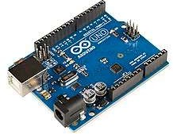

**FIG1.2: ARDUINO UNO**

Arduino uno board is a micro controller kit that is used to get data from peripheral devices like IR sensor, ultrasonic sensors etc. The Arduino uno microcontroller board is based on the ATmega328P IC. This detect & scan RFID tag object in its path and information from the RFID reader is also processed through it. Arduino uno board consists of sets of Digital and Analogue pins that may acts as an interface to various expansion board and other circuit. The operating voltage of Arduino uno is 5v and it can also be operated in between 6v-20v.

### DC MOTOR:

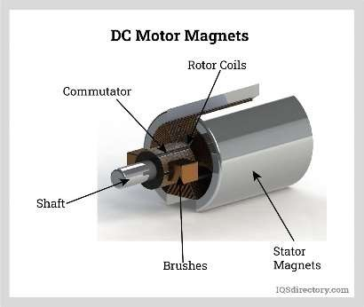

**Fig 1.3: DC MOTOR**

DC motor with appropriate torque and speed specification to ensure smooth and controlled lid movement. The motor should also be compact and lightweight to fit within the trolley’s design constraints. Determine the power supply requirements of the DC motor to ensure compatibility with the trolley's electrical system. Consider factors such as voltage, current, and the integration of any necessary motor control circuit. Rotate wheels to move the robot. DC Motors: Provide movement to the robot Provide torque to overcome obstacles.

### IR SENSOR:

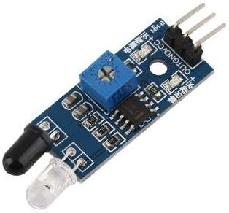

#### Fig 1.4: IR SENSOR

The emitter is simply an IR LED (Light Emitting Diode) and the detector is simply an IR photodiode. Photodiode is sensitive to IR light of the same wavelength which is emitted by the IR LED. When IR light falls on the photodiode, the resistances and the output voltages will change in proportion to the magnitude



of the IR light received.IR sensor is an electronic device, that emits the light in order to sense some object of the surroundings. An IR sensor can measure the heat of an object as well as detects the motion. Usually, in the infrared spectrum, all the objects radiate some form of thermal radiation. These types of radiations are invisible to our eyes, but infrared sensor can detect these radiations. - IR Sensors: Detect humans and obstacles using infrared light. Examples: IR Sensor Module, VL53L0X.

### ULTRASONIC SENSOR:

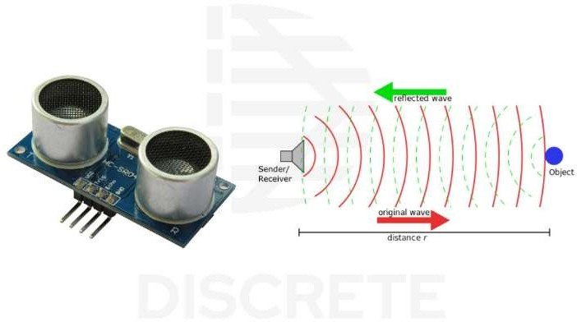

#### Fig1.5: ULTRASONIC SENSOR

Ultrasonic sensors emit short, high-frequency sound pulses at regular intervals. These propagate in the air at the velocity of sound. If they strike an object, then they reflected back as an echo signal to the sensor, which itself computes the distance to the target based on the time-span between emitting the signal and receiving the echo. Ultrasonic sensors are excellent at suppressing background interference. Virtually all materials which reflect sound can be detected, regardless of their colour. Even transparent materials or thin foils represent no problem for an ultrasonic sensor. micro sonic ultrasonic sensors are suitable for target distances from 20 mm to 10 m and as they measure the time of flight they can ascertain a measurement with pinpoint accuracy. Some of our sensors can even resolve the signal to an accuracy of 0.025 mm. Ultrasonic sensors can see through dust-laden air and ink mists. Even thin deposits on the sensor membrane do not impair its function**.** Ultrasonic Sensors: Detect obstacles and measure distance using high-frequency sound waves. Examples: HC-SR04, Ultrasonic Sensor Module. Measure distance to obstacles. - Detect presence of humans or obstacles.



### MOTOR DRIVER:

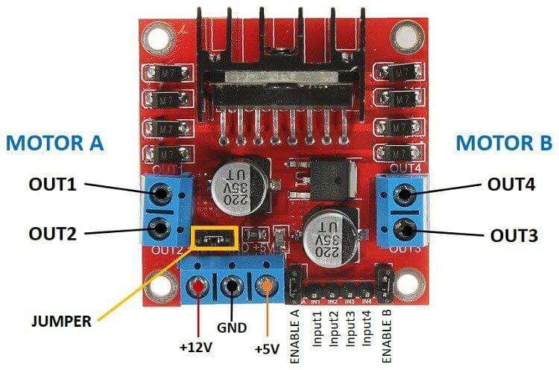

#### Fig 1.6: L298 MOTOR DRIVER

The speed of a DC motor can be controlled by changing its input voltage. A widely used technique to accomplish this is Pulse Width Modulation (PWM). PWM is a technique in which the average value of the input voltage is adjusted by sending a series of ON-OFF pulses. This average voltage is proportional to the width of the pulses, which is referred to as the Duty Cycle. The higher the duty cycle, the higher the average voltage applied to the DC motor, resulting in an increase in motor speed. The shorter the duty cycle, the lower the average voltage applied to the DC motor, resulting in a decrease in motor speed. - Motor Driver: Controls the speed and direction of the motors. We use an L298N Receive commands from the Arduino. Control motor speed and direction.

### POWER SUPPLY:

* Provides power to the system components.
* Examples: Battery (Li-ion, NiMH, etc.), Power Adapter.
* Responsibilities:
* Supply power to the microcontroller, sensors, motors, and other components.
* Regulate voltage to ensure stable operation.

### CHASSIS AND WHEELS:

* Provide structural support and mobility to the robot.
* Examples: Aluminum or Plastic Chassis, Wheels with Rubber Tires.
* Responsibilities:
* Support the weight of the robot and its components.
* Enable movement and navigation through the environment.



### SOFTWARE:

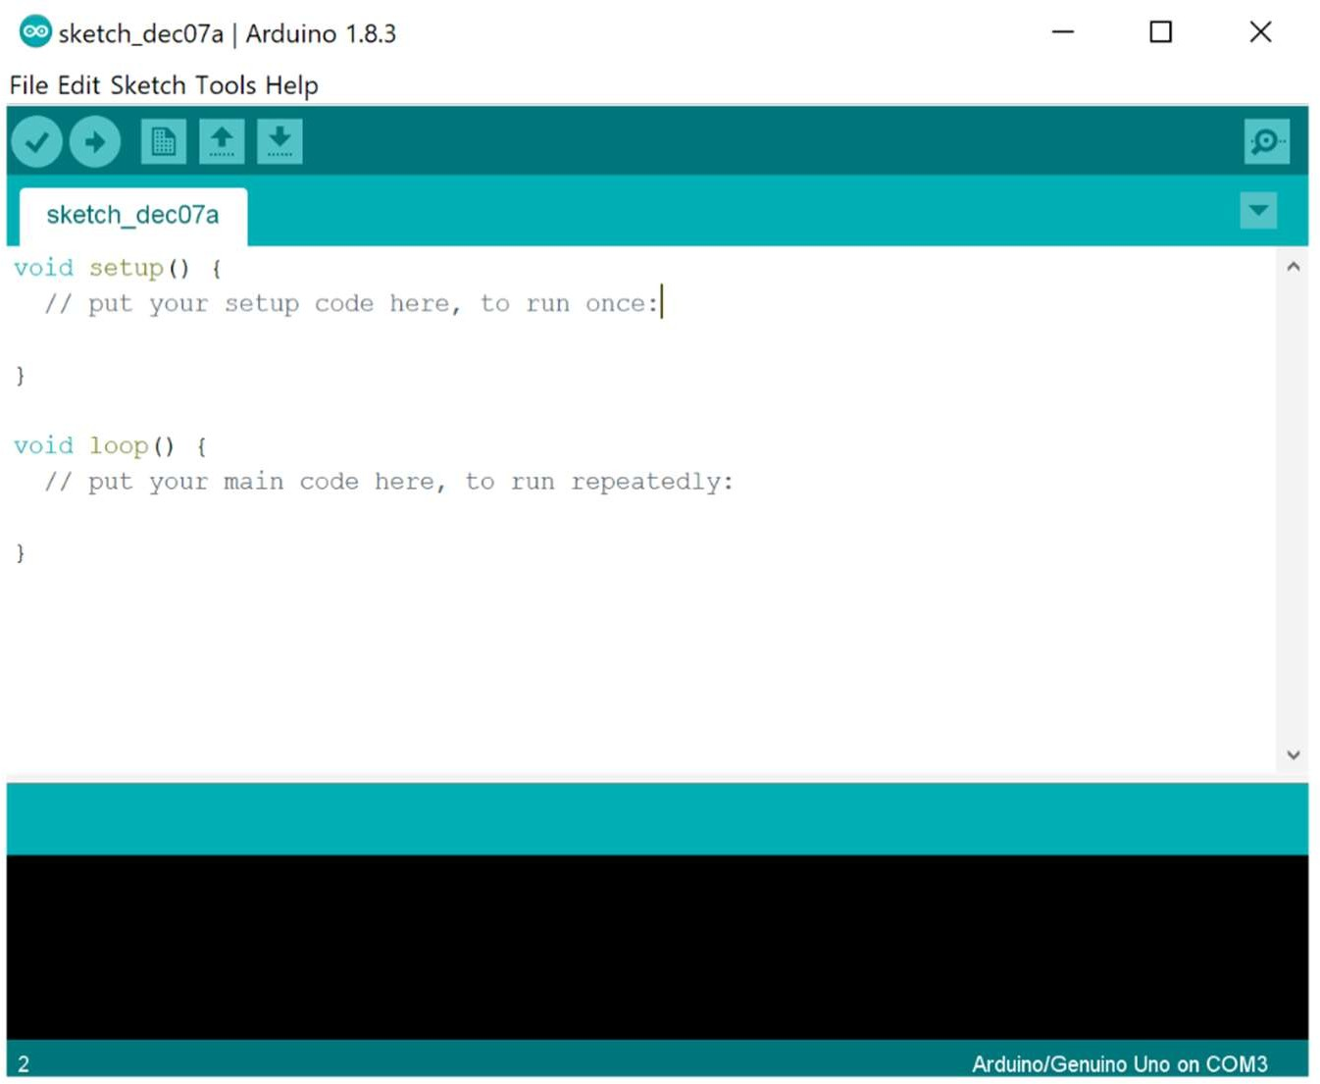

#### Fig 1.7: ARDUINO SOFTWARE

* Programming environment: Arduino IDE
* Programming language: C
* Algorithms for human detection and motion control.

### PROGRAMMING ENVIRONMENT: ARDUINO IDE:

* + The Arduino IDE is a free, open-source software that allows users to write, compile, and upload code Arduino boards.
  + The IDE provides a simple and intuitive interface for programming and debugging
  + Features:
    - Code editor with syntax highlighting and auto-completion.
    - Compiler and uploader for Arduino boards.
    - Serial monitor for debugging and communication with the board.
    - Library manager for installing and managing libraries.



It is a Gateway to Creative Electronics

The Arduino IDE is the cornerstone of the Arduino ecosystem. It's a free and open-source software environment that provides a user-friendly interface for writing, compiling, and uploading code to Arduino boards.

Key Features:

* Code Editor: This is where you write your Arduino sketches (programs). The IDE offers features like syntax highlighting, code completion, and auto-indentation, making it easier to write and read code.
* Compiler: This powerful tool translates your human-readable code into machine code that the Arduino can understand.
* Board Manager: This allows you to select the specific Arduino board you are using. You can also download and install the necessary software libraries for your board from here.
* Library Manager: This is a treasure trove of pre-written code for various functionalities. You can easily install libraries for controlling motors, interfacing with sensors, and much more.
* Serial Monitor: This feature enables communication between your computer and the Arduino board. You can send commands to the Arduino, receive data from sensors, and display messages on the computer screen.

Why is the Arduino IDE so popular?

* User-friendly: The IDE is designed to be accessible to beginners, with a simple and intuitive interface.
* Open-source: Being open-source allows for continuous development and improvement by the community.
* Cross-platform: The IDE runs on Windows, macOS, and Linux, making it accessible to a wide range of users.
* Powerful: Despite its simplicity, the IDE offers a powerful set of tools for creating complex projects.

In Conclusion:

The Arduino IDE is an indispensable tool for anyone working with Arduino boards. It provides a comprehensive environment for developing and interacting with Arduino projects, empowering makers of all skill levels to bring their creative ideas to life.



### CIRCUIT DIAGRAM:

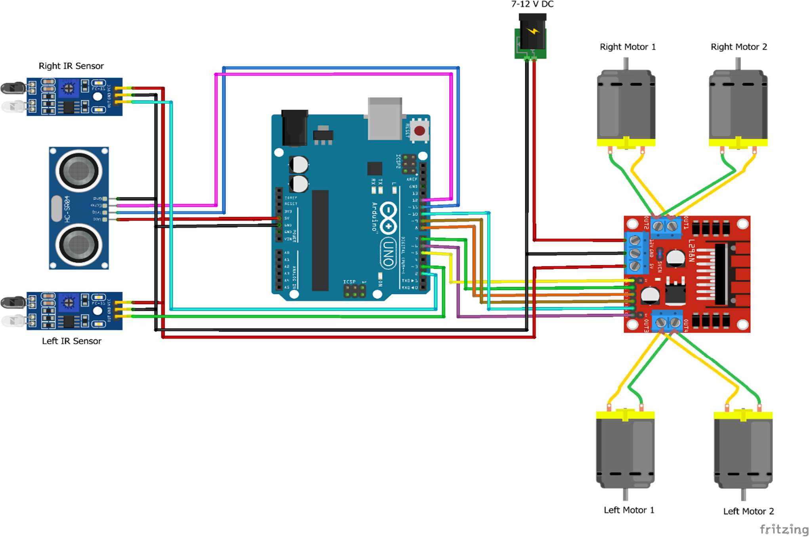

**FIG 1.8: CIRCUIT DIAGRAM**

The circuit diagram illustrates the connection between sensors, the microcontroller, and actuators.

### WORKING:

The system operates as follows:

* Sensors detect the user's position and send data to the microcontroller.
* The microcontroller processes the data and controls the motors to follow the user.
* Obstacle detection sensors ensure safe operation by avoiding collisions.
* The smart trolley is designed to assist customers in navigating through the store and avoiding collisions with obstacles or other shoppers.
* The system uses sensors and motors to detect and respond to the environments.

1. Initialization: The Arduino board initializes the ultrasonic sensor, IR sensor, and motor.
2. Sensor Data Collection: The ultrasonic sensor and IR sensor collect data on the distance to obstacles and the presence of humans or obstacles.
3. Data Processing: The Arduino board processes the sensor data to detect obstacles and humans.



1. Motor Control: Based on the processed data, the Arduino board controls the motor to adjust the trolley's speed and direction.
2. Collision Avoidance: If an obstacle or human is detected, the Arduino board sends a signal to the motor to slow down or change direction to avoid a collision.
3. Navigation: The trolley navigates through the store using the sensor data and motor controlor.

### FLOWCHART:

A detailed flowchart describing the step-by-step operation of the robot.

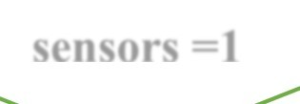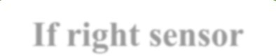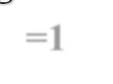

**START**

**YES**

**Ultrasonic**

**sensors =1**

**Move forward**

**NO**

**If right sensor**

**=1**

**YES**

**Turn right**

**NO**

**If left sensor = 1**

**YES**

**Turn left**

**NO**

**YES**

**Ultrasonic sensors=0**

**stop**

**NO**

**Reverse**



### EXPLANATION:

The system ensures real-time responsiveness and accuracy in human detection. It effectively maneuvers in crowded spaces, providing a practical solution for smart shopping.

Here's a brief explanation of each step:

1. Initialize System: The system is initialized, and the sensors and motors are set up.
2. Read IR Sensor: The IR sensors (right and left) are read to detect obstacles.
3. Check IR Sensor Readings: The IR sensor readings are checked to determine if an obstacle is detected.
4. If Right IR Sensor Detects Obstacle, Turn Right: If the right IR sensor detects an obstacle, the system turns the trolley to the right.
5. If Left IR Sensor Detects Obstacle, Turn Left: If the left IR sensor detects an obstacle, the system turns the trolley to the left.
6. If No Obstacle Detected, Continue Moving Forward: If no obstacle is detected, the system continues to move the trolley forward.
7. Repeat IR Sensor Readings: The IR sensor readings are repeated continuously to ensure the system is aware of its surroundings.



## CHAPTER 3: RESULTS

### 3.1 SNAPSHOT:

Snapshots of the implemented system, including:

1. Hardware assembly.
2. System in operation.
3. Customer Enters Store: A customer enters the store and approaches the smart trolley.
4. Trolley Detects Customer: The smart trolley's sensors detect the customer's presence and automatically unlock the trolley.
5. Customer Loads Items: The customer loads items into the smart trolley.
6. Trolley Detects Items: The smart trolley's sensors detect the items loaded into the trolley and update the customer's shopping list.
7. Trolley Navigates Store: The smart trolley uses its navigation system to guide the customer through the store, suggesting the most efficient route to complete their shopping.
8. Trolley Avoids Obstacles: The smart trolley's sensors detect obstacles in its path and automatically adjust its route to avoid collisions.
9. Customer Completes Shopping: The customer completes their shopping and approaches the checkout counter.
10. Trolley Automatically Checks Out: The smart trolley automatically checks out the customer's items and updates their shopping list.
11. Customer Receives Receipt: The customer receives a digital receipt for their purchase, which is automatically sent to their email or mobile device.
12. Trolley Returns to Docking Station: The smart trolley returns to its docking station, where it is recharged and prepared for its next use.

These snap shorts illustrate the potential benefits of using a smart trolley system, including increased efficiency, convenience, and personalized shopping experiences.



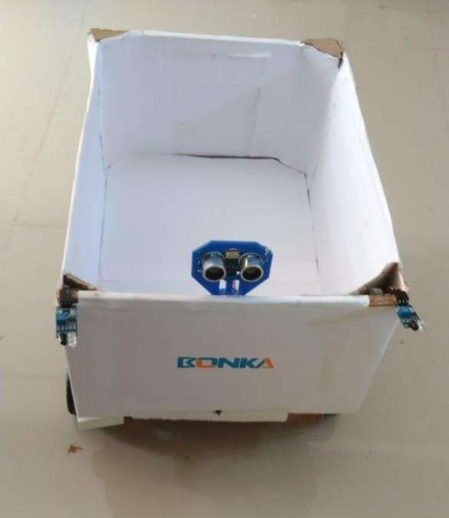

**FIG 4.1: SNAPSHOT OF HARDWARE ASSEMBLY**

### CONCLUSION:

The human-following robot for a smart shopping trolley is a step toward modernizing retail shopping. It offers a convenient and efficient solution for consumers by leveraging robotics and automation. The smart trolley system designed using a microcontroller, ultrasonic and IR sensors, motors and driver, power supply, chassis and wheels, and programmed using Arduino IDE and C language, is a reliable and efficient solution for navigating through a store or warehouse while avoiding obstacles and detecting humans. The system's ability to detect obstacles and humans using ultrasonic and IR sensors, and to navigate through the environment using motors and driver, makes it an ideal solution for various applications such as retail, logistics, and manufacturing.

The use of Arduino IDE and C language for programming the system makes it easy to develop and deploy, and the system's modular design allows for easy maintenance and upgrading. The smart trolley system has numerous advantages, including efficient navigation, obstacle avoidance, and human detection, which improve safety and reduce the risk of accidents. Additionally, the system increases efficiency and productivity, and is easy to use and maintain. Smart Shopping Trolley" project successfully demonstrates the potential of robotics in enhancing shopping experiences. By integrating sensors, machine learning, and autonomous navigation, the robot efficiently followed the user, reducing physical effort and providing a hands-free shopping experience. This innovation showcases the practicality of human-following robots in



crowded environments like supermarkets. The project also highlights the potential for integrating additional features, such as barcode scanning, automatic billing, or voice assistance, to further enhance usability. Despite its success, challenges such as obstacle avoidance in dynamic environments and battery optimization remain areas for improvement.

The smart trolley system is a innovative solution that has the potential to revolutionize the way we navigate through stores and warehouses. Its ability to detect obstacles and humans, navigate through the environment, and improve safety and efficiency make it an ideal solution for various applications. In conclusion, this project is a step towards smart retail automation, offering a glimpse into how technology can revolutionize everyday tasks. Future iterations could explore advanced AI algorithms and connectivity with smart retail systems to create an even more seamless and user-friendly shopping solution.

### ADVANTAGES:

* Reduces manual effort during shopping.
* Enhances user convenience.
* Safe and reliable operation with obstacle avoidance.
  1. Improved Shopping Experience:
     + Smart trolleys can guide customers through the store to find items on their shopping list. They can also provide recommendations, discounts, or promotions, enhancing customer engagement.
  2. Time Saving:
     + By automating item detection and checkout, smart trolleys reduce the time customers spend in queues, making the shopping experience faster and more efficient.
  3. Inventory Management:
     + The system can track inventory in real-time, alerting staff when stocks are low or when shelves need to be restocked.
  4. Reduces physical strain:
     + It is helpful for old age people, pregnant ladies which reduces for carrying the shopping products.



### APPLICATIONS:

Smart shopping trolleys have a wide range of applications in the retail industry:

* Personalized recommendations: Suggest products based on past purchases and preferences.
* Queue management: Reduce wait times and improve the overall checkout experience.
* Smart trolleys can guide customers through the store to find items on their shopping list. They can also provide recommendations, discounts, or promotions, enhancing customer engagement.
* Retail Stores: Smart trolleys can be used in retail stores to enhance the shopping experience, improve inventory management, and reduce labour costs.
* Supermarkets: Smart trolleys can be used in supermarkets to help customers navigate the store, find products, and checkout quickly.
* Airports: Smart trolleys can be used in airports to help passengers transport their luggage, find gates, and navigate the airport.
* Hospitals: Smart trolleys can be used in hospitals to transport patients, medical equipment, and supplies.
* Warehouses: Smart trolleys can be used in warehouses to improve inventory management, reduce labour costs, and enhance efficiency.
* Logistics and Delivery: Smart trolleys can be used in logistics and delivery services to improve package tracking, reduce labour costs, and enhance efficiency.
* Pharmacies: Smart trolleys can be used in pharmacies to improve inventory management, reduce labour costs, and enhance patient safety.
* Libraries: Smart trolleys can be used in libraries to improve book tracking, reduce labor costs, and enhance the borrowing experience.
* Industrial Settings: Smart trolleys can be used in industrial settings to improve material handling, reduce labour costs, and enhance efficiency.
* Agricultural Settings: Smart trolleys can be used in agricultural settings to improve crop monitoring, reduce labour costs, and enhance efficiency.
* Healthcare Settings: Smart trolleys can be used in healthcare settings to improve patient care, reduce labour costs, and enhance efficiency.



### DISADVANTAGES:

* Initial cost of implementation.
* Dependence on battery power limits operational time.
* Sensor limitations in highly dynamic environments. Battery life:
  + Limited battery life may require frequent recharging or replacement.

Initial investment:

* + Implementing smart shopping trolleys can be costly for retailers.

Social Implications:

* + Job displacement: The increased automation of shopping processes may lead to job displacement for cashiers and other retail workers.

Environmental Impact:

* + Electronic waste: Increased use of electronic devices can contribute to electronic waste.
  + Energy consumption: The operation of smart trolleys requires energy, potentially increasing environmental impact.

### FUTURE SCOPE:

* Integration with IoT for real-time inventory management.
* Advanced navigation using AI and machine learning.
* Voice control for enhanced user interaction.

1. Integration with Store Management Systems: Integrate the smart trolley with store management systems to enable real-time inventory management, automated billing, and personalized marketing.
2. Artificial Intelligence (AI) and Machine Learning (ML): Implement AI and ML algorithms to enable the smart trolley to learn and adapt to customer behavior, preferences, and shopping patterns.
3. Computer Vision and Object Recognition: Integrate computer vision and object recognition technologies to enable the smart trolley to recognize and track products, reducing the need for manual scanning.



1. Voice Assistant Integration: Integrate popular voice assistants like Alexa, Google Assistant, or Siri to enable customers to interact with the smart trolley using voice commands.
2. Augmented Reality (AR) Integration: Integrate AR technology to provide customers with immersive and interactive shopping experiences, such as virtual product demonstrations and tutorials.
3. Smart Payment Systems: Integrate smart payment systems, such as mobile payments, contactless payments, or cryptocurrency payments, to provide customers with convenient and secure payment options.
4. Real-time Analytics and Insights: Provide retailers with real-time analytics and insights on customer behavior, shopping patterns, and product preferences to inform marketing strategies and improve customer experiences.
5. Autonomous Navigation: Enable the smart trolley to navigate autonomously through the store, using sensors and mapping technologies to avoid obstacles and find the most efficient route.
6. Integration with Wearable Devices: Integrate the smart trolley with wearable devices, such as smartwatches or fitness trackers, to provide customers with personalized recommendations and offers based on their preferences and shopping history.
7. Sustainability and Energy Efficiency: Design the smart trolley with sustainability and energy efficiency in mind, using eco-friendly materials and minimizing energy consumption to reduce its environmental impact.



### REFERENCES:

[1]. RFID Based Wireless Intelligent Cart Using ARM7, Suraj. S, Vishal Guruprasad, Udayagiri R Pranava,

Preetham S Nag

[2]. Akshay Kumar, Abhinav Gupta, Balamurugan S. Balaji, Marimuthu

[3]. Harpreet Singh Bedi", Nikhil Goyal, Sunil Kumar and Avinash Gupta - Smart Trolley for Smart Shopping, Publisher.

[4]. Rejini Jose, Saleh Musallam Abdullah AI Harthi; Asis Kumar Tripathy; Kathiravan Srinivasan - A Smart Trolley for Smart Shopping.