Maharaja Institute Of Technology Mysore



Department Of Information Science Engineering

Assignment on

Different protocol layers used in



**Messenger**

BY TO

Amith N C Puneeth P

USN:4MH17IS005 Asst. Prof.

Christian Stephen ISE dept.

USN:4MH17IS017 MIT, Mysore

4th sem, ISE

MIT, Mysore

**Introduction**

WhatsApp is a Instant messenger allows to sending of texts and voice, video calls, images and other media, documents, and user location. The methodology for the voice communications is Voice over Internet Protocol (VoIP) and for the attachments the are using IP, XMPP,TCP protocols.

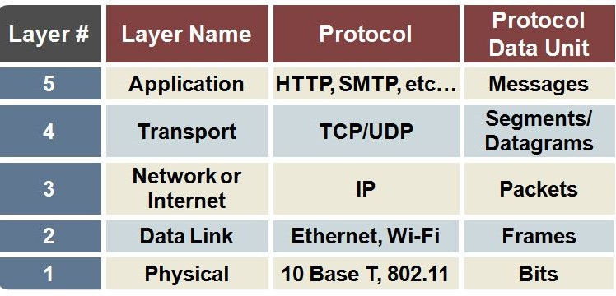

**Application layer :**

User of WhatsApp whenever wants to send Images, Videos and etc. he will intern call e15.whatsapp.net e16.whatsapp.net(server address for android) to load the data to server.

Images, Videos and etc. are first uploaded to HTTP server.

**Transport layer:**

WhatsApp uses XMPP (extensible Messaging and Presence Protocol) to handle the message delivery system.  
XMPP is mostly like HTTP where the client opens the socket with the XMPP server and keeps it open as long as the client is logged in. It's not like the regular rest API where the client opens the socket send/receive the data and close the socket. The socket is opened as long as you are signed in

**Network Layer:**

**Internet protocol**

Internet Protocols are methods which sent and receive data from one device to another on the Internet with some network boundaries. Internet Protocol has two major versions such as IPv4 & IPv6

# **1.IPv4**

Internet Protocol Version 4 (IPv4) is the fourth revision of the Internet Protocol and a widely used protocol in data communication over different kinds of networks. IPv4 is a connectionless protocol used in packet-switched layer networks, such as Ethernet. It provides the logical connection between network devices by providing identification for each device.

An IP addresses consists of a 32 bit address, which contains 4 octets with numbers ranging from 0-255. An example of an IP address is 192.168.1.1.

# **2.IPv6**

IPv6 is a new version of IP (Internet Protocol). IPv4 has 2^32 number of IP addresses available to it whereas IPv6 has 2^128 number of IP addresses available. Currently by default, IPv4 is being used but the IP addresses has been used up. That is why IPv6 was created.

Here is an example for IPv6= 2001:db8:0:1234:0:567:8:1

# **How WhatsApp is Programmed**

WhatsApp was programmed in **Erlang (**is a programming language used to build massively scalable soft real-time system) and Server was maintained by **FreeBSD, PHP** and **Yaws** , for backbone purpose they have chosen **XMPP**(extensible Messaging and Presence Protocol) to handle the message delivery system.**.**

Once we registered to WhatsApp with our mobile number, WhatsApp create a table (Known as WhatsApp Username) with our mobile number (XXXX@s.whatsapp.net). For the Password previously they have used the mobile’s IMEI number and now they are using Mobile’s Wi-Fi MAC address. Since all are using DUAL SIM smartphone WhatsApp generates a random password on the server side now. But for the standard **Apple, Nokia, Samsung devices used the phone’s Wi-Fi MAC address instead of IMEI.**

Images, Videos and etc. are first uploaded to HTTP server and encrypted with **SRTP**(Secure Real-Time Transport Protocol or Secure RTP),systems are currently maintaining the encryption part. (End-End encryption). Each and every content are sending with BASE 64, RADIX 64 thumbnails. **Undelivered messages are in the server among with username only 30days**. If the user comes online it will be delivered and if not applicable automatically messages were deleted from server.

**WhatsApp IP addresses & Ports**

As WhatsApp has huge amount of users, they are having huge IP range.

208.43.122.131 - 208.43.122.135  
184.173.136.80 - 184.173.136.154

Ports

80 |443 | 5222 | 223 |5228 | 5060 , 5064 for SIP (Session Initiation Protocol)/Voip(voice and multimedia content over Internet Protocol)

**Store & Forward Mechanism**

WhatsApp is using a big mechanism named S&F Mechanism, Store and forward mechanism is network technique where we can save locally and sent to another destination. This mechanism is mainly used in emails with UDP and FTP protocols.

**In general**

SSL (Secure Sockets Layer) socket to the WhatsApp server pools. All messages are queued on the server until the client reconnects to retrieve the messages. The successful retrieval of a message is sent back to the WhatsApp server which forwards this status back to the original sender (will see that as a "checkmark" icon next to the message). Messages are wiped from the server memory as soon as the client has accepted the message