Customer Behavior Analysis Dashboard
Tool Used: Microsoft Power BI
Data Source: Customer Purchase Dataset

1. Project Overview
This project focuses on analyzing customer purchase behavior using Power BI. The objective is to understand revenue patterns, customer segments, product performance, and the impact of subscriptions and shipping preferences.

2. Objective of the Project
- Analyze customer purchase patterns
- Identify high-revenue customer segments
- Understand product-wise and demographic-wise revenue contribution
- Support business decision-making through insights

3. Data Description
The dataset contains customer purchase-related information such as gender, age group, items purchased, revenue, discount rate, subscription status, and shipping type.

4. Data Cleaning & Transformation (Exploratory Data Analysis) Using Python
Data cleaning was performed using python. Missing values were handled, data types were corrected, and categorical fields were standardized.
- Data Loading: Imported the dataset using Pandas.
- Initial Exploration: Used df.info () to check structure and. describe() for summary statistics.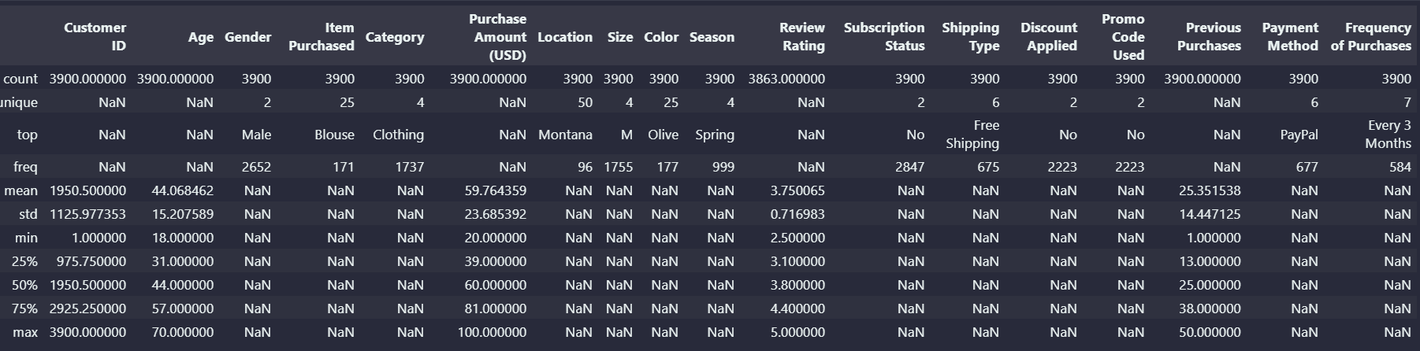

5. Dashboard Overview
An interactive dashboard was designed to present key metrics and visual insights. The dashboard includes KPIs, charts, slicers, and tables for effective analysis.
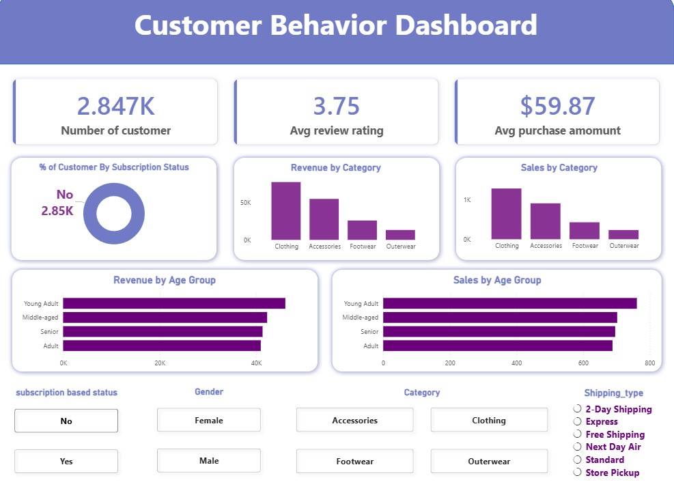

6. Key Analysis & Insights

6.1 Gender-wise Revenue Analysis
Revenue distribution shows that male customers contribute a higher share compared to female customers.
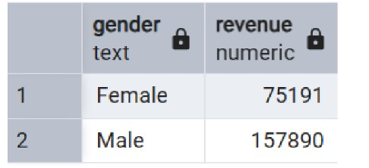

6.2 Age Group Revenue Contribution
Adults and middle-aged customers generate the highest revenue, indicating strong purchasing power.
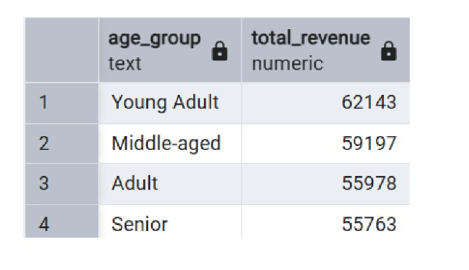

6.3 Product Performance Analysis
Products like Sneakers, Coats, Sweaters, and Pants are top-performing items in terms of revenue.

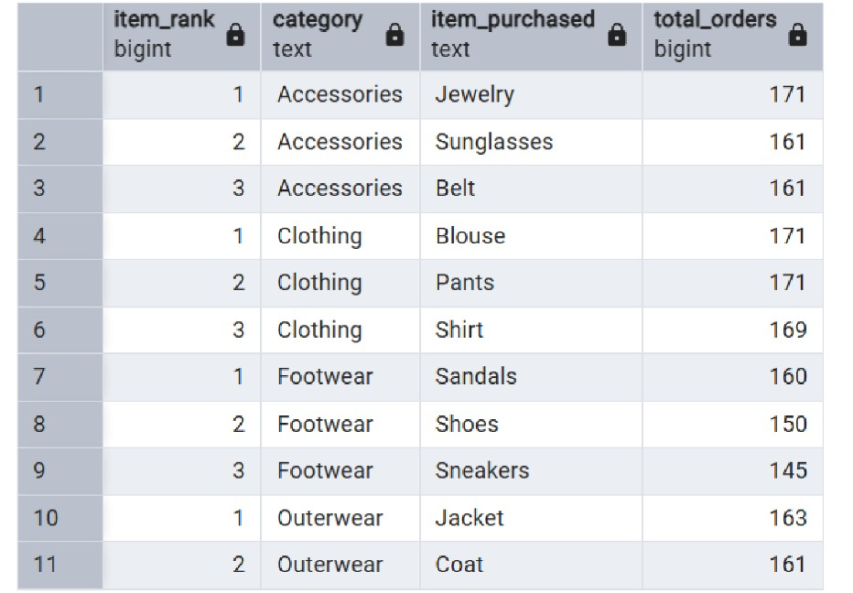

6.4 Subscription Impact Analysis
Subscribed customers contribute significantly more revenue compared to non-subscribed customers.
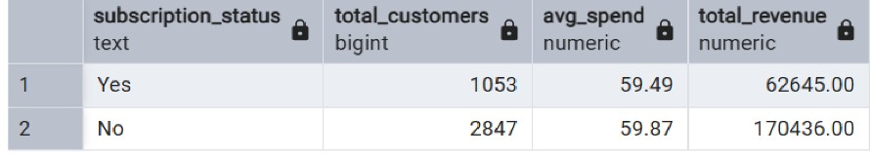

7. Business Recommendations
- Promote subscription plans to increase customer lifetime value
- Target high-revenue age groups with personalized marketing
- Focus inventory on high-performing products
- Optimize shipping strategies based on customer preference

8. Conclusion
This Power BI project provides meaningful insights into customer behavior and revenue trends. The interactive dashboard helps stakeholders make informed business decisions.

