Question Paper Navigator
Technical Architecture Document
Online mock-exam platform for CTET / TET question papers (Sets H, K, L, M, N)

Item | Detail
Project | TET — question-paper-platform (package: question-paper-navigator)
Document type | High-level design (HLD) and low-level design (LLD)
Date | 10 October 2026
Basis | Project documentation: README, SOURCE_DATA_MANIFEST, ENHANCEMENT_CHANGELOG, PATCH_MANIFEST, package.json, .gitignore, .gitattributes
Status | Draft — to be reconciled against the source code (see Section 1.2)

Contents

If the table above appears empty, right-click it in Word and choose Update Field.

1. Introduction

1.1 Purpose
This document describes the architecture of the Question Paper Navigator, a web application that lets students attempt existing examination papers under timed conditions, and lets administrators upload or generate new paper datasets. It provides a high-level view (context, components, data flow, deployment) and a low-level view (modules, data contracts, algorithms, sequences) intended for maintainers, reviewers and any LLM or engineer picking up the codebase.

1.2 Evidence basis and limits
Important: This document was prepared from the seven project documents available in the Project (README, manifests, changelog, package.json and ignore/attribute files). The application source code (frontend/, processor/, tools/, data/) was not accessible. Component names in the low-level diagrams are therefore logical groupings derived from documented behaviour, not verified class or file names. Anything stated as a data contract, script name, dataset count or security limitation comes directly from the documents.

1.3 Product summary
Per the project description: a website where students can access existing papers and sit the exam, while an admin holds full privilege to upload exam papers so that required changes can be made. The bundled content covers five 150-question paper sets across two exam sessions.

1.4 Key architectural characteristics
- Static-first: the runtime app is a React/Vite single-page application that fetches static JSON; there is no application backend in production.
- Local-only admin plane: the AI proxy and the dataset file-writer exist only as Vite dev-server middleware.
- Canonical-then-sync data model: canonical data in data/ is synchronised into frontend/public/data/ by a script.
- Browser-local state: exam timer, active attempt and history live in localStorage and do not sync across devices.
- Bilingual content: English and Hindi records with language-specific answer keys for Q91–Q150.

2. High-Level Design

2.1 System context and architecture
Figure 1 shows the end-to-end architecture. Students and admins enter through a shared login. Students use the catalog, exam engine and results screens, all of which read static JSON. Admins additionally reach the dataset uploader, which talks to a local Vite middleware that proxies LLM calls and writes validated datasets into the runtime data folder. An offline Python pipeline converts source PDFs into canonical data.
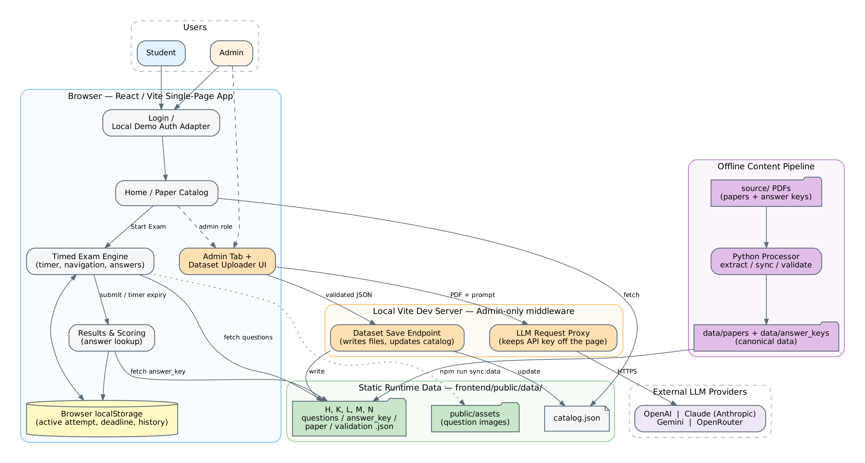
Figure 1 — High-level architecture

2.2 Component responsibilities
Component | Responsibility
Login / local demo auth | Client-side gate with two roles (student, admin). MVP only — not secure authentication.
Home / paper catalog | Lists available papers from catalog.json; entry point to start an exam.
Timed exam engine | Starts the attempt, computes the deadline from paper.json (duration_minutes, default 150), supports navigation, answer selection and language switching, and auto-submits on expiry.
Results & scoring | Resolves correct answers via the answer-lookup contract; reports correct, attempted, unanswered, scorable and percentage.
Admin tab + dataset uploader | Admin-only area with two paths: AI Document Generator (PDF to JSON via an LLM) and Manual JSON Upload.
Vite middleware | LLM request proxy (keeps provider keys out of page source) and dataset save endpoint (writes files, updates catalog.json).
Static runtime data | frontend/public/data/: catalog.json plus per-set questions, answer_key, paper and validation JSON; public/assets holds question images.
Python processor | Extracts PDFs into normalised records, syncs canonical data to runtime, validates datasets.
External LLM providers | OpenAI, Claude (Anthropic), Gemini and OpenRouter, selectable by the admin.

2.3 Content and data pipeline
Content flows in one direction from source PDFs to the app. Edits must be made to canonical data first; the sync step then rebuilds the runtime copy. The Admin save endpoint is the one exception: it writes directly to the runtime copy.
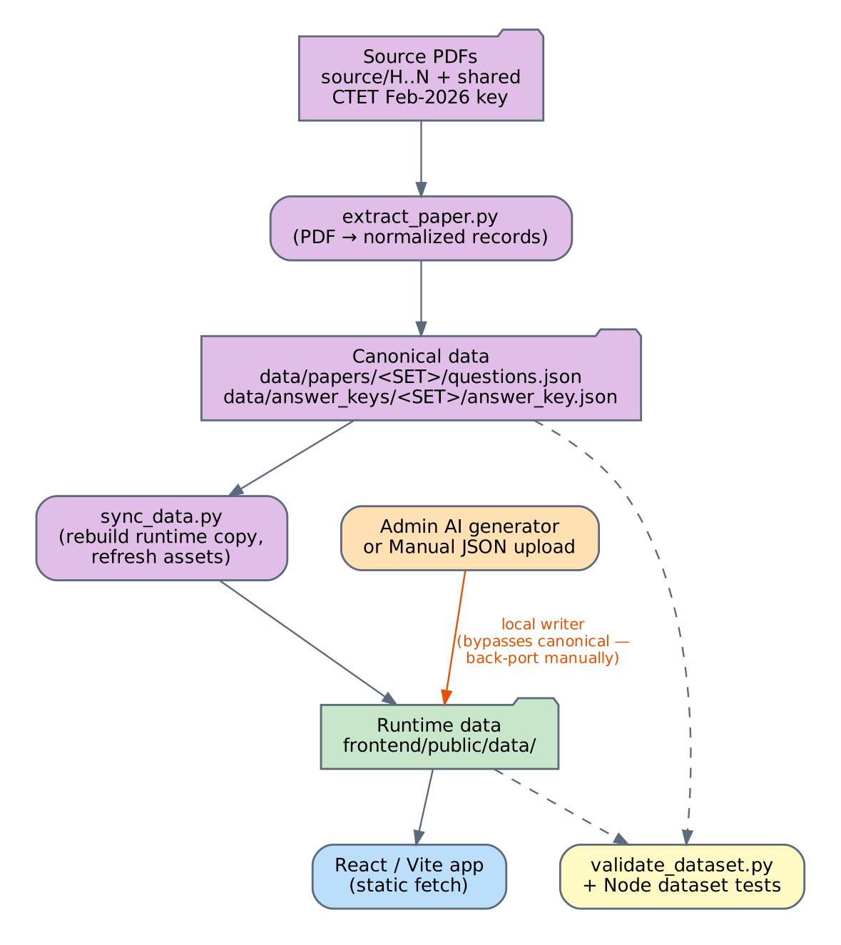
Figure 2 — Content pipeline and the admin write path
Risk: Datasets saved through the admin uploader land only in frontend/public/data/. Running npm run sync:data afterwards rebuilds that folder from canonical data and would overwrite them unless the same changes are also placed in data/papers and data/answer_keys.

2.4 Deployment and runtime modes
Mode | What works | What does not
Local dev (npm run dev, http://localhost:5173) | Everything: student exam flow, admin AI generation, manual upload, file write-back. | Not for exposure to untrusted networks.
Static build (npm run build) e.g. GitHub Pages | Login, catalog, timed exams, results — all static JSON. | AI generation and save-to-repo (no proxy, no writer); no secure auth; no cross-device history.

2.5 Technology stack
Layer | Technology (as documented)
Frontend | React, Vite (multi-page build; the admin upload HTML page is an explicit Vite input), neumorphic styling
Backend (local only) | Vite dev-server middleware (Node.js)
Content processing | Python scripts with requirements in processor/requirements.txt; pytest tests
Testing | pytest, frontend test runner (test:web), Node test scripts in tools/
Tooling | npm scripts at repository root; PowerShell-oriented local setup (Windows)

3. Low-Level Design

3.1 Frontend module view
Figure 3 decomposes the browser application and the admin tooling into logical modules. Orange nodes are admin-only; green marks the answer-lookup logic that must stay consistent with the data contract.
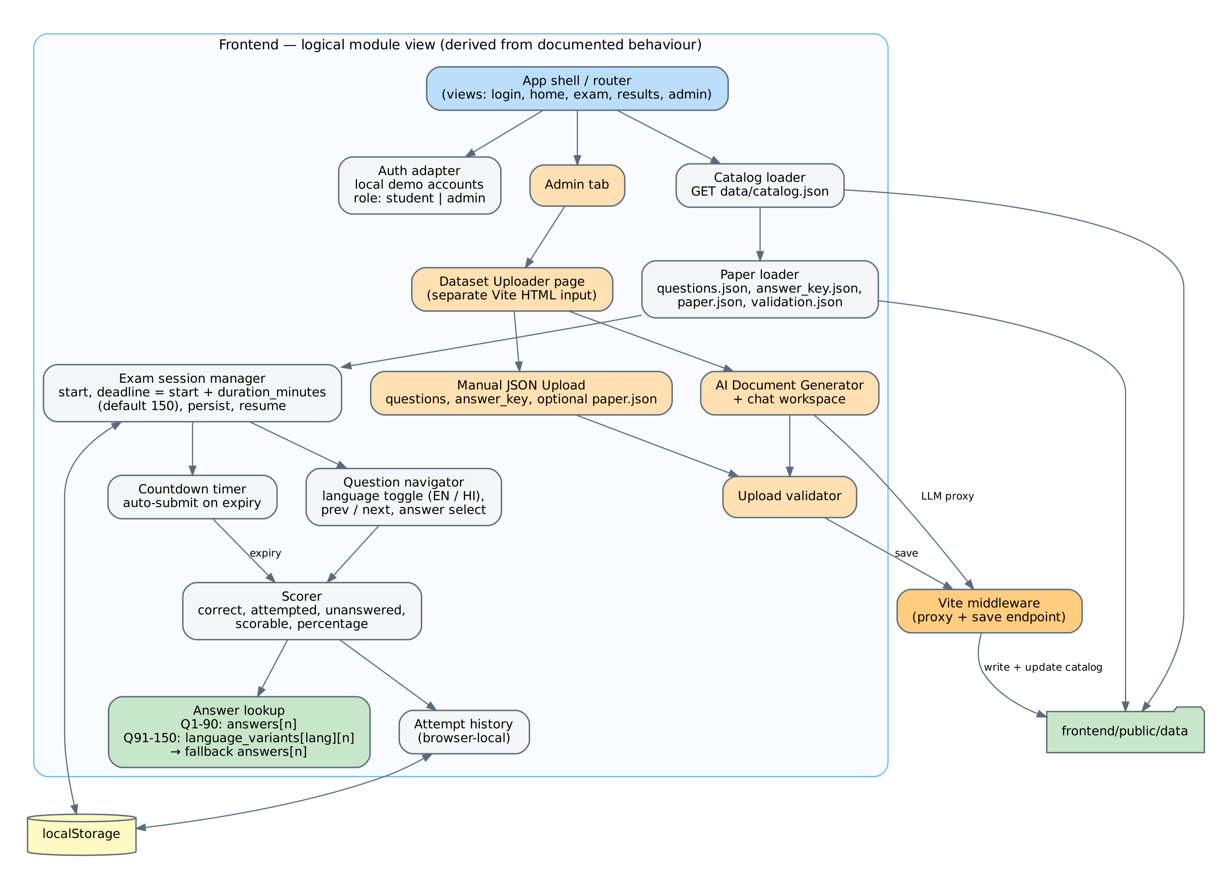
Figure 3 — Frontend logical module view (derived from documented behaviour)

3.2 Data model and file contracts
Each paper set has four runtime files, plus one global catalog. Figure 4 shows their relationships and the fields documented for each.
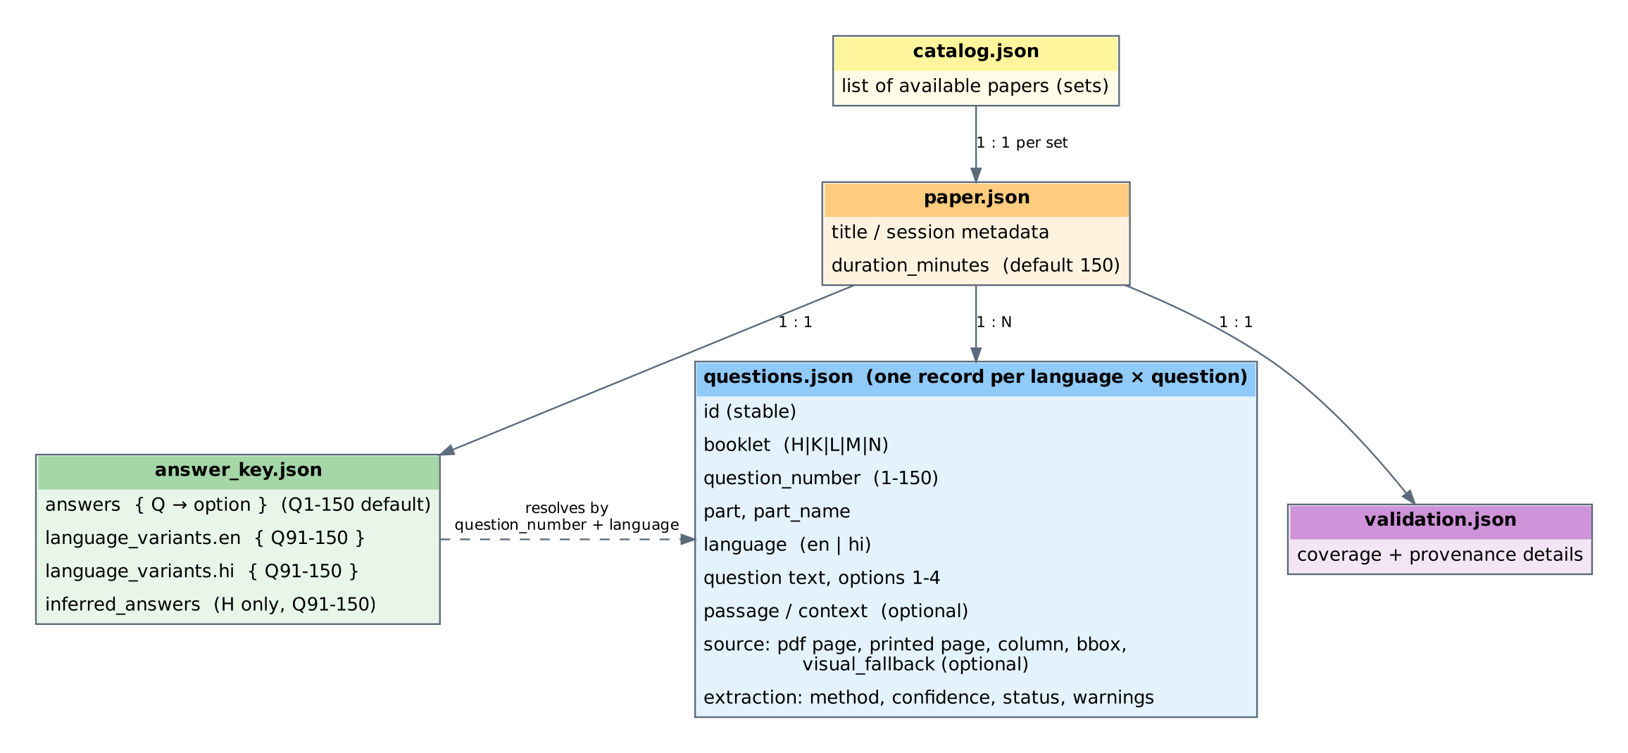
Figure 4 — Runtime JSON files and key fields

Question records
questions.json holds one normalised record per language/question pair. For this paper family, Q1–Q90 are bilingual (one en and one hi record each), Q91–Q120 are Language-I sections and Q121–Q150 are Language-II sections, each in English and Hindi. Each record carries a stable ID, booklet code, question number, part and part name, language, text, options 1–4, optional passage, source provenance (PDF page, printed page, column, bounding box, optional visual fallback for vector-only content) and extraction metadata (method, confidence, status, warnings).

Answer lookup contract
Question range | Lookup rule
Q1–Q90 | answer_key.json → answers[question_number]
Q91–Q150 | answer_key.json → language_variants[language][question_number]; fall back to answers only if the language-specific variant is absent
H set, Q91–Q150 | Values are model-inferred (recorded under inferred_answers) and must be verified by a human before any high-stakes use

K, L, M and N each contain 150 English plus 150 Hindi physical records but 150 logical questions; language variants must be kept separate. H currently publishes English records only.

3.3 Timed exam session
The attempt lifecycle is shown in Figure 5. The deadline is stored when the exam starts, so a page refresh restores the timer rather than resetting it. Expiry triggers an automatic submission; manual submission is offered on the final question.
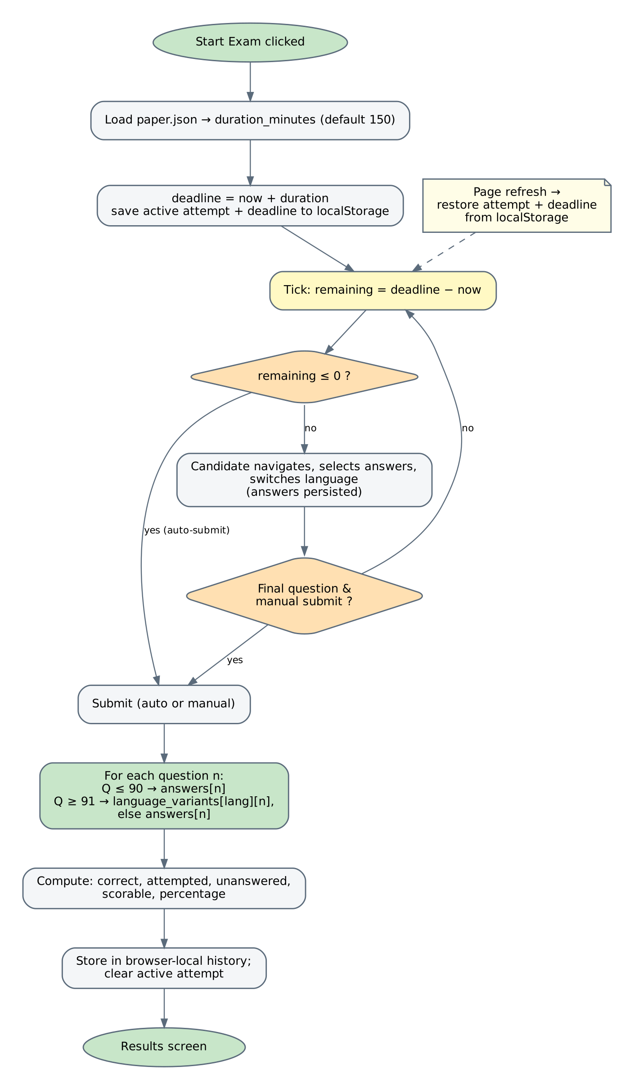
Figure 5 — Exam session and scoring flow
Result metric | Meaning
Correct | Answers matching the resolved key
Attempted | Questions with a selected option
Unanswered | Questions with no selected option
Scorable | Questions for which a key value exists
Percentage | Derived from correct and scorable counts

Active attempt, deadline and attempt history are stored in this browser’s localStorage only; they do not sync between devices or accounts.

3.4 Admin dataset ingestion
Admins can create datasets two ways, both converging on a shared validator and the save endpoint (Figure 6). The AI path sends the question-paper and answer-key PDFs, with the PDF-to-JSON prompt from docs/AI_QUESTION_ANSWER_JSON_GENERATION_PROMPT.md, through the local proxy, then normalises the provider response. The manual path accepts questions.json, answer_key.json and an optional paper.json.
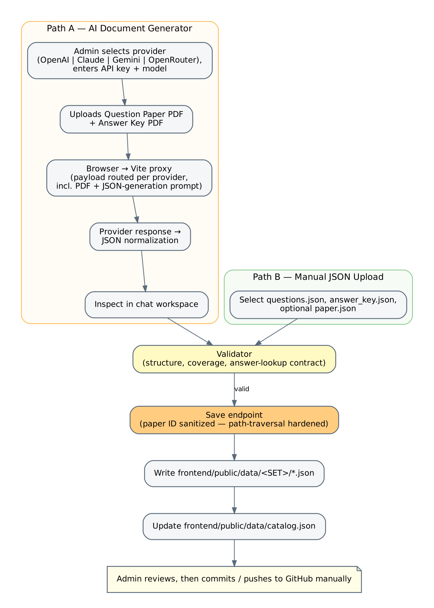
Figure 6 — Admin ingestion flow
- Provider payloads are routed per provider (OpenAI, Claude, Gemini, OpenRouter); the default OpenRouter slug was corrected in the latest changelog.
- The save endpoint sanitises the source-folder paper ID to prevent path traversal (hardening noted in the changelog).
- API keys are entered at runtime; they must never be placed in source files or dataset JSON.
- After saving, the admin reviews provenance and commits to GitHub manually.

3.5 PDF extraction pipeline
The Python processor turns each source PDF into normalised records (Figure 7). The stages shown are a logical decomposition from the documented record schema and the npm extract:* scripts; internal function boundaries should be confirmed in processor/src/.
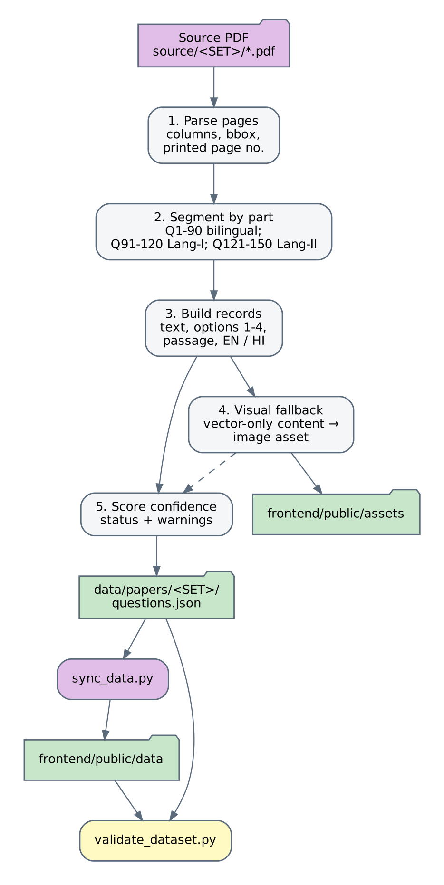
Figure 7 — PDF extraction pipeline (logical stages)

3.6 Repository layout (as documented)
Path | Contents
frontend/ | React/Vite app; public/data (runtime JSON), public/assets, Vite config with proxy and save middleware
processor/ | src/extract_paper.py, sync_data.py, validate_dataset.py; local_admin_server.py; tests/; requirements.txt
data/papers/<SET>/ | Canonical questions.json per set
data/answer_keys/<SET>/ | Canonical answer_key.json per set
source/ | Original question-paper and answer-key PDFs (H, K, L, M, N, plus shared CTET Feb-2026 key); not committed by default
exports/ | Answer-key workbooks; outdated H workbook under exports/legacy/
tools/ | Node test scripts: datasets, admin-ai, exam session, bundle integrity
docs/ | Technical architecture, LLM handoff, AI prompt, Admin AI docs, release manifest, architecture diagram

3.7 Dataset inventory
Set | Session | Logical Qs | Physical records | Answer-key status
H | SED-24-I, Dec 2024 | 150 | 150 (EN) | Q1–Q90 from supplied sheet; Q91–Q150 model-inferred, needs verification
K | ACF-26-I, Feb 2026 | 150 | 300 (EN+HI) | Official shared CTET Feb-2026 key with language variants
L | ACF-26-I, Feb 2026 | 150 | 300 (EN+HI) | Official shared key with language variants
M | ACF-26-I, Feb 2026 | 150 | 300 (EN+HI) | Official shared key with language variants
N | ACF-26-I, Feb 2026 | 150 | 300 (EN+HI) | Official shared key with language variants

3.8 Build, test and automation scripts
npm script | Purpose
install:all / dev / build | Install frontend dependencies; run Vite dev server; production build
extract:k | l | m | n | Run the extraction pipeline for one set into data/papers/<SET>/questions.json
sync:data | Rebuild frontend/public/data from canonical data and refresh assets
validate | Run processor/src/validate_dataset.py
test | pytest on processor/tests
test:web | Frontend test suite
test:datasets | All five datasets, validator compatibility and answer lookup availability
test:admin-ai | Provider routing, PDF requirements, JSON normalisation with mocked responses (no paid API calls)
test:session | Timer, session and scoring helpers
test:bundle | Source files and all datasets present
admin:local | Run processor/local_admin_server.py

Note: package.json exposes extract scripts for K, L, M and N only. H has no extract script because its runtime data was produced separately; confirm how H is regenerated if its source needs reprocessing.

4. Security, Risks and Limitations

4.1 Security considerations
Area | Current state and guidance
Authentication | Client-side demo accounts only (documented student and admin credentials). Anyone with the built bundle can read them. Not suitable for a public or paid site.
Authorisation | Admin features are gated in the UI; the write endpoint exists only in the dev server, so protection depends on not exposing that server.
API keys | Entered at runtime and sent through the local proxy; never store in source or datasets. .env files are git-ignored.
File writes | Paper ID sanitised against path traversal in the save endpoint.
Source PDFs | Excluded from commits by .gitignore (source/*.pdf, sample_inputs/*.pdf); review redistribution rights for examination papers.

4.2 Known limitations
- No secure production authentication, user accounts or per-user repositories.
- Attempt history and timers are browser-local; no cross-device sync.
- AI generation and save-to-repo are unavailable in a static deployment.
- No payment verification, private object storage, background jobs or automated public publishing.
- H Q91–Q150 answers are inferred and not verified against any supplied key.
- H runtime records are English only.
- Admin-saved data can be overwritten by sync:data unless back-ported to canonical data.

4.3 Recommended evolution path
# | Recommendation | Rationale
1 | Verify or replace H Q91–Q150 keys | Removes the only model-inferred scoring data before students rely on it.
2 | Introduce managed authentication and a small backend API | Moves admin proxy and writer out of the dev server and secures roles server-side.
3 | Persist attempts per user server-side | Gives cross-device history and tamper-resistant timing.
4 | Make sync/save one pipeline | Have the admin save write canonical data, then run sync, to remove the overwrite risk.
5 | Add CI running validate and all test:* scripts | Catches dataset and lookup regressions on every change.

5. Appendix: Open Items
The following should be confirmed against the source code when it is available, then folded back into this document.
- Exact React component, hook and module names under frontend/src, and the router/view mechanism.
- The localStorage key names and stored attempt schema.
- The Vite middleware route paths and request/response shapes for the proxy and save endpoint.
- Validator rules applied to uploads (field-level checks beyond those documented).
- Internal stages and function names in processor/src/extract_paper.py.
- Contents and format of catalog.json and paper.json beyond duration_minutes.

