HOUSING SOCIETY BILLING &
COLLECTIONS ANALYSIS REPORT

1. Executive Summary
This report analyses a full-year (Apr 2025 – Mar 2026) billing and collections dataset for eight housing societies located across the Mumbai Metropolitan Region (Thane, Powai, Mulund, Andheri, Kalyan, Navi Mumbai, Dombivli, Bhiwandi). The dataset contains 10,000 invoice-level records covering maintenance, water, parking, late fees and other charges.
Key headline results:
- Total Billed: ₹3.82 crore
- Total Collected: ₹3.06 crore
- Total Outstanding: ₹0.76 crore
- Overall Collection Rate: 80.2%
- Paid invoices: 7,489 (74.9%) | Partially Paid: 1,016 (10.2%) | Unpaid: 1,495 (15.0%)
The collection rate is healthy for residential FM operations, yet the absolute outstanding of ~₹76 lakh and nearly 2,500 non-fully-paid invoices represent a material recovery opportunity. Mulund, Powai and Bhiwandi show the highest outstanding balances and should be prioritised for follow-up.
2. Data Overview & Scope
The source data is invoice-level transactional data cleaned and structured into 18 columns: Invoice ID, Flat ID, Society Name, Area, Flat Number, Flat Type, Area (SqFt), Occupancy Type (Owner/Tenant), Billing Month, component charges (Maintenance, Water, Parking, Late Fee, Other), Total Bill, Amount Paid, Payment Status and Outstanding.
Coverage snapshot:
Metric | Value
Number of invoices | 10,000
Number of unique flats | ~10,000 (one record per flat-month)
Societies | 8 (Lakeview, Sunrise, Green Heights, Royal Orchid, Maple, Palm Gardens, Harmony, Silver Oak)
Geographic areas | 8 (Powai, Mulund, Bhiwandi, Kalyan, Andheri, Thane, Navi Mumbai, Dombivli)
Flat types | 1 BHK, 2 BHK, 3 BHK, 4 BHK

Occupancy mix: Owners 62%, Tenants 38%. Flat-type mix is dominated by 2 BHK (~48%), followed by 3 BHK (~27%), 1 BHK (~20%) and 4 BHK (~5%). Billing is monthly; each month has roughly 780–880 invoices.
3. Financial Performance Analysis
3.1 Overall Collection Health
An 80.2% collection rate indicates that the majority of billed amounts are realised within the observation window. However, the unpaid portfolio alone accounts for ₹57.8 lakh (≈76% of total outstanding), while partially paid accounts contribute another ₹17.8 lakh. This split suggests two distinct recovery streams: full-balance recovery from unpaid invoices and residual collection from partial payers.
3.2 Monthly Trend
Monthly billed amounts range from ₹29.9 lakh (Mar 2026) to ₹33.9 lakh (Jan 2026). Collection rates stay relatively stable between ~78–81% across months, with no sharp seasonal collapse. January 2026 shows both the highest billed and highest absolute outstanding, consistent with higher invoice volume that month. March 2026 is the lowest-billed month, possibly reflecting a shorter billing cycle or data cut-off.
3.3 Area-wise Performance
Outstanding balances are fairly evenly distributed across the eight areas, each contributing roughly ₹8.5–10.4 lakh. Mulund has the highest outstanding (₹10.4 lakh), followed by Navi Mumbai (₹9.7 lakh) and Powai (₹9.5 lakh). Thane posts the lowest outstanding (₹8.7 lakh) and a relatively stronger collection rate. Because invoice counts are similar across areas, the differences are driven more by payment behaviour than by volume.
3.4 Society-wise Performance
All eight societies have between 1,221 and 1,294 invoices. Outstanding is highest for societies that also show lower collection rates. The ranking by outstanding (from the dashboard) should be used by the FM team to allocate recovery resources—starting with the top three societies by outstanding amount.
4. Payment Status, Risk & Recovery Priorities
Payment status breakdown is the primary risk lens:
Status | Invoices | Outstanding (₹)
Paid | 7,489 (74.9%) | 0
Partially Paid | 1,016 (10.2%) | 17,78,487
Unpaid | 1,495 (15.0%) | 57,78,550

Recommended recovery sequence:
- Immediate: Contact all Unpaid invoices older than 60–90 days (especially high-value 3/4 BHK and societies with elevated outstanding).
- Short-term: Follow up Partially Paid accounts—these residents have already engaged and may clear residual balances with a reminder or payment-plan option.
- Process: Enable online payment reminders, late-fee enforcement consistency, and clear communication of outstanding on the next invoice.
- Analytics: Refresh the dashboard monthly; track collection rate by society/area and set internal targets (e.g., move overall rate from 80% toward 85–88%).
5. Dashboard Features & How to Use
The accompanying Excel workbook contains four sheets:
- Dashboard – KPI cards, monthly trend tables, area/society/flat-type summaries, and six charts (line, pie, column, bar).
- Cleaned Data – Full 10,000-row transactional dataset with AutoFilter enabled and frozen header row for easy slicing.
- Pivot Summaries – Pre-calculated monthly, area, society and payment-status tables (refresh-friendly; not native PivotTables).
- Raw Data – Identical to Cleaned Data for backup/audit.
Charts included: (1) Monthly Billed vs Collected line chart, (2) Payment Status pie, (3) Outstanding by Area column chart, (4) Outstanding by Society horizontal bar, (5) Monthly Collection Rate line, (6) Invoices by Flat Type pie.
For slicer-like interactivity: On the Cleaned Data sheet use Excel’s built-in Filter (Data → Filter) on Society, Area, Billing Month, Payment Status, Flat Type or Occupancy. To create true Slicers, insert a PivotTable from Cleaned Data and then Insert → Slicer on the desired fields.
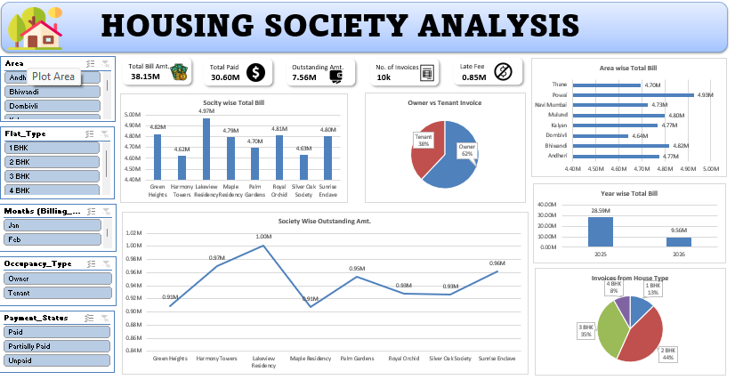

6. Conclusions & Next Steps
The FM billing portfolio is fundamentally sound with an 80%+ collection rate, yet ₹76 lakh remains unrealised. Concentrating recovery effort on the Unpaid segment (especially in Mulund, Powai and high-outstanding societies) and systematically closing Partially Paid balances can lift the overall collection rate by several percentage points within one to two quarters.
Suggested next steps for the Facility Management team:
- Export the list of Unpaid and Partially Paid invoices from the Cleaned Data sheet and assign to collection officers by society.
- Set a monthly dashboard review cadence and track collection-rate trend by society.
- Evaluate introduction of digital payment incentives or automated reminders for residents with recurring late payments.
- Re-run the same analysis after each billing cycle to measure improvement.

