Stakeholder Feedback Report
Project Title: Eco Switch (Eco-Switch-AI)
Project Stage: Prototype
Internship Phase: Week 3
Objective of the Document: To present stakeholder feedback collected for validating the concept, feasibility, usability expectations, and potential impact of the Naked Eco Switch prototype.

1. Introduction
Eco Switch (Eco-Switch-AI) is an AI-based smart energy management solution aimed at reducing electricity wastage through intelligent switching and usage optimization. The project is currently in the prototype stage. As part of Week 3 of the internship, stakeholder feedback was collected to assess the clarity of the concept, relevance of AI usage, feasibility for further development, and expected environmental impact.

2. Feedback Collection Methodology
- Stakeholder feedback was collected using a structured Google Form designed specifically for a prototype-stage evaluation. The form included both quantitative and qualitative questions to gather balanced insights. Respondents included students, faculty members, and individuals with exposure to technology and sustainability concepts.

Feedback was collected to validate:
  - Concept clarity
  - Feasibility
  - Expected usability
  - Environmental impact
This tells evaluators you understand process, not just results.

3. Stakeholder Profile
- - Students with technical background
- Faculty members
- Technology and sustainability enthusiasts
- Early-stage industry exposure respondents
Total responses: 8
- Majority background (students / mixed)
- Experience with AI / eco solutions (average or general observation)
No personal data needed — just high-level summary.

4. Key Feedback Findings
• Most stakeholders reported a clear understanding of the project’s objective and problem statement.
• The use of AI in the proposed solution was perceived as relevant and appropriate for energy optimization.
• Stakeholders recognized strong potential for environmental impact if the system is fully developed.
• The prototype was considered feasible for further enhancement with improvements in automation and usability.

5. Suggested Improvements and Expectations
Stakeholders suggested prioritizing the following features in future iterations:
- Real-time energy monitoring and analytics
- Enhanced AI-based decision-making logic
- Improved user interface for better usability
- Clear visualization of energy savings and eco-impact

6.Quantitative Analysis
This section presents a quantitative analysis of the stakeholder feedback collected through the Google Form. The objective of this analysis is to evaluate stakeholder perception regarding the project’s direction, clarity, usability expectations, and potential environmental impact. The responses are visualized using charts similar to Google Forms analytics for better clarity and interpretation.
6.1 Support for Further Development
Question considered:
“Would you support further development of this project?”
Stakeholders were asked whether they would support the continued development of the Naked Eco Switch (Eco-Switch-AI) prototype. This question aimed to assess overall acceptance and confidence in the project’s direction at its current prototype stage.
The responses indicate that a majority of stakeholders are positively inclined toward further development, suggesting that the core idea and proposed solution are well-received. This provides strong validation for proceeding with additional development and refinement.
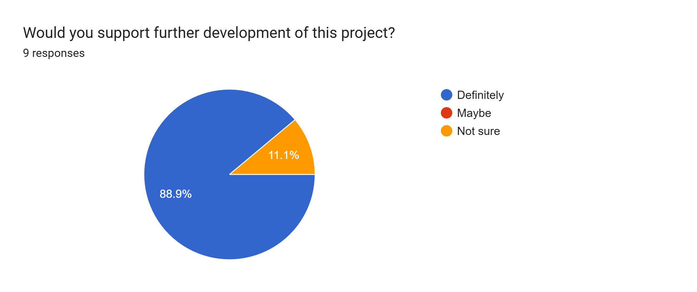
6.2 Expected Environmental Impact
Question considered:
“What level of environmental impact do you expect if this concept is fully developed?”
This question was included to understand stakeholder perception of the project’s potential contribution to environmental sustainability. Respondents evaluated the expected environmental impact assuming the system is fully developed and implemented.
The results show that stakeholders largely expect a moderate to high environmental impact, highlighting the perceived relevance of AI-based smart switching in reducing energy wastage and promoting sustainable practices.
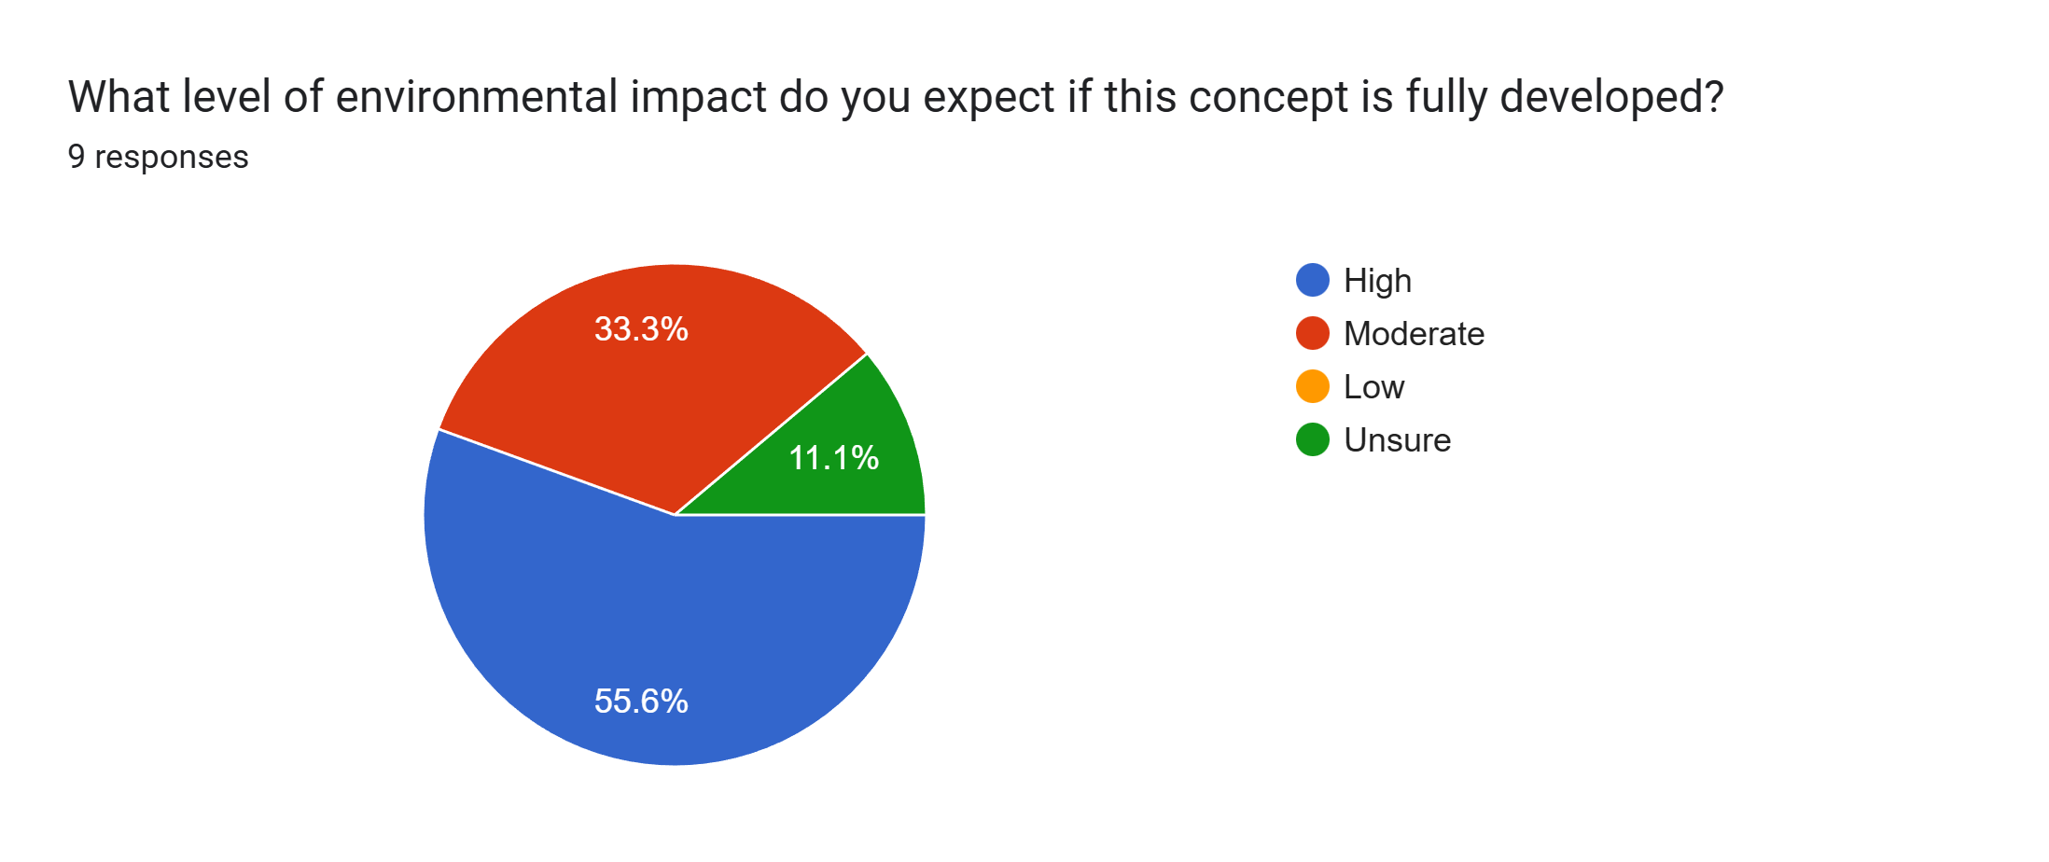
6.3 Clarity of the Project Idea
Question considered:
“How clear is the idea of Eco Switch (Eco-Switch-AI) as presented?”
To evaluate how effectively the project concept was communicated, stakeholders were asked to rate the clarity of the project idea. This analysis helps determine whether the problem statement and solution approach are easily understandable at the prototype stage.
The responses indicate that most stakeholders found the idea to be clear or very clear, suggesting that the project’s objectives and approach are well-defined, even in its early development phase.
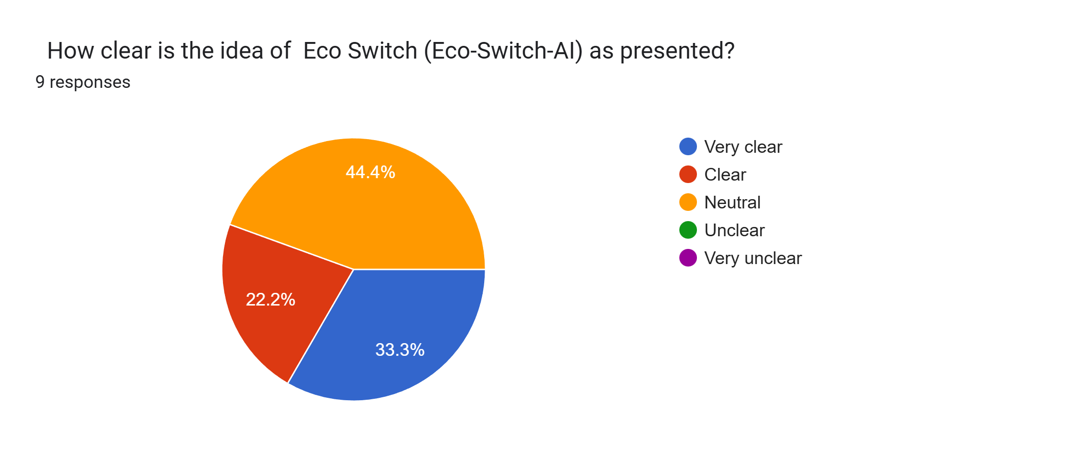

6.4 Usability Expectations
Question considered:
“Based on the concept, how usable do you expect the system to be for end users?”
Stakeholders were asked to evaluate the expected usability of the system based on the current prototype and overall concept presentation. Since the project is in the prototype stage, responses were collected to understand user expectations rather than final usability performance.
The feedback indicates generally positive usability expectations. Most stakeholders believe that the system can be made user-friendly with further refinement, improved interface design, and enhanced system responsiveness. This suggests confidence in the project’s direction while highlighting the importance of usability-focused development in future iterations.
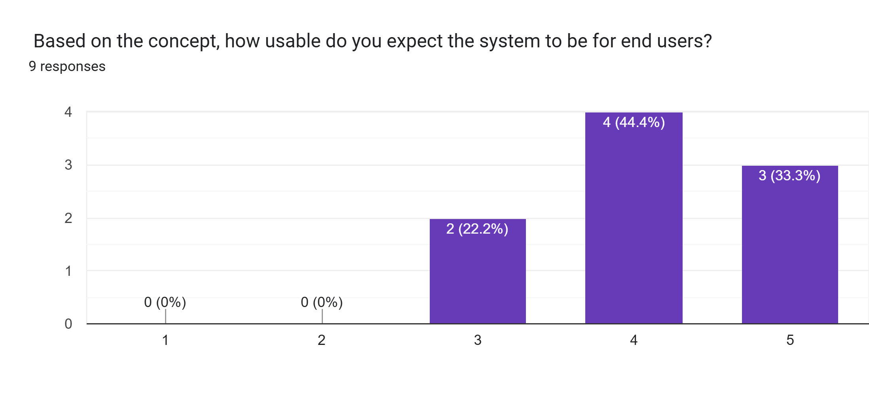
The results indicate that stakeholders perceive usability as a strength of the proposed solution, provided that further interface refinement and user-centered design considerations are applied.
7. Qualitative Insights
In addition to quantitative data, qualitative feedback was collected through open-ended questions to gain deeper insights into stakeholder expectations, suggestions, and perceived challenges. The responses were analyzed and grouped into common themes to identify key areas of improvement and future focus.

7.1 Features Stakeholders Want Next
Multiple stakeholders emphasized the importance of real-time energy monitoring and usage analytics as a priority feature for future development. Respondents expressed interest in having clear visibility into energy consumption patterns, which would help users understand savings and optimize usage more effectively. Enhanced AI-driven automation was also identified as a desirable feature to improve intelligent decision-making.

7.2 Suggestions for Improvement
Stakeholders suggested improving the user interface and overall system usability to ensure ease of adoption by non-technical users. Several responses highlighted the need for clearer data visualization and smoother interaction between users and the system. These suggestions indicate that usability and user experience should be key focus areas in upcoming iterations.

7.3 Risks and Challenges Identified
Some stakeholders identified potential challenges related to system reliability, scalability, and accuracy of AI-based decisions. Others noted concerns about real-world implementation, including adaptability to different environments and user behavior. These insights highlight the importance of thorough testing, validation, and gradual scaling during future development phases.

Overall, the qualitative feedback provided constructive guidance, validating the project’s concept while clearly identifying areas for refinement. These insights will play a critical role in shaping the next iteration of the Naked Eco Switch prototype.
8. Key Learnings
The stakeholder feedback process provided valuable insights and learning opportunities during the prototype stage of development.
Validated Aspects:
- The core idea of AI-based eco-friendly switching was well understood and positively received.
- Stakeholders recognized the relevance of the project in addressing energy wastage and sustainability.
- There was strong support for further development of the system.
Areas Needing Improvement:
- Enhanced usability and interface design
- More refined AI logic and automation
- Clear visualization of energy consumption and savings
Personal Learnings as an Intern/Developer:
- Learned the importance of validating ideas early through stakeholder feedback
- Gained experience in converting user feedback into actionable development goals
- Developed a better understanding of how prototype-stage projects are evaluated in real-world and industry contexts
This feedback-driven approach reinforced the importance of iterative development and user-centered design.

9.Conclusion
Overall, the stakeholder feedback collected during Week 3 reflects a positive response toward the Naked Eco Switch prototype. Stakeholders demonstrated strong support for further development and acknowledged the project’s potential contribution to sustainable energy management.
The feedback received will directly guide the next phase of development by helping prioritize features, address identified challenges, and refine system usability. This validation confirms that the project is progressing in the right direction and provides a strong foundation for future enhancements.

