AIDA CLOUD | MODULE 1: DIGITAL FOUNDATIONS & PYTHON
Session 9: Your First Python Program
Student Study Notes • Read after class to revise
WHAT YOU WILL LEARN
1. Running Python in a Jupyter notebook cell
2. print(): your first command, and its variations
3. Reading an error message calmly
4. Comments (#): notes inside code
5. Meeting the data types and data structures: int, float, str, bool, list, dict

1. Jupyter Notebook
Jupyter Notebook = a page where you write Python in boxes called cells and see the result right under each box.
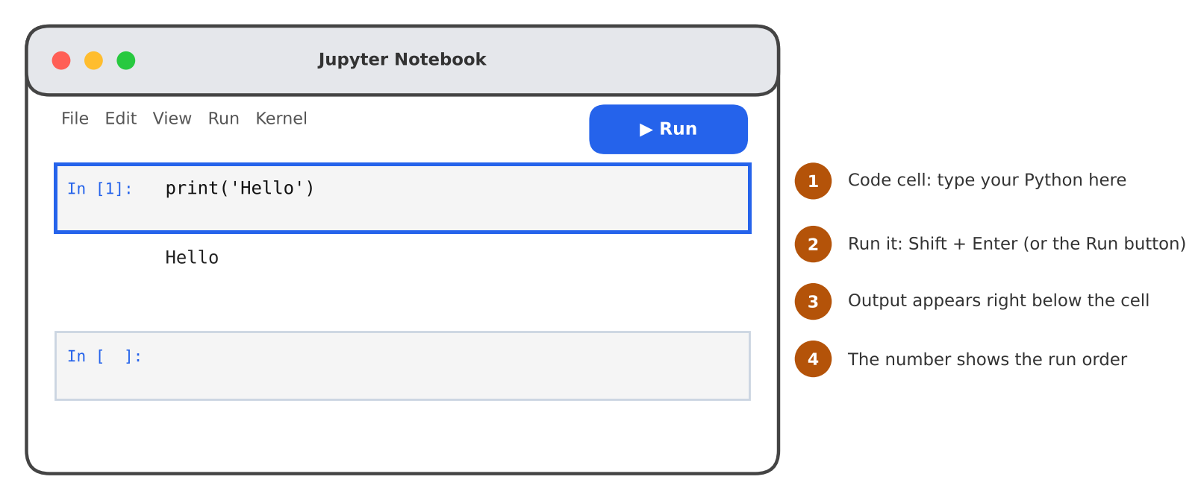
Figure 1: A notebook cell and its output
Term | Meaning
Cell | One box that holds a few lines of code. You run it on its own.
Output | What the cell prints. Shown right below the cell.
Kernel | The Python engine running behind the notebook. It remembers what you ran.
In [1] | The run order. The number goes up each time you run a cell.

Open a notebook
Step | Action
1 | Open the terminal and go to your course folder (cd aida-course).
2 | If Jupyter is missing, install it once: pip install notebook
3 | Start it: jupyter notebook. A browser tab opens.
4 | Click New → Python 3 (ipykernel). A blank notebook opens.
5 | Click in the first cell, type your code, press Shift + Enter.

NOTE
You can also open a .ipynb notebook file directly in VS Code. The cells work the same way.
Save with Ctrl + S (Cmd + S on Mac). Notebook files end in .ipynb.

Useful keys
Keys | Action
Shift + Enter | Run the cell and move to the next one.
Ctrl + Enter | Run the cell and stay on it.
Esc, then B | Add a new cell below.
Esc, then D D | Delete the current cell.

2. Notebook vs Script
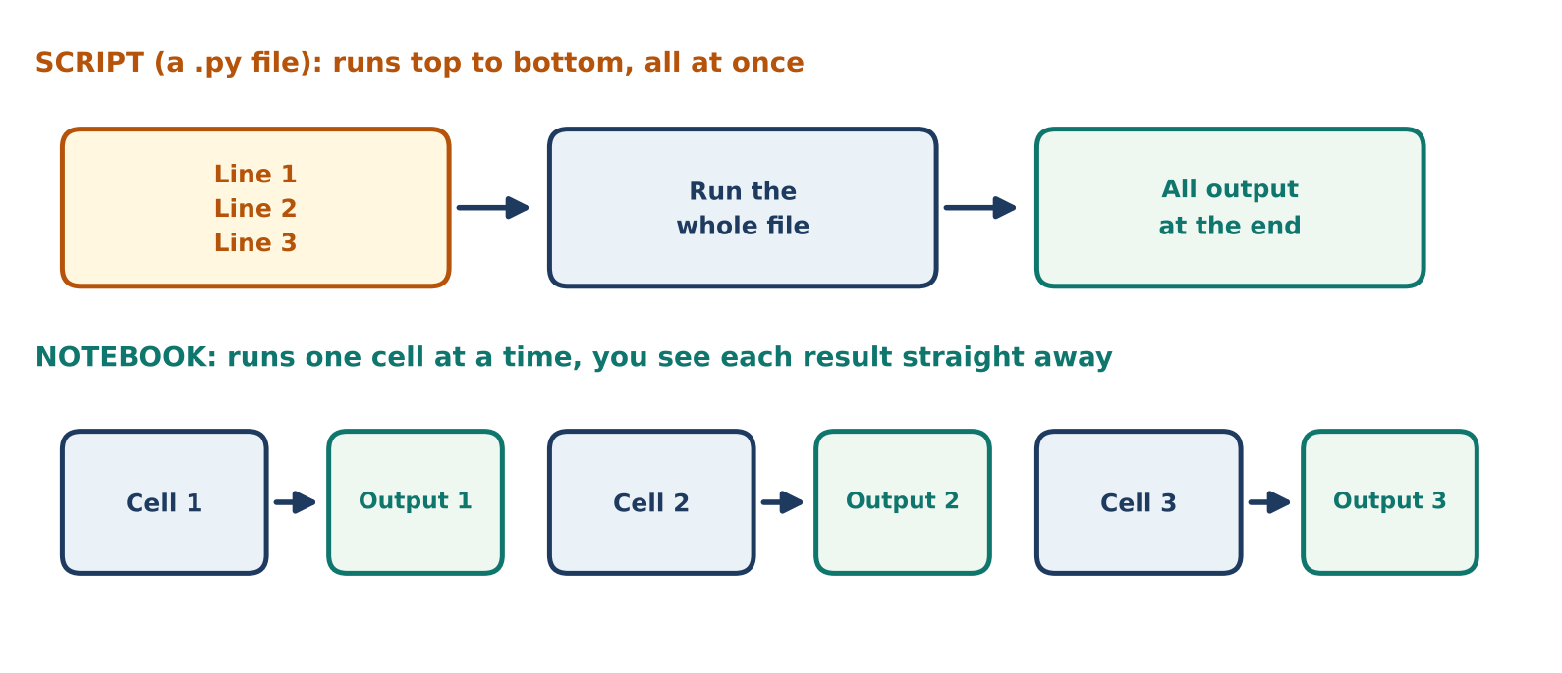
Figure 2: A script runs all at once. A notebook runs cell by cell.
 | Script (.py file) | Notebook (.ipynb)
Runs | Whole file, top to bottom | One cell at a time
Output | All at the end | Under each cell, straight away
Best for | Finished programs | Learning, testing ideas, data work
Mistake | Fix, then run the whole file again | Fix and re-run just that cell

3. print(): Your First Command
print() shows something on the screen. Whatever you put inside the brackets is displayed.
EXAMPLE
print('Hello')
Output: Hello

Parts of a print line
Part | Looks like | Job
Function name | print | The command. Lowercase.
Brackets | ( ) | Hold what you want to show.
Quotes | ' ' or " " | Tell Python this is text. Single or double both work.

Three variations
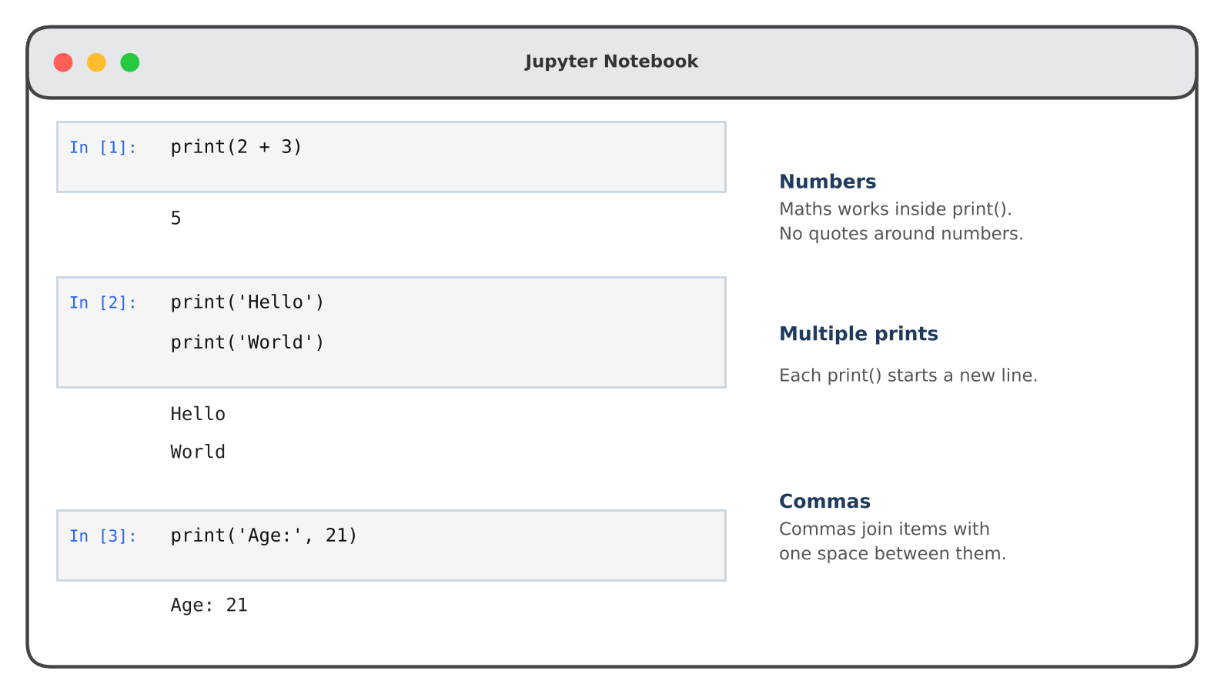
Figure 3: Numbers, multiple prints and commas
Variation | Code | Output
Numbers | print(2 + 3) | 5
Multiple prints | print('Hello') then print('World') | Hello on one line, World on the next
Commas | print('Age:', 21) | Age: 21

REMEMBER
Text needs quotes. Numbers do not.
print(2 + 3) shows 5 (Python calculates)
print('2 + 3') shows 2 + 3 (Python just displays the text)

4. Reading an Error Message Calmly
An error is Python telling you what to fix. It is a friend, not a failure. Every programmer sees errors every day.
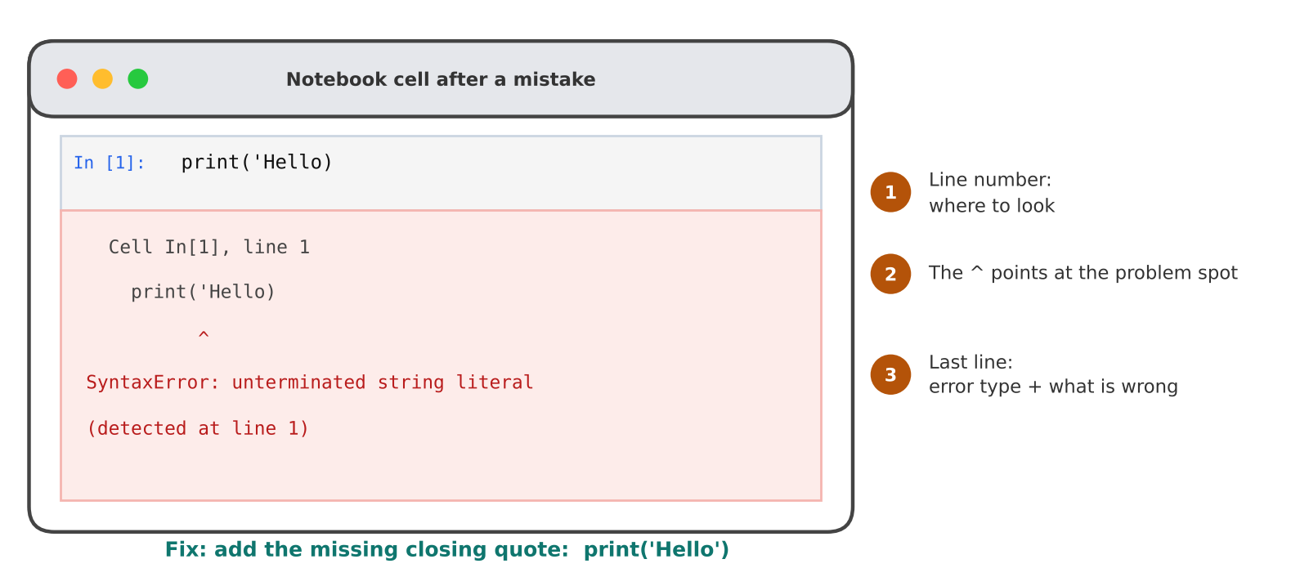
Figure 4: The parts of an error message

How to read one, in 4 steps
Step | What to do
1 | Take a breath. Nothing is broken. Your computer is fine.
2 | Read the last line first. It names the error type and says what is wrong.
3 | Find the line number and look at that line. The ^ points to the spot.
4 | Fix it and run the cell again.

Common errors in print
Code | Error message | Fix
print('Hello) | SyntaxError: unterminated string literal | Add the closing quote.
print('Hello' | SyntaxError: '(' was never closed | Add the closing bracket ).
print(Hello) | NameError: name 'Hello' is not defined | Put the text in quotes.
Print('Hello') | NameError: name 'Print' is not defined | Use lowercase: print.
print 'Hello' | SyntaxError: Missing parentheses in call to 'print' | Use brackets: print('Hello').

TIP
Python is case-sensitive: print and Print are different words.
Copy the last line of an error into a search engine. Many people have met it before.

5. Comments
A comment is a note for humans. Python ignores everything after # on that line.
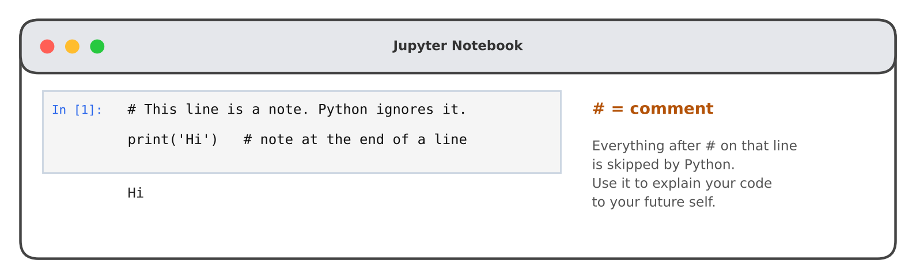
Figure 5: Comments are not run
Use | Example
Explain what code does | # Show a greeting
Note at end of a line | print('Hi') # greeting
Switch a line off for now | # print('Test') (Python skips it)

6. Data Types and Data Structures (Preview)
Today we only meet the names. Each one gets its own session later. You will see them again and again.
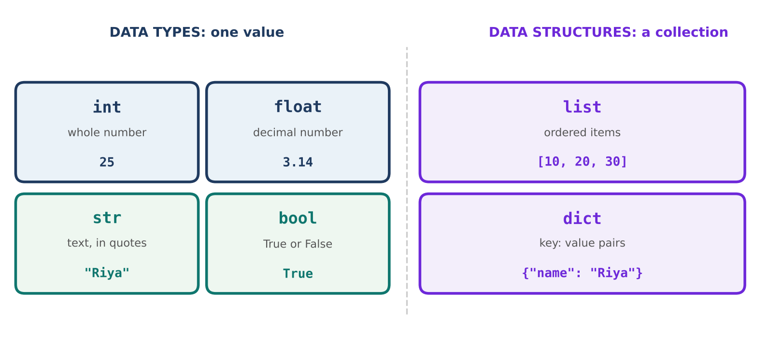
Figure 6: Six building blocks of Python data
Name | Meaning | Example | Check with type()
int | Whole number | 25 | print(type(25)) → <class 'int'>
float | Number with a decimal point | 3.14 | <class 'float'>
str | Text (in quotes) | "Riya" | <class 'str'>
bool | True or False | True | <class 'bool'>
list | Ordered items in [ ] | [10, 20, 30] | <class 'list'>
dict | key: value pairs in { } | {"name": "Riya"} | <class 'dict'>

REMEMBER
int, float, str and bool hold one value. list and dict hold many values (data structures).
True and False start with a capital letter.
type() tells you what kind of data something is. We use it again later.

7. Practice (Do it yourself)

Follow the class steps
- Run: In a new notebook, type print('Hello') and press Shift + Enter.
- Break it: Delete the last quote. Run it. Read the error line by line. Fix it.
- Three variations: Try print(2 + 3), two prints in one cell, and print('Age:', 21).
- Comment: Add a # line above your code. Run again. Nothing changes.
- Tour: Run print(type(25)) and the same for 3.14, "Riya", True, [1, 2] and {"a": 1}.

Now write your own (solo, in a fresh notebook)
# | Idea
1 | Print your name and your city on two lines.
2 | Print a sentence with a number using a comma, for example your age.
3 | Print the result of a calculation, for example 12 * 4.
4 | Add a # comment above each program explaining what it does.

Write at least two programs. If you see an error, read the last line first.

8. Cheat Sheet
Code | Meaning
print('text') | Show text
print(5 + 3) | Show a calculation result
print('A:', 5) | Show text and a value together
# note | Comment, ignored by Python
type(value) | Tells the data type
Shift + Enter | Run the cell

9. Quick Revision
Question | Answer
What does print() do? | Shows something on the screen.
How do you run a notebook cell? | Shift + Enter
Which line of an error do you read first? | The last line.
What does # do? | Starts a comment that Python ignores.
Name the six types and structures. | int, float, str, bool, list, dict
print(2 + 3) vs print('2 + 3')? | 5 vs 2 + 3

Self-check
- What error do you get from print('Hello) and how do you fix it?
- Why is print(Hello) an error but print('Hello') is not?
- Which of the six are data structures?

