AIDA CLOUD | MODULE 1: DIGITAL FOUNDATIONS & PYTHON
Session 1: How Computers Run Programs
Student Study Notes • Read after class to revise
WHAT YOU WILL LEARN
1. What software is
2. Files, folders and paths
3. What an Operating System (OS) does
4. What “code” means: source code, interpreter, compiler

1. What is Software?
Software = a set of instructions that tell the computer what to do, step by step. It is not magic. The computer only follows the steps it is given.
Term | Meaning and example
Hardware | Physical parts you can touch. Example: keyboard, screen, CPU, hard disk.
Software | Instructions that run on hardware. Example: Chrome, WhatsApp, Excel, VS Code.
Instruction | One small step. Example: “Add 2 + 3”, “Show this text on screen”.

EXAMPLE
Calculator app: You press 5 + 3 → the software follows its instructions: read 5, read 3, add, show 8.

2. Files, Folders and Paths
Term | Meaning | Example
File | One item that stores data. | resume.docx, photo.jpg, app.py
Folder | A container that holds files and other folders. | Documents, Downloads
Path | The full address of a file or folder. | C:\Users\Riya\Documents\app.py (Windows)  /Users/riya/Documents/app.py (Mac)

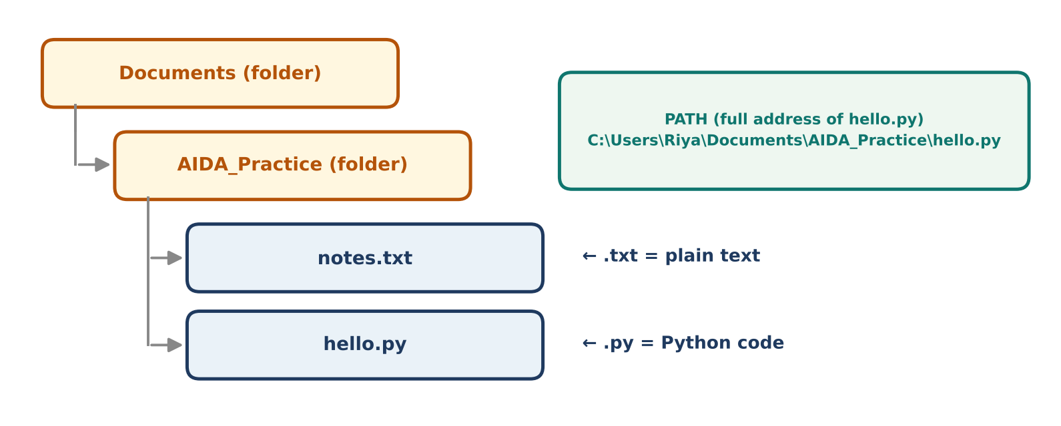
Figure 1: Folders, files and the full path of a file

File extension
The extension is the part after the dot. It tells the computer (and you) the file format.
Extension | Type | Opens with
.txt | Plain text | Notepad, VS Code
.py | Python code | VS Code, Python
.docx | Word document | MS Word
.jpg | Image | Photos, browser

REMEMBER
Extension is only a format hint. Renaming notes.txt to notes.py does not make it real Python code.
Windows and Mac use different path styles (\ vs /), but the idea is the same: folder → folder → file.

3. What does an Operating System (OS) do?
OS = the manager between you, your apps and the hardware. Examples: Windows, macOS, Linux.
OS job | Example
Runs programs | You double-click Chrome → OS loads it and starts it.
Manages files | You save a file → OS decides where on the disk it is stored.
Shares hardware | Music, browser and Word run together → OS gives each its share of CPU and memory.
Handles input/output | You type on the keyboard → OS passes it to the active app.

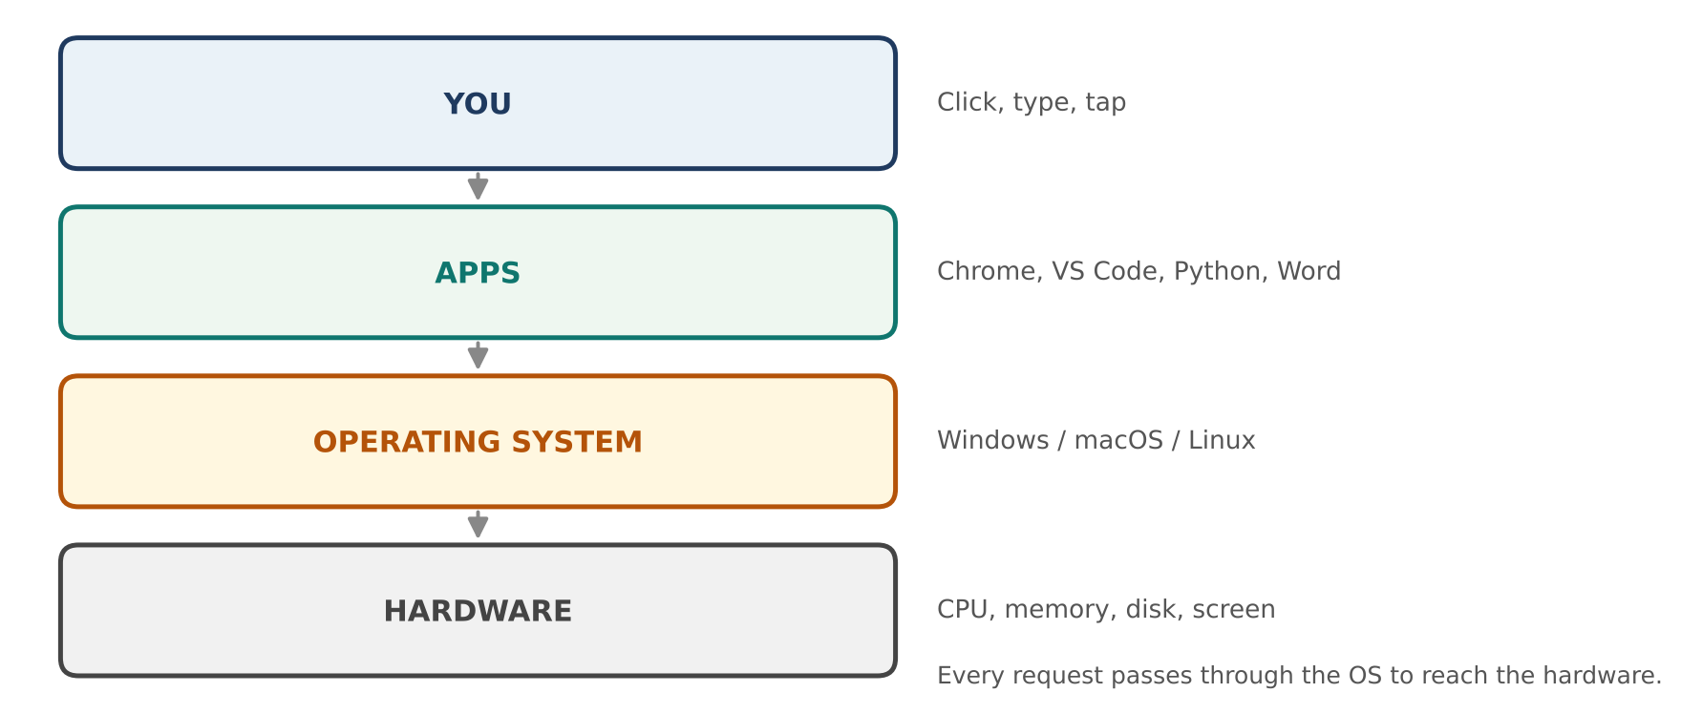
Figure 2: Where the OS sits between you and the hardware

4. What does “Code” mean?
Code = instructions written in a programming language (like Python) that humans can read.
EXAMPLE: A simple line of Python code
print("Hello, World!")
This instruction tells the computer: show the text Hello, World! on the screen.

Source code → Machine
A computer only understands 0s and 1s (machine language). Human-written code must be translated first.
 | Interpreter | Compiler
How it works | Translates and runs the code line by line. | Translates the whole code first, then runs it.
Analogy | Live translator: speaks each sentence as you say it. | Book translator: translates the full book, then you read it.
Example language | Python | C, C++

Flow: Source code (app.py) → Interpreter (Python) → Computer runs it → Output
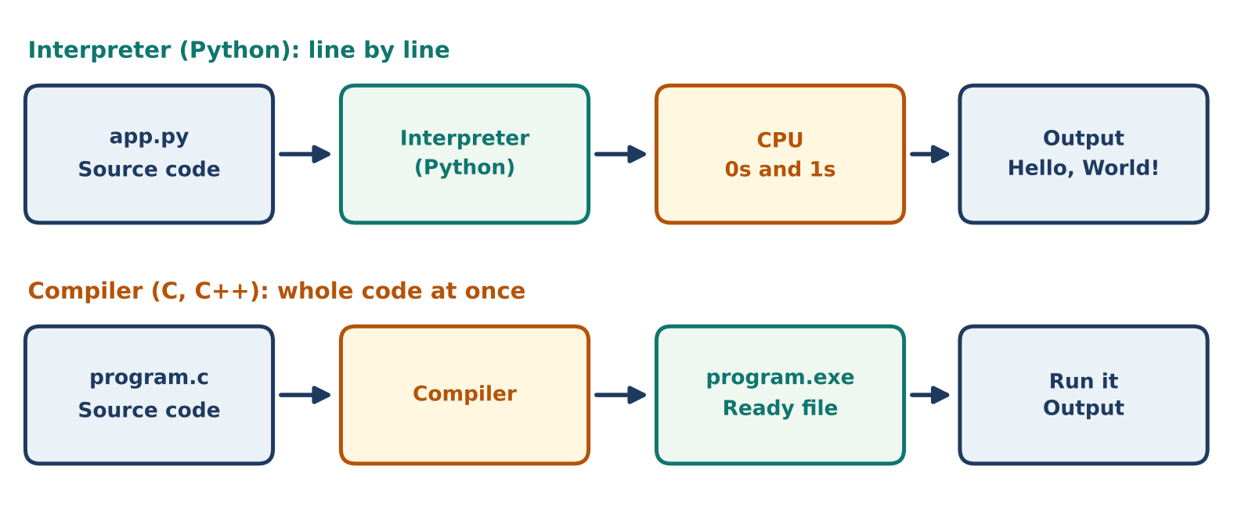
Figure 3: Interpreter vs compiler flow

5. Everyday Analogy: Kitchen
Kitchen | Computer | Example
Recipe | Code | print("Hello")
Cook | Interpreter / CPU | Python
Kitchen (stove, tools, space) | Operating System | Windows, macOS
Ingredients | Data | Names, numbers, files
Finished dish | Output | Text on screen, a saved file

6. Practice (Do it yourself)
Repeat what we did in class. Treat every click as an instruction.
- Explore: Open File Explorer (Windows) or Finder (Mac). Open Documents and look at the folder tree.
- Show extensions: Turn on “File name extensions” (Windows: View menu) or “Show all filename extensions” (Mac: Finder → Settings → Advanced).
- Create: Make a new folder named AIDA_Practice.
- Rename and move: Rename it to Session1, then move any file into it.
- Compare: In VS Code, open a notes.txt and a hello.py. Note how the extension changes the file type shown.

7. Quick Revision
Question | Answer
What is software? | A set of instructions for the computer.
What is a path? | The full address of a file or folder.
What does the extension tell us? | The file format (a hint only).
What does an OS do? | Manages programs, files and hardware.
Interpreter vs compiler? | Line by line vs whole code at once.

Self-check
- Write the path of a file named data.csv inside a folder Reports on your Desktop.
- Is Python mostly interpreted or compiled?
- Give one example of the OS sharing hardware between two apps.

