AIDA CLOUD | MODULE 1: DIGITAL FOUNDATIONS & PYTHON
Session 2: How the Internet Works
Student Study Notes • Read after class to revise
WHAT YOU WILL LEARN
1. Client-server model
2. What a website really is
3. What an API is (request and response)
4. DNS: how a name becomes an address

1. Client-Server Model
The internet works on requests and responses. A client asks. A server answers.
Term | Meaning | Example
Client | The device or app that asks for something. | Your browser (Chrome, Edge)
Server | A computer that stores data and replies to requests. | Google's computer that holds the search page
Request | The question the client sends. | “Give me the homepage”
Response | The answer the server sends back. | The homepage files

Restaurant analogy
Restaurant | Internet | Example
Customer | Client | Your browser
Kitchen | Server | Website's computer
Order | Request | “Show me amazon.in”
Food served | Response | The web page

Flow: Client → Request → Server → Response → Client
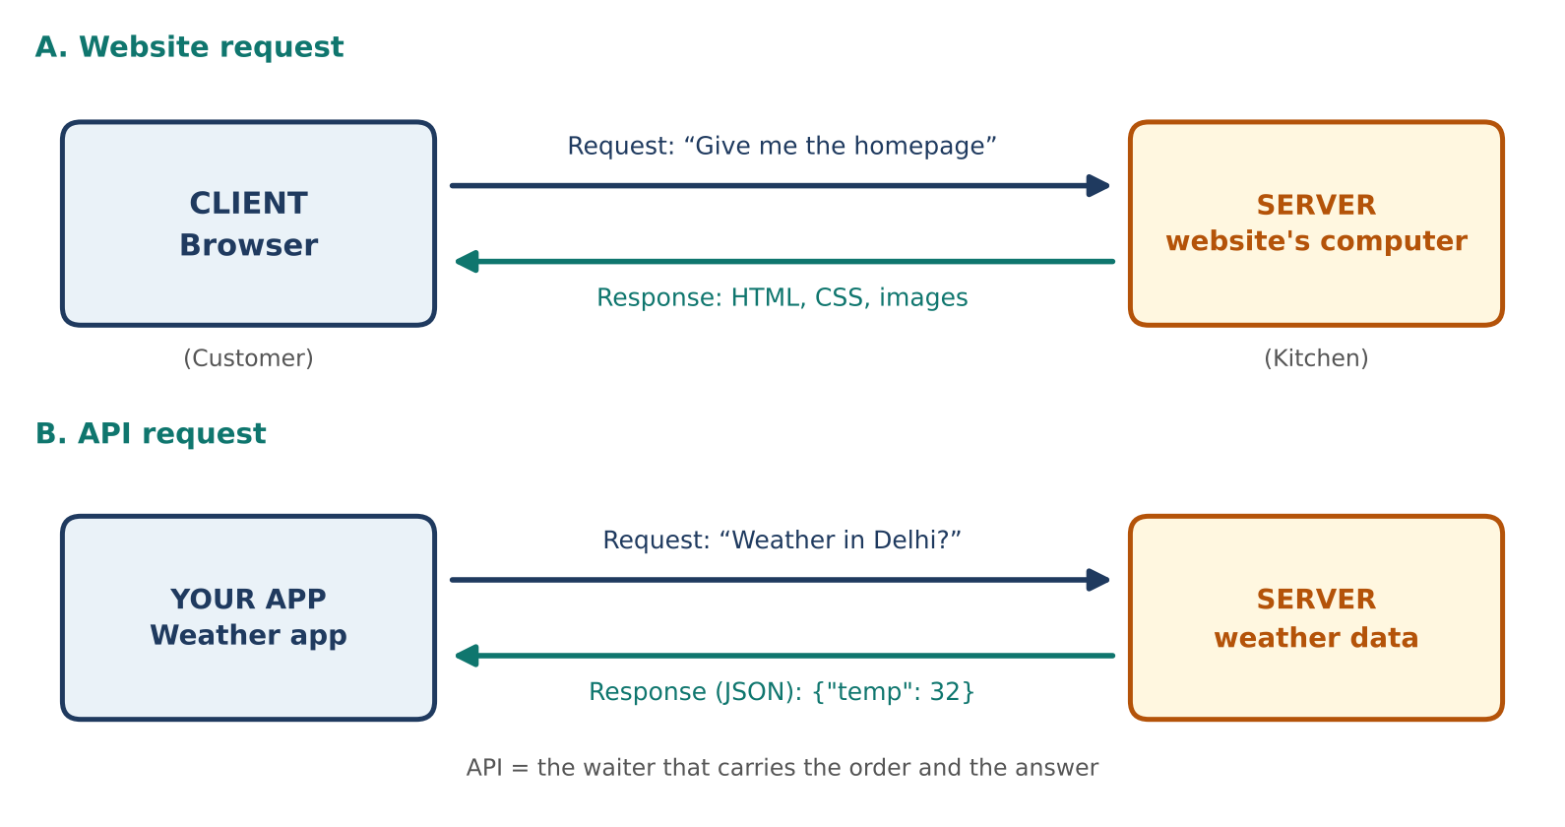
Figure 1: Client-server request and response (website and API)

2. What is a Website, Really?
A website = a set of files stored on a server. The server sends them, and your browser shows them. Nothing more.
File type | Job | Example
HTML | Structure and content | Headings, paragraphs, buttons
CSS | Looks and style | Colors, fonts, layout
JavaScript | Behavior | Click a button → menu opens
Images | Pictures | logo.png, banner.jpg

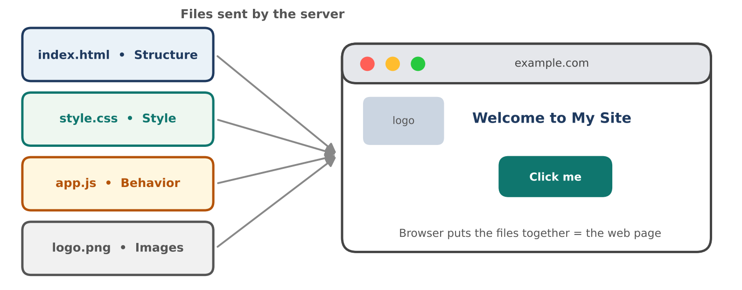
Figure 2: A web page is built from files sent by the server
EXAMPLE
You type example.com → the server sends HTML, CSS and image files → the browser puts them together → you see the page.

REMEMBER
The browser does not “open a website”. It downloads files and displays them.
Right-click → View Page Source shows the raw HTML the server sent.

3. What is an API?
API = a way for one program to ask another program for data. It follows the same request and response idea.

Waiter analogy
Restaurant | API world | Example
Customer | Your app | Weather app
Waiter | API | The connection point
Kitchen | Server / database | Weather company's server
Order → Dish | Request → Response | “Weather in Delhi?” → “32°C, sunny”

What an API response looks like (JSON)
EXAMPLE: JSON response
{ "city": "Delhi", "temp": 32, "sky": "sunny" }
JSON is plain text with key: value pairs. It is easy for both humans and programs to read.

Website vs API: A website returns a page (HTML) for humans to see. An API returns raw data (JSON) for programs to use.

4. DNS Basics
DNS = the internet's phonebook. It converts a name into a number (IP address), because computers find each other by numbers.
Phonebook | DNS | Example
Person's name | Domain name | google.com
Phone number | IP address | 142.250.190.14

What happens when you type google.com
- Browser asks DNS: “What is the address of google.com?”
- DNS replies with the IP address.
- Browser sends a request to that address.
- Server sends back the page files.
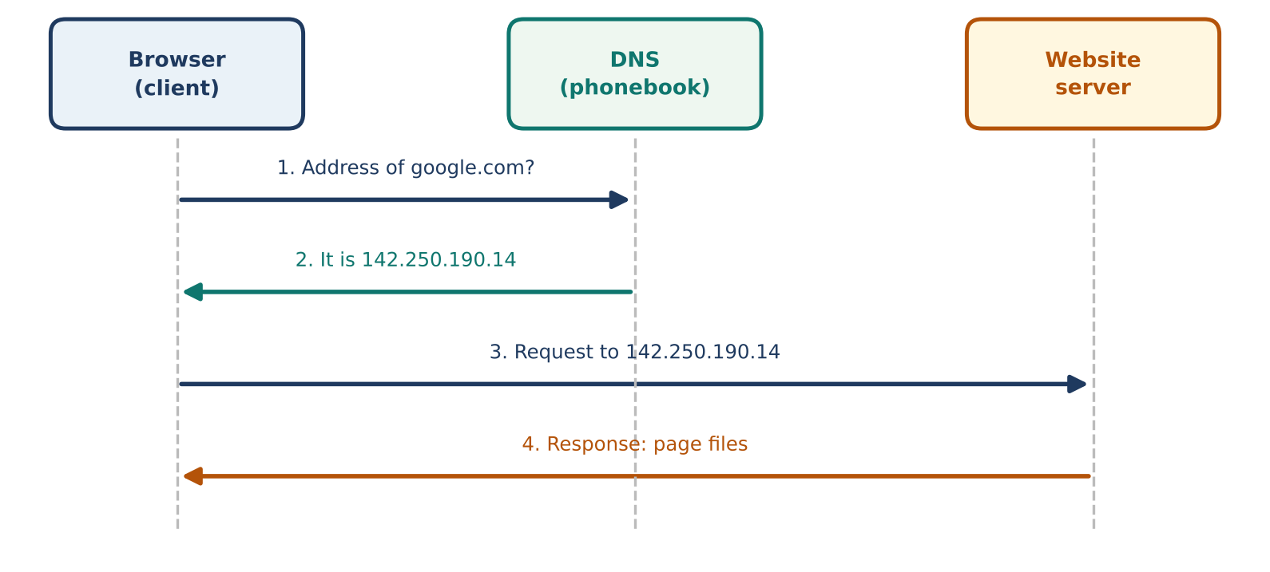
Figure 3: DNS lookup, step by step

5. Practice (Do it yourself)
Repeat what we did in class using Chrome or Edge.
- Open DevTools: Go to any simple website. Press F12 and click the Network tab.
- Reload: Refresh the page. Watch the requests appear. Each row is one request.
- Inspect: Click one request. Look at the Request Headers and Response Headers.
- View source: Type view-source: before the site address. Compare the HTML with the page you see.
- Try an API: Open any public API URL in the browser. Notice the raw JSON instead of a page.
- Draw: Sketch Client → Request → Server → Response for the page you reloaded.

6. Quick Revision
Question | Answer
Who is the client? | The device or app that asks (browser).
Who is the server? | The computer that stores data and replies.
What is a website? | Files (HTML, CSS, JS, images) sent by a server.
What is an API? | A way for programs to request data from each other.
What does DNS do? | Converts a domain name into an IP address.

Self-check
- In the restaurant analogy, who is the waiter in an API?
- What is the difference between a web page response and an API response?
- Why do we need DNS?

