AIDA CLOUD | MODULE 1: DIGITAL FOUNDATIONS & PYTHON
Session 3: Meet the Terminal I
Student Study Notes • Read after class to revise
WHAT YOU WILL LEARN
1. Why professionals use the terminal
2. How to open the terminal
3. Navigation commands: pwd, ls / dir, cd
4. Absolute vs relative paths
5. Tab, up-arrow and reading error messages

1. Why Use the Terminal?
Terminal = a text window where you give the computer instructions by typing. No mouse, no clicks.
Reason | What it means | Example
Speed | One command can do what many clicks do. | Rename 500 files with one command instead of 500 right-clicks.
Automation | Commands can be saved and re-run. | Run the same backup every day automatically.
Remote servers | Servers far away have no screen or mouse. Only text. | You connect to a company server from your laptop and work on it by typing.

2. Opening the Terminal
 | Windows | Mac
App name | Windows Terminal / PowerShell | Terminal
How to open | Start menu → type “Terminal” → Enter | Cmd + Space → type “Terminal” → Enter
Prompt looks like | PS C:\Users\Riya> | riya@mac ~ %

REMEMBER
The text before > or % is the prompt. It shows where you are right now.
Type a command, then press Enter to run it.

3. The Three Navigation Commands
Command | What it does | Example
pwd | Shows where you are (Print Working Directory). | pwd → /Users/riya
ls (Mac)  dir (Windows) | Lists files and folders inside the current folder. | ls → Desktop Documents Downloads
cd | Moves into a folder (Change Directory). | cd Documents
cd .. | Goes one level up (back out). | From Documents → back to Riya

NOTE
PowerShell understands pwd, ls and dir, so the same commands work on Windows too.
Match the terminal with File Explorer / Finder: the folder you see there is the one pwd shows here.
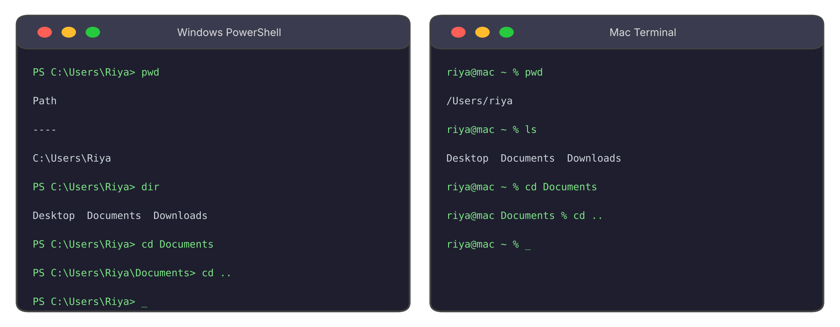
Figure 1: The same commands in Windows PowerShell and Mac Terminal

4. Absolute vs Relative Paths
 | Absolute path | Relative path
Meaning | Full address from the very top. | Address from the folder you are in now.
Starts with | C:\ (Windows) or / (Mac) | A folder name, or .. or .
Works from | Anywhere | Only from the right starting folder
Example | cd /Users/riya/Documents | cd Documents
Analogy | “Flat 4, Park Street, Kolkata” | “Second house on your left”

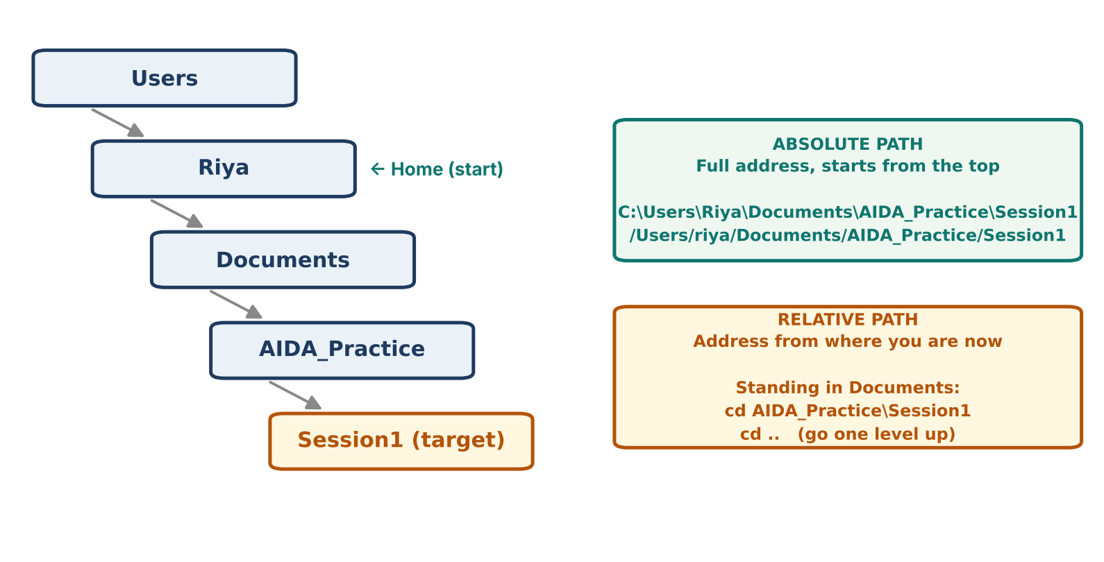
Figure 2: Folder tree with absolute and relative paths

Useful shortcuts
Symbol | Meaning
. | The current folder.
.. | The parent folder (one level up). Example: cd ..
~ | Your home folder (Mac). Example: cd ~

5. Moving Without Fear
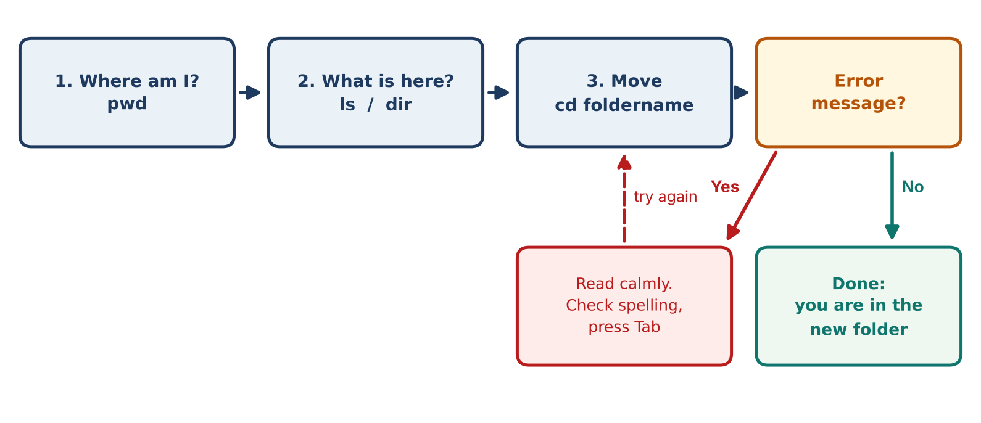
Figure 3: A safe navigation routine

Tab completion
Type the first letters of a name and press Tab. The terminal finishes it for you.
EXAMPLE
Type cd Doc → press Tab → it becomes cd Documents
Saves typing and avoids spelling mistakes.

Up-arrow recall
Press ↑ to bring back your last command. Press it again to go further back. Press Enter to run it again.

Errors are normal
A mistyped path gives an error. It does not break anything. Read the message, fix the spelling, run again.
System | Example error for cd Documnts
Windows | Set-Location : Cannot find path 'C:\Users\Riya\Documnts' because it does not exist.
Mac | cd: no such file or directory: Documnts

Fix: Check the spelling, use ls / dir to see the real name, or use Tab.

6. Practice (Do it yourself)
Repeat what we did in class.
- Open the terminal. Run pwd and ls (Mac) or dir (Windows).
- Match: Open File Explorer / Finder at the same folder. Compare what you see with the terminal output.
- Go in: Run cd Documents, then cd AIDA_Practice (the folder from Session 1). Run pwd after each step.
- Go out: Run cd .. twice. Check with pwd.
- Tab and ↑: Type cd Doc and press Tab. Then press ↑ to bring back old commands.
- Make a mistake: Type cd Documnts. Read the error, then fix it.

7. Quick Revision
Question | Answer
Why use the terminal? | Speed, automation, remote servers.
Which command shows where I am? | pwd
Which command lists the contents? | ls (Mac) or dir (Windows)
How to go one folder up? | cd ..
Absolute vs relative path? | Full address from the top vs address from here.
What helps avoid typos? | Tab completion

Self-check
- You are in /Users/riya. Write the relative path to go into Documents.
- What does cd .. do if you are in Documents?
- Is C:\Users\Riya\Desktop absolute or relative?

