AIDA CLOUD | MODULE 1: DIGITAL FOUNDATIONS & PYTHON
Session 4: Meet the Terminal II + Tool Setup
Student Study Notes • Read after class to revise
WHAT YOU WILL LEARN
1. File commands: mkdir, cp, mv, rm (and rm safety)
2. What Python and VS Code are, and why you need them
3. PATH: why “command not found” happens and how to fix it
4. Checking your installs
5. The clean course folder structure

1. File Commands
Command | What it does | Example
mkdir | Make a new folder. | mkdir test_folder
cp | Copy a file. The original stays. | cp notes.txt test_folder
mv | Move a file. Also used to rename. | mv notes.txt old_notes.txt (rename)
rm | Remove (delete) a file. | rm notes.txt

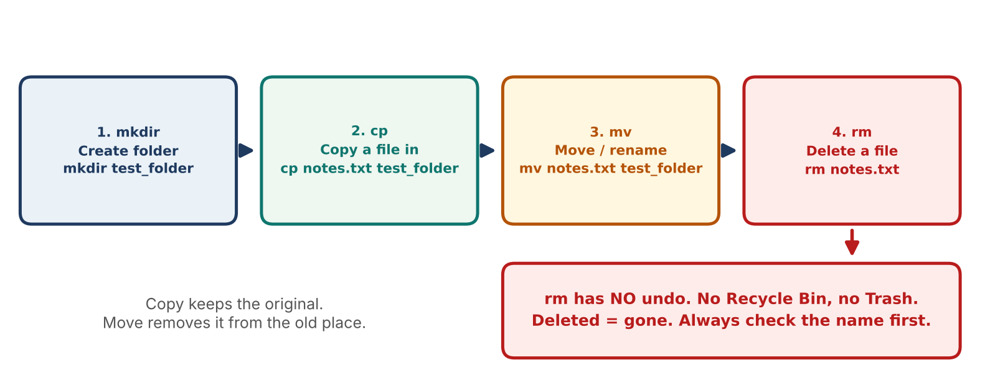
Figure 1: The four file commands in order
⚠ rm SAFETY WARNING
rm has no undo. Files do not go to the Recycle Bin or Trash. They are gone for good.
• Run ls / dir first and check the exact file name.
• Never run rm -r on a folder unless you are sure what is inside it.
• Practice only on files inside your test folder.

Worked example
Command | Result
mkdir test_folder | Folder test_folder is created.
cp notes.txt test_folder | notes.txt now exists in two places.
mv notes.txt archive.txt | The original is renamed to archive.txt.
rm test_folder/notes.txt | The copy is deleted. (Windows: test_folder\notes.txt)

2. Python and VS Code
 | Python | VS Code
What it is | A programming language. You write instructions in it. | A code editor. The place where you write and run code.
Analogy | The language you write in (English) | The notebook and pen you write with
Used for | Data, automation, AI, web | Writing code, running it, built-in terminal
Example | print("Hello") | Open hello.py, click Run

Why every course needs them: from now on, every session writes and runs Python code inside VS Code.

pip
pip is Python's app installer. It downloads extra tools (libraries) for Python. Example: pip install pandas

3. PATH in Plain Words
PATH = a list of folders the computer searches when you type a command. If the program is not in any of those folders, you get an error.
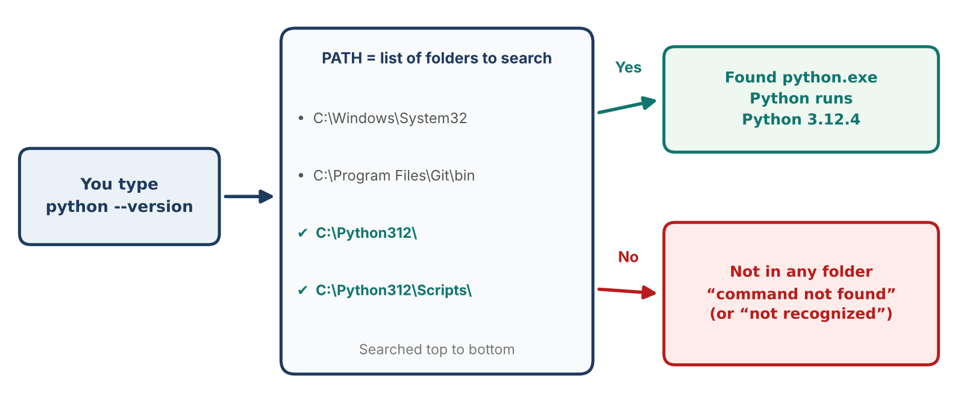
Figure 2: How the terminal uses PATH to find a command
EXAMPLE
You type python. The terminal looks in each PATH folder. Python is installed, but its folder is missing from PATH → command not found.
The program exists. The terminal just does not know where to look.

How to fix it
Problem | Fix
python not found (Windows) | Re-run the Python installer. Tick “Add python.exe to PATH”. Choose Modify / Install.
python not found (Mac) | Use python3 --version and pip3 --version. If still missing, reinstall Python from python.org.
code not found (Mac) | In VS Code press Cmd+Shift+P → type “Shell Command: Install 'code' command in PATH”.
code not found (Windows) | Re-run the VS Code installer and tick “Add to PATH”.

REMEMBER
After changing PATH or reinstalling, close the terminal completely and open a new one.
The old window does not see the change.

4. Check Your Installs
Command | Good output looks like | Checks
python --version | Python 3.12.4 | Python
pip --version | pip 24.0 from ... | pip
code --version | 1.90.0 | VS Code

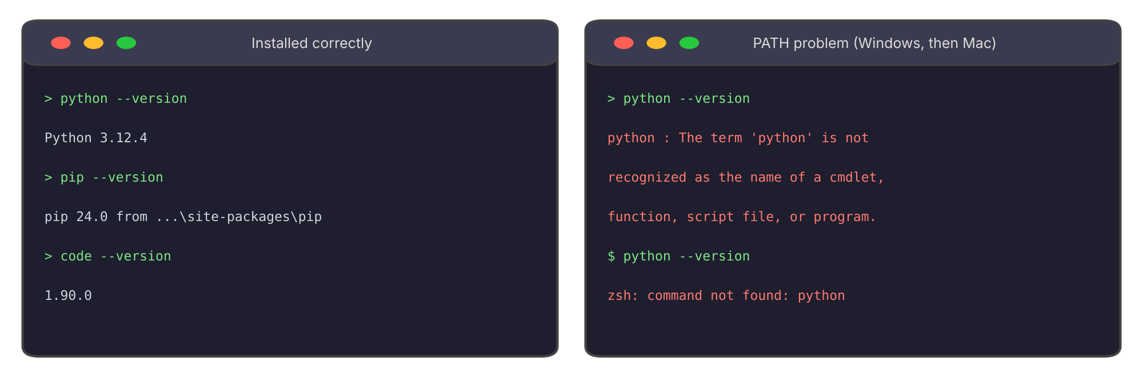
Figure 3: A working install vs a PATH problem
Mac note: use python3 and pip3 if python is not recognized.

5. Course Folder Structure
One clean folder keeps all your work in one place. We set this up together in class.
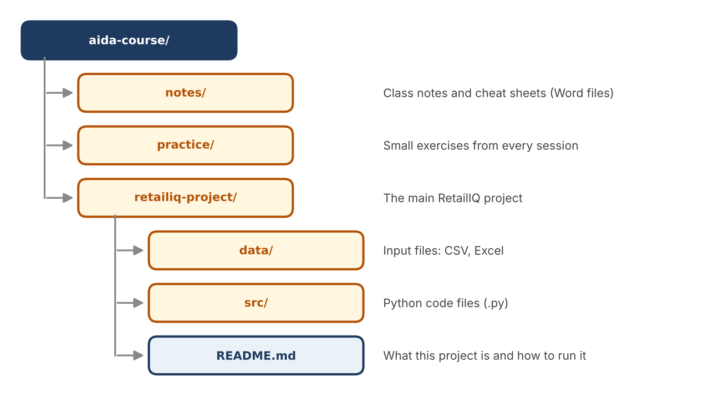
Figure 4: The course folder structure

Create it from the terminal
COMMANDS
mkdir aida-course
cd aida-course
mkdir notes practice retailiq-project
cd retailiq-project
mkdir data src

Tip: use lowercase names and hyphens. Avoid spaces in folder names. A space can break commands.

6. Practice (Do it yourself)
- Test folder: Run mkdir test_folder.
- Copy and move: Create notes.txt in VS Code. Run cp notes.txt test_folder, then mv notes.txt archive.txt.
- Delete safely: Run ls / dir. Then rm the copy inside test_folder only.
- Verify: Run python --version, pip --version and code --version. Note any error.
- Fix PATH: If something is not found, use the fix table above. Open a new terminal and test again.
- Build: Create the aida-course folder structure from Figure 4.

7. Quick Revision
Question | Answer
Which command makes a folder? | mkdir
Copy vs move? | cp keeps the original. mv removes it from the old place.
Can you undo rm? | No. The file is permanently deleted.
What is VS Code? | A code editor for writing and running code.
What is PATH? | The list of folders searched for commands.
What does “command not found” mean? | The program is not in any PATH folder.
What to do after fixing PATH? | Close and reopen the terminal.

Self-check
- Write the command to copy report.csv into a folder named data.
- Why should you run ls before rm?
- python works on your friend's laptop but not yours. What do you check first?

