AIDA CLOUD | MODULE 1: DIGITAL FOUNDATIONS & PYTHON
Session 5: What Is Cloud Computing?
Student Study Notes • Read after class to revise
WHAT YOU WILL LEARN
1. Renting vs buying computers (what “cloud” means)
2. What AWS is and why companies use it
3. Four core AWS services: S3, EC2, Lambda, Bedrock
4. A quick tour of the AWS Console
5. Setting a budget alert so you never get a surprise bill

1. Cloud = Rented Computers
Cloud computing = renting computing power over the internet instead of buying and running your own machines.
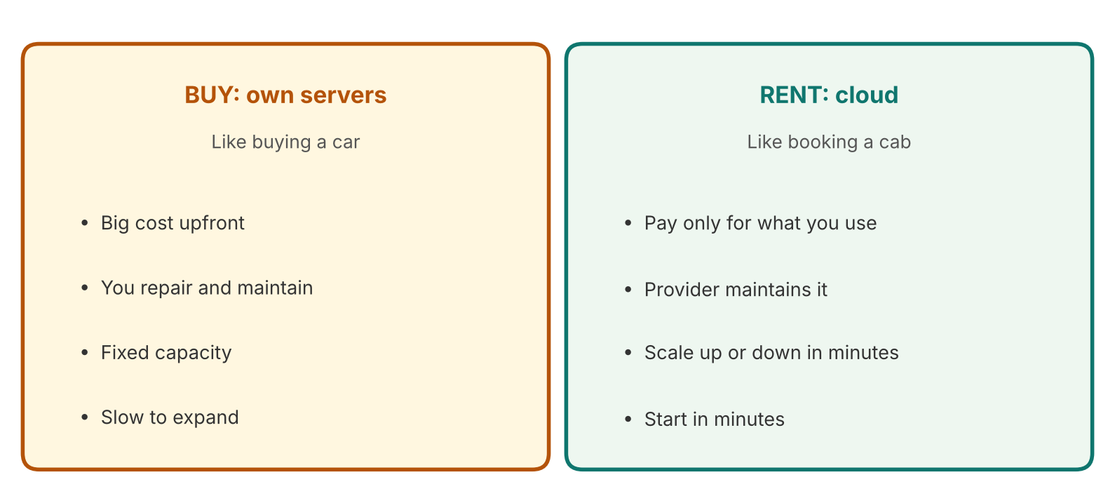
Figure 1: Buying servers vs renting from the cloud
 | Buy (own servers) | Rent (cloud)
Cost | Large payment upfront | Pay for what you use
Setup time | Weeks or months | Minutes
Growth | Buy more machines | Click to add more
Example | A company builds its own server room. | A startup launches an app in one afternoon.

EXAMPLE
Shopping website on sale day: traffic jumps 10x for one day. With the cloud, extra computers are rented for that day and released after. With owned servers, the company must buy machines that sit idle the rest of the year.

2. What is AWS?
AWS (Amazon Web Services) is a cloud provider. It rents out computers, storage, databases, AI and more, from data centres around the world.
Why it is widely used | Meaning
Many services | Hundreds of tools in one place.
Pay as you go | No upfront hardware cost.
Global | Data centres in many regions.
Enterprise trust | Banks, retailers and startups run on it.

NOTE
AWS is one provider. Others exist (Microsoft Azure, Google Cloud). The ideas you learn here carry over.

3. Four Core Services
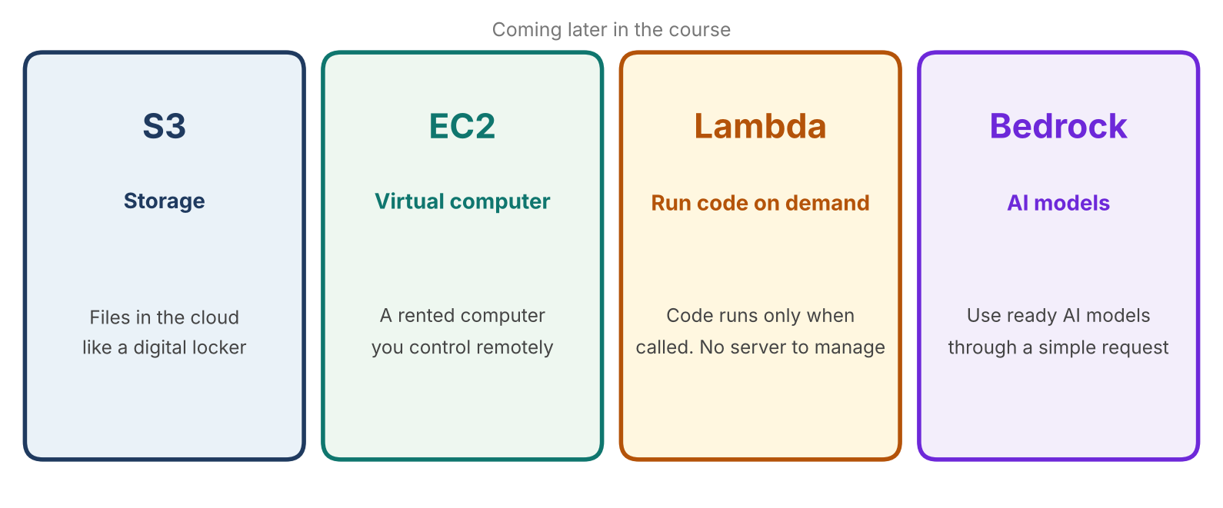
Figure 2: The four AWS services used later in this course
Service | Think of it as | Example
S3 | A digital locker | Store your documents, images and datasets.
EC2 | A rented computer | Run a website on a computer you control remotely.
Lambda | A helper that runs on call | Run a small piece of code only when a user clicks.
Bedrock | AI models on tap | Ask an AI model a question from your own code.

How they work together: the capstone RAG bot
In class we saw a finished bot on a public URL. It answers questions using your own documents.
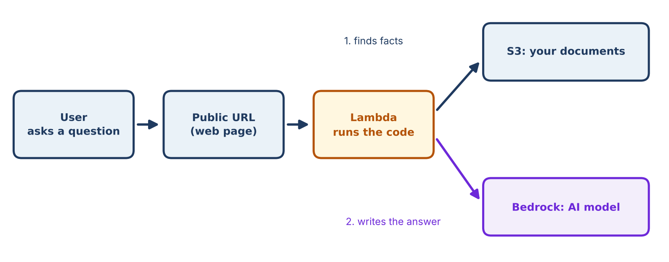
Figure 3: How the capstone chatbot uses these services
REMEMBER
You do not need to understand these services yet. We use them one by one in later sessions.

4. AWS Console Tour
The Console is the AWS website where you manage everything with clicks.
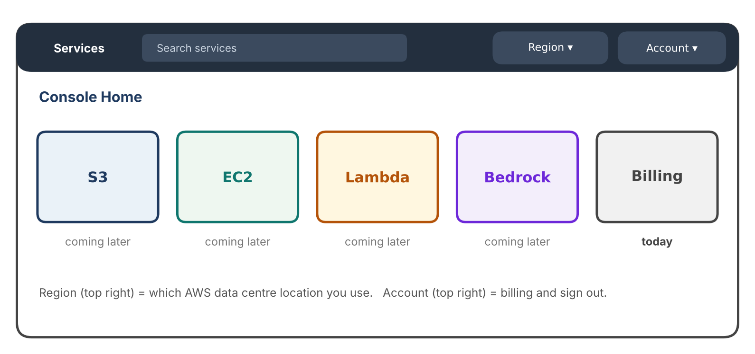
Figure 4: The AWS Console home (simplified)
Part | What it does
Search bar | Type a service name (S3, Lambda) to open it fast.
Region | The location of the data centre you are using. Many resources are tied to one region, so always check it.
Account menu | Billing, security settings and sign out.

5. Budget Alert: Protect Your Wallet
Cloud bills by usage. A forgotten resource can keep costing money. A budget alert emails you before it gets big.
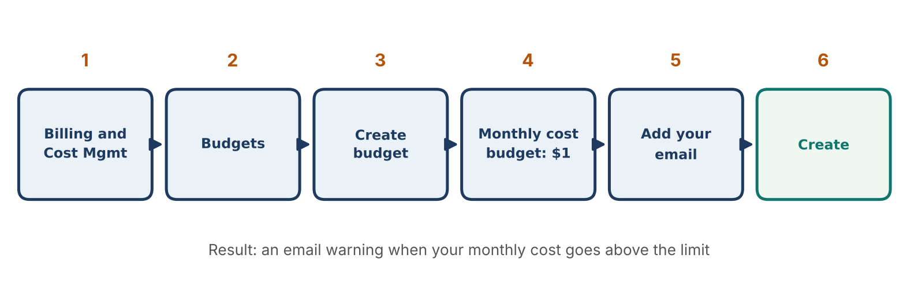
Figure 5: Creating a $1 budget alert
Step | Action
1 | Search for “Billing and Cost Management” and open it.
2 | Click Budgets in the left menu.
3 | Click Create budget.
4 | Choose a monthly cost budget. Set the amount to 1 (USD).
5 | Enter your email for alerts.
6 | Click Create budget. Check your email for the confirmation.

SAFETY HABITS
• Turn on MFA (two-step login) for your AWS account.
• Never share your password or access keys, and never put them in code or screenshots.
• Delete resources you no longer need after each practice session.

6. Setup Check (done at home)
Before class you created your AWS account. Confirm each item:
Item | Check
Account created and email verified | You can sign in to the Console.
Phone OTP and card verification done | Account shows as active.
Region chosen | Use the region your instructor tells you. Keep it the same.
Budget alert set | Confirmation email received.

7. Quick Revision
Question | Answer
What is cloud computing? | Renting computing power over the internet.
What is AWS? | A cloud provider that rents computing services.
S3 / EC2 / Lambda / Bedrock? | Storage / virtual computer / code on demand / AI models.
What is a Region? | The location of the data centre you use.
Why set a budget alert? | To get an email before costs grow.

Self-check
- Give one reason a company would rent instead of buy servers.
- Which service would you use to store a PDF?
- Where in the Console do you set a budget?

