AIDA CLOUD | MODULE 1: DIGITAL FOUNDATIONS & PYTHON
Session 10: Variables & Data Types
Student Study Notes • Read after class to revise
WHAT YOU WILL LEARN
1. Variables: labeled boxes that hold values
2. Strings vs numbers (str, int, float)
3. input(): taking answers from the user
4. TypeError: why it happens and how to fix it with int()
5. Arithmetic operators: + - * / // % **
6. Project: a greeting card program

1. Variables: Labeled Boxes
A variable is a name that holds a value. Think of a box with a label stuck on it. The label is the name, the content is the value.
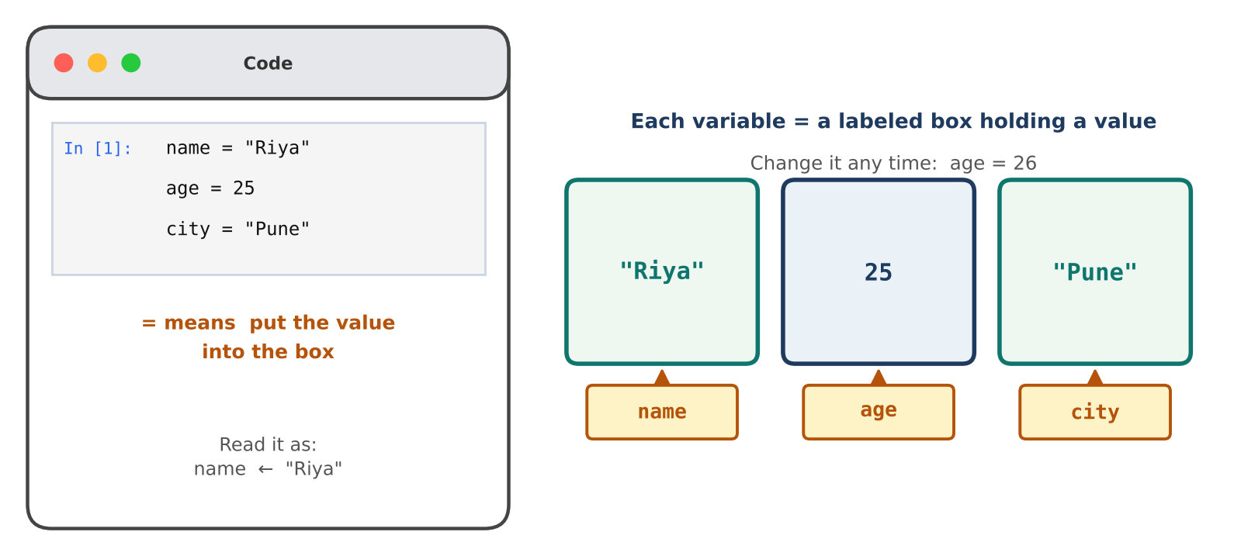
Figure 1: Three variables as labeled boxes
Part | Meaning
name | The label on the box (the variable name).
= | Assignment: put the value on the right into the box on the left. It is not “equals” as in maths.
"Riya" | The value stored in the box.

Create and print variables
EXAMPLE
name = "Riya"
age = 25
city = "Pune"
print(name) → Riya
print(name, age, city) → Riya 25 Pune

Change a variable: assign again. age = 26 replaces 25. The old value is gone.

Rules for variable names
Rule | Good | Bad
Letters, digits and underscore only | student_name | student-name
No spaces | my_age | my age
Cannot start with a digit | age2 | 2age
Case matters (Age and age differ) | age | Age (if you meant age)
Pick meaningful names | city | x

TIP
Use lowercase words joined with underscores: first_name, total_marks. This style is called snake_case.

2. Strings vs Numbers
Same look, different meaning. Quotes make it text. No quotes makes it a number.
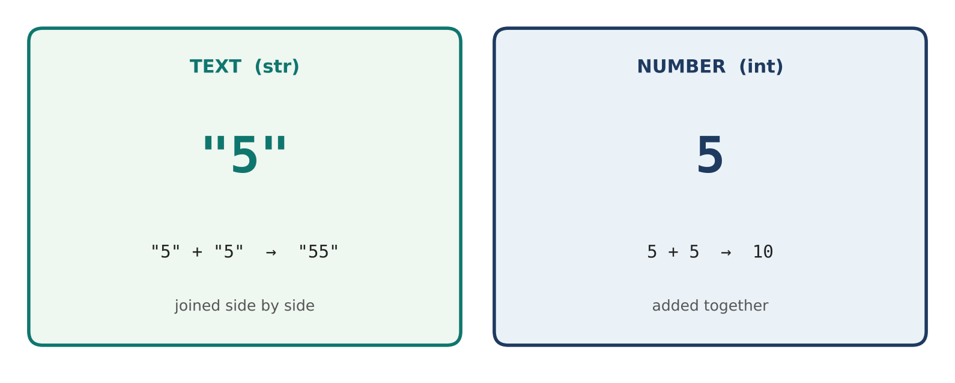
Figure 2: "5" is text and 5 is a number
Type | Meaning | Example | Notes
str | Text, inside quotes | "Riya", '25' | '25' in quotes is text, not a number.
int | Whole number | 25, -3, 0 | No quotes, no decimal point.
float | Number with decimal point | 3.14, 99.5 | Prices, averages, measurements.

Check a type: print(type(25)) → <class 'int'>
EXAMPLE
"5" + "5" → "55" (text is joined)
5 + 5 → 10 (numbers are added)

3. input(): Ask the User
input() pauses the program and waits for the user to type. What they type is stored in a variable.
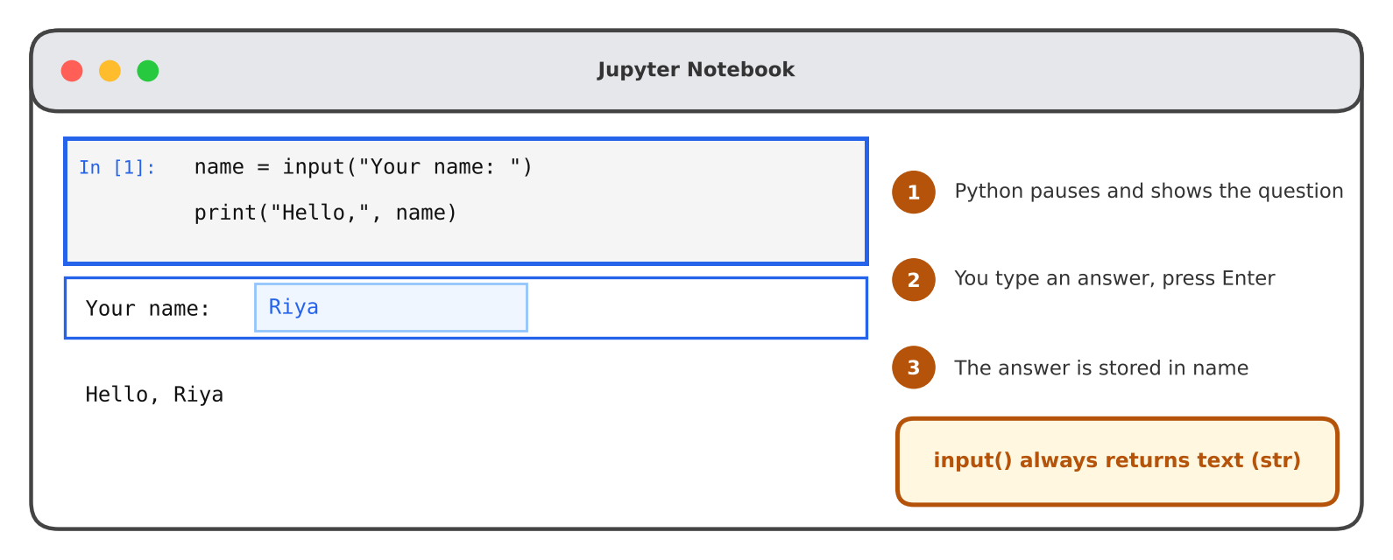
Figure 3: input() asks, the user types, the answer is stored
EXAMPLE
name = input("Your name: ")
print("Hello,", name)
Run: Your name: Riya → Hello, Riya

REMEMBER
input() always gives you text (str), even if the user types a number.
If the user types 25, you get the text '25', not the number 25.

Two ways to combine text
 | Comma | Plus (+)
Code | print("Hello,", name) | print("Hello, " + name)
Space | Added automatically | You add it yourself inside the quotes
Works with | Text and numbers | Text with text only
Output | Hello, Riya | Hello, Riya

4. TypeError: Mixing Text and Numbers
Python cannot add a number to text. It does not know if you mean 25 + 5 or the text “255”.
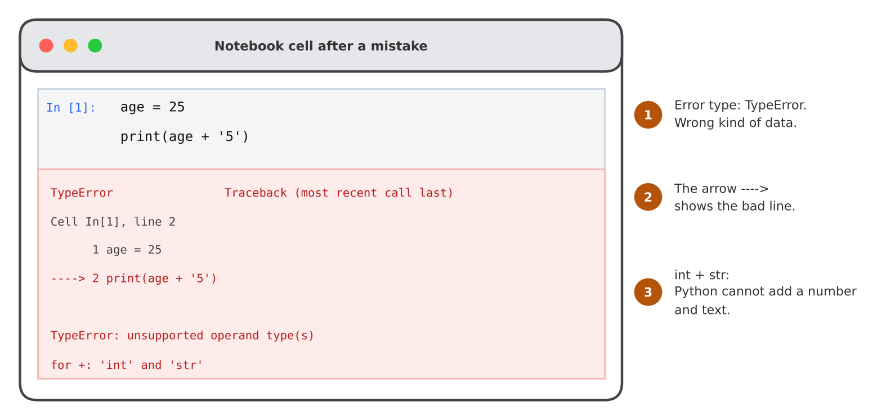
Figure 4: int + str gives a TypeError

Fix it slowly, in 3 steps
Step | Question | Answer
1 | What is the error type? | TypeError. The data types do not match.
2 | Which types are involved? | int (age) and str ('5').
3 | What do I want? | Maths: turn text into a number with int(). Joining: turn the number into text with str().

Goal | Code | Result
Add as numbers | age + int('5') | 30
Join as text | str(age) + '5' | '255'

Converting types
Function | What it does | Example
int() | Text or decimal to whole number | int('25') → 25
float() | Text or whole number to decimal | float('3.5') → 3.5
str() | Number to text | str(25) → '25'

The input() trap
EXAMPLE
age = input("Age: ") user types 25
print(age + 1) → TypeError: can only concatenate str (not "int") to str
Fix: age = int(input("Age: ")) then print(age + 1) → 26

Note: int('abc') gives a ValueError, because “abc” is not a number. Convert only text that looks like a number.

5. Arithmetic Operators
Try each one with two numbers: a = 17 and b = 5.
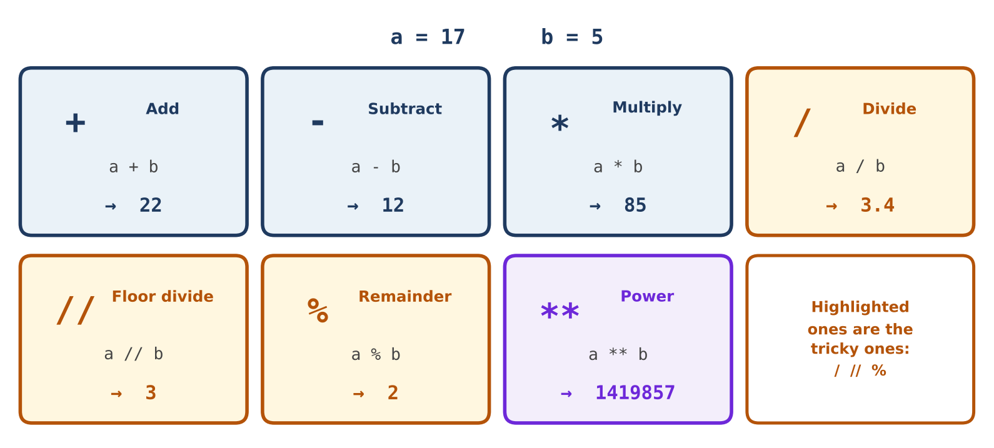
Figure 5: All seven operators on a = 17 and b = 5
Sign | Name | Example | Meaning
+ | Add | 17 + 5 → 22 | Sum
- | Subtract | 17 - 5 → 12 | Difference
* | Multiply | 17 * 5 → 85 | Product
/ | Divide | 17 / 5 → 3.4 | Normal division. Always gives a float.
// | Floor divide | 17 // 5 → 3 | Division, keep only the whole part.
% | Remainder | 17 % 5 → 2 | What is left after dividing.
** | Power | 17 ** 5 → 1419857 | 17 multiplied by itself 5 times.

// vs / vs %
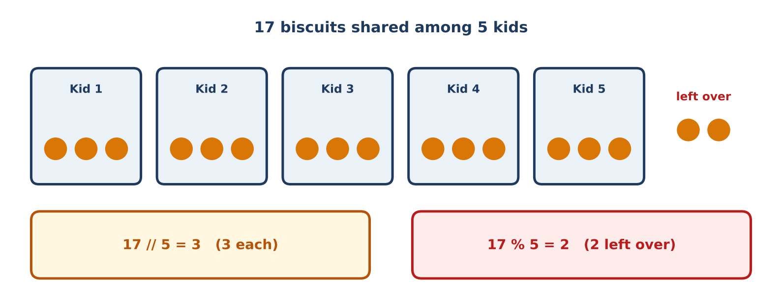
Figure 6: Sharing 17 biscuits among 5 kids
Code | Result | Meaning
7 / 2 | 3.5 | Exact answer.
7 // 2 | 3 | How many whole times 2 fits in 7.
7 % 2 | 1 | What is left over.
10 / 2 | 5.0 | / always gives a float, even when the answer is whole.

EXAMPLE: even or odd
n % 2 gives 0 for even numbers and 1 for odd numbers.
8 % 2 → 0 (even). 9 % 2 → 1 (odd).

Order of operations
Python follows maths order. Use brackets to be clear.
Order | Operators | Example
1st | Brackets ( ) | (2 + 3) * 4 → 20
2nd | Power ** | 2 ** 3 → 8
3rd | * / // % | 2 + 3 * 4 → 14
4th | + - | 10 - 4 + 1 → 7

6. Project: Greeting Card Program
Ask the user three questions and print a card. Use input() and variables.
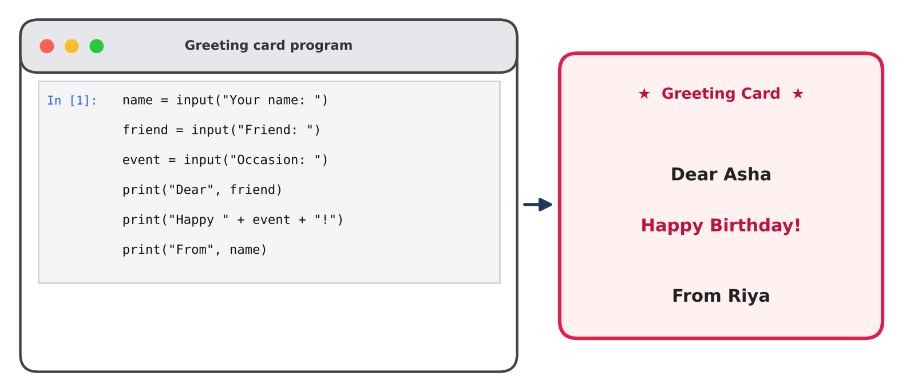
Figure 7: A greeting card built with input() and print()

Sample run
The user types | The program prints
Your name: Riya | Dear Asha
Friend: Asha | Happy Birthday!
Occasion: Birthday | From Riya

Level up
# | Idea
1 | Add a line with the friend's age: age = int(input("Age: ")), then print("Next year you will be", age + 1).
2 | Add a personal message using another input().
3 | Print a border line such as print("*" * 20). Multiplying text by a number repeats it.

7. Common Mistakes
Code | Error | Fix
print(nam) | NameError: name 'nam' is not defined | Check spelling and case of the variable.
my name = 'Riya' | SyntaxError: invalid syntax | No spaces: my_name.
2age = 5 | SyntaxError: invalid decimal literal | Names cannot start with a digit.
age = input(...) then age + 1 | TypeError | Wrap with int(input(...)).
print('Age: ' + 25) | TypeError: can only concatenate str | Use a comma, or str(25).
Using / and expecting a whole number | Result like 3.5 or 5.0 | Use // for whole-number division.

8. Practice (Do it yourself)

Follow the class steps
- Variables: Create name, age and city. Print each, then print all three together.
- input: Ask for the user's name with input() and print a greeting.
- TypeError: Run age + '5'. Read the error. Fix it with int('5').
- Operators: Use two numbers. Run + - * / // % ** in separate cells. Compare / and //.
- Greeting card: Build your own card using input() and variables.

9. Cheat Sheet
Code | Meaning
x = 10 | Store 10 in variable x
input("text") | Ask the user, returns str
int("25") | Text to whole number
float("3.5") | Text to decimal
str(25) | Number to text
type(x) | Check the type
+ - * / // % ** | Add, subtract, multiply, divide, floor divide, remainder, power

10. Quick Revision
Question | Answer
What is a variable? | A named box that holds a value.
What does = do? | Puts the right-side value into the left-side variable.
What type does input() return? | str (text), always.
Why does 25 + '5' fail? | int and str cannot be added. TypeError.
What is 17 // 5? And 17 % 5? | 3 and 2
What does / always return? | A float.

Self-check
- What is the output of print(7 // 2, 7 % 2)?
- A user types 30 into input(). What is the type of the value, and how do you do maths with it?
- Why is 2age not a valid variable name?

