AIDA CLOUD | MODULE 1: DIGITAL FOUNDATIONS & PYTHON
Session 7: Linux Basics II (Practice Day)
Student Study Notes • Read after class to revise
WHAT YOU WILL LEARN
1. Linux architecture: kernel, shell, filesystem
2. The Linux filesystem tree: /, home, etc, var
3. Creating and editing files: touch, cat, nano
4. Permissions: read, write, execute (locker-room analogy)
5. chmod, and what “Permission denied” means
6. Common beginner mistakes and how to fix them

1. Linux Architecture
Linux has three layers you meet every day: shell, kernel and filesystem.
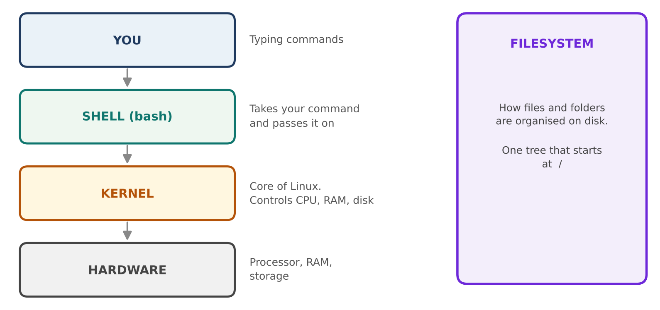
Figure 1: From your command to the hardware
Layer | What it is | Hotel analogy
Shell | The program that reads the commands you type (bash). | Reception desk: takes your request.
Kernel | The core of Linux. Controls CPU, memory and disk. | Hotel staff: does the real work.
Filesystem | How files and folders are organised on disk. | Room numbers: where everything is kept.

EXAMPLE
You type ls → the shell reads it → the kernel asks the filesystem what is in the folder → the list comes back to your screen.

2. The Linux Filesystem Tree
Linux has one tree that starts at / (root). Every file and folder sits somewhere under it.
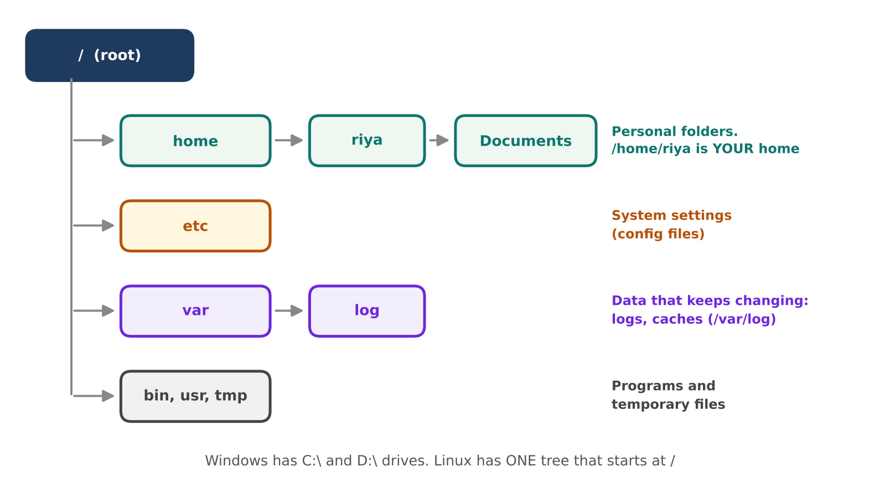
Figure 2: Main folders under root
Folder | Holds | Example
/ | The root. Top of everything. | Contains home, etc, var and more.
/home | Personal folders of users. | /home/riya/Documents
/etc | System settings (configuration files). | /etc/hosts
/var | Data that changes: logs and caches. | /var/log

See it yourself: ls -la /
Option | Meaning
-l | Long format: permissions, owner, size, date.
-a | All files, including hidden ones (names starting with a dot).
/ | Look at the root folder, from any location.

NOTE
On Mac, personal folders are in /Users, not /home. The idea is the same.
Windows has separate drives (C:\, D:\). Linux has one tree, and drives are attached inside it.

3. Create and Edit Files
Command | What it does | Example
touch | Creates an empty file. | touch notes.txt
cat | Prints a file's content on screen. | cat notes.txt
nano | Opens a simple text editor in the terminal. | nano notes.txt

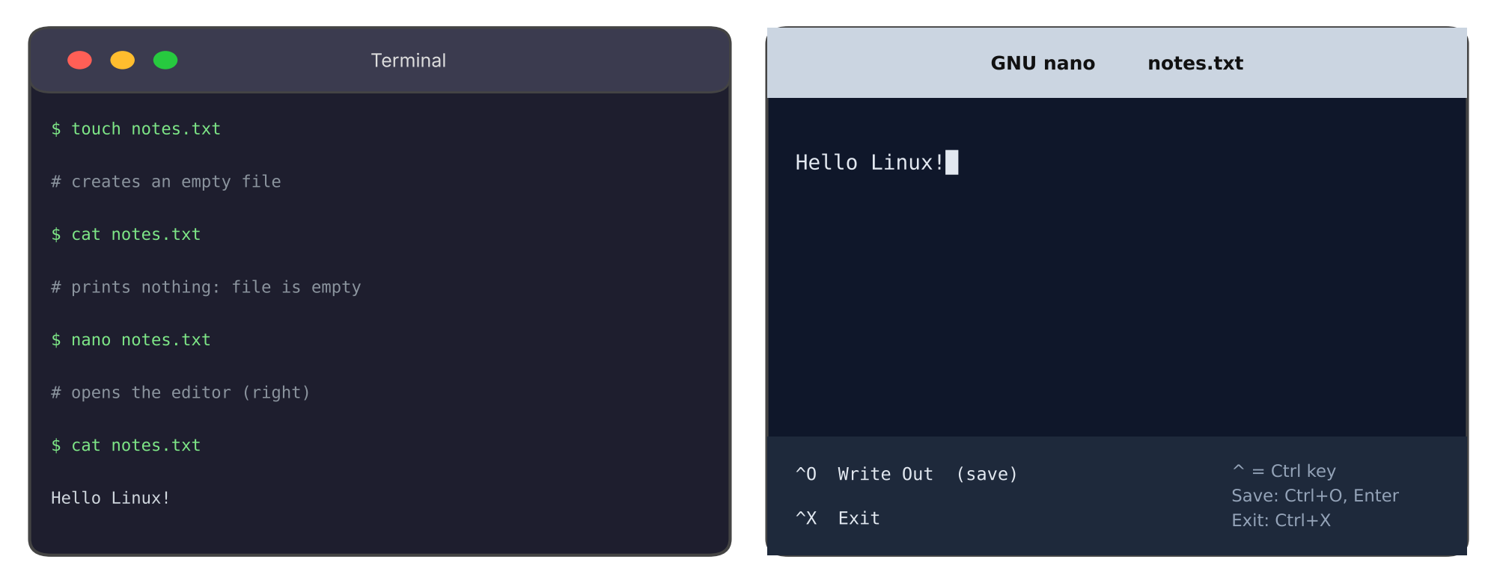
Figure 3: touch, cat, nano, cat: the file goes from empty to filled

nano keys
Keys | Action
Type normally | Write your text.
Ctrl + O, then Enter | Save the file (Write Out).
Ctrl + X | Exit nano.

REMEMBER
In nano you cannot use the mouse. Use the keyboard and read the shortcut bar at the bottom.
The ^ symbol means the Ctrl key.

4. Permissions
Permissions decide who can do what with a file. There are three permissions and three groups of people.
Letter | Permission | On a file | On a folder
r | Read | See the content | See what is inside
w | Write | Change the content | Add or delete files inside
x | Execute | Run it as a program | Enter it (cd)
- | None | Permission not given | Permission not given

Locker-room analogy
Who | Locker-room role | Can do
Owner | The person who owns the locker | Has the key: opens it, changes things, uses it.
Group | Teammates on the same team | Can look and use, but not change.
Others | Visitors | Can only peek in.

Decode a permission string
Run ls -l and read the first column. Example: -rwxr-xr--
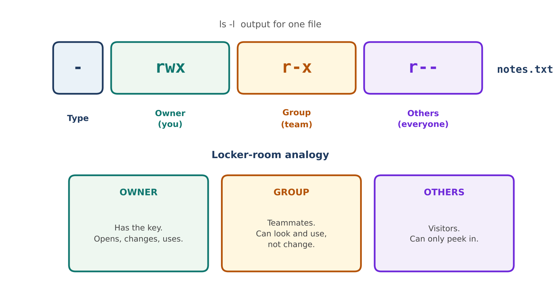
Figure 4: Reading -rwxr-xr-- piece by piece
Part | Value | Meaning
Type | - | Regular file. (d = directory)
Owner | rwx | Owner can read, write and execute.
Group | r-x | Group can read and execute, but not write.
Others | r-- | Everyone else can only read.

The columns of ls -l
Example | Meaning
-rw-r--r-- | Permissions (type + owner + group + others)
1 | Number of links
riya riya | Owner name, then group name
12 | Size in bytes
Oct 10 notes.txt | Last modified date, then file name

5. chmod: Changing Permissions
chmod = change mode. It adds or removes permissions.
Command | Meaning | Example effect
chmod u-r file | Remove read from the owner | -rw-r--r-- → --w-r--r--
chmod u+r file | Give read back to the owner | --w-r--r-- → -rw-r--r--
chmod +x file | Let everyone execute it | -rw-r--r-- → -rwxr-xr-x

Who letters: u = owner (user), g = group, o = others, a = all. Actions: + adds, - removes.

Number shortcut (for later)
Letter | Number | Example
r | 4 | rwx = 4 + 2 + 1 = 7
w | 2 | r-x = 4 + 0 + 1 = 5
x | 1 | r-- = 4 + 0 + 0 = 4

So chmod 754 file gives owner 7 (rwx), group 5 (r-x), others 4 (r--).

Live demo: permission denied, then restore
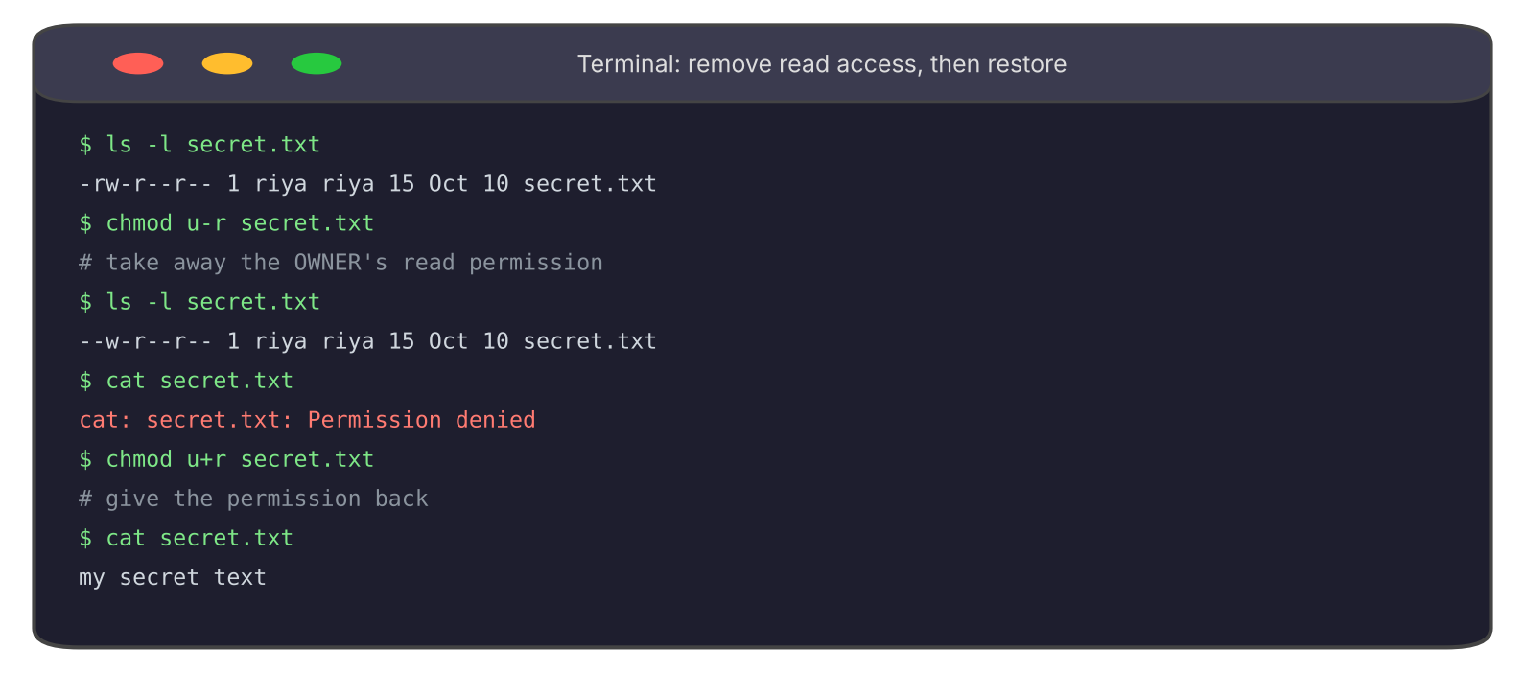
Figure 5: Removing read access, seeing the error, restoring it
REMEMBER
Permission denied is not a broken system. It means “you are not allowed to do that to this file”.
Fix it only on your own files. Do not change permissions on system folders.

6. Common Beginner Mistakes
Error message | Usual cause | Fix
No such file or directory (cd) | Wrong path or spelling mistake. | Run pwd and ls. Check spelling. Use Tab completion.
No such file or directory (cat) | Wrong name or wrong capital letters. | Match the exact name. Linux is case-sensitive.
Permission denied | You lack the permission for that action. | Check ls -l. If it is your file, use chmod.

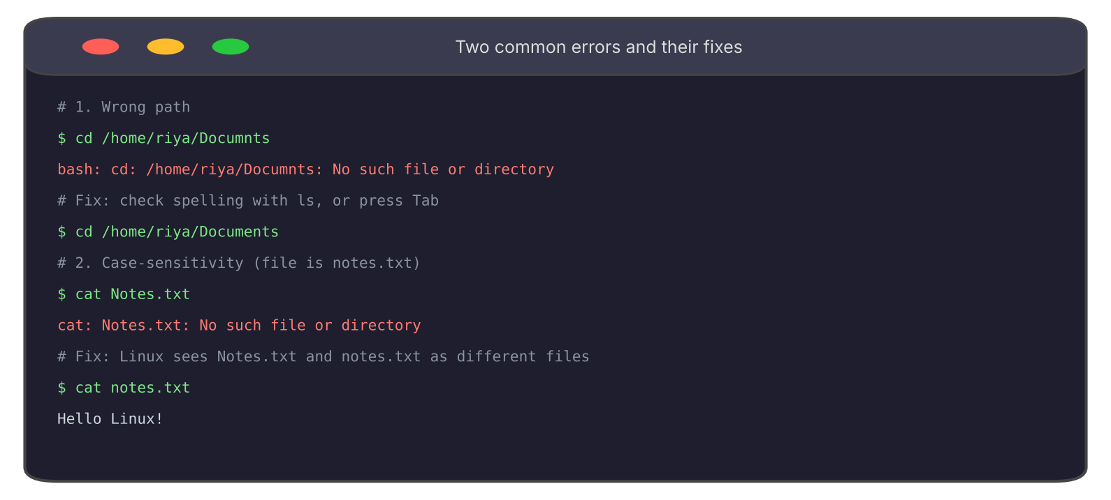
Figure 6: A wrong path and a case-sensitivity error, fixed
CASE-SENSITIVITY
Notes.txt, notes.txt and NOTES.TXT are three different files on Linux.
Mac is usually not case-sensitive by default, so this error is most common on Linux and WSL2.

7. Practice (Do it yourself)
Repeat the class flow in WSL2 (Windows) or Terminal (Mac).
- Walk the tree: Run ls -la /. Spot home (or Users), etc and var. Then ls /etc and ls /var.
- Create: Run touch notes.txt, then cat notes.txt. It prints nothing.
- Edit: Run nano notes.txt. Type a line. Save with Ctrl+O, Enter. Exit with Ctrl+X. Run cat notes.txt again.
- Decode: Run ls -l. Read the permission string of notes.txt using the locker analogy.
- Break and fix: Run chmod u-r notes.txt then cat notes.txt. See Permission denied. Run chmod u+r notes.txt to restore.
- Two errors: Type a wrong path with cd. Then run cat Notes.txt with a capital N. Fix both.

8. Command Cheat Sheet
Command | Use
ls -la / | List the root folder with details and hidden files
touch file | Create an empty file
cat file | Show a file's content
nano file | Edit a file in the terminal
ls -l | Show permissions, owner and size
chmod u-r file / chmod u+r file | Remove / restore owner's read permission

9. Quick Revision
Question | Answer
What does the kernel do? | Controls CPU, memory and disk for the system.
What does the shell do? | Reads your typed commands and passes them on.
What is /etc for? | System settings (configuration files).
What is /var for? | Changing data such as logs.
What does r-x mean? | Read and execute, but no write.
Which command changes permissions? | chmod
Is Notes.txt the same as notes.txt on Linux? | No. Linux is case-sensitive.

Self-check
- Decode -rw-r----- : what can owner, group and others do?
- You get “Permission denied” on your own file. What do you check first?
- Why does cat Report.txt fail when the file is called report.txt?

