AIDA CLOUD | MODULE 1: DIGITAL FOUNDATIONS & PYTHON
Session 6: Linux Basics I
Operating Systems, Windows vs Unix vs Linux, Server vs Desktop • Student Study Notes
WHAT YOU WILL LEARN
1. What an OS is and why it matters
2. Types of operating systems
3. Windows vs Unix vs Linux
4. Server vs desktop OS, and why servers run Linux
5. Your first Linux commands: whoami, uname -a

1. What is an OS and Why It Matters
An OS (Operating System) is the software that runs your device and lets apps use the hardware. Nothing works without it.
Daily-life device | What the OS does
Phone | Android or iOS opens apps, takes calls, manages the battery.
Laptop | Windows or macOS manages files, windows and apps.
ATM / smart TV / car | A small OS runs the screen and buttons.
Websites you visit | A server OS (mostly Linux) serves the pages.

EXAMPLE
Booking a train ticket: your phone OS runs the app → the request goes online → a server OS runs the booking system → the answer comes back.

2. Types of Operating Systems
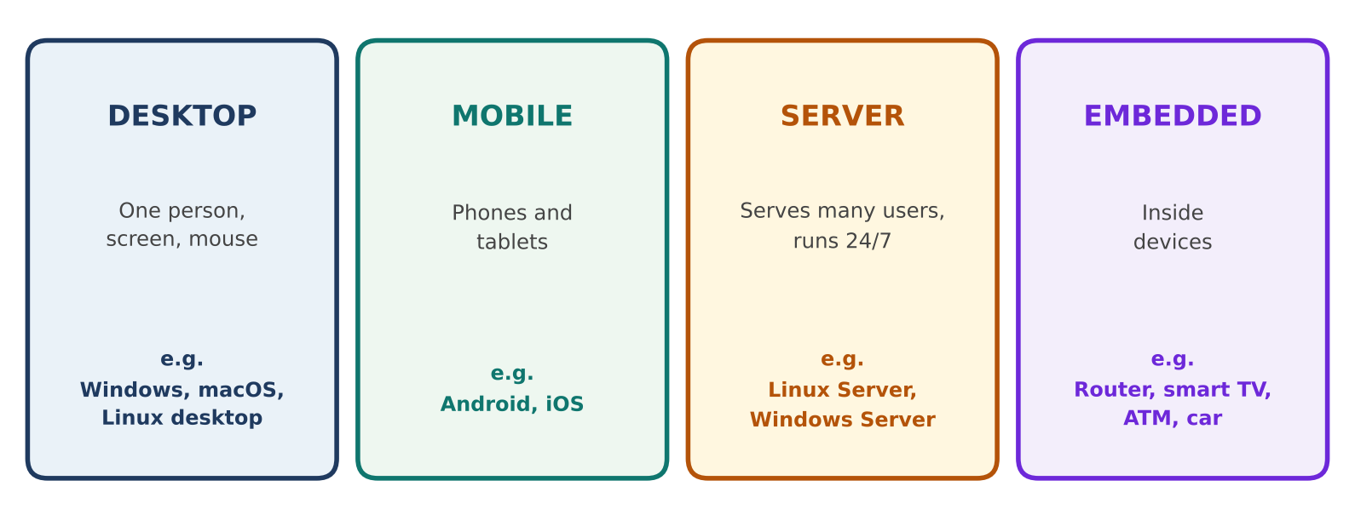
Figure 1: Four main types of OS
Type | Built for | Examples
Desktop | One person using a laptop or PC | Windows, macOS, Ubuntu desktop
Mobile | Touch screens, battery life | Android, iOS
Server | Many users, 24/7, stability | Linux Server, Windows Server
Embedded | One fixed job inside a device | Router, smart TV, ATM

3. Windows vs Unix vs Linux
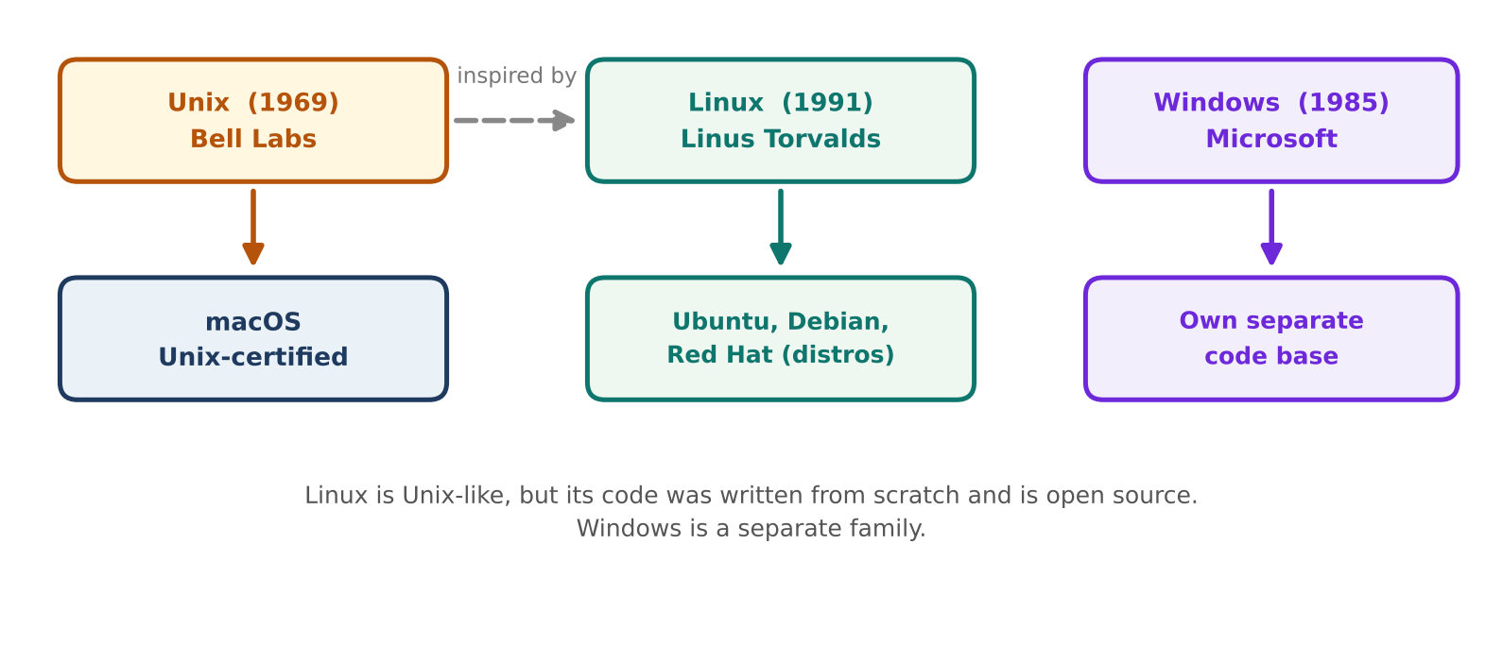
Figure 2: Where Windows, Unix and Linux come from
 | Windows | Unix | Linux
Owner / origin | Microsoft (1985) | Bell Labs (1969) | Linus Torvalds and community (1991)
Cost | Paid license, usually bundled with the PC | Mostly commercial variants | Free and open source
Source code | Closed | Mostly closed | Open for anyone to read
Examples | Windows 11 | macOS, Solaris, AIX | Ubuntu, Debian, Red Hat

Security, privacy and interface
 | Windows | macOS (Unix) | Linux
Security | Most popular, so the biggest malware target | Strong built-in protections | Strict permissions, open code that many people review
Privacy | Collects usage data (telemetry) by default | Collects some data | Usually collects none by default
Interface | Graphical (GUI) first | Graphical (GUI) first | Terminal first, optional desktop

REMEMBER
No OS is perfectly safe. Updates and careful habits matter on all of them.
Linux is “Unix-like”: it works like Unix, but its code was written from scratch.

4. Server vs Desktop OS
A server = a computer that serves others. Websites, apps and files you use are stored on servers and sent to you on request.
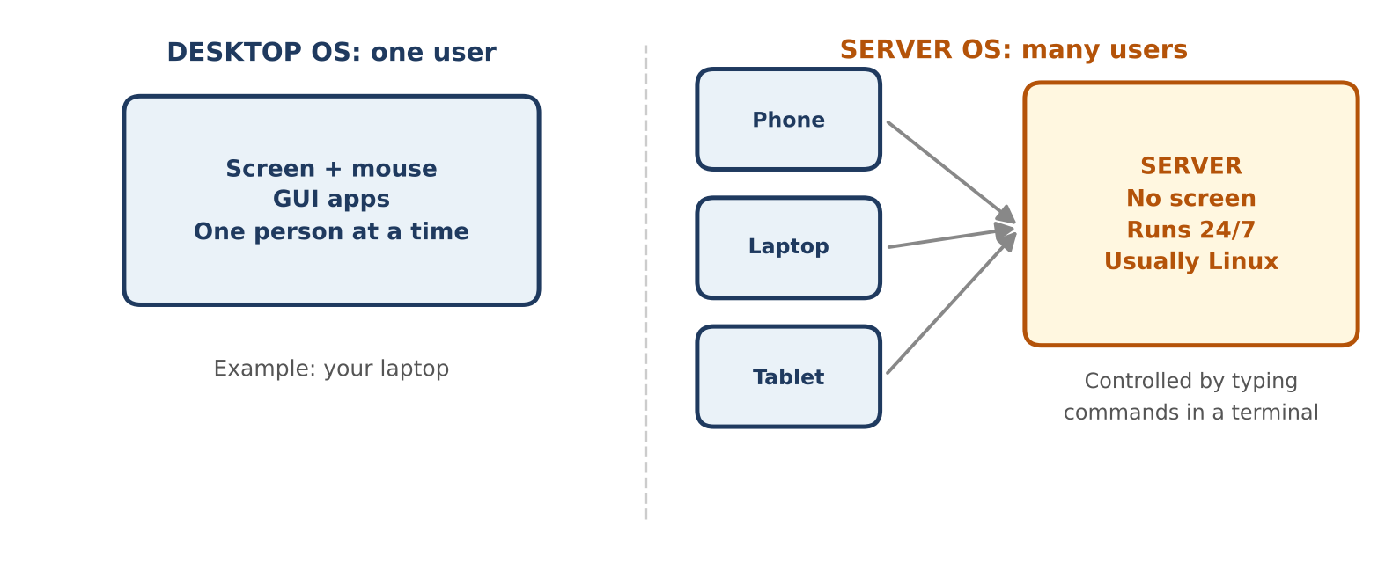
Figure 3: One user on a desktop vs many users on a server
 | Desktop OS | Server OS
Users | One person | Many users at the same time
Screen | Yes, with mouse and GUI | Usually none (headless)
Runs | When you use it | 24/7, for months without restart
Managed by | Clicking | Typing commands in a terminal
Example | Your laptop | The computer behind a cloud console

EXAMPLE
Cloud link: when you rent a server in the AWS Console, it usually runs Linux. You control it by typing commands, not clicking.

Same job, different tool
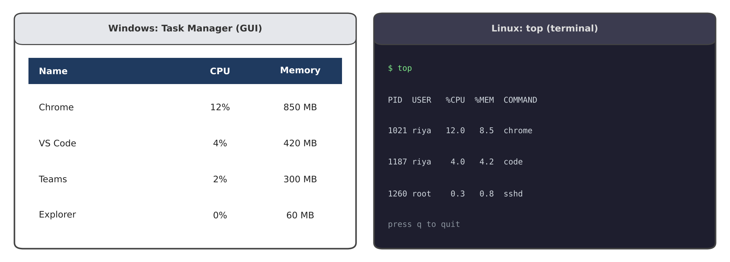
Figure 4: Windows Task Manager vs Linux top. Both show what is running and how much it uses.
Task | Windows | Linux
See running programs | Task Manager | top or htop
Stop a program | End task button | kill command
Style | Graphical | Text in terminal

5. Your First Linux Commands
Command | What it does | Example output
whoami | Shows your username. | riya
uname -a | Shows the OS name and version. | Linux pc 5.15.0 ... x86_64 GNU/Linux

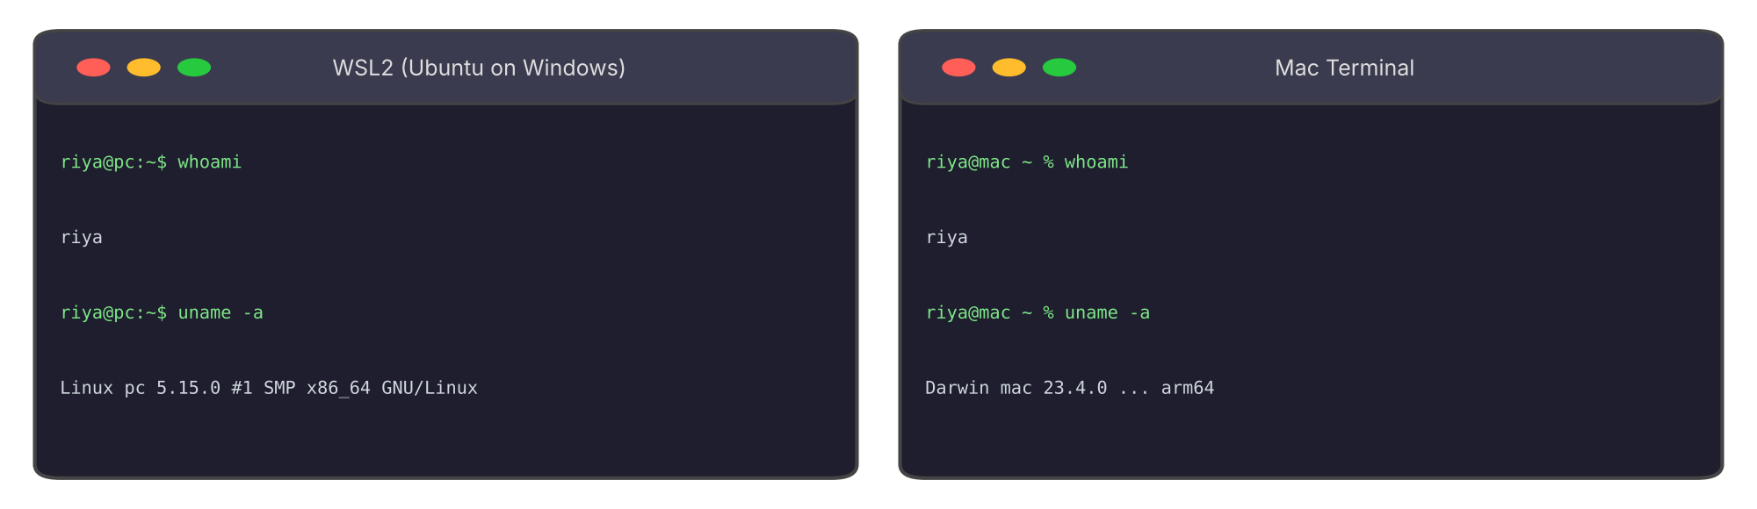
Figure 5: whoami and uname -a (output varies by machine)
NOTE
WSL2 gives Windows users a real Linux terminal inside Windows. Mac Terminal is Unix-based, so these commands work there too.
Next session: we use the terminal to move around Linux and manage files.

6. Group Activity: Desktop or Server?
Sort each device. Cover the answer column first.
Device | OS type | Why
Laptop | Desktop | One user, screen and mouse.
Phone | Mobile | Touch screen, battery.
Web server | Server | Serves many users, runs 24/7.
Router | Embedded | Fixed job inside a device.
Database server | Server | Stores data for many apps.
Smart TV | Embedded | Runs only TV functions.
ATM | Embedded | Fixed job: cash and banking screens.
Tablet | Mobile | Touch screen, battery.

7. Quick Revision
Question | Answer
What is an OS? | Software that runs the device and lets apps use hardware.
Who created Linux? | Linus Torvalds, in 1991.
Is Linux free? | Yes, free and open source.
What is a server? | A computer that serves other devices, often 24/7.
Linux version of Task Manager? | top or htop
Command to see your username? | whoami

Self-check
- Give two differences between a desktop OS and a server OS.
- Why do many servers run Linux instead of Windows?
- Which command shows the OS name and version?

