AIDA CLOUD | MODULE 1: DIGITAL FOUNDATIONS & PYTHON
Session 8: Git I (Version Control, GitHub, Branches)
Student Study Notes • Read after class to revise
WHAT YOU WILL LEARN
1. Why version control exists (the final_final_v2 problem)
2. git init, add, commit: save points in a game
3. git log: reading your history
4. Local repo vs remote repo (GitHub), and git push
5. Branches: a parallel save-line

1. The final_final_v2 Problem
Version control = a system that records every change to your files. You can see old versions and go back to any of them.
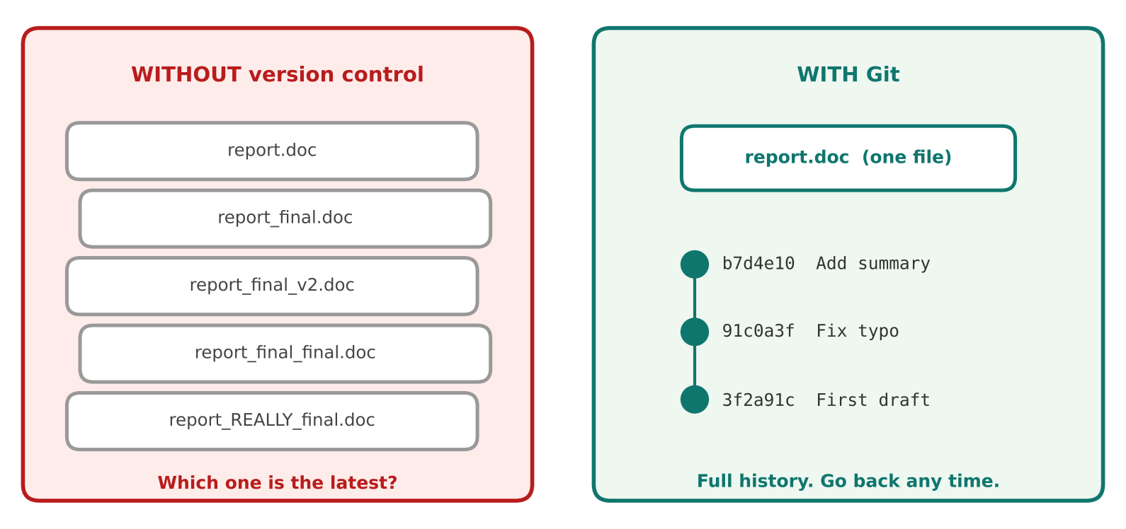
Figure 1: Many copies of one file vs one file with a full history
Problem without Git | What Git gives you
Many copies: report_final_v2.doc | One file. Every version is stored inside Git.
Which version is the latest? | The newest save point is always on top.
You broke something and cannot undo | Go back to any earlier save point.
Two people edit the same file | Everyone works safely and changes are combined later.

2. Git vs GitHub
 | Git | GitHub
What it is | A tool installed on your computer. | A website that stores Git projects online.
Works | Offline | Needs internet
Job | Records versions (save points). | Keeps a shared copy, for backup and teamwork.
Analogy | The game's save system | The cloud save

REMEMBER
Git is the tool. GitHub is the place to upload your Git projects. They are not the same thing.

3. Save Points: init, add, commit
Think of a video game. You play, pick what to keep, then save. Git works the same way.
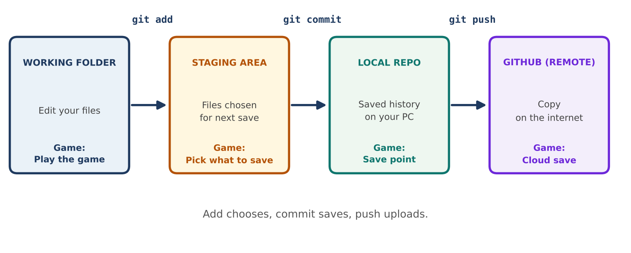
Figure 2: The journey of a change, from your folder to GitHub
Command | What it does | Game meaning
git init | Turns a folder into a Git repository (starts tracking). | Start a new game with save feature
git status | Shows what changed and what is ready to save. | Check your inventory
git add file | Chooses a file for the next save point. | Pick items to save
git commit -m "msg" | Saves a snapshot with a message. | Create a save point
git log | Shows all save points. | List of checkpoints

One-time setup (before your first commit)
COMMANDS
git config --global user.name "Your Name"
git config --global user.email "you@example.com"

Git stamps your name and email on every commit. Without this you get an “Author identity unknown” error.

Your first commit
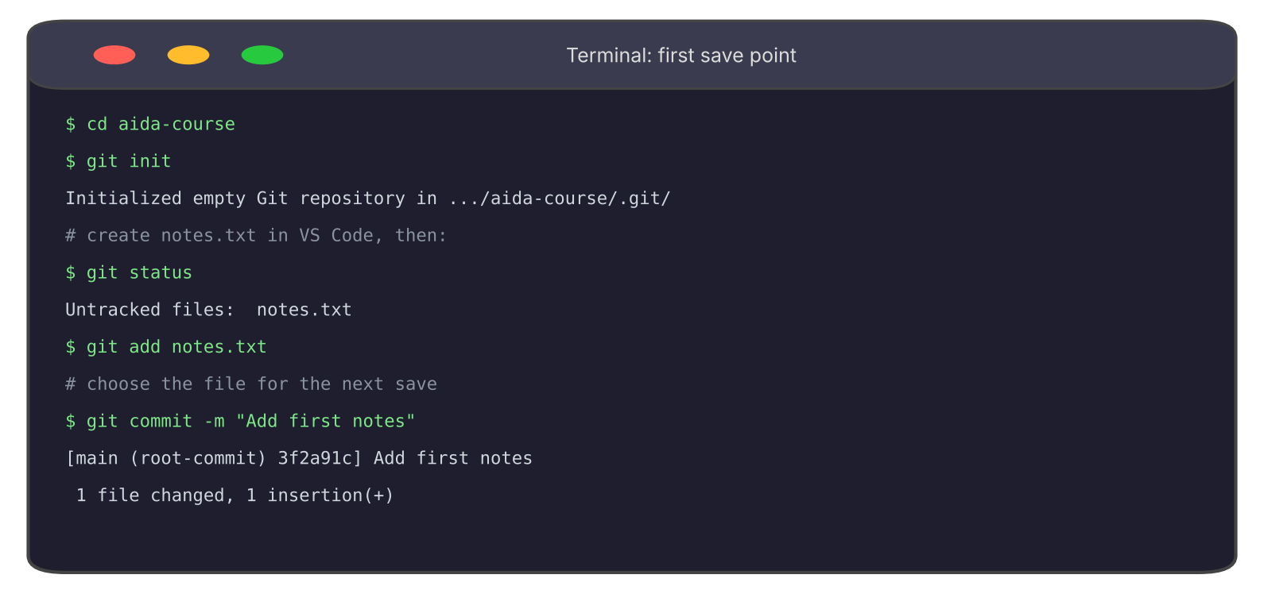
Figure 3: init, add and commit in the course folder
EXAMPLE
Commit = a snapshot. The message says what changed. Good: "Add title". Weak: "stuff".
Write short messages that start with a verb: Add, Fix, Update, Remove.

Repeat it five times
In class we made five commits, one small edit each time. Each cycle is the same: edit, add, commit.
# | Edit | Commit
1 | Create notes.txt | git add notes.txt → git commit -m "Add first notes"
2 | Add a title line | git add notes.txt → git commit -m "Add title"
3 | Add a practice list | git add . → git commit -m "Add practice list"
4 | Fix a typo | git add notes.txt → git commit -m "Fix typo in notes"
5 | Add a summary | git add notes.txt → git commit -m "Add summary section"

Tip: git add . adds every changed file in the folder. Run git status first to check what you are adding.

4. Reading History: git log
Run git log --oneline to see one line per save point. Newest is on top.
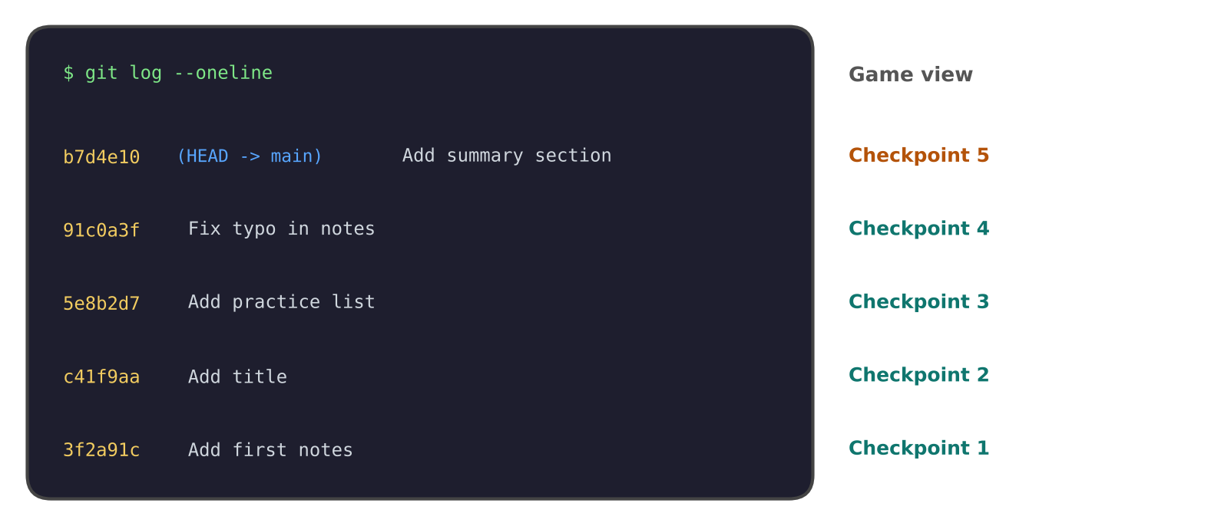
Figure 4: Each commit is a checkpoint in the game
Part | Meaning
b7d4e10 | Short ID of the commit (like a checkpoint number).
(HEAD -> main) | Where you are now: the latest commit on the main branch.
Add summary section | The message you wrote.

5. Local Repo vs Remote Repo (GitHub)
 | Local repo | Remote repo
Where | On your computer | On GitHub's servers
Used for | Daily work and save points | Backup, sharing, teamwork
Updated by | git commit | git push

Create a repo on GitHub
Step | Action
1 | Create a free account on github.com and sign in.
2 | Click the + icon at the top right → New repository.
3 | Name it, for example aida-course.
4 | Leave “Add a README” unticked, so the repo starts empty.
5 | Click Create repository. Copy the repo URL (ends with .git).

Connect and upload
COMMANDS
git remote add origin https://github.com/riya/aida-course.git
git branch -M main
git push -u origin main

Command | Meaning
git remote add origin URL | Tell Git where the GitHub copy lives. “origin” is its nickname.
git branch -M main | Make sure your main line is named main.
git push -u origin main | Upload your commits. -u remembers this link for next time.

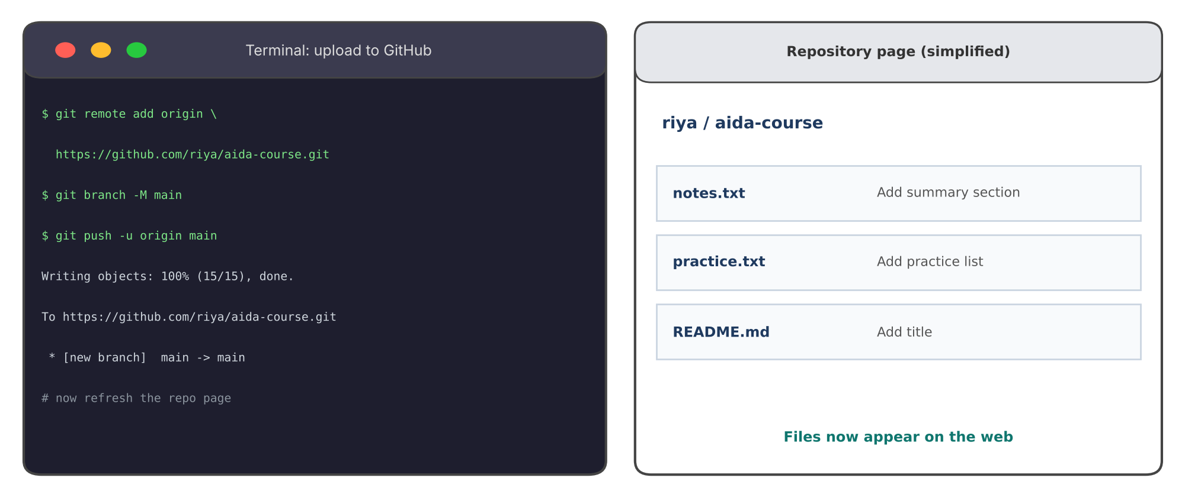
Figure 5: After git push, refresh the page and your files appear
NOTE
GitHub no longer accepts your account password in the terminal. If asked, sign in through the browser window, or use a personal access token.
Your commits stay safe on your PC. The push only adds a copy on GitHub.

6. Branches: a Parallel Save-Line
A branch = a separate line of save points that starts from your current work. Changes on it do not touch main until you choose.
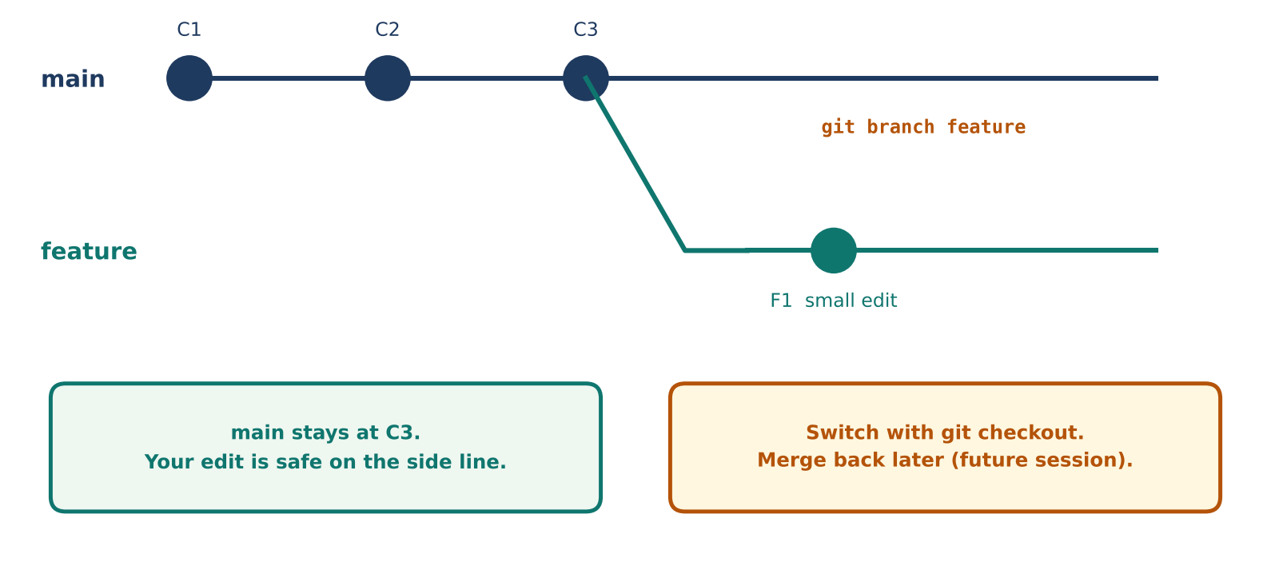
Figure 6: A branch splits from main and keeps experiments safe
Command | Meaning
git branch | List branches. The current one has a *.
git branch feature | Create a branch named feature.
git checkout feature | Switch to it. (git switch feature does the same.)
git checkout -b feature | Create and switch in one step.
git checkout main | Go back to main.

What we did in class
COMMANDS
git branch feature
git checkout feature
# edit notes.txt, then: git add notes.txt
git commit -m "Edit on feature"
git checkout main
# open notes.txt: the edit is not there. Main is untouched.

WHY TEAMS USE BRANCHES
• Try a new idea without risking the working version.
• Many people work in parallel, each on their own branch.
• When the work is ready, it is merged into main (a later session).

7. Common Errors
Message | Cause | Fix
fatal: not a git repository | You are outside a repo folder, or never ran git init. | cd into the project folder, or run git init.
Author identity unknown | Name and email not set. | Run the two git config commands.
nothing to commit | No changes since the last commit. | Edit a file first, then git add.
remote origin already exists | You ran git remote add twice. | Skip it, or fix the URL with git remote set-url origin URL.
Changes not staged | You edited but did not git add. | git add the file, then commit.

8. Practice (Do it yourself)
- Setup: Run git --version and set your name and email with git config.
- Init: In your course folder run git init. Create a file and run git status.
- Commit x5: Add, commit, edit, commit. Make five commits with clear messages.
- Log: Run git log --oneline. Count your checkpoints.
- GitHub: Create an empty repo. Run the three connect commands. Refresh the page.
- Branch: Create and switch to a branch. Edit and commit. Switch to main and check the file.

9. Command Cheat Sheet
Command | Use
git init | Start tracking a folder
git status | See what changed
git add . | Stage all changes
git commit -m "msg" | Save a snapshot
git log --oneline | See save-point history
git remote add origin URL | Link to GitHub
git push -u origin main | Upload to GitHub
git branch name | Create a branch
git checkout name | Switch branch

10. Quick Revision
Question | Answer
Why use Git? | To keep history, undo mistakes and work in teams.
Git vs GitHub? | Git is the tool. GitHub hosts repos online.
Order of saving? | git add, then git commit.
What does git push do? | Uploads commits to GitHub.
What is a branch? | A parallel line of save points.
Does an edit on a branch change main? | No, not until you merge.

Self-check
- What is the difference between git add and git commit?
- Why leave “Add a README” unticked when creating a repo you will push to?
- You edit a file on a branch and switch to main. What do you see?

