**MetaCHIP User Manual**

V1.0.1

  Copyright  © Weizhi Song

Centre for Marine Bio-Innovation, University of New South Wales

 January 1st, 2019

[songwz03@gmail.com](mailto:songwz03@gmail.com)

1. **Introduction**

MetaCHIP is implemented in Python, a list of dependencies needs to be installed before running. Details of these dependencies can be found at: .

MetaCHIP makes use of the following 3rd party dependencies and assumes these are on your system path. Specify full path   
to their executables in the config file if they are not on the system path.

To  install  MetaCHIP,  simply  download  the  package  and  run  the  programs  from a command  line  interface. **The full path to a list of dependencies needs to be specified in the config.txt file, if not in environment variables**; otherwise, keep the config.txt file as is.

The input files for MetaCHIP include a folder that holds the sequence file (in FASTA format) of all query genomes, as well as a text file, which holds taxonomic classification of all input genomes. Please make sure the length of sequence IDs for all input genomes is **NO LONGER THAN 22 letters**.

The MetaCHIP pipeline contains three main modules: PI, BM and PG.

$ MetaCHIP -h

...::: MetaCHIP :::...

HGT detection modules:

PI -> Prepare Input files

BM -> Best-Match approach

PG -> PhyloGenetic approach

# for command specific help

MetaCHIP <command> -h

**PI module**

MetaCHIP PI -h

-i input genome folder

-taxon taxonomic classification

-p output prefix

-r grouping rank

-g grouping file

-x file extension

-grouping_only run grouping only, deactivate Prodigal and Blastn

-nonmeta annotate Non-metagenome-assembled genomes (Non-MAGs)

-noblast not run all-vs-all blastn

-t number of threads

-qsub run blastn with job scripts, only for HPC users

-force overwrite previous results

-quiet not report progress

PI modulewillgroup input genomes at defined taxonomic rank according to their taxonomic classification results. GTDBTk (<https://github.com/Ecogenomics/GTDBTk>) is recommended for taxonomic classification of input genomes. An example of the taxonomic classification file is provided together with the scripts. Options for “-r” include: d (domain), p (phylum), c (class), o (order), f (family) and g (genus).

**Example command:**

# grouping input genomes at provided levels according to taxonomic classifications

$ MetaCHIP PI -i soil_bins -x fa -taxon GTDB_op.tsv -r c -p Soil -t 6

$ MetaCHIP PI -i soil_bins -x fa -taxon GTDB_op.tsv -r o -p Soil -t 6 -grouping_only

$ MetaCHIP PI -i soil_bins -x fa -taxon GTDB_op.tsv -r f -p Soil -t 6 -grouping_only

# run with customized grouping profile

$ MetaCHIP PI -i soil_bins -x fa -g customized_grouping.txt -p Soil -t 6

**Output files:**

1. Grouping result is exported to **[prefix]_grouping_[taxon_rank][group_num].txt**.
2. Gene calling results in GenBank and FASTA format.
3. A SCG protein tree of input genomes.
4. A bar plot shows the number of input genomes in each group at provided taxonomic rank.
5. Blast results

**BM module**

MetaCHIP BM -h

-p output prefix

-r grouping rank

-g grouping file

-cov coverage cutoff, default: 75

-al alignment length cutoff, default: 200

-flk the length of flanking sequences to plot (Kbp), default: 10

-ip identity percentile cutoff, default: 90

-ei end match identity cutoff, default: 95

-plot_iden plot identity distribution

-NoEbCheck disable contig end match and full length match checking for

fast processing, not recommend for metagenome-assembled genomes.

-force overwrite previous results

-t number of threads, default: 1

-quiet Do not report progress

-tmp keep temporary files

HGT candidates predicted by the best-match approach, as well as the plots of their flanking regions are exported to a folder named in the following format:

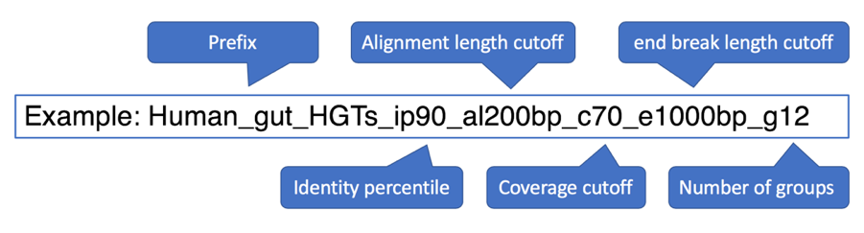

**Example command:**

$ MetaCHIP BM -p Soil -r c -t 6

# run with customized grouping profile

$ MetaCHIP BM -p Soil -g customized_grouping.txt -t 6

**Output files:**

A list of HGT candidates identified by the BM approach are exported to **HGT_candidates_BM.txt**. Their nucleotide and amino acid sequences are exported to **HGT_candidates_BM_nc.fasta** and **HGT_candidates_BM_aa.fasta**.

**PG module**

MetaCHIP PG -h

-p output prefix

-r grouping rank

-g grouping file

-cov coverage cutoff, default: 75

-al alignment length cutoff, default: 200

-flk the length of flanking sequences to plot (Kbp), default: 10

-ip identity percentile, default: 90

-ei end match identity cutoff, default: 95

-t number of threads, default: 1

-force overwrite previous results

-quiet Do not report progress

**Example command:**

$ MetaCHIP PG -p NorthSea -r c -t 6

# run with customized grouping profile

$ MetaCHIP PG -p NorthSea -g customized_grouping.txt -t 6

**Output files:**

HGT candidates validated by PG approach are exported to the same folder as BM approach.

1. **HGT_candidates_PG.txt**: BM approach predicted HGTs, with additional information provided by the PG approach.
2. **HGT_candidates_PG_validated.txt**: HGTs that are only validated by the PG approach.
3. **HGT_candidates_PG_aa.fasta**: Nucleotide sequences of HGTs that are validated by the PG approach.
4. **HGT_candidates_PG_nc.fasta**: Amino acid sequences of HGTs that are validated by the PG approach.
5. **[prefix]_plot_at_ends_stat.png**: Location statistics of predicted HGTs by BM and PG approaches.

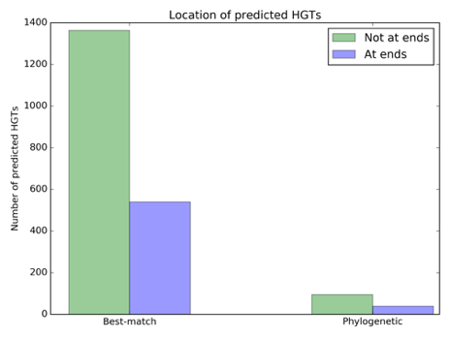

1. **[prefix]_plot_HGT_identities_BM.png**: Identity distribution of BM approach predicted HGTs.

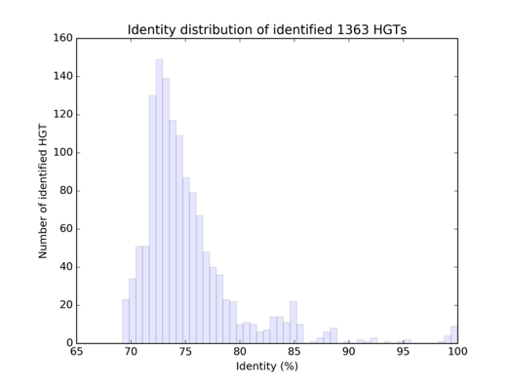

1. **[prefix]_plot_HGT_identities_PG.png**: Identity distribution of predicted HGTs that are validated by the PG approach.

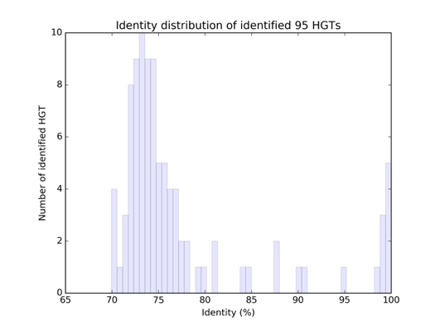

1. **[prefix]_plot_circos_PG.png**: Gene flow between groups. Bands on the plot connect donors and recipients, with the width of the band correlating to the number of HGTs and the colour corresponding to the donors.

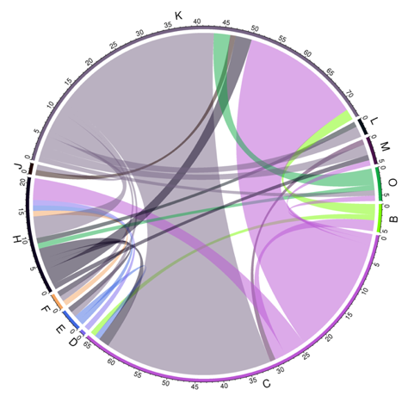

**References**

1. Parks DH, Imelfort M, Skennerton CT, Hugenholtz P, Tyson GW: CheckM: assessing the quality of microbial genomes recovered from isolates, single cells, and metagenomes. Genome research 2015, 25:1043-1055.
2. Contreras-Moreira B, Vinuesa P: GET_HOMOLOGUES, a versatile software package for scalable and robust microbial pangenome analysis. Applied & Environmental Microbiology 2013, 79:7696-7701.