

Project Name: Mobijet

Branch C-DAC Sept-2022

Documentation On

**“Mobijet”**

C-DAC SEPT 2022

**Guided By: Rishi Sir**

Submitted By :

**Group No: 01**

* **Amit Nehete** 220960520007
* **Abhinav Tongale** 220960520002
* **Khileshwari Firke** 220960520026
* **Yatish Chaudhari** 220960520090
* **Ajinkya Survase** 220960520005
* **Aniket Shingne** 220960520010

**Table of Contents**

**1. Introduction 4**

1.1 Document Purpose **4**

1.2 Project Background **4**

1.3 Aim & Objectives **4**

**2. Business Requirements Overview**…………………………………………………………**5**

**3.Functional Requirements** **5**

3.1 Customer Module **5**

3.2 Service Provider Module **6**

3.3 Admin Module **6**

3.4 Message Acknowledgement Module**.............................................................................................6**

**4.** **Non-Functional Requirement………………………………………………………………7**

**5. Use Case Diagram 8**

5.1 Admin **9**

5.2 Customer **10**

5.3 Service Provider **11**

**6. Database Design 11**

1 Login **11**

2 User **11**

3 City ………………………………………………………………………………… .......**12**

4 Area **12**

5 Product **12**

6 Customer request **13**

7 Solution **13**

8 Order **13**

9 Rating **14**

10 Admin **14**

**7. E-R Diagram………………………………………………………………………………………15**

**8. Snapshots 16**

**9. Conclusion 23**

**List of Figures**

Fig 1 Admin 8

Fig 2 Customer 9

Fig 3 Service Provider 10

Fig 4 ER Diagram 15

1. **Introduction:**
   1. **Document Purpose:**

This document communicates the business requirements and scope for developing Mobile Selling System. The scope of this document is to define the functional and non-functional requirements, business rules and other constraints requirements.

## Project Background:

There is no such online platform available for customers where they are able to buy reasonable refurbish phones. Currently, if customers want to buy product at affordable cost, then they are not getting quality product, other than that if they are facing technical problems in their device there is no pick up and drop facility for repairing, service and all these processes are so much time consuming. There is no facility available today where they can sell their product from home at efficient cost.

## Aim & Objectives:

The main objective of MobiJet is to provide online platform of sale and purchase of mobiles in an efficient manner and no time wasting for selling & purchasing the mobiles. The main objective of on-line mobile sale purchase system simulator is to efficiently evaluate the product thoroughly through a fully online system that not only saves lot of time but also gives fast results. As well as we provide a pick-up and drop service about technical issue of mobiles and mobile services.

1. **Business Requirements Overview:**

* MobiJet is the public web application.
* MobiJet will be opened to the global, but in the phase 1, the main target is in the India.
* There are mainly three types of users. Customer, Admin, Service Provider.
* Customer can search the Service Provider or market value of related mobile products.
* Also Customer can sell the mobile product which is available in stock.
* MobiJet is platform where Customers and Service Provider connect easily and in within short time period.
* MobiJet platform could be maintained by Administrator.

# Functional Requirements Overview:

MobiJet System consists of three modules described as below.

1. Customer Module
2. Service Module
3. Admin Module

# 3.1 Customer Module

* Customer can register and create his own account.
* MobiJet System provides the function which allows Customer to buy or sell their products.
* Customer is able to compare between current market price and price provided by MobiJet.
* The Customers could find what services is provided in his region.
* Providing return policy in case of dissatisfaction.

# 3.2 Service Module

* Service Provider can register and create his own account.
* Service Provider can provide pick-up and drop service for repairing.
* Service Provider can check the mobile and buy it from customer at affordable price.
* Post the photos and description about product on site.
* Providing service about dissatisfaction of Customer regarding product.

# 3.3 Admin Module

* MobiJet System should provide all function to admin how to handle the System.
* Can handle the authorized Service Provider and Registered Customers.
* Could able to track all the Transaction.
* Maintaining the stock record of the products.

# 3.4 Message Acknowledgement Module

* Message Acknowledge Module should provide the entire users feedback message about their completion of transaction.

1. **Non-Functional Requirement:**

* The website should use professional design, look and feel and color scheme.
* Users will have no limitations for accessing the application through Internet. The portal being an internet application, it is difficult specify exact number of visitor or users. Hence we will target the system to support between 5 and 10 million users on launch of phase 1.
* Being a public website, the site must follow general usability guidelines for menus, navigation, colors, links and other actions provided on the screens.
* The system should be designed in such a manner that user will be able to complete tasks in minimum number of steps.

## Use-Case Diagram

**5.1 Admin:**



Admin

Fig. Use-Case Diagram for Admin

## 5.2 Customer:



Customer

Fig. Use-Case Diagram for Customer

**5.3 Service Provider:**



Service Provider

Fig. Use-Case Diagram for Service Provider

1. **Database Design:**

**1] Login table**

|  |  |  |  |  |  |
| --- | --- | --- | --- | --- | --- |
| **Field** | **Type** | **Null** | **Key** | **Default** | **Description** |
| uid | Integer | No | Primary key | Auto, Not Null | Login ID |
| useremail | Varchar(45) | No |  | Not Null | Username for login |
| userpassword | Varchar(45) | No |  | Not Null | Password for login |
| role | Varchar(45) | No |  | Not Null | customer/admin/ser. provider |
| status | TINYINT | No |  | Not Null | true/false |

**2] User table**

|  |  |  |  |  |  |
| --- | --- | --- | --- | --- | --- |
| **Field** | **Type** | **Null** | **Key** | **Default** | **Description** |
| userid | Integer | No | Primary Key | Auto, Not Null | Customer/Service Provider ID |
| uid | Integer | No | Foreign key | Not Null | Login ID |
| fname | Varchar(45) | No |  | Not Null | First Name |
| lname | Varchar(45) | No |  | Not Null | Last Name |
| emailid | Varchar(45) | No |  | Not Null | Email ID Of Customer |
| password | Varchar(15) | No |  | Not Null | Account Password |
| contactno | Varchar(14) | No |  | Not Null | Contact No. Of Customer |
| address | Varchar(45) | No |  | Not Null | Permanent Address |
| areaid | Integer | No | Foreign key | Not Null | Area ID from Address Master class |
| role | Varchar(15) | No |  | Not Null | Customer/Service Provider |

**3] City table**

|  |  |  |  |  |  |
| --- | --- | --- | --- | --- | --- |
| **Field** | **Type** | **Null** | **Key** | **Default** | **Description** |
| id | Integer | Not Null | Primary key | Auto Inc Not Null | City ID |
| cityname | Varchar(15) | Not Null |  | Not Null | City Name |

**4] Area table**

|  |  |  |  |  |  |
| --- | --- | --- | --- | --- | --- |
| **Field** | **Type** | **Null** | **Key** | **Default** | **Description** |
| areaid | Integer | No | Primary key | Auto Inc, Not Null | Area ID |
| areaname | Varchar(45) | No |  | Not Null | Area Name |
| cityid | Integer | No | Foreign Key | Not Null | City ID |
| pincode | Integer | No |  | Not Null | Area Pincode |

**5] Product table**

|  |  |  |  |  |  |
| --- | --- | --- | --- | --- | --- |
| **Field** | **Type** | **Null** | **Key** | **Default** | **Description** |
| pid | Integer | No | Primary key | Auto, Not Null | Product ID |
| userid | Varchar(45) | No | Foreign key | Not Null | Service Provider ID |
| price | Varchar(45) | No |  | Not Null | Product Price |
| company | Varchar(45) | No |  | Not Null | Company Name |
| model | Varchar(45) | No |  | Not Null | Model name/number |
| description | Varchar(200) | No |  | Not Null | Description |
| image | LONGBLOB | No |  | Not Null | Image |

**6] Customer request table**

|  |  |  |  |  |  |
| --- | --- | --- | --- | --- | --- |
| **Field** | **Type** | **Null** | **Key** | **Default** | **Description** |
| req_id | Integer | No | Primary key | Not Null | Request ID |
| user_id | Integer | No | Foreign Key | Not Null | Customer ID |
| company | Varchar(45) | No |  | Not Null | Company |
| model | Varchar(45) | No |  | Not Null | Model |
| description | Varchar(45) | No |  | Not Null | Product description |
| type | Varchar(45) | No |  | Not Null | Type-Repair/sell |
| date | Date | No |  | Not Null | Date |

**7] Service Problem Solution table**

|  |  |  |  |  |  |
| --- | --- | --- | --- | --- | --- |
| **Field** | **Type** | **Null** | **Key** | **Default** | **Description** |
| sid | Integer | No | Primary key | Not Null | Solution ID |
| req_id | Integer | No | Foreign key | Not Null | Request ID |
| remark | Varchar(25) | No |  | Not Null | Completed or Not |
| user_id | Integer | No | Foreign key | Not Null | Service Provider ID |
| status | Varchar(15) | No |  | Not Null | Status |

**8] Order table**

|  |  |  |  |  |  |
| --- | --- | --- | --- | --- | --- |
| **Field** | **Type** | **Null** | **Key** | **Default** | **Description** |
| oid | Integer | No | Primary key | Auto, Not Null | Order ID |
| pid | Integer | No | Foreign key | Not Null | Product ID |
| payment_mode | Varchar(45) | No |  | Not Null | Cash/UPI/Card |
| status | Varchar(45) |  |  | Not Null | Success/Failed |
| user_id | Integer | No | Foreign key | Not Null | Customer ID |
| Date | Date | No |  | Not Null | Date of Order |

**9] Rating table**

|  |  |  |  |  |  |
| --- | --- | --- | --- | --- | --- |
| **Field** | **Type** | **Null** | **Key** | **Default** | **Description** |
| pid | Integer | No | Foreign key | Not Null | Product ID |
| user_id | Integer | No | Foreign key | Not Null | Customer ID |
| rating | Integer | No |  | Not Null | Rating to product |
| comment | Varchar(45) | No |  | Null | Comment |
| rid | Integer | No | Primary  Key | Not Null | Rating ID |

**10] Admin table**

|  |  |  |  |  |  |
| --- | --- | --- | --- | --- | --- |
| **Field** | **Type** | **Null** | **Key** | **Default** | **Description** |
| id | Integer | Not Null | Primary key | Auto Inc Not Null | City ID |
| emailid | Varchar(15) | Not Null |  | Not Null | City Name |
| Password | Varchar(45) | Not  Null |  | Not  Null | Password |
| Contact No | Varchar (45) | Not  Null |  | Not  Null | Contact No |

## ER-Diagram:

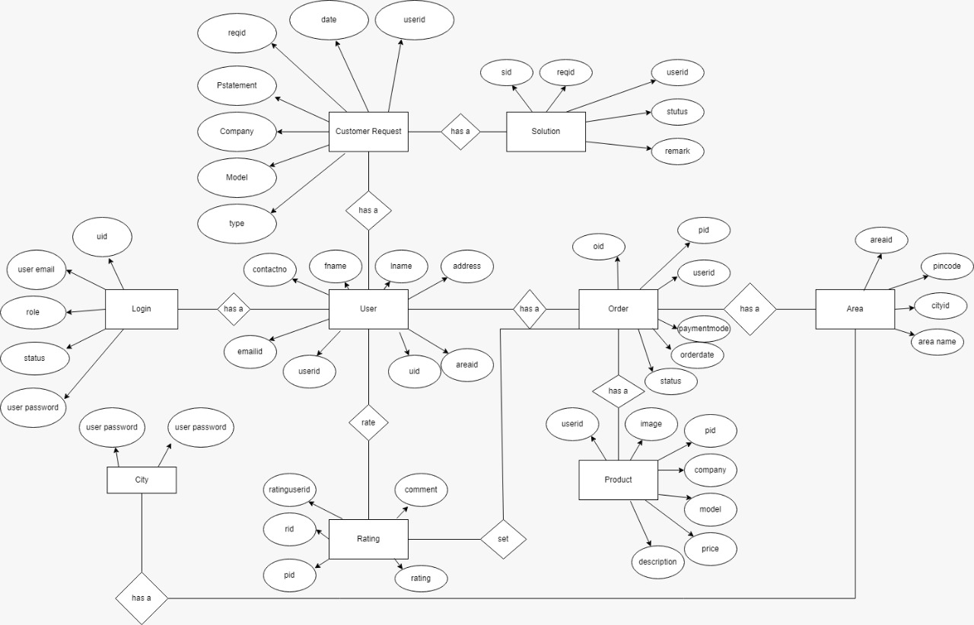

1. **Snapshots**

8.1 Home Page :-

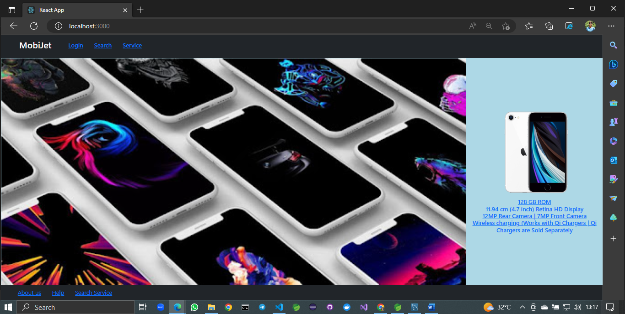

8.2 Login Form

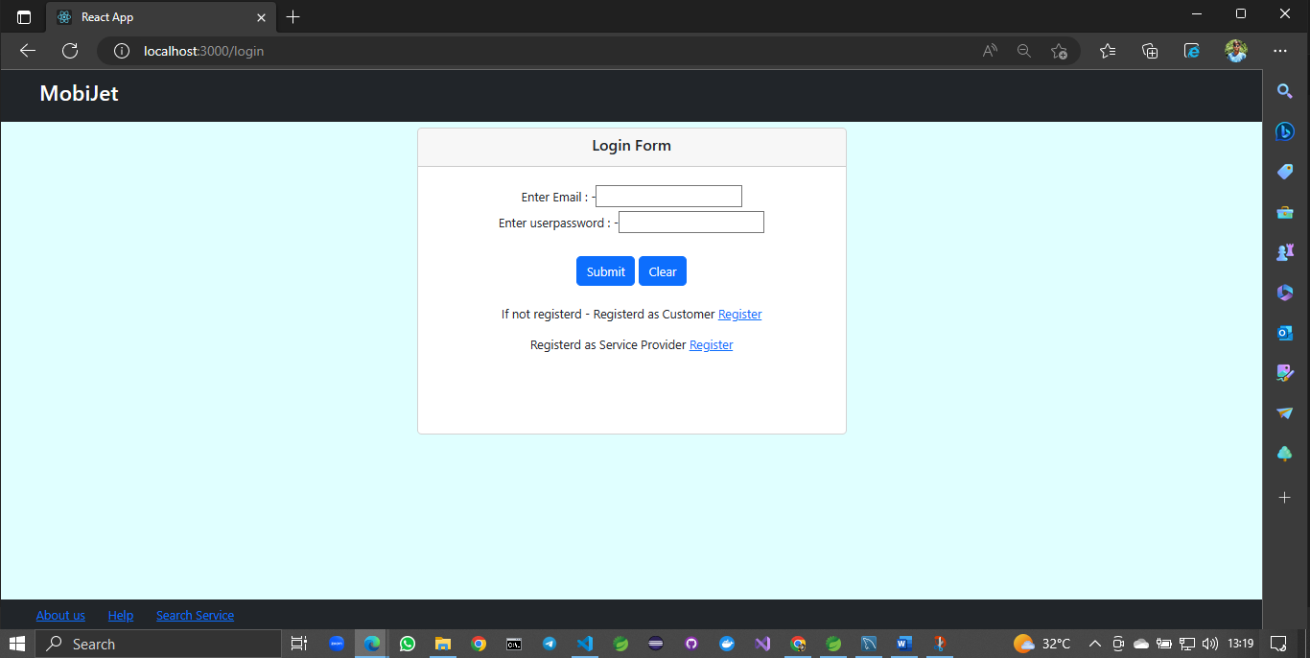

8.3 Customer Registration Form

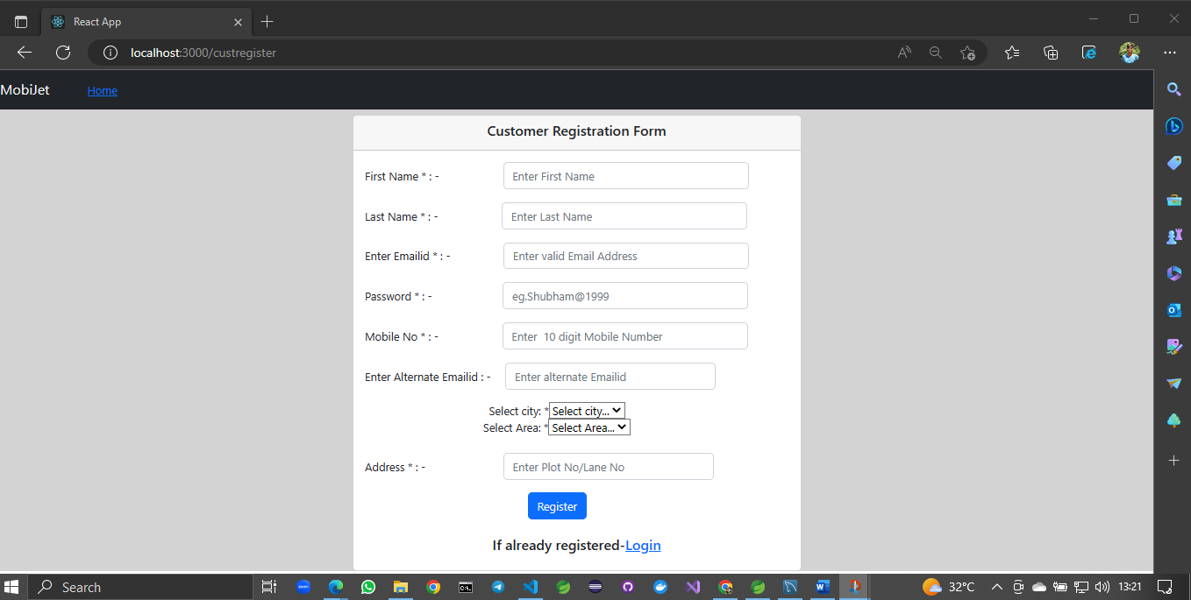

8.4 Service Provider Registration Form

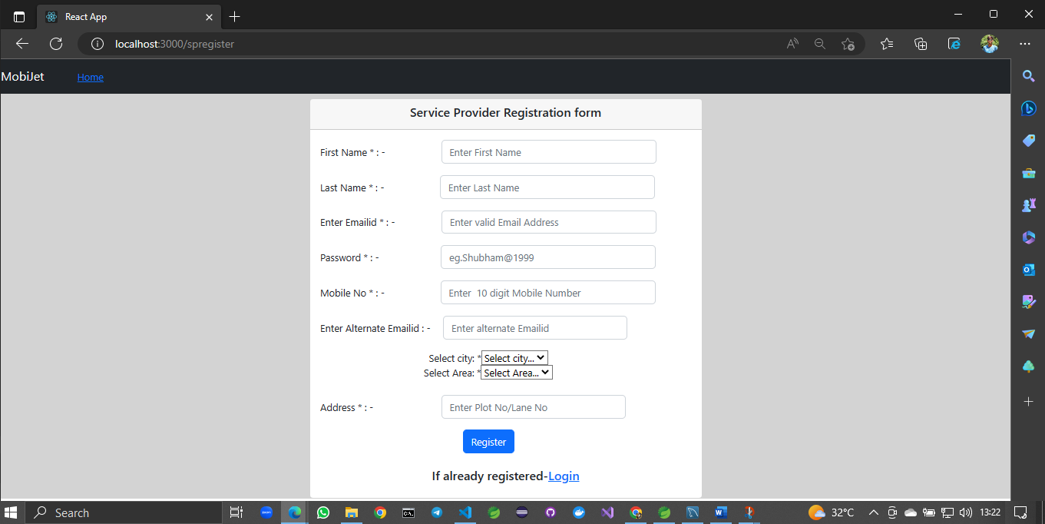

8.5 About Us

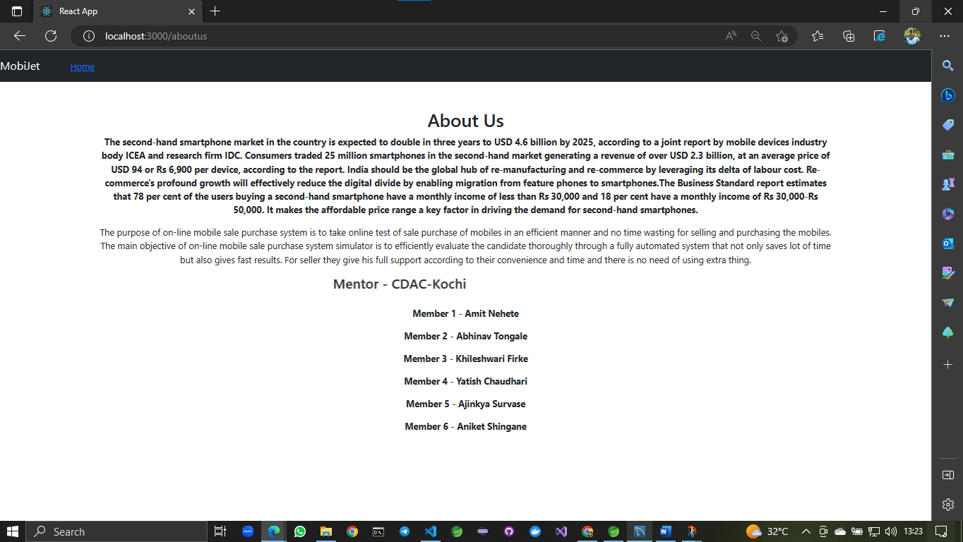

8.6 Customer Home

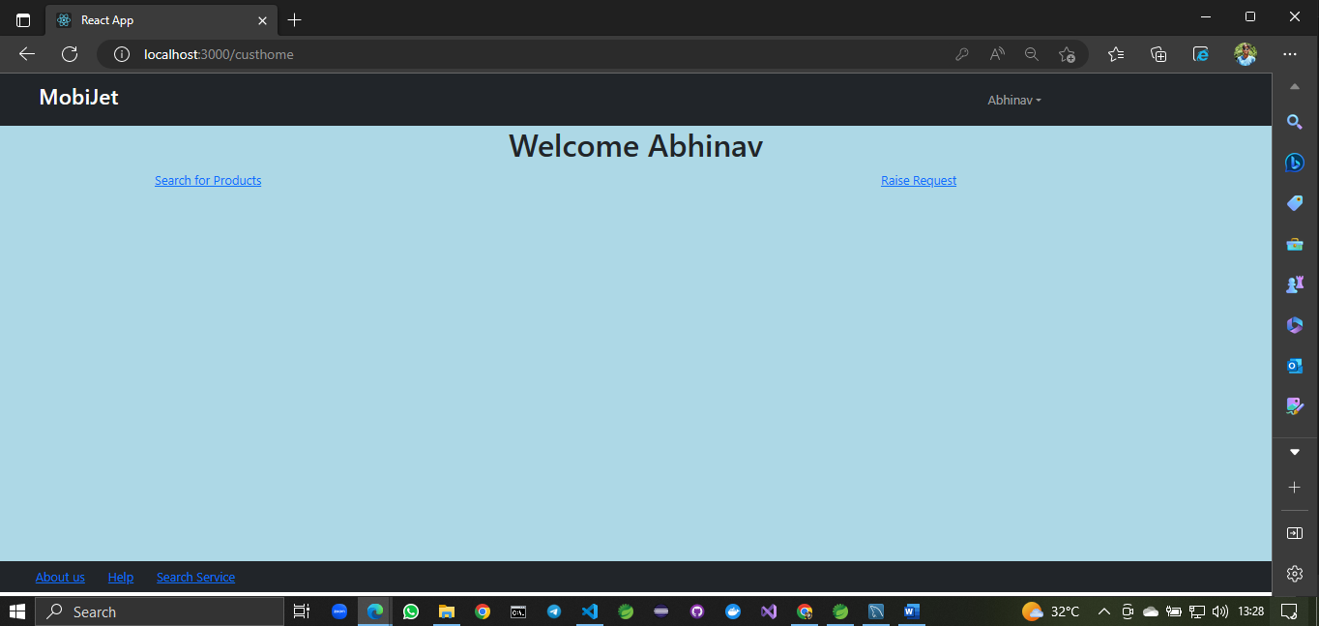

8.6.1 Customer can browse through all available products

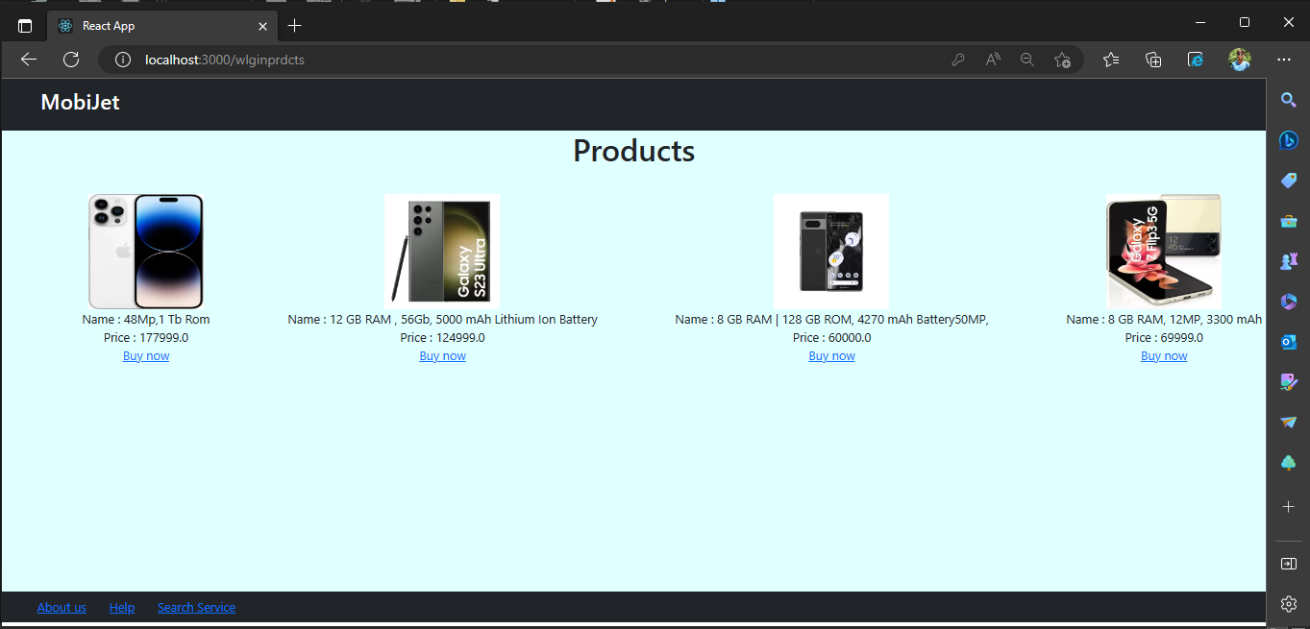

8.6.2 Customer can send request for service

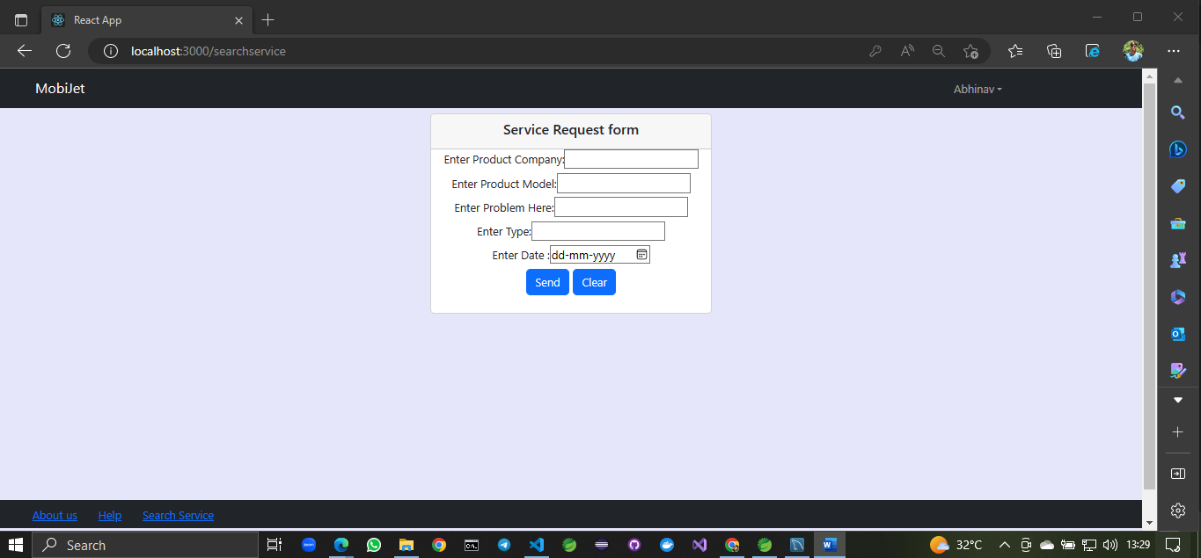

8.6.3 Rate Us

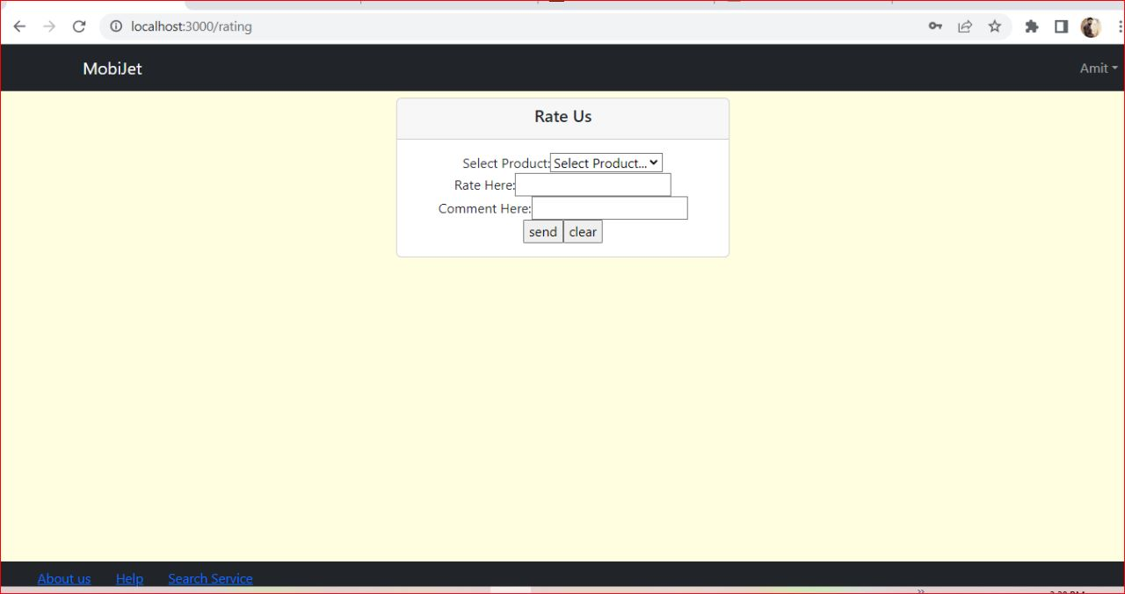

8.7 Service Provider Home

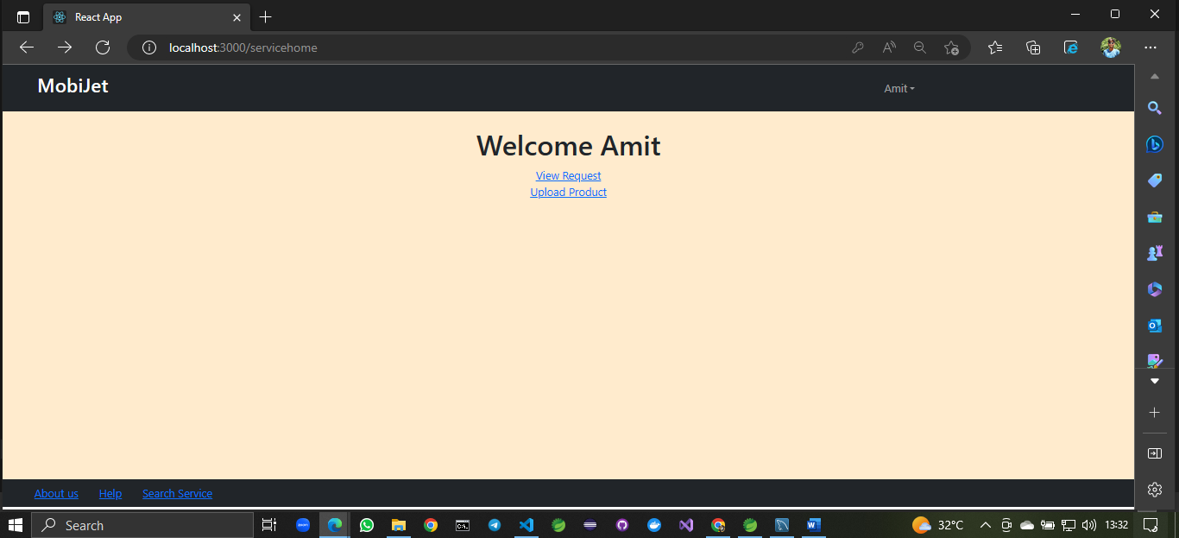

8.7.1 Upload product details by service provider

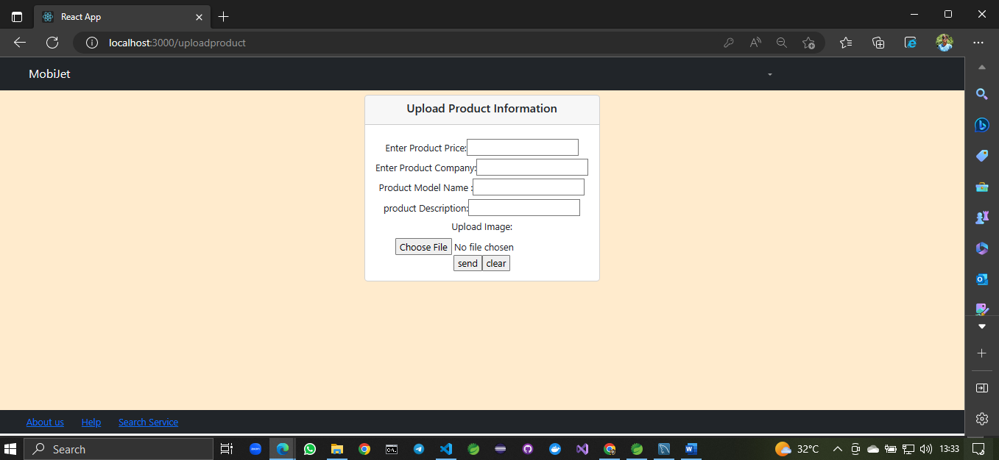

8.7.2 View all request for service send from customer

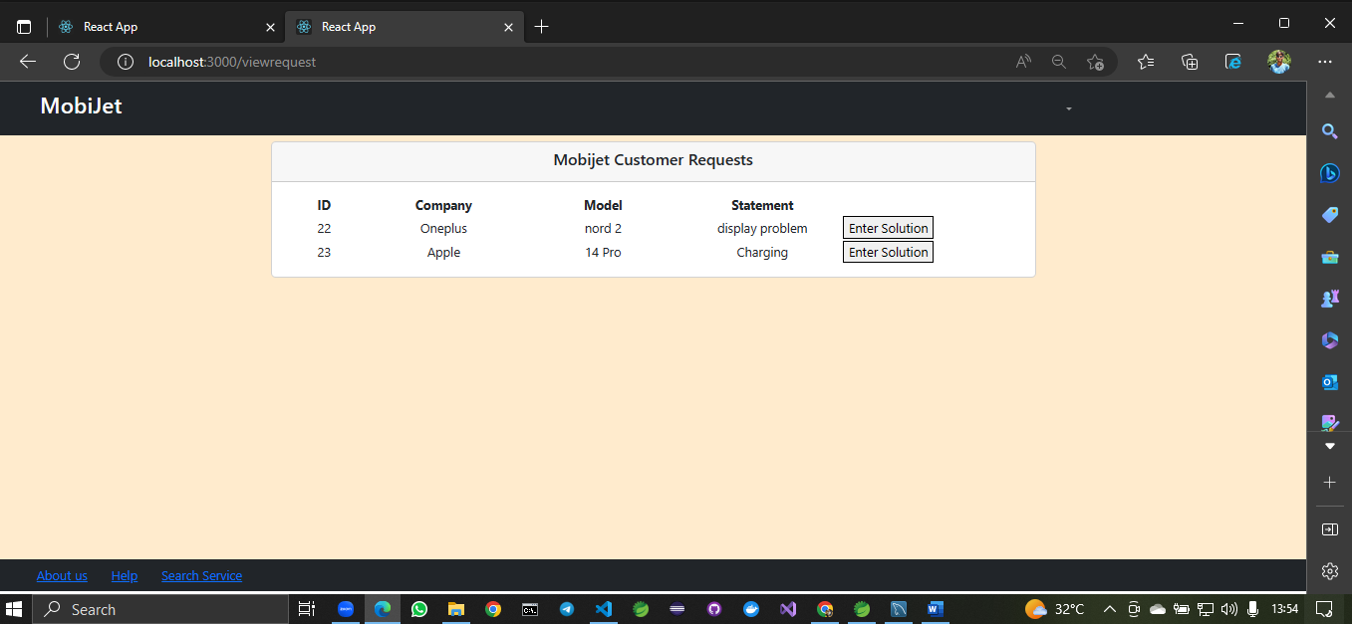

8.7.3 Enter solution of customer

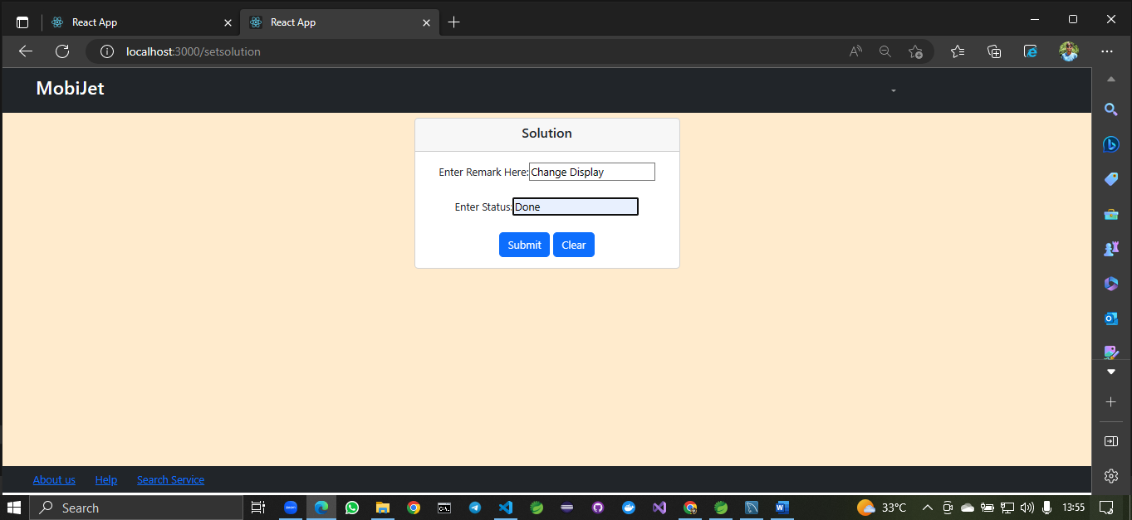

8.7.4 Admin

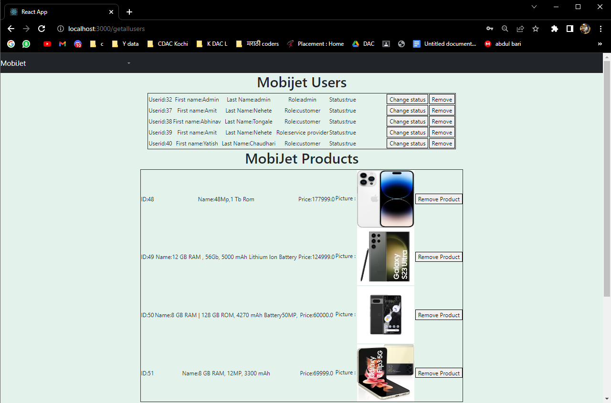

**9. CONCLUSION**

MobiJet online system provide platform for customer and service provider to get connected with each other efficiently. Our system provides a user-friendly platform where customer can easily Buy-Sell and book appointment to take a mobile repairing services from Service Provider to solve their problems. Customer can also give feedback to the respective Products after buying it. Our system provides various verified second hand mobiles also repair services from respective area service provider. MobiJet is most efficient for customers, it is easy to use and can be handled by everyone.

**9.1 FUTURE SCOPE**

In future If any product is short of its accessories and if customer requests then we will provide them. We could extend this site with new mobiles and electronic gadget and want to increase our service as many areas as we can